Table of Contents

1 Acknowledgement 4

2 Introduction 5

3 Background 6

4 Objective 7

5 Problem 8

5.1 Depletion of Time 8

5.2 Depletion of Human Resources 8

5.3 Stock unbalance 8

5.4 Incorrect payment 9

5.5 Island of technology 9

5.6 All the records are kept in hard copy 9

6 Scope 10

7 Gantt chart 11

7.1 Gantt chart 1 11

7.2 Gantt chart 2 12

8 Workload Matrix 13

9 Work Breakdown Structure 15

10 Hierarchy chart 16

10.1 Main Module 16

10.2 Membership Department Module 17

10.3 Login Module 17

10.4 Stock Department Module 17

10.5 Restaurant Module 18

10.6 Account Department Module 19

11 Flowchart 20

11.1 Main Menu 20

11.2 Membership Registration 21

11.3 Point-Of-Sales (POS) for the outlets 22

11.4 Members Billing 23

11.5 Accounts Receivable (payments received from members) 24

11.6 Inventory Management 25

12 Screen Design 26

13 Report Design 37

13.1 Bill Report 37

13.2 Registration Receipt Report 38

13.3 Monthly Statement Report 39

13.4 Stock Balance Report 40

13.5 Purchase Order Report 41

13.6 Goods Received Note Report 42

13.7 Requisition Order Report 43

13.8 Issues Note Report 44

14 Test Plan 45

15 Limitation 56

16 Future Enhancement 56

17 Assumption 57

18 Database Structure 58

19 Data Flow Diagram 62

19.1 Context Diagram 62

19.2 Level 0 diagram 67

19.3 Level 1Process 1 Diagram 75

19.4 Level 1 Process 2 Diagram 75

19.5 Level 1 Process 3 Diagram 76

19.6 Level 1 Process 4 Diagram 77

19.7 Level 1Process 5 Diagram 79

19.8 Level 1 Process 7 Diagram 81

20 User Manual 82

20.1 Login 82

20.2 Registration 84

20.2.1 Register 84

20.2.2 Edit 85

20.2.3 History 86

20.3 Point Of Sales 88

20.3.1 Add Items 88

20.3.2 History 90

20.4 Inventory Management 92

20.4.1 Add Inventory 92

20.4.2 Stock list 93

20.4.3 Edit Inventory 93

20.4.4 Generate PO 94

20.4.5 Update PO 95

20.5 Billing 97

20.5.1 History 97

20.6 Account Receivable 98

20.6.1 Statement 98

20.7 User Management 99

20.7.1 Generate 99

20.7.2 History 100

20.7.3 Edit 100

20.8 Outlet Management 101

20.8.1 Create 101

20.9 Food Management 102

20.9.1 Add Recipe 102

20.9.2 History 102

20.9.3 Edit Recipe 103

21 Minutes of Meeting 104

21.1 Minutes of Meeting 104

21.2 Minutes of Meeting 105

21.3 Minutes of Meeting 106

22 Reference 107

23 Source Code of the system 108

# Acknowledgement

We would like to express profound gratitude to our advisor Mr. Sivananthan, for his valuable support, encouragement, supervision and useful suggestions throughout this research work. His moral support and continuous guidance enabled us to complete our work successfully. We also highly thankful to our group members, (Saw Wei Chang, Chan Chew Thien, Muhammad Asyraf ) who have did hard work until this project done.

Besides, we would like to thank the Asia Pacific Institute of Information Technology for providing a great facilities and studying environment which included well-equipped computer labs for student to learn and hand on for the practical training. Nevertheless, there are reliable sources able to be found from the library which does help the student a lot to achieve better throughout the entire project development process.

We are as ever, especially indebted to our parents, for their love and support throughout our life. We are also thankful to our group members (Saw Wei Chang, Chan Chew Thien, Muhammad Asyraf), who guided each other on the direction of our project from the beginning. Moreover, our sincere thanks go to all our classmates, who shared their love and experiences with us.

# Introduction

As a part of our in course assessment for Software Development Project, we were requested to develop a new updated computing automation system for a golf club which the name is called “KelabDarulEshan” (KDE) and design our own system based on the system given. According to the problem that is found in the current system used by the golf club, we are going to provide a time save and cost effective solution to support the club business activities. Our group was assembling with three member, LiewChoonKit , Ng Rui Xiang, and Soh Lin Keong.

The KDE golf club was incorporated in 1990 and it is the most luxurious recreational development in South East Asia. In the beginning the club contained with 200 members and it was all manual works system which based on papers and pen. When the membership gradually increased, the club installed standalone personal computers system in some of the departments to support the business activities and made the work more efficiency.

Nowadays, the KDE club are handling over 5000 members and the current system they used is not suitable to continuo support the club and the duplicate data update works were gradually deteriorating. The situation made the operations of the business take longer time cant accurately provided the data which required of each departments. Furthermore, in the end of the month, the current system needs a numbers of operators to sort out the daily bills according to the each membership and regenerate monthly bills to each club members. Besides that, the poor stock controlling system also made the club keep losing their resources.

In our project, full analysis of the whole system of “KelabDarulEshan”. Within our research, we are able to identify the problems of the system, which is out dated and unreliable. Besides that, the system causes the work disorderliness and badly affects the business status. Due to the situation mentioned, we are hereby to implement a better version of the system that is being modified with more improvement compare to the earlier version.

# Background

The current system at the club include of standalone systems that have resulted in *'Islands of Technologies’*. The resultant scenario has caused obvious inefficiencies. For example, the membership department maintains a database of all members’ particulars, the Point-Of-Sales (POS) at the various outlets also maintained a database of members and the accounts department also maintained another database for invoice production. The replication has resulted in inconsistencies, redundancies and inaccuracy of information.

To become a member, customers are required to fill up a membership application form and submit it to management for approval. Upon approval of the application, members will receive an invoice from the accounts department amounting to RM30,000/- being payment for the entrance fees. Members are required to making payments.

To develop these facilities at the various outlets in the club, the members are required to make their membership card for verification of their current status. Members who have been suspended will be declined all the facilities. No cash transactions are allowed at the outlets in the club. The members will sign the bills for the facilities used and are invoiced on a monthly basis. Bills generated at the individual outlets.

The accounts department invoices the club members on a monthly basis using a statement including details of the transaction from the various outlets. Members upon receipt of the monthly statement will make payments to the club. The Accounts department will update the individual accounts with the cheques or cash and issue receipts to the members. Members are required to settle the invoiced amount within 30 days. Members who do not make the settlements within 30 days are imposed late charges penalty of 10% of the outstanding amount. Late charge transactions are posted into their individual ledgers.

The management of the club will receive various types of reports from the outlets and the accounts department to make tactical or strategic plans for the organisation.

# Objective

The main objective of the project is to analyze, evaluate, and identify the problems in the current system, and the objectives are listed as below:

* To improve the functionality of the system.
* To investigate and list down the conditions and needs for the new system.
* To resolve all the problems and limitations which faced by the current system.
* To implement a working, friendly user, and error-free system.
* To design and make an implementation plan for the new system.

# Problem

## Depletion of Time

The current system used by the club is a wasting time system. Example when the member who wants to utilise the facilities at the various outlets in the club, the steward requires a long time period to verify the member is suspended or not suspended from the latest membership status report. The other example is every the end of the month, the club requires a number of the operators to sort out the member bills and enter the totals payments of each bills by according the expense of each member then only generate the monthly bills to each member.

Solution

The function of current system doesn’t have the verify member status and generated monthly bills function. In the propose system, we will include this two functions. With the verify member status function, the operators can verify the member status within a very fast period with an easy way. On the other side, the generated monthly bills function also can help the account department to look up the totals monthly payment each club member with an automatically function. So that, the operator don’t need sort out the member bills by themselves

## Depletion of Human Resources

In the account department, the club required a number of the operator to update all the transactions of the club and generate the total monthly payment of each club member. Furthermore, the services department also required a number of stewards for checking the club member status before the member utilise the club facilities.

Solution

In the propose system, the account department only required a limited operator because some of the transaction will update automatically when the other department update their transaction. Besides that, the services department will not require many stewards in each facility part because the stewards can look up the status of each club member easy and faster. So there will not appear the problem of too much member waiting the verify services at the same time.

## Stock unbalance

Stock unable to manage properly when using current system, staff may wrongly calculate the amount of stock and affect the stock balance. Staff may steal the raw material from stock because using manual calculate system need depend on the staff to make calculation for every changes of the stock.

Solution

With the new system, staffs don’t need to calculate the stock manually. When the member takes an order and the order has been approved, the system will automatic generate a bill and deduct the stock. When stock balances reach the minimum limit, system will generate a Purchase Order (PO) to supplier for restocking, so that the stock will be increase again.

## Incorrect payment

The total payment may calculate wrongly by using current manual system. Depend on a lot of part-time employer to calculate the total payment may cause miscalculate payment amount occurs. Some payment maybe missing, this issue cause the account department cannot get back the payment from the member and club will need to bear the financial loss.

Solution

With the help of new automated system, every time the bill had been generated, the database will be auto update. It means that, account department will get the total payment from the system and doesn’t need to calculate the payment manually. This not only increase the efficiency and it also reduce the inaccurate for calculate the total payment.

## Island of technology

The old system separate every section with different database, it means that database need to update every time when any of the section making changes to its own database. Update database was done by manually, and it causes a lot of inconvenience.

Solution

We will make a database which is a “headquarter”, mean database will located and maintain in one location, it save time instead of update database one by one. This is strongly increased the efficient and accuracy.

## All the records are kept in hard copy

By keeping entire of the records in hard copy causing some of the important paper and receipt missing. This will affect the results that calculate by account department, causing the inaccurate total amount occurs.

Solution

With the help of our enhance system, the data can be find out easily. Even the hardcopy lost, the data will keep inside database. Search customer information with a search engine which in the system, instead of searching manually. It save our time and efficient.

# Scope

* Should deduce the manual work to decrease the inaccurate that may happen and increase the productivity of staff.
* Must linking all the system to centralised database, so that all information will be update to database each time the system make any changes.
* Should checking member status when the member ID has been enter into system to make sure the member is not under suspended.
* Must check the stock balance of the raw material from store each time the member takes an order to make sure member will not order any meal that is not enough material to prepare.
* Should generates a purchase orders (PO) which used for forward to suppliers when the stock of raw materials reached the minimum number.
* Should request raw materials from store automatically when the orders of the members have been approved.
* Must generate the member monthly statement report, amount should take from the transactions that have been make on specific month.
* Should update member status to suspend automatically when the member does not pay their payment during the allowed period.

# Gantt chart

## Gantt chart 1

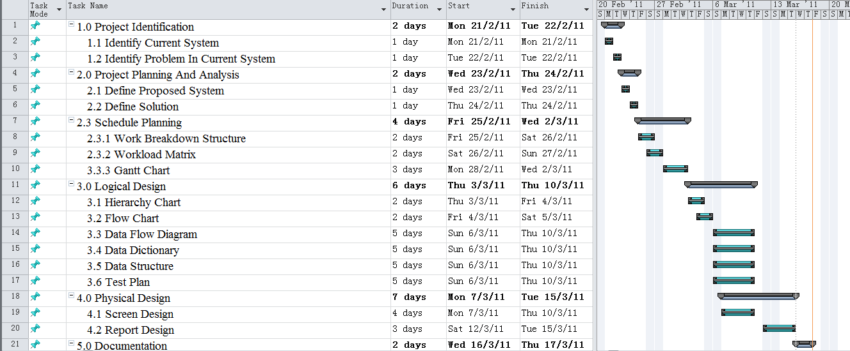

## Gantt chart 2

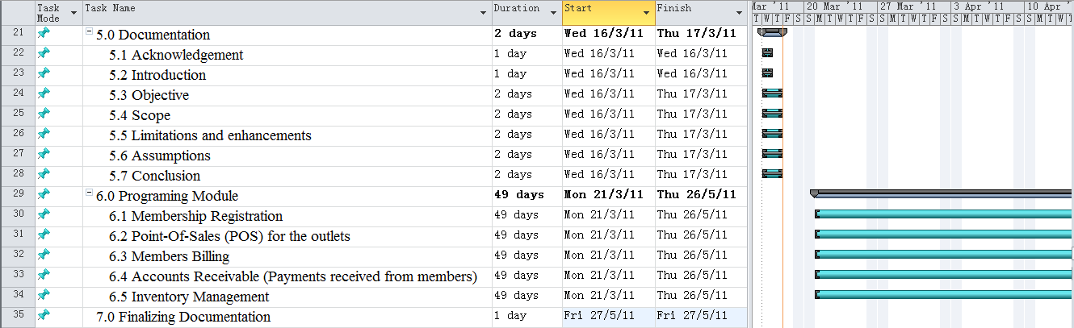

# Workload Matrix

|  |  |  |  |
| --- | --- | --- | --- |
| Task | Soh Lin Keong | Ng Rui Xiang | LiewChoon Kit |
| 1. Introduction |  |  | ✓ |
| 2. Data Flow Diagrams |  | | |
| 2.1 Context Diagram | ✓ | ✓ | ✓ |
| 2.2 Level 0 Diagram | ✓ | ✓ | ✓ |
| 2.3 Level 1 Process 1 Diagram |  | ✓ |  |
| 2.4 Level 1 Process 2 Diagram | ✓ |  |  |
| 2.5 Level 1 Process 3 Diagram |  | ✓ |  |
| 2.6 Level 1 Process 4 Diagram |  |  | ✓ |
| 2.7 Level 1 Process 5 Diagram | ✓ |  |  |
| 2.8 Level 1 Process 7 Diagram |  |  | ✓ |
| 2.9 Data Dictionary | ✓ | ✓ | ✓ |
| 3. Gantt Charts | ✓ |  |  |
| 4. Workload matrix | ✓ |  |  |
| 5. Hierarchy Chart |  | | |
| 5.1 Main Module |  |  | ✓ |
| 5.2 Membership Department Module |  |  | ✓ |
| 5.3 Login Module |  | ✓ |  |
| 5.4 Stock Department Module |  | ✓ |  |
| 5.5 Restaurant Module | ✓ |  |  |
| 5.6 Account Department Module | ✓ |  |  |
| 6. Flowcharts | ✓ | ✓ | ✓ |
| 6.1 Main Menu | ✓ |  |  |
| 6.2 Membership Registration |  | ✓ |  |
| 6.3 Point-of-Sales(POS) for the Outlets |  | ✓ |  |
| 6.4 Members Billing | ✓ |  |  |
| 6.5 Account Receivable(Payments received from members) |  |  | ✓ |
| 6.6 Inventory Management |  |  | ✓ |
| 7. Screens design |  | | |
| 7.1 Home Panel | ✓ |  |  |
| 7.2 Member Registration-Edit | ✓ |  |  |
| 7.3 Member Registration-History | ✓ |  |  |
| 7.4 Point of Sales-Add Items | ✓ |  |  |
| 7.5 Point of Sales- History | ✓ |  |  |
| 7.6 Account Receivable-Statement | ✓ |  |  |
| 7.7 Billing-History | ✓ |  |  |
| 7.8 Inventory Management-Stock List | ✓ |  |  |
| 7.9 Inventory Management-Purchase Order | ✓ |  |  |
| 7.10 Inventory Management-Add Inventory | ✓ |  |  |
| 8. Report design |  | | |
| 8.1 Bill Report | ✓ |  |  |
| 8.2 Registration Receipt Report | ✓ |  |  |
| 8.3 Monthly Statement Report | ✓ |  |  |
| 8.4 Stock Balance Report | ✓ |  |  |
| 8.5 Purchase Order Report | ✓ |  |  |
| 8.6 Goods Received Note Report | ✓ |  |  |
| 9. Test plan |  | | |
| 9.1 Home Panel |  |  | ✓ |
| 9.2 Member Registration-Edit | ✓ |  |  |
| 9.3 Member Registration-History | ✓ |  |  |
| 9.4 Point of Sales-Add Items | ✓ |  |  |
| 9.5 Point of Sales- History | ✓ |  |  |
| 9.6 Account Receivable-Statement |  | ✓ |  |
| 9.7 Billing-History |  | ✓ |  |
| 9.8 Inventory Management-Stock List |  |  | ✓ |
| 9.9 Inventory Management-Purchase Order |  |  | ✓ |
| 9.10 Inventory Management-Add Inventory |  | ✓ |  |
| 10. Perceived limitations |  | ✓ |  |
| 11. Perceived assumptions |  | ✓ |  |

# Work Breakdown Structure

|  |  |  |  |
| --- | --- | --- | --- |
| Students  Tasks | Soh Lin Keong  TP022659 | Ng Rui Xiang  TP022658 | LiewChoon Kit  TP019008 |
| 1. Introduction | 0% | 0% | 100% |
| 2. Data Flow Diagrams | 33.3% | 33.3% | 33.3% |
| 3. Gantt Charts | 100% |  |  |
| 4. Workload matrix | 100% |  |  |
| 5. Hierarchy Chart | 33.3% | 33.3% | 33.3% |
| 6. Flowcharts | 33.3% | 33.3% | 33.3% |
| 7. Screens design |  |  | 100% |
| 8. Report design |  | 100% |  |
| 9. Test plan | 36% | 32% | 32% |
| 10. Perceived limitations |  | 100% |  |
| 11. Perceived assumptions |  | 100% |  |
| *Signature* |  |  |  |

# Hierarchy chart

## Main Module

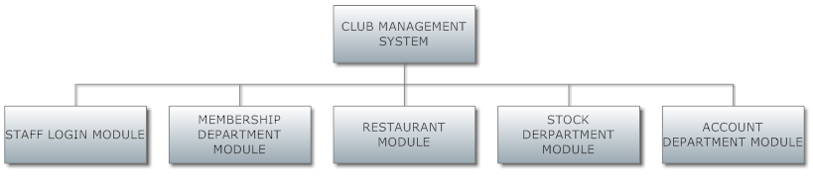

## Membership Department Module

# C:\Users\alexsoh\Desktop\2.png

## Login Module

## C:\Users\alexsoh\Desktop\3.png

## Stock Department Module

## Restaurant Module

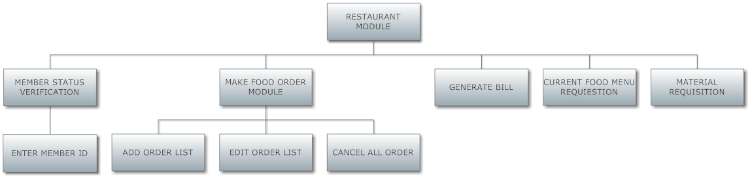

## Account Department Module

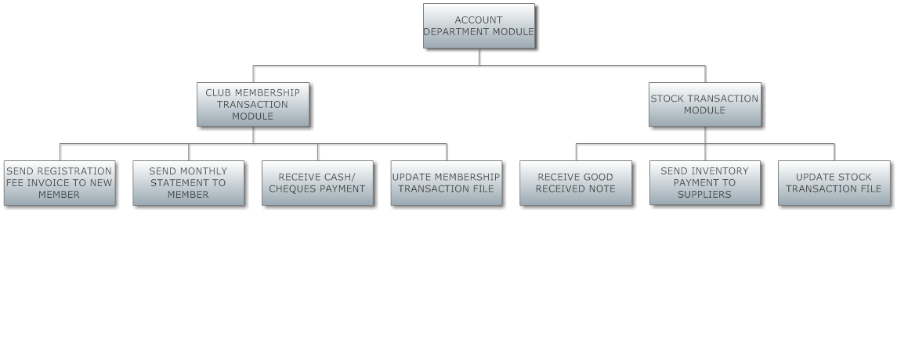

# Flowchart

## main.pngMain Menu

## Membership Registration

## 1.png

## Point-Of-Sales (POS) for the outlets

## 2.png

## Members Billing

## 3.png

## Accounts Receivable (payments received from members)

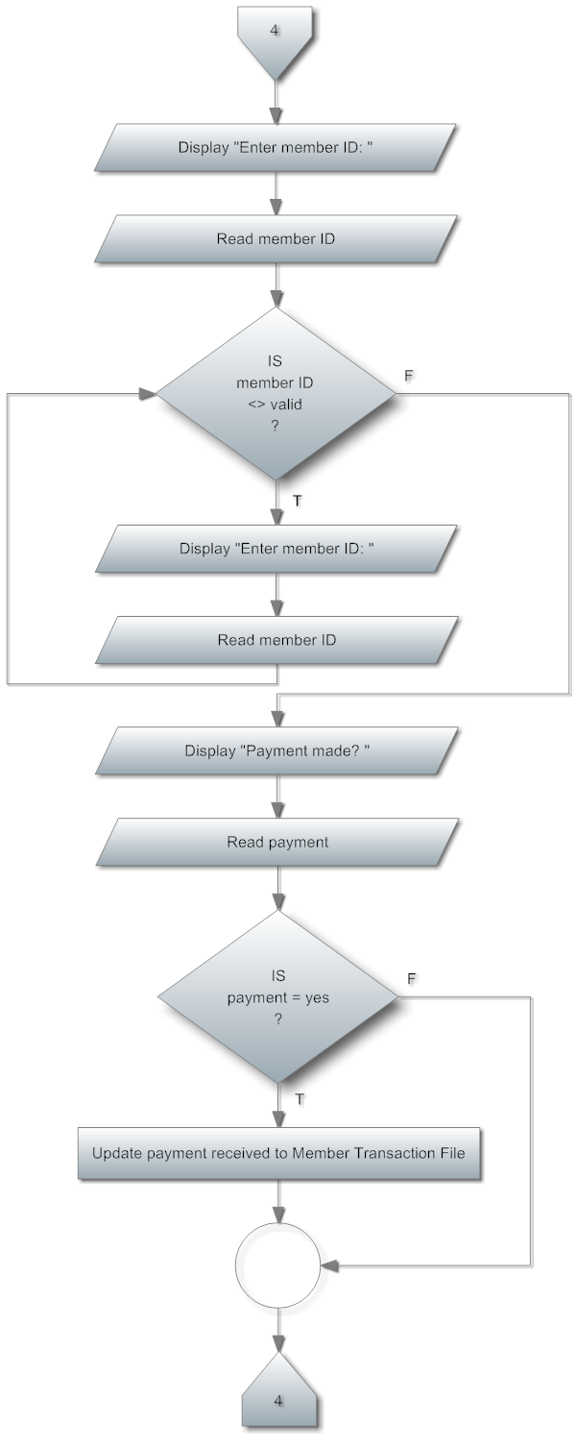

## 5.pngInventory Management

# Screen Design

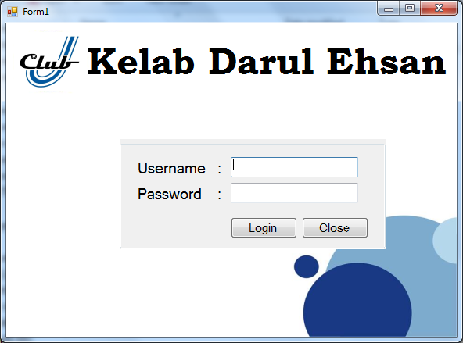

This is the login page of KelabDarulEhsan, users have to enter username and password to enter.

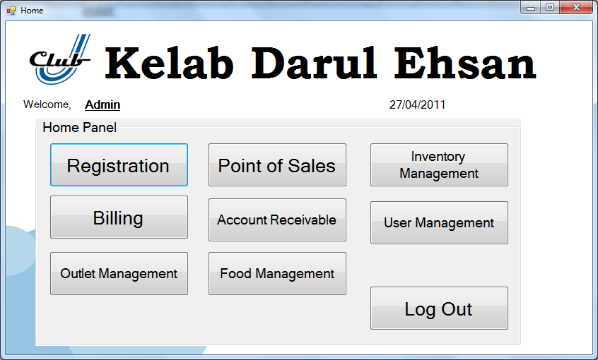

The Home page is for the Admin user after he log in to the system. In home page, there are some buttons for access certain function which included registration, Point of Sales, Billing, Inventory Management, Billing, Account Receivable, User Management, outlet Management and food Management.

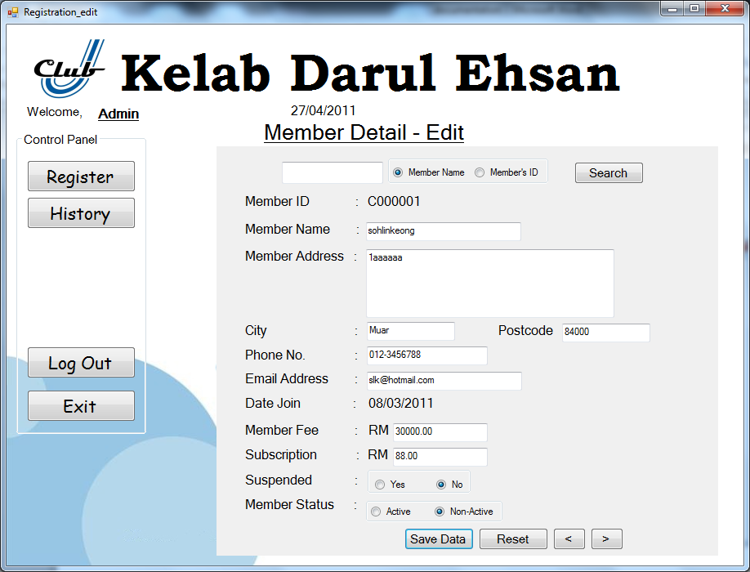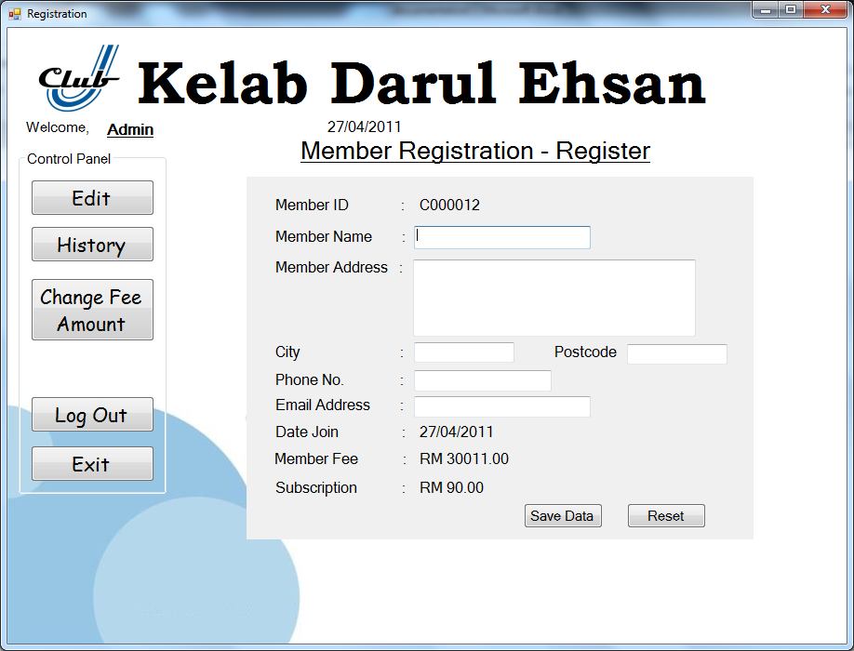

This is member registration page, which allow user to register a new member. User is required to fill up the new member information. Which contains name, home address, city, postcode, phone number and email address. Member ID, date join, member fee and subscription is generate automatically. Save data for keep the data in the database, and reset to reset the entire field. On the left side, is a control panel anditallowed user can easy access to others functions for the Member departments.

On the Member Detail- Edit page, is allow users to search, correct and update information of member. Member will suspended when they overdue the bill, and the member status is to show if the member is quit from club or still in club.

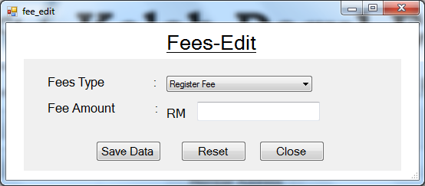

The Fees - Edit page is allow user to change the amount of the each type of fees.

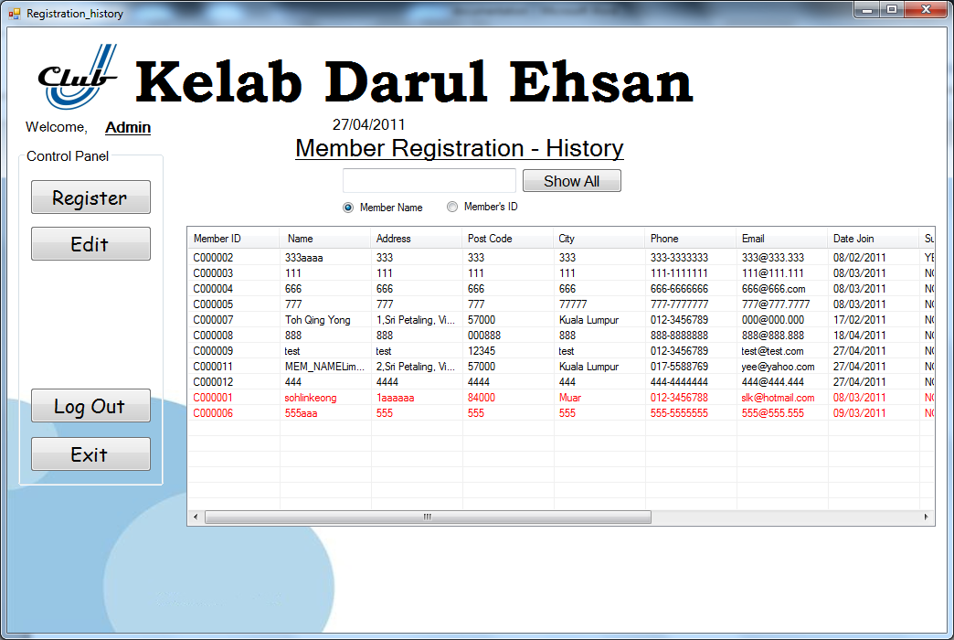

In this member registration history page is able user to check the member info. Besides that, the record of the member who is quit from the club will show in red colour.

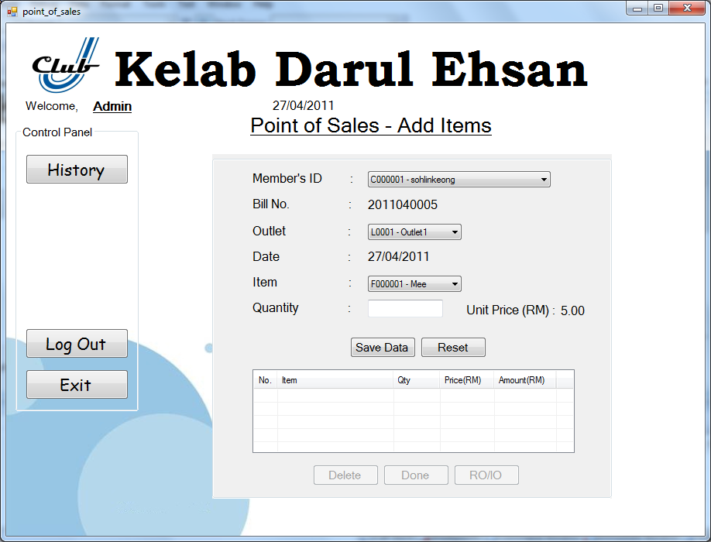

Point of Sales - Add Items page allow users to order items for customers, users have to fill up member’s ID, outlet, item, and quantity. Bill number, unit price and date are auto generate, the result will appear in the list box after save data, and click done for final confirm. On the left side, is a control panel anditallowed user can easy access to others functions for the POS departments.

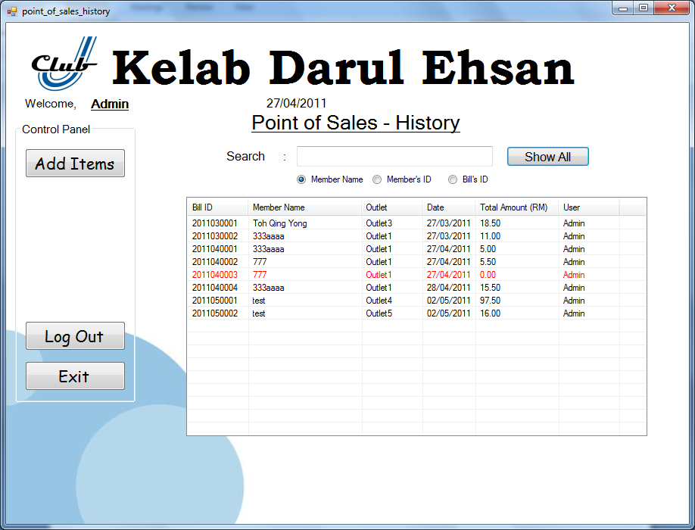

Point of Sales -History page allows users to search member‘sPOSrecord. The red colour record with showing RM0.00 for total amount means that ithas not been generated by users.

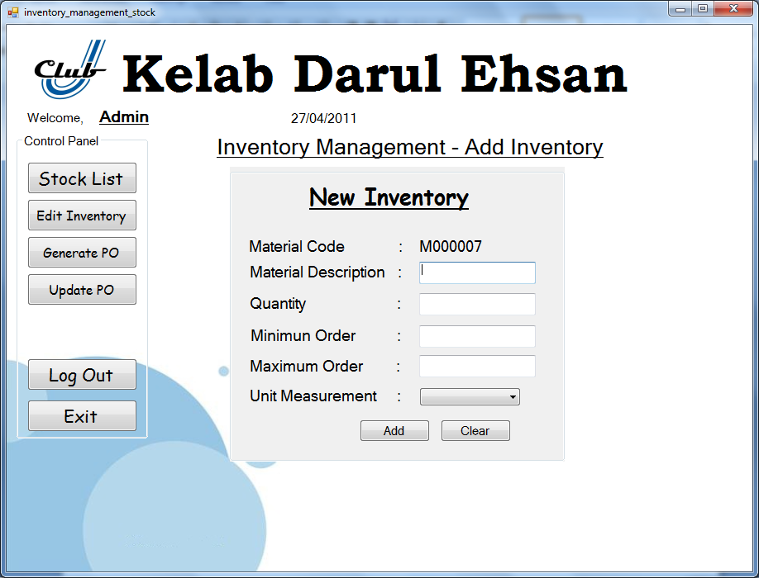

Inventory Management- Add Inventory allows users to add new inventory, restock the items. Users have to enter item description, quantity, minimum order, maximum order and unit measurement.On the left side, is a control panel anditallowed user can easy access to others functions for the Inventory departments.

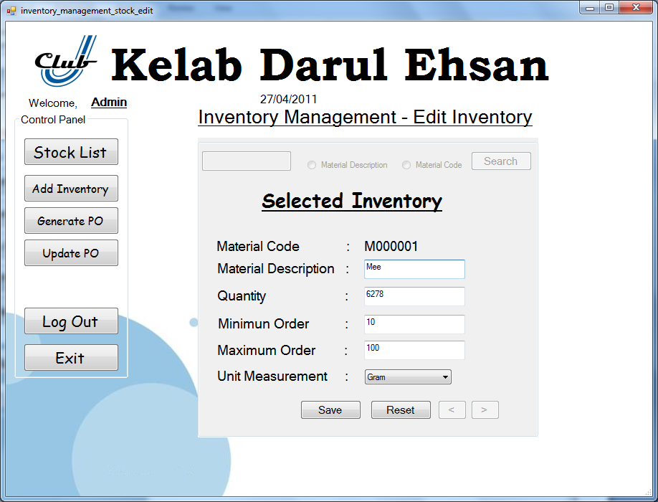

On the Inventory edit page, is allow users to search, correct and update information of Inventory.

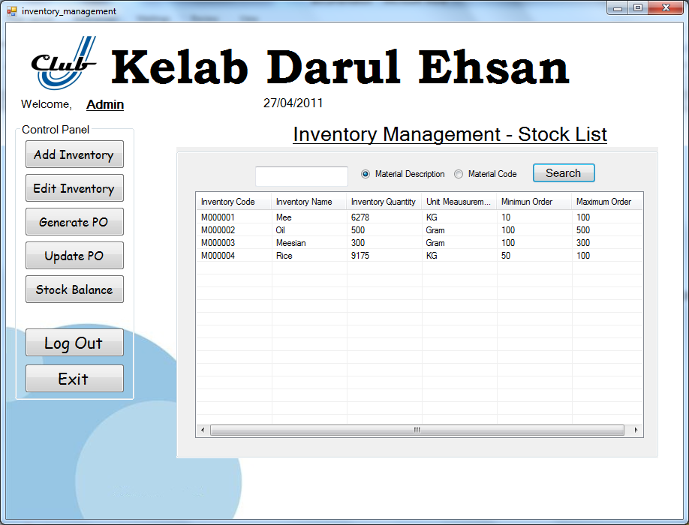

In this Inventory Management - Stock List page is able user to check the Inventorystock information. Furthermore, the stock balance button is allowing user to print the stock balance report.

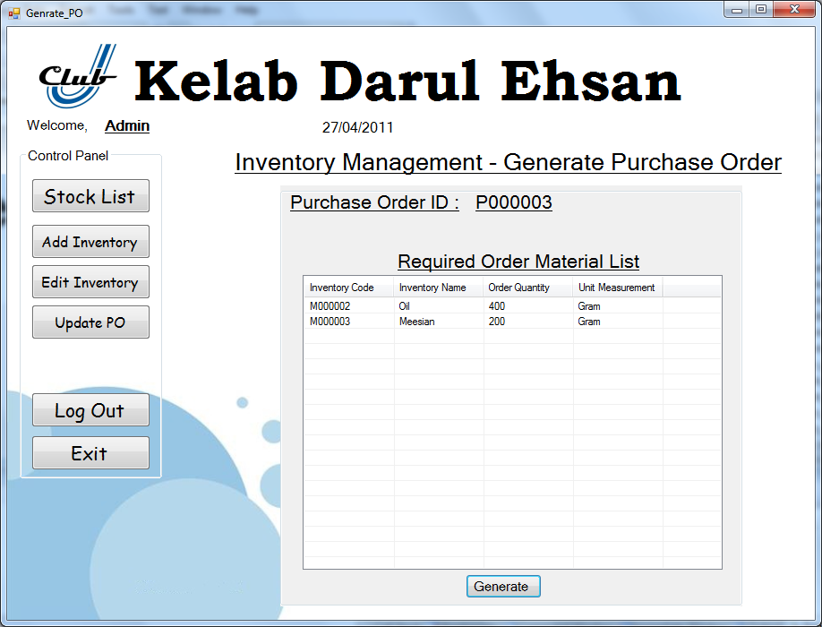

In this Generate Purchase Order page is able the user to Generate Purchase order when the material is less than the requirement.

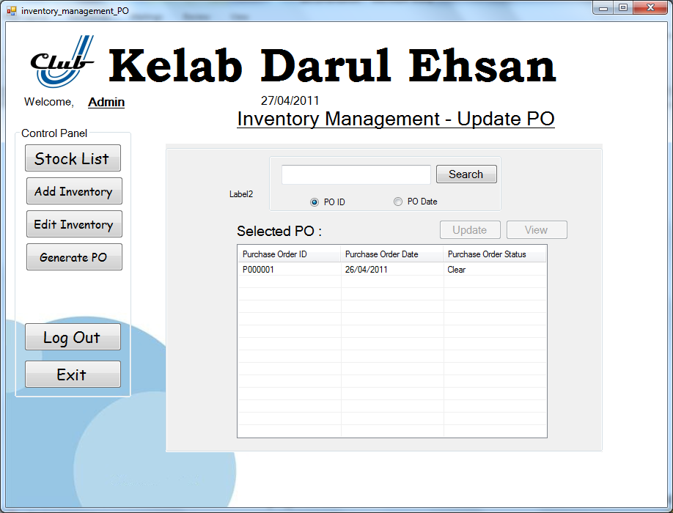

In this Update PO page, the user is able to Update and clear the PO when receive the Ordered material. After the user clear the PO, the material stock value will raise up.

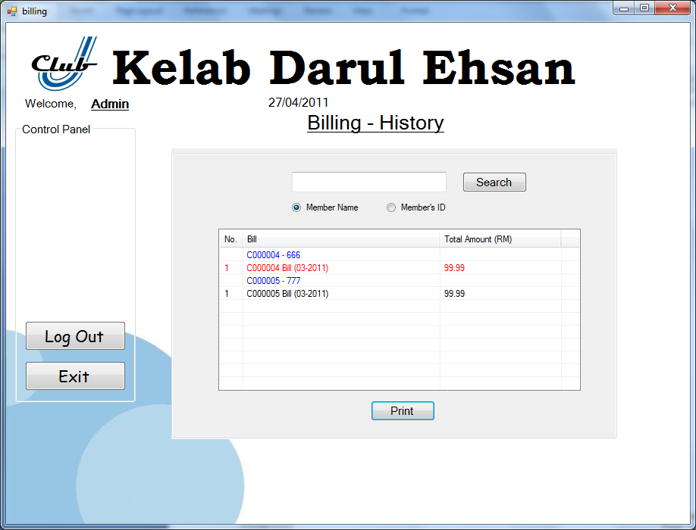

In this Bill - History page is able user to check Member Bill information. The bill with red colour means this bill hasnot printed by user before.

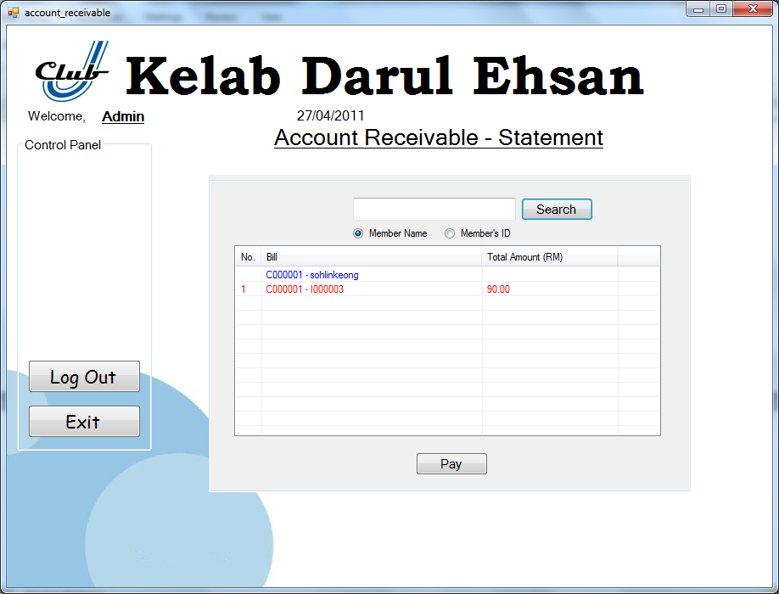

In Account Receivable – Statement page, the user is allow to clear the statement when user paying their bill.

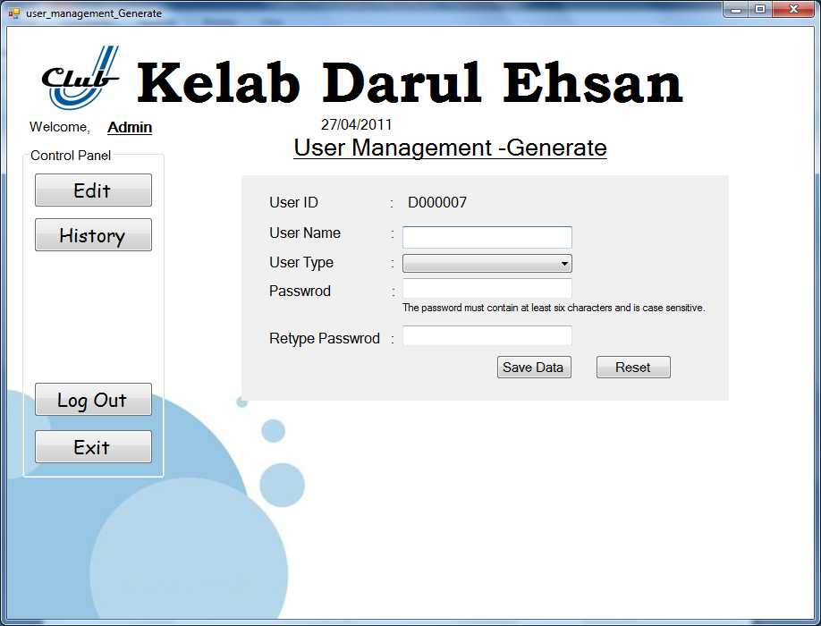

User management- Generate allows Admin to create new user according by their working department.Admin have to enter the user name, select the working department and password.On the left side, is a control panel anditallowed admin can easy access to others functions for the User management.

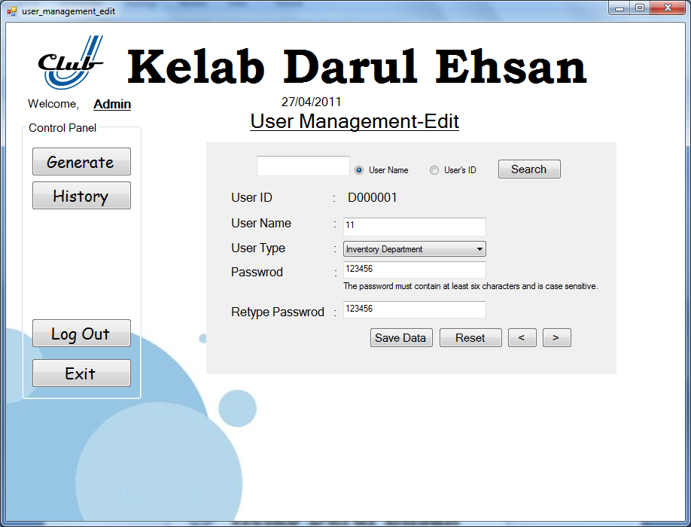

On the User Management - Edit page, is allow admin to search, correct and update information of user.

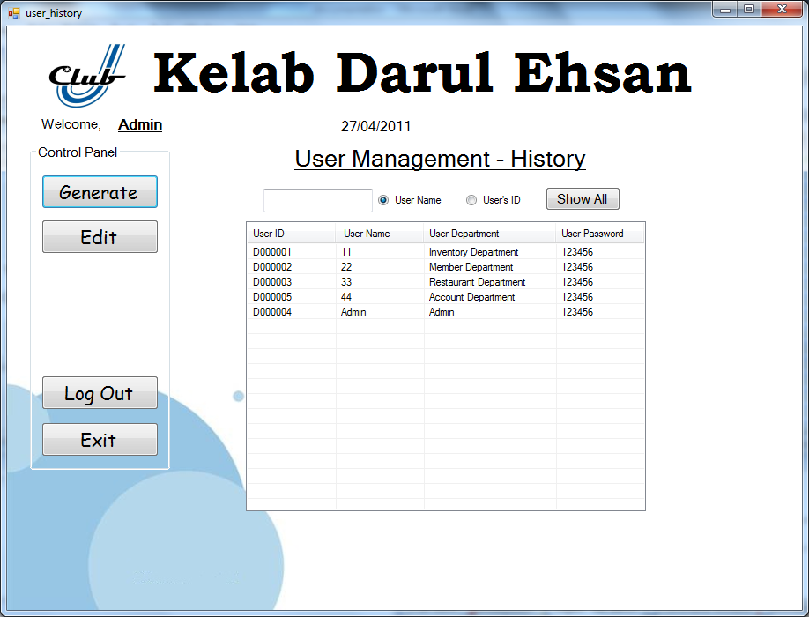

In this User Management- History page is able user to check the user info.

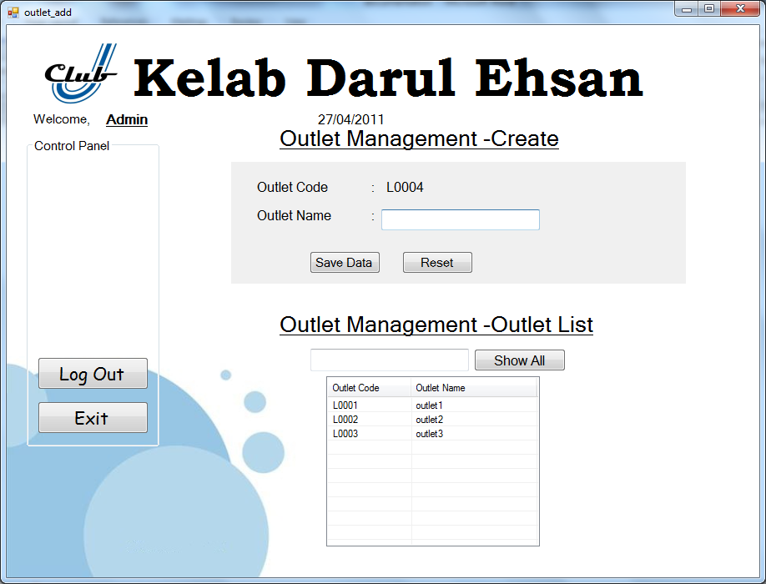

In the Outlet Management page, the admin is allowed to add and look though all outlet information.

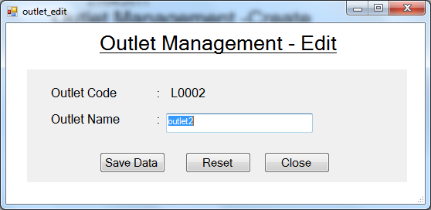

In the Outlet Management -Edit page, the admin is allowed to edit the outlet Detail.

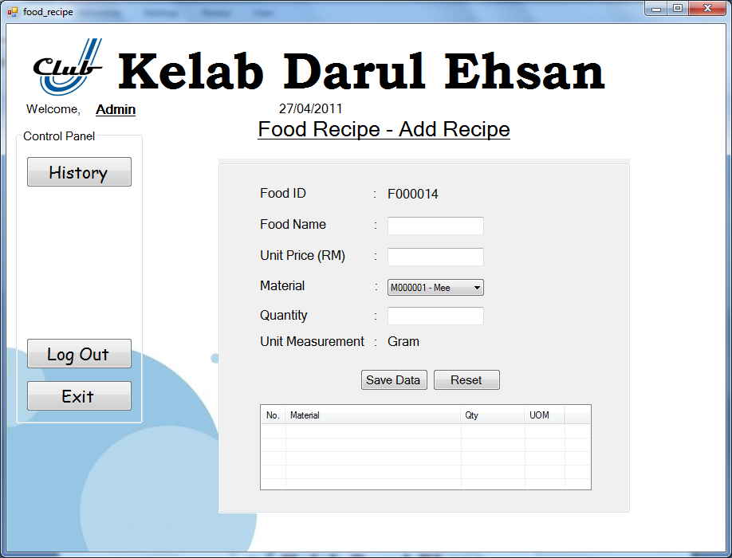

In Food Recipe - AddRecipe allows users to add new food recipe. Users have to enter food name, unit price and select the material and quantity.On the left side, is a control panel anditallowed user to access history function for searching previous records.

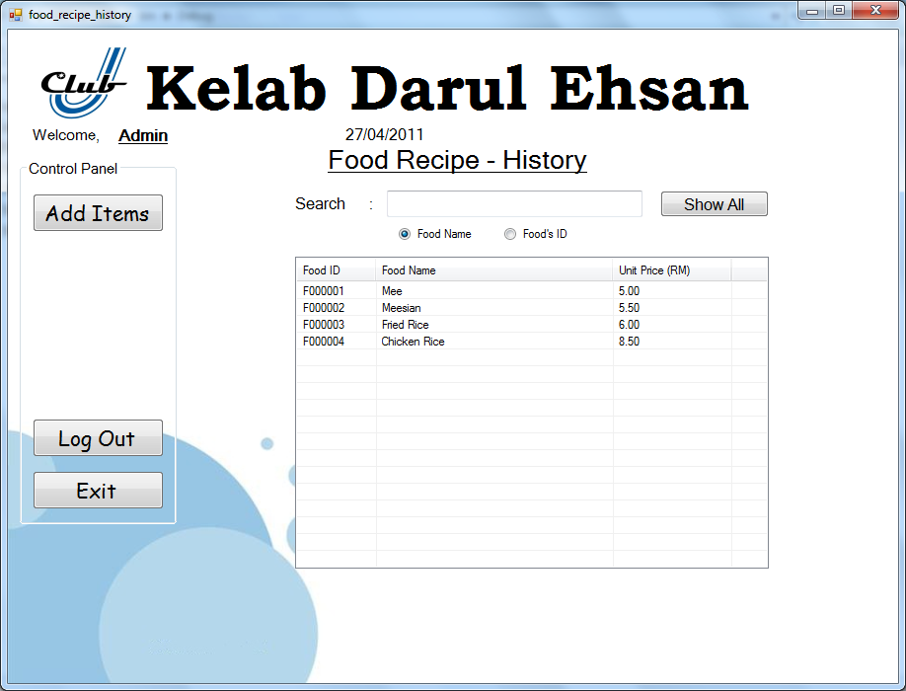

In this Food Recipe - History page is able user to check the food recipe info.

# Report Design

## Bill Report

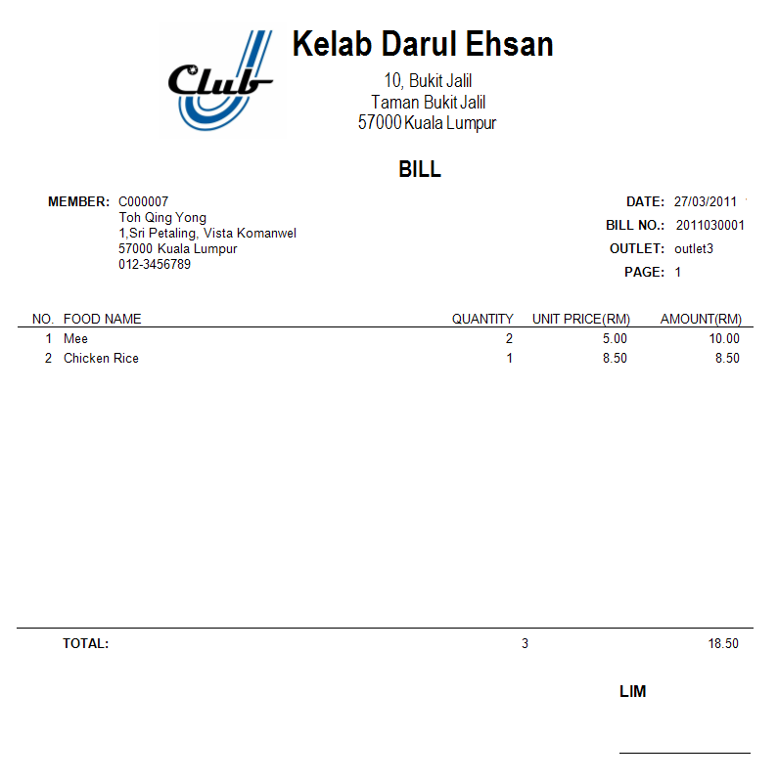

The bill report will be generated when a member order the food from restaurant. This report will be kept by member, the name of the staff that help member to make order will be display at right bottom, and it required staff to sign this bill.

## Registration Receipt Report

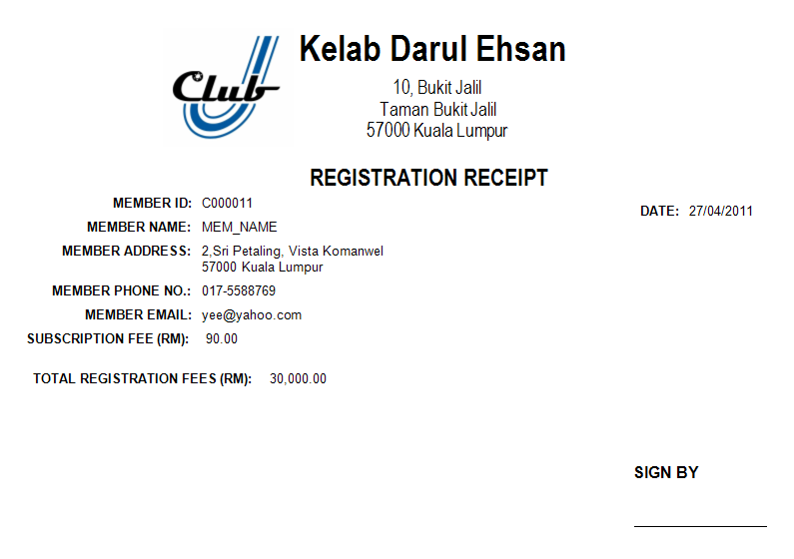

When a customer had paid his registration fees and has been register as a member successfully, this registration receipt will be generated. The receipt required member to sign when he received it from staff.

## Monthly Statement Report

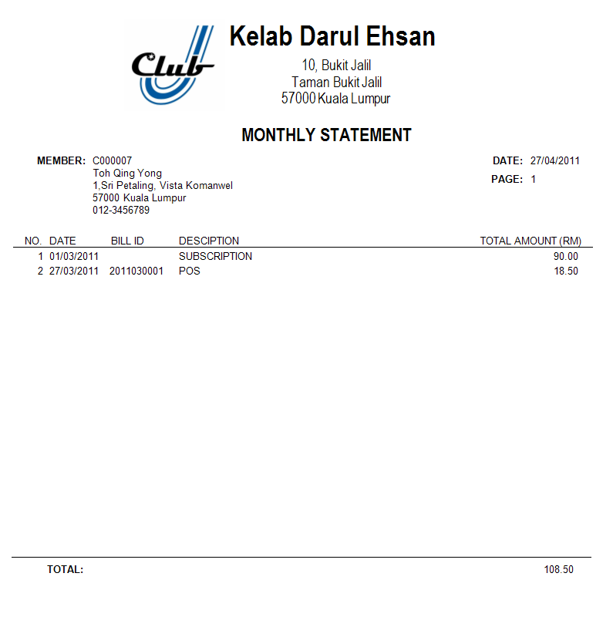

The staffs of the club will generate statement report every month. After the monthly statement report had been generated, the staffs will need to send it to the members. So that, members will get the notification for the total payment that they need to pay.

## Stock Balance Report

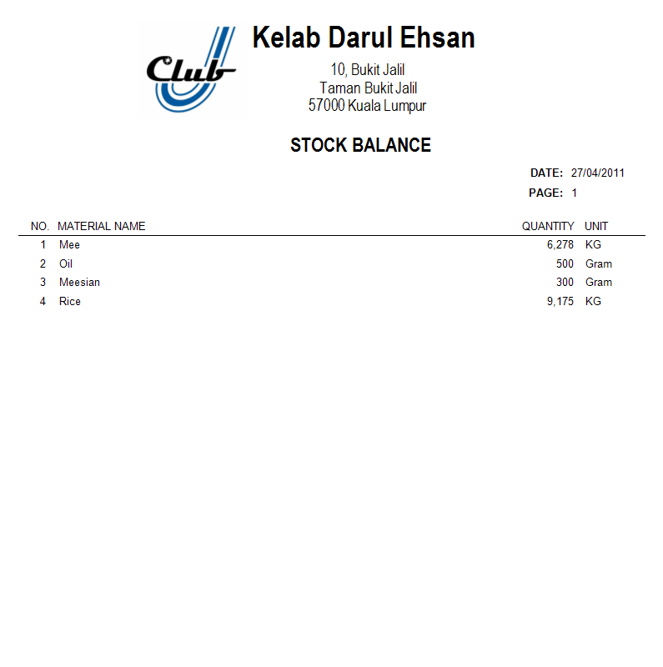

Stock department will need to check their stock balance frequently. This report will display entire stock balance of raw material in the store, it helps stock department to list out all stock with a balance quantity.

## Purchase Order Report

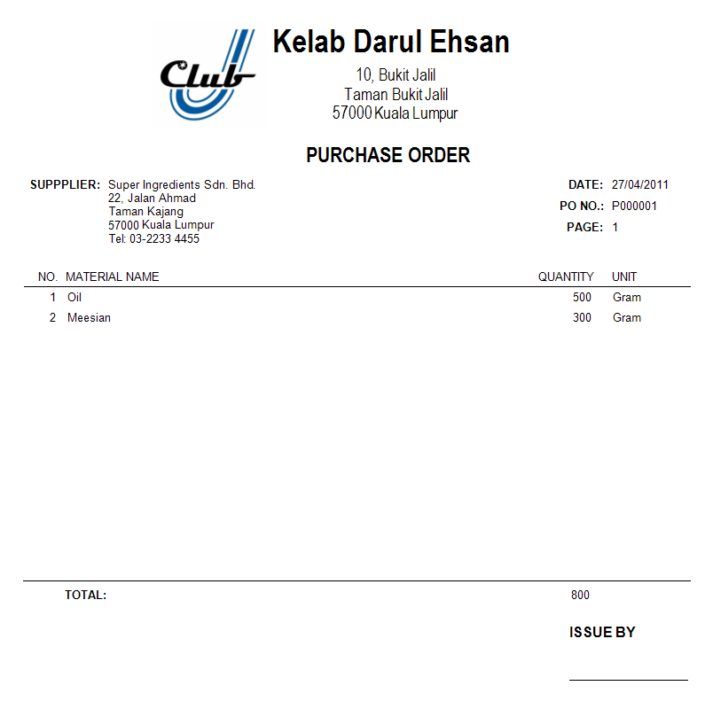

When the balances of the raw material in the store reach its minimum quantity, staffs will need to generate the purchase order (PO) and send it to supplier for purchase the new material. Staff that generates PO was required to attach with his signature.

## Goods Received Note Report

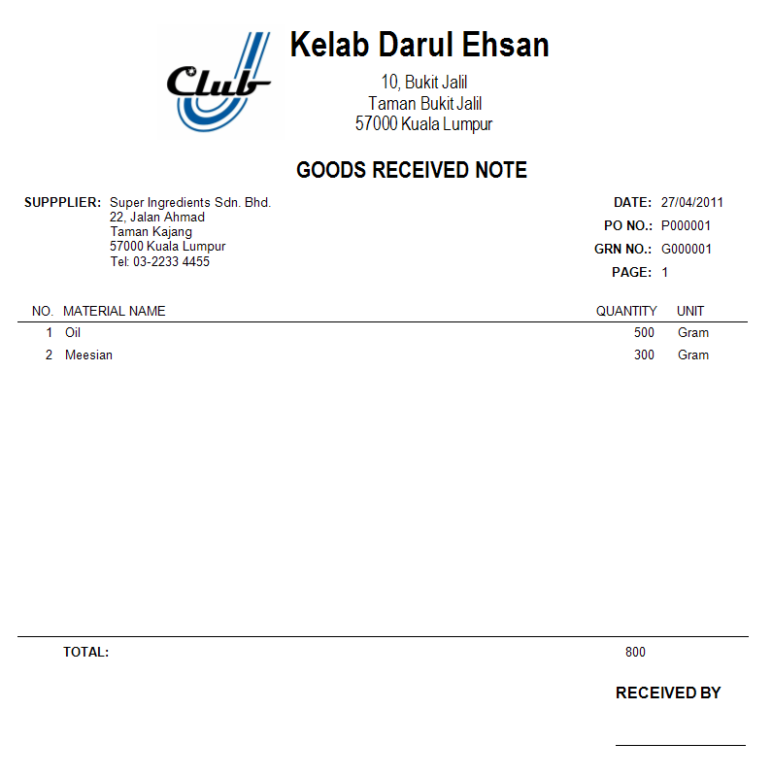

When the staffs receive the material that order from the supplier, they need to update related material balance using the system. After updated to the system, the goods received note (GRN) will be generated, so that staff can keep it as a record.

## Requisition Order Report

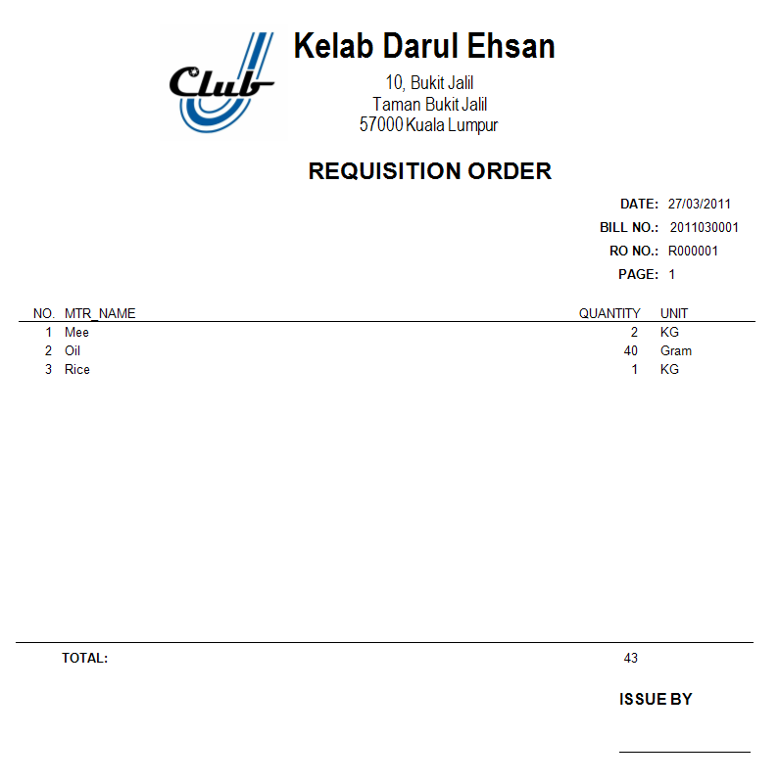

When the restaurant receives the orders from the members, they need to request related materials fromstockdepartment. The system will generatethe requisition order (RO) after the members confirm their orders, staffs can print it out and save as a hardcopy.

## Issues Note Report

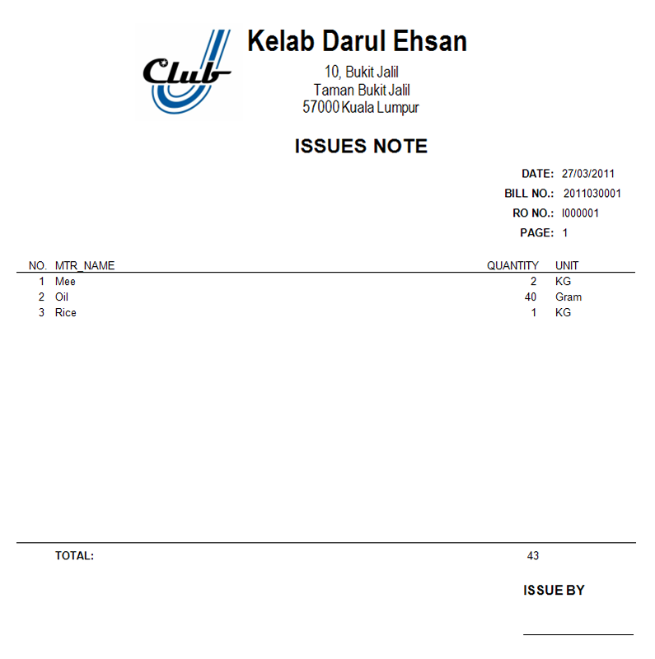

When the stockdepartment issue the materials that requestby the restaurant, issue note (IO) will be required to print out. Since the system will process the material adjustment, so that the IO will not be print out automatically, staffs can print it out by manually.

# Test Plan

Login

|  |  |  |
| --- | --- | --- |
| Test Case | Expected Result | Actual Result |
| Entering Correct Admin ID and Password and click “Login” | Go to Home Panel | As Expected |
| Entering Correct User ID and Password and click “Login” | Go to certain Function form according the user department | As Expected |
| Entering incorrect User ID and Password and click “Login” | Error message notifying incorrect user name or password | As Expected |
| Click on “Close” | Close the program | As Expected |

Home Panel

|  |  |  |
| --- | --- | --- |
| Test Case | Expected Result | Actual Result |
| Click on “Registration” | Go to Member Registration-Register form | As Expected |
| Click on “Point of Sales” | Go to Point of Sales-Add Items form | As Expected |
| Click on “Inventory Management” | Go to Inventory Management-Add Inventory form | As Expected |
| Click on “Billing” | Go to Billing-History form | As Expected |
| Click on “Account Receivable” | Go to Account Receivable-Statement form | As Expected |
| Click on “User Management” | Go to User generate form | As Expected |
| Click on “Outlet Management” | Go to Create Outlet form | As Expected |
| Click on “Food Management” | Go to Add Recipe form | As Expected |
| Click on “Log out” | Go to Login form | As Expected |

Member Registration- Control Panel

|  |  |  |
| --- | --- | --- |
| Click on “Register” | Go to Member Registration-Register form | As Expected |
| Click on “Edit” | Go to Member Registration-Edit form | As Expected |
| Click on “History” | Go to Member registration – History form | As Expected |
| Click on “Change Fee Amount” | Go to Fees Edit form | As Expected |
| Click on “Log Out” | Go to Login form | As Expected |
| Click on “Exit” | Close the system | As Expected |

Member Registration-Register

|  |  |  |
| --- | --- | --- |
| Test Case | Expected Result | Actual Result |
| Entering member name, member address, city, Postcode, Phone no, Email address and click “Save Data” | Pop up a message notifying success adding and pop up a member registration fee invoice for printing | As Expected |
| Entering invalid (member name, member address, city, Postcode, Phone no, Email address) and click “Save Data” | Appear error provided icon with error messagebeside the fields which contain errors | As Expected |
| Click on “Reset” | Clear the data in all fields | As Expected |

Member Registration–Search Function

|  |  |  |
| --- | --- | --- |
| Test Case | Expected Result | Actual Result |
| Entering correct member name and selecting member name option then click “Search” | Show out the specific member data in the correct fields | As Expected |
| Entering wrong member name and selecting member name option then click “Search” | Pop up a message to remind user no such member name in member record. | As Expected |
| Entering correct member ID and selecting member’s ID option then click “Search” | Show out the specific member data in the correct fields | As Expected |
| Entering wrong member ID and selecting member’s ID option then click “Search” | Pop up a message to remind user no such member ID in member record. | As Expected |
| Editing member name, member address, city, Postcode, Phone no, Email address and click “Save Data” | Pop up a message to inform user successful updating member data. | As Expected |

Member Registration-Edit

|  |  |  |
| --- | --- | --- |
| Editing invalid (member name, member address, city, Postcode, Phone no, Email address) and click “Save Data” | Appear error provided icon with error messagebeside the fields which contain errors | As Expected |
| Click on “Reset” | The member data in the field will restore to the default member record. | As Expected |
| Click on “>” | Display the next member data in correct field. | As Expected |
| Click on “<” | Display the previous member data in correct field. | As Expected |

Fees Edit form

|  |  |  |
| --- | --- | --- |
| Test Case | Expected Result | Actual Result |
| Not filling fields and click “Save Data” | Appear error provided icon with error messagebeside the fields which contain errors. | As Expected |
| Editing invalid fees record and click “Save Data” | Appear error provided icon with error messagebeside the fields which contain errors | As Expected |
| Click on “Reset” | Empty all field. | As Expected |
| Click on “Close” | Close Fee Edit form | As Expected |

Member Registration-History

|  |  |  |
| --- | --- | --- |
| Test Case | Expected Result | Actual Result |
| Double click on “certain member record” | Pop up Member Registration-Edit form and fill the specific member data into correct field | As Expected |

Inventory Management – Control Panel

|  |  |  |
| --- | --- | --- |
| Test Case | Expected Result | Actual Result |
| Click “Stock List” | Go to Inventory Management - stock list form | As Expected |
| Click “Add Inventory” | Go to Inventory Management – Add Inventory form | As Expected |
| Click “Edit Inventory” | Go to Inventory Management – Edit Inventory form | As Expected |
| Click “Generate PO” | Go to Inventory Management – Generate Purchase Order form | As Expected |
| Click “Update PO” | Go to Inventory Management – Update PO form | As Expected |
| Click “Stock Balance” | Pop up Stock Balance Report | As Expected |
| Click on “Log Out” | Go to Login form | As Expected |
| Click on “Exit” | Close the system | As Expected |

Inventory Management – Add Inventory

|  |  |  |
| --- | --- | --- |
| Test Case | Expected Result | Actual Result |
| Entering Material Description, Quantity, Minimum Order, Maximum Order, select Unit Measurement and click “Add” | Pop up a message notifying success adding. | As Expected |
| Entering invalid (Material Description, Quantity, Minimum Order, Maximum Order, select Unit Measurement) and click “Add” | Appear error provided icon with error messagebeside the fields which contain errors | As Expected |
| Click on “Reset” | Clear the data in all fields | As Expected |

Inventory Management – Search Function

|  |  |  |
| --- | --- | --- |
| Test Case | Expected Result | Actual Result |
| Entering correct MaterialDescription and selecting MaterialDescription option then click “Search” | Show out the specific Material data in the correct fields | As Expected |
| Entering wrong MaterialDescription and selecting MaterialDescription option then click “Search” | Pop up a message to remind user no such MaterialDescription in Materialrecord. | As Expected |
| Entering correct MaterialCode and selecting MaterialCode option then click “Search” | Show out the specific Material data in the correct fields | As Expected |
| Entering wrong MaterialCode and selecting MaterialCode option then click “Search” | Pop up a message to remind user no such MaterialCode in Material record. | As Expected |

Inventory Management – Edit Inventory

|  |  |  |
| --- | --- | --- |
| Test Case | Expected Result | Actual Result |
| EditingMaterial Description, Quantity, Minimum Order, Maximum Order, select Unit Measurement and click “Save” | Pop up a message to inform user successful updating Material data. | As Expected |
| Click on “Reset” | The Material data in the field will restore to the default Material record. | As Expected |
| Click on “>” | Display the next Material data in correct field. | As Expected |
| Click on “<” | Display the previous Material data in correct field. | As Expected |

Inventory Management – Generate Purchase Order

|  |  |  |
| --- | --- | --- |
| Test Case | Expected Result | Actual Result |
| Double click on “certain Required Order Material” | Pop up Message box with “Yes No” to remove order the material | As Expected |
| Click “Yes” for remove order the Material | Remove the Material in the required order material list | As Expected |

Inventory Management – Update PO

|  |  |  |
| --- | --- | --- |
| Test Case | Expected Result | Actual Result |
| Double click on “certain PO record” | Display PO ID in selected PO ID field | As Expected |
| Click on “Update” | Update the GRN report and add in all ordered material quantity | As Expected |
| Click on “View” | Pop up the PO report | As Expected |
| Entering correct PO ID name and selecting PO ID option then click “Search” | Show out the specific PO data in the PO list | As Expected |
| Entering wrong PO ID and selecting PO ID option then click “Search” | Pop up a message to remind user no such PO ID in POrecord. | As Expected |
| Select Correct PO Date and selecting PO Date option then click “Search” | Show out the specific PO data in the PO list | As Expected |
| Select PO DateCode and selecting PO Date option then click “Search” | Pop up a message to remind user no such PO with the Date in PO record. | As Expected |

Inventory Management – Stock List

|  |  |  |
| --- | --- | --- |
| Test Case | Expected Result | Actual Result |
| Double click on “certain Stock record” | Pop up Edit Inventory form and fill the specific Material data into correct field | As Expected |

User Management – Control Panel

|  |  |  |
| --- | --- | --- |
| Test Case | Expected Result | Actual Result |
| Click on “Generate” | Go to User Management – Generate form | As Expected |
| Click on “Edit” | Go to User Management – Edit form | As Expected |
| Click on “History” | Go to User Management – History form | As Expected |
| Click on “Log Out” | Go to Login form | As Expected |
| Click on “Exit” | Close the system | As Expected |

User Management – Search Function

|  |  |  |
| --- | --- | --- |
| Test Case | Expected Result | Actual Result |
| Entering correct User name and selecting Username option then click “Search” | Show out the specific User data in the correct fields | As Expected |
| Entering wrong User name and selecting Username option then click “Search” | Pop up a message to remind user no such Username in Userrecord. | As Expected |
| Entering correct UserID and selecting UserID option then click “Search” | Show out the specific User data in the correct fields | As Expected |
| Entering wrong UserID and selecting UserID option then click “Search” | Pop up a message to remind user no such UserID in User record. | As Expected |

User Management – Generate

|  |  |  |
| --- | --- | --- |
| Test Case | Expected Result | Actual Result |
| Entering User Name, User Password, select User Type and click “Save Data” | Pop up a message notifying success create. | As Expected |
| Entering invalid (User Name, User Password, select User Type) and click “Save Data” | Appear error provided icon with error messagebeside the fields which contain errors | As Expected |
| Click on “Reset” | Clear all data in the field | As Expected |

User Management – Edit

|  |  |  |
| --- | --- | --- |
| Test Case | Expected Result | Actual Result |
| EditingUser Name, User Password, select User Type and click “Save Data” | Pop up a message to inform user successful updating User data. | As Expected |
| Click on “Reset” | The User data in the field will restore to the default User record. | As Expected |
| Click on “>” | Display the next User data in correct field. | As Expected |
| Click on “<” | Display the previous User data in correct field. | As Expected |

User Management – History

|  |  |  |
| --- | --- | --- |
| Test Case | Expected Result | Actual Result |
| Double click on “certain User record” | Pop up User Management – Edit form and fill the specific User data into correct field | As Expected |

Outlet Management – Create & Outlet list

|  |  |  |
| --- | --- | --- |
| Test Case | Expected Result | Actual Result |
| Entering Outlet name and click “Save Data” | Pop up a message notifying success create. | As Expected |
| EnteringinvalidOutlet name and click “Save Data” | Appear error provided icon with error messagebeside the fields which contain errors | As Expected |
| Click on “Reset” | Clear all data in the field | As Expected |
| Entering correct Outlet name and selecting Materialname option then click “Search” | Show out the specific User data in the correct fields | As Expected |
| Double click on “certain Outlet record” | Pop up Outlet Management – Edit form and fill the specific User data into correct field | As Expected |

Outlet Management – Edit

|  |  |  |
| --- | --- | --- |
| Test Case | Expected Result | Actual Result |
| Entering Outlet name and click “Save Data” | Pop up a message to inform user successful updating Outlet data. | As Expected |
| Click on “Reset” | The Outlet data in the field will restore to the default Outlet record. | As Expected |
| Click on “Close” | Close the program | As Expected |

Point of Sales – Control Panel

|  |  |  |
| --- | --- | --- |
| Test Case | Expected Result | Actual Result |
| Click on “Add Items” | Go to Point of Sales – Add Item form | As Expected |
| Click on “History” | Go to Point of Sales – History form | As Expected |
| Click on “Log Out” | Go to Login form | As Expected |
| Click on “Exit” | Close the system | As Expected |

Point of Sales – Add Items

|  |  |  |
| --- | --- | --- |
| Test Case | Expected Result | Actual Result |
| Selecting Member ID, outlet, item, entering Quantity and click “Save Data” | Added item show in bottom table | As Expected |
| Selecting Member ID, outlet, item, entering invalid Quantity material and click “Save Data”” | Pop up message box inform what error is. | As Expected |
| Double click on “certain item record” | Fill the record in correct field and change the reset button to delete button | As Expected |
| Click on “Delete” after double click on “certain item record” | Delete the selected item record from the table | As Expected |
| Click on “Reset” | Clear the quantity field | As Expected |
| Click on “Delete” | Clear all data in the field | As Expected |
| Click on “Done” after fill in item in table | Pop up message box with (Yes No) and total enough of the bill | As Expected |
| Click on “Yes” after click “Done” | Pop up Bill report | As Expected |
| Click on “No” after click “Done” | Return to the Point of Sales – Add Items form | As Expected |

Point of Sales-History

|  |  |  |
| --- | --- | --- |
| Test Case | Expected Result | Actual Result |
| Entering correct member name and selecting member name option then click “Show All” | List out the specific member bill with the bill detail in the bottom. | As Expected |
| Entering wrong member name and selecting member name option then click “Search” | Pop up a message to remind user no such member name in member record. | As Expected |
| Entering correct member ID and selecting member’s ID option then click “Search” | List out the specific member bill with the bill detail in the bottom. | As Expected |
| Entering wrong member ID and selecting member ID option then click “Search” | Pop up a message to remind user no such member ID in member record. | As Expected |
| Entering correct bill ID and selecting bill ID option then click “Show All” | List out the specific bill with the bill detail in the bottom. | As Expected |
| Entering wrong bill ID and selecting bill ID option then click “Search” | Pop up a message to remind user no such bill ID in bill record. | As Expected |
| Double click on “certain POS record” | Go to Point of Sales – Print form and fill the specific User data into correct field | As Expected |

Point of Sales-Print item

|  |  |  |
| --- | --- | --- |
| Test Case | Expected Result | Actual Result |
| Click on “Print” | Pop up the Bill | As Expected |
| Click on “ROID” | Pop up the Requisition Order and Issues Note | As Expected |

Billing – History

|  |  |  |
| --- | --- | --- |
| Test Case | Expected Result | Actual Result |
| Entering correct member name and selecting member name option then click “Search” | Show out the specific member Bill in the table | As Expected |
| Entering wrong member name and selecting member name option then click “Search” | Pop up a message to remind user no such member Bill record. | As Expected |
| Entering correct member ID and selecting member’s ID option then click “Search” | Show out the specific member Bill in the table | As Expected |
| Entering wrong member ID and selecting member’s ID option then click “Search” | Pop up a message to remind user no such member Bill record. | As Expected |
| Click on the certain Bill record and Click “Print” | Pop up the selected statement for printing out | As Expected |
| Click on “Log Out” | Go to Login form | As Expected |
| Click on “Exit” | Close the system | As Expected |

Account Receivable – Statement

|  |  |  |
| --- | --- | --- |
| Test Case | Expected Result | Actual Result |
| Entering correct member name and selecting member name option then click “Search” | Show out the specific member Bill in the table | As Expected |
| Entering wrong member name and selecting member name option then click “Search” | Pop up a message to remind user no such member Bill record. | As Expected |
| Entering correct member ID and selecting member’s ID option then click “Search” | Show out the specific member Bill in the table | As Expected |
| Entering wrong member ID and selecting member’s ID option then click “Search” | Pop up a message to remind user no such member Bill record. | As Expected |
| Click on the certain Bill record and Click “Pay” | The paid statement will update and can’t search out in this form again. | As Expected |
| Click on “Log Out” | Go to Login form | As Expected |
| Click on “Exit” | Close the system | As Expected |

Food Recipe – Control Panel

|  |  |  |
| --- | --- | --- |
| Test Case | Expected Result | Actual Result |
| Click on “Add Recipe” | Go to Food Recipe – Add Recipe form | As Expected |
| Click on “History” | Go to Food Recipe – History form | As Expected |
| Click on “Log Out” | Go to Login form | As Expected |
| Click on “Exit” | Close the system | As Expected |

Food Recipe – Add Recipe

|  |  |  |
| --- | --- | --- |
| Test Case | Expected Result | Actual Result |
| Entering Food Name, Unit Price, Quantity material ,Select material, and click “Save Data” | Added Food name and recipe show in bottom table | As Expected |
| Entering invalid (Food Name, Unit Price, Quantity material ,Select material,) and click “Save Data” | Appear error provided icon with error messagebeside the fields which contain errors | As Expected |
| Double click on “certain Food recipe record” | Fill the record in correct field and change the reset button to delete button | As Expected |
| Click on “Delete” after double click on “certain Food recipe record” | Delete the selected Food recipe record from the table | As Expected |
| Click on “Reset” | Clear the quantity field | As Expected |

Food Recipe – History

|  |  |  |
| --- | --- | --- |
| Test Case | Expected Result | Actual Result |
| Entering correct Food name and selecting Food name option then click “Search” | Show out the specific Foodrecipe record in the table | As Expected |
| Entering wrong Food name and selecting Food name option then click “Search” | Pop up a message to remind user no such Food record record. | As Expected |
| Entering correct Food ID and selecting Food ID option then click “Search” | Show out the specific Foodrecipe record in the table | As Expected |
| Entering wrong Food ID and selecting Food ID option then click “Search” | Pop up a message to remind user no such Food record record. | As Expected |
| Double click on “certain Food recipe record” | Go to Food Recipe – Add Recipe form and fill the food recipe in the table of the Food Recipe – Add Recipe table | As Expected |

# Limitation

* The system is based on data entry mode, it means that staffs need to enter member ID each time when members want to make their order.
* The system is linking database with local area network, staffs must control the computer that is connected in this network to using the system application.
* The system does not link to credit card system, payment that made by credit card must be collected by staffs with manually and entered the amount into the system.
* The system is focus on the part of restaurant which means that other facilities in club are not including inside this system.
* The system can only print out the report to staffs when they request and they need to mail it to members manually.

# Future Enhancement

* The system can be improve by include recognition system such as biometric system, facial recognition system and so on. So that, staffs can simply using these systems to getting member ID without need to entering the data.
* The system can be change to web system, it means that staffs can using the system online. With using web based system, the database can be store on the web server, staffs can simply using web browser to running the system and company does not need to install any application for new system.
* The system can be linking to credit card system, when the members paying their payment by credit card, the system can getting the full amount of the payment and insert into database automatically.
* The system can implement other facilities in the club and not only restaurant, so that all information of the club facilities can be managed by the management of the club with using computer system.
* The system can be adding email function, when the staffs request the report such as monthly statement which need to send for members, system can simply sending it by email with automatically.

# Assumption

* All staffs are familiar with the computer system and management does not need to provide training the staff to using the purposed system.
* All record will be inserting by using data entry and key in by the staff of the club.
* Customers must pay their registration fees to register as a member, if the registrations fees do not paid by customers, the registration process will not be continue.
* Member ID will be generating by system automatically when the member registration has been approved.
* When there is necessary to remove a member account, the member record won’t be deleted, but the member status will be change to “Close”.
* All customers who order meal are club members, the customers who are not club members are not allowed to make orders.
* When the members order the meal at restaurant, once the bill has been generated, it cannot be edit anymore.
* The staff of account department will print out the statements every month and send it to members by manually.
* The members who not pay their monthly payment for 2months statements, their account status will be changed to “suspended”when account department printing and sending third month statement to members, which means that members cannot use any facilities of the club until they pay their payment.
* Members are not allowed to make any order when their accounts are under suspended.
* The staff of account department will need to update the payment that has been paid by member.
* Members will pay full amount of the payment when they pay their monthly payment, they will not pay by partial and there won’t have any balance after they had paid their monthly payment.
* There had only one supplier that will supply all raw materials to stock department, all PO and payment will issue to this supplier only.
* The system will request material from kitchen to store automatically, there is no need to print Requisition Order (RO) and Issues Note (IO) automatically, staffs may print it when necessary.
* When the stock department receives the goods that order from supplier, the number of material that received will be same with the quantity which defined in the Purchase Order (PO).
* The amount of the raw material for constructing a meal will be an integer, it means that there are no any decimal amount of quantity appear such as 0.5, 2.3, and etc.

# Database Structure

User Database Table Structure

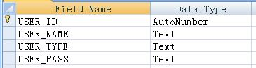

User database stores the staffs information such as member name and member password, when the staff login to system, it will connect to this database to make validation whether the staff user name and password that provide by staff are correct or not.

Outlet Database Table Structure

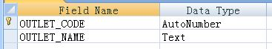

Outlet database used to stores the entire outlet in the club, when the members order their food, staffs need to select the outlet place that they receive the order.

Member Database Table Structure

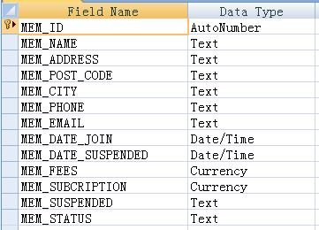

Member database stores all information of the members, when there have any people want to register as a member, staffs will entered the data that provide by them to the system. System will then store the information to this database.

Material Database Table Structure

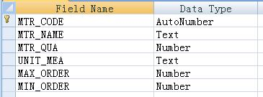

Material database stores the material details such as material name, unit of measurement, and etc. The stock balance of the material will also be recorded into this database, so that stock department gets to checking stock balance according to the database.

Food Database Table Structure

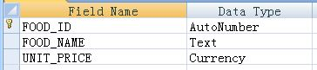

Food database used to stores the meal list that is available to provide for the members to make their order. The name and price of the food will also be store, so that system gets to calculate the total amount refer to this database.

Recipe Database Table Structure

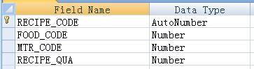

Recipe database stores the ingredients that need to provide for making the food. When member make their order, the quantity of raw material will be deduce according to this database.

Subscription Database Table Structure

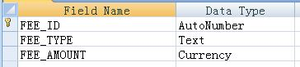

Subscription database store the type and amount of the fee that need to pay by members. The default value of the payment will be stored, when staffs register a new member, these payments will be also store to the Member database.

POS (Point of Sales) Header Database Table Structure

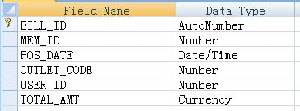

POS (Point of Sales) header database used to stores bill information such as bill ID, date, outlet and etc. When staff entered member’s order, the system will save the data into this database.

POS (Point of Sales) Body Database Table Structure

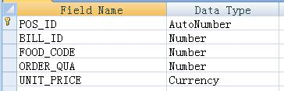

POS (Point of Sales) body database stores the food list that ordered by members. The quantity and unit price that been store will be used to calculate and store to POS (Point of Sales) header database, so that it can be display in the members monthly statement report.

Fee Receive Database Table Structure

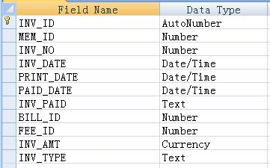

Fee receive database used to store the payment that paid by members, the system will update this database when account department receive the payment.

Purchase Order Database Table Structure

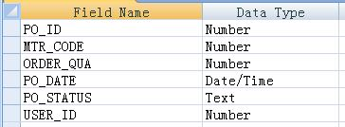  
Purchase order database store the raw material list that need to be order, when stock department checking stock balance, system will generate PO when raw material reach its minimum quantity.

Requisition Order and Issue Note Database Table Structure

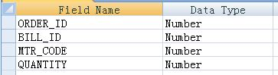

This database used to store the materialthatrequestby restaurant. When staffs request to print a RO (Requisition Order) and IO (Issue Note) report, the system will connect to this database and display the correct information in the report.

# Data Flow Diagram

## Context Diagram

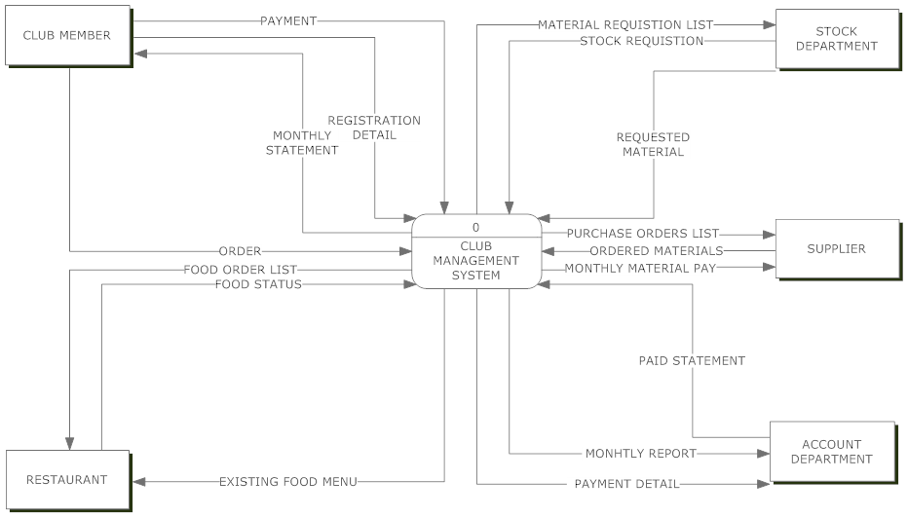**EXTERNAL ENTITY IN CONTEXT DIAGRAM**

|  |  |  |
| --- | --- | --- |
| Name | : | **CULB MEMBER** |
| Description | : | The club members make order and receipt monthly statement for making their payment. The club members must register first before doing any order. |
| Input data flows | : | MONTHLY STATEMENT |
| Output data flows | : | ORDER, REGISTRATION DETAIL, PAYMENT |
|  |  |  |
| Name | : | **RESTAURANT** |
| Description | : | Receive order and update foods status when the food has been done. The restaurant can keep track the existing food list with the existing food menu. |
| Input data flows | : | FOOD ORDER LIST, EXISTING FOOD MENU |
| Output data flows | : | FOOD STATUS |
|  |  |  |
| Name | : | **ACCOUNT DEPARTMENT** |
| Description | : | Receive and checking account report that generated by the system. After that, the account department will generate the paid statement follow by the payment detail. |
| Input data flows | : | MONHTLY REPORT, PAYMENT DETAIL |
| Output data flows | : | PAID STATEMENT |
|  |  |  |
| Name | : | **STOCK DEPARTMENT** |
| Description | : | Get the material requisition and sort out the requested material. When the stock inventory is low then the minimum level, the stock department will make the stock requisition for adding stock. |
| Input data flows | : | ORDERED MATERIALS |
| Output data flows | : | STOCK REQUISTION, REQUESTED MATERIAL |
|  |  |  |
| Name | : | **SUPPLIER** |
| Description | : | Receive purchase order list and send the ordered materials to club. The supplier will receive the material pay in every end of the monthly. |
| Input data flows | : | PURCHASE ORDERS LIST, MONTHLY MATERIAL PAY |
| Output data flows | : | ORDERED MATERIALS |

**PROCESS IN CONTEXT DIAGRAM**

|  |  |  |
| --- | --- | --- |
| Name | : | **CLUB MANAGEMENT SYSTEM** |
| Description | : | Collecting all necessary information to process and manage them |
| Input data flows | : | ORDER, REGISTRATION DETAIL, PAYMENT, FOOD STATUS, PAID STATEMENT, STOCK REQUISTION, REQUESTED MATERIAL, ORDERED MATERIALS |
| Output data flows | : | MONTHLY STATEMENT, FOOD ORDER LIST, EXISTING FOOD MENU, MONHTLY REPORT, PAYMENT DETAIL, ORDERED MATERIALS, PURCHASE ORDERS LIST, MONTHLY MATERIAL PAY |
| Process description | : | Getting information from club member and each club department, then manage it with inform to the each department according with their requirement. |

**DATA FLOWS IN CONTEXT DIAGRAM**

|  |  |  |
| --- | --- | --- |
| Name | : | **ORDER** |
| Description | : | Contain the food order details that placed by club member |
| Origin / Source | : | CLUB MEMBER external entity |
| Destination / Sink | : | CLUB NAMAGEMENT SYSTEM process |
| Data structure | : | Food name, quantity, club member detail |
|  |  |  |
| Name | : | **REGISTRATION DETAIL** |
| Description | : | Used to register new account as a club member |
| Origin / Source | : | Club member external entity |
| Destination / Sink | : | CLUB NAMAGEMENT SYSTEM process |
| Data structure | : | Customer name, address, contact no, email address, date join |
|  |  |  |
| Name | : | **PAYMENT** |
| Description | : | The club member make payment when they receive invoice |
| Origin / Source | : | Club member external entity |
| Destination / Sink | : | CLUB NAMAGEMENT SYSTEM process |
| Data structure | : | Register fees, monthly payment amount |
|  |  |  |
| Name | : | **MONTHLY STATEMENT** |
| Description | : | The monthly statement that has been generated by system will be review by club member for ask member give payment. |
| Origin / Source | : | CLUB NAMAGEMENT SYSTEM process |
| Destination / Sink | : | Club member external entity |
| Data structure | : | Total amount, each bill id, order date, and bill amount. |
|  |  |  |
| Name | : | **MATERIAL REQUISTION LIST** |
| Description | : | The material list and amount which requested by the restaurant for making food. |
| Origin / Source | : | CLUB NAMAGEMENT SYSTEM process |
| Destination / Sink | : | Stock department external entity |
| Data structure | : | Material name, requirement amount |
|  |  |  |
| Name | : | **STOCK REQUISTION** |
| Description | : | The inventory order list for stock department to order the material from the supplier. |
| Origin / Source | : | Stock department external entity |
| Destination / Sink | : | CLUB NAMAGEMENT SYSTEM process |
| Data structure | : | Ordered inventory name, ordered quantity, date order. |
|  |  |  |
| Name | : | **REQUESTED MATERIAL** |
| Description | : | The material which order by the restaurant follow the food order list |
| Origin / Source | : | Stock department external entity |
| Destination / Sink | : | CLUB NAMAGEMENT SYSTEM process |
| Data structure | : | Food material |
|  |  |  |
| Name | : | **PURCHASE ORDERS LIST** |
| Description | : | The club will send the purchase order to buy in the new material to support the restaurant. |
| Origin / Source | : | CLUB NAMAGEMENT SYSTEM process |
| Destination / Sink | : | Supplier external entity |
| Data structure | : | Material name, material purchase quantity amount |
|  |  |  |
| Name | : | **ORDERED MATERIALS** |
| Description | : | The material which order by the club for raise up the quantity in the stock department to continuous support the restaurant. |
| Origin / Source | : | Supplier external entity |
| Destination / Sink | : | CLUB NAMAGEMENT SYSTEM process |
| Data structure | : | New material |
|  |  |  |
| Name | : | **MONTHLY MATERIAL PAY** |
| Description | : | The club makes payment in every month for the supplier to pay the buy of the material. |
| Origin / Source | : | CLUB NAMAGEMENT SYSTEM process |
| Destination / Sink | : | Supplier external entity |
| Data structure | : | Material payment |
|  |  |  |
| Name | : | **PAID STATEMENT** |
| Description | : | The account department generate the paid statement to the club member when club member making payment. |
| Origin / Source | : | Account department external entity |
| Destination / Sink | : | CLUB NAMAGEMENT SYSTEM process |
| Data structure | : | Club member id, invoice id, total amount payment, paid date. |
|  |  |  |
| Name | : | **MONHTLY REPORT** |
| Description | : | The report for the account department to keep track and check member transaction detail. |
| Origin / Source | : | CLUB NAMAGEMENT SYSTEM process |
| Destination / Sink | : | Account department external entity |
| Data structure | : | Month invoice, club member id |
|  |  |  |
| Name | : | **PAYMENT DETAIL** |
| Description | : | The type of payment which the club members pay for and the payment amount. |
| Origin / Source | : | CLUB NAMAGEMENT SYSTEM process |
| Destination / Sink | : | Account department external entity |
| Data structure | : | Club member id, payment type |
|  |  |  |
| Name | : | **EXISTING FOOD MENU** |
| Description | : | The current food can be provided by the restaurant and the quantity can be order by the club member. |
| Origin / Source | : | CLUB NAMAGEMENT SYSTEM process |
| Destination / Sink | : | Restaurant external entity |
| Data structure | : | Current food name list and the quantity can be order by the club member |
|  |  |  |
| Name | : | **FOOD STATUS** |
| Description | : | The status of ordered food that need to update into system when it has been done |
| Origin / Source | : | Restaurant external entity |
| Destination / Sink | : | CLUB NAMAGEMENT SYSTEM process |
| Data structure | : | Bill id, completed food name |
|  |  |  |
| Name | : | **FOOD ORDER LIST** |
| Description | : | The food name and quantity which order by the club member. |
| Origin / Source | : | Restaurant external entity |
| Destination / Sink | : | CLUB NAMAGEMENT SYSTEM process |
| Data structure | : | Bill id, ordered food name, ordered quantity |

## Level 0 diagram

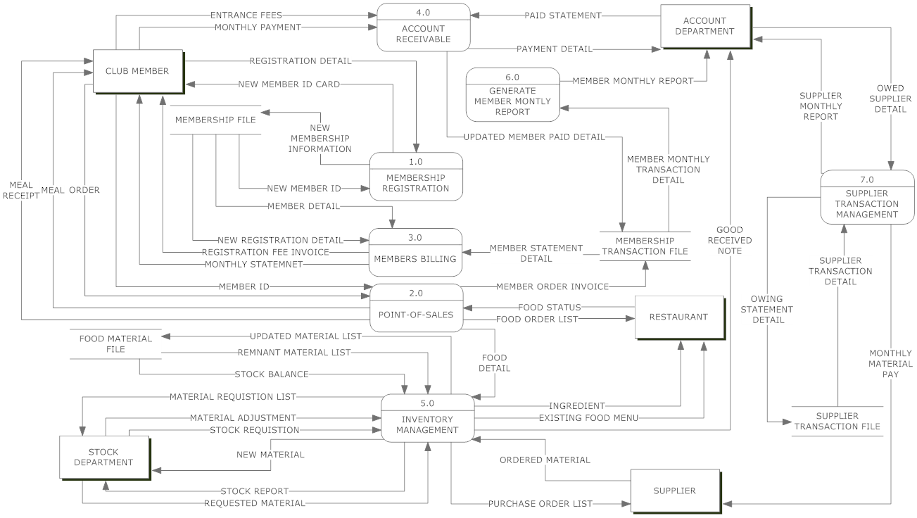

**PROCESS IN LEVEL 0 DIAGRAM**

|  |  |  |
| --- | --- | --- |
| Name | : | **1.0 MEMBERSHIP REGISTRATION** |
| Description | : | Record the new member information and generate a member id |
| Input data flows | : | REGISTRATION DETAIL, |
| Output data flows | : | NEW MEMBER ID CARD, NEW MEMBERSHIP INFORMATION |
| Process description | : | The club member giving the personal information for register as the club member and he will receive a new member id card |
|  |  |  |
| Name | : | **2.0 POINT-OF-SALES** |
| Description | : | Receive and sort out all the food order information detail and send the necessary information to each part |
| Input data flows | : | MEMBER ID, ORDER, FOOD STATUS |
| Output data flows | : | MEAL, MEAL RECEIPT, FOOD ORDER LIST |
| Process description | : | Record the order from the club member and send order information to each department and process it. The club member will receive the meal receipt when finish order and send the meal to club member when the foods is done. |
|  |  |  |
| Name | : | **3.0 MEMBERS BILLING** |
| Description | : | Sort out and calculate the total amount of each member statement and create the monthly statement for each club member |
| Input data flows | : | NEW REGISTRATION DETAIL, MEMBER STATEMENT DETAIL |
| Output data flows | : | REGISTRATION FEE INVOICE, MONTHLY STATEMNET |
| Process description | : | Collect all member statement detail and generate the monthly total amount statement for the club member. |
|  |  |  |
| Name | : | **4.0 ACCOUNT RECEIVABLE** |
| Description | : | Collect the payment from the club member and verify the payment type. |
| Input data flows | : | ENTRANCE FEES, MONTHLY PAYMENT, PAID STATEMENT |
| Output data flows | : | PAYMENT DETAIL |
| Process description | : | Receive the payment from the club member and send the payment detail to the account department. After that, sort out the paid statement information and store into member transaction file. |
|  |  |  |
| Name | : | **5.0 INVENTORY MANAGEMENT** |
| Description | : | Receive and sort out all the material information detail and send the necessary information to each part |
| Input data flows | : | FOOD DETAIL, REMNANT MATERIAL LIST, STOCK BALANCE, MATERIAL ADJUSTMENT, STOCK REQUISTION, REQUESTED MATERIAL, ORDERED MATERIAL |
| Output data flows | : | UPDATED MATERIAL LIST, MATERIAL REQUISTION LIST, STOCK REPORT, PURCHASE ORDER LIST, INGREDIENT, GOOD RECEIVED NOTE |
| Process description | : | Collecting the ordered food detail and sort out the requested material according the ordered food. The process also generates the stock report for the stock department to keep track the inventory stock level. |
|  |  |  |
| Name | : | **6.0 GENERATE MEMBER MONTLY REPORT** |
| Description | : | Gathering the each member monthly transaction detail and generate member monthly report |
| Input data flows | : | MEMBER MONTHLY TRANSACTION DETAIL |
| Output data flows | : | MEMBER MONTHLY REPORT |
| Process description | : | Collect all member monthly payment detail and generate the monthly report to account department |
|  |  |  |
| Name | : | **7.0 SUPPLIER TRANSACTION MANAGEMENT** |
| Description | : | Gathering all the supplier transaction information then generate the material pay to supplier and supplier monthly report to account department |
| Input data flows | : | OWED SUPPLIER DETAIL, SUPPLIER TRANSACTION DETAIL, |
| Output data flows | : | MONTHLY MATERIAL PAY, SUPPLIER MONTHLY REPORT,  OWING STATEMENT DETAIL |
| Process description | : | Collecting the supplier statement and generate the total pay to supplier. Furthermore, create the supplier monthly report for the account department. |

**DATASTORE IN LEVEL 0 DIAGRAM**

|  |  |  |
| --- | --- | --- |
| Name | : | **MEMBERSHIP FILE** |
| Description | : | Store the member id, account status and personal information |
| Input data flows | : | NEW MEMBERSHIP INFORMATION |
| Output data flows | : | NEW MEMBER ID, MEMBER DETAIL |
| Data structure | : | member ID, address, contact no, member status, email |
|  |  |  |
| Name | : | **MEMBERSHIP TRANSACTION FILE** |
| Description | : | Store every member transaction detail |
| Input data flows | : | UPDATED MEMBER PAID DETAIL, MEMBER ORDER INVOICE |
| Output data flows | : | MEMBER MONTHLY TRANSACTION DETAIL, MEMBER STATEMENT DETAIL |
| Data structure | : | Bill id, member id, invoice type, invoice date |
|  |  |  |
| Name | : | **FOOD MATERIAL FILE** |
| Description | : | Store the material detail, each material stock level information |
| Input data flows | : | UPDATED MATERIAL LIST |
| Output data flows | : | REMNANT MATERIAL LIST, STOCK BALANCE |
| Data structure | : | Material name, material id, material quantity, maximum material level, minimum material level |
|  |  |  |
| Name | : | **SUPPLIER TRANSACTION FILE** |
| Description | : | Store every supplier transaction detail |
| Input data flows | : | SUPPLIER TRANSACTION DETAIL |
| Output data flows | : | OWING STATEMENT DETAIL |
| Data structure | : | Purchase order id, purchase order date, purchase material name and quantity, purchase order status |

**DATA FLOWS IN LEVEL 0 DIAGRAM**

|  |  |  |
| --- | --- | --- |
| Name | : | **ENTRANCE FEES** |
| Description | : | The payment for registration fee |
| Origin / Source | : | Club member external entity |
| Destination / Sink | : | 4.0 ACCOUNT RECEIVABLE process |
| Data structure | : | Cash, cheque, registration fee invoice |
|  |  |  |
| Name | : | **MONTHLY PAYMENT** |
| Description | : | The payment for pay the club every month |
| Origin / Source | : | Club member external entity |
| Destination / Sink | : | 4.0 ACCOUNT RECEIVABLE process |
| Data structure | : | Cash, cheque, month invoice |
|  |  |  |
| Name | : | **NEW MEMBER ID CARD** |
| Description | : | The member id card for validate the member information and status |
| Origin / Source | : | 1.0 MEMBERSHIP REGISTRATION process |
| Destination / Sink | : | Club member external entity |
| Data structure | : | Member id, member name |
|  |  |  |
| Name | : | **NEW MEMBERSHIP INFORMATION** |
| Description | : | New member information when the member register to become club member |
| Origin / Source | : | 1.0 MEMBERSHIP REGISTRATION process |
| Destination / Sink | : | MEMBERSHIP FILE data store |
| Data structure | : | Member id, membership detail information |
|  |  |  |
| Name | : | **NEW MEMBER ID** |
| Description | : | The new member id for verify member status and member information |
| Origin / Source | : | 1.0 MEMBERSHIP REGISTRATION process |
| Destination / Sink | : | MEMBERSHIP FILE data store |
| Data structure | : | Member id |
|  |  |  |
| Name | : | **MEMBER DETAIL** |
| Description | : | The member detail for generate invoice |
| Origin / Source | : | MEMBERSHIP FILE data store |
| Destination / Sink | : | 3.0 MEMBERS BILLING process |
| Data structure | : | Member id, member address, member contract number |
|  |  |  |
| Name | : | **NEW REGISTRATION DETAIL** |
| Description | : | The new member detail for generate registration fee invoice |
| Origin / Source | : | MEMBERSHIP FILE data store |
| Destination / Sink | : | 3.0 MEMBERS BILLING process |
| Data structure | : | New member id, new member personal detail, register date |
|  |  |  |
| Name | : | **REGISTRATION FEE INVOICE** |
| Description | : | The invoice for the club member to pay the registration fee. |
| Origin / Source | : | 3.0 MEMBERS BILLING process |
| Destination / Sink | : | Club member external entity |
| Data structure | : | Member id, total amount of registration fee, register date |
|  |  |  |
| Name | : | **MEMBER ID** |
| Description | : | The member id for verify member status and getting member information whiles the member making order. |
| Origin / Source | : | Club member external entity |
| Destination / Sink | : | 2.0 POINT-OF-SALES process |
| Data structure | : | Member id, member name, member status |
|  |  |  |
| Name | : | **MEAL** |
| Description | : | The all food which order by the club member |
| Origin / Source | : | 2.0 POINT-OF-SALES process |
| Destination / Sink | : | Club member external entity |
| Data structure | : | Food |
|  |  |  |
| Name | : | **MEAL RECEIPT** |
| Description | : | The receipt for the club member when they making order |
| Origin / Source | : | 2.0 POINT-OF-SALES process |
| Destination / Sink | : | Club member external entity |
| Data structure | : | Member id, order date, ordered food list, total amount of meal, outlet name |
|  |  |  |
| Name | : | **MEMBER STATEMENT DETAIL** |
| Description | : | The each member statement detail for generate the monthly statement |
| Origin / Source | : | MEMBERSHIP TRANSACTION FILE data store |
| Destination / Sink | : | 3.0 MEMBERS BILLING process |
| Data structure | : | Bill id, bill date, bill payment amount |
|  |  |  |
| Name | : | **MEMBER ORDER INVOICE** |
| Description | : | The invoice when the member making order and it will keep in the membership transaction store |
| Origin / Source | : | 2.0 POINT-OF-SALES process |
| Destination / Sink | : | MEMBERSHIP TRANSACTION FILE data store |
| Data structure | : | Bill id, member id, bill date, outlet name |
|  |  |  |
| Name | : | **FOOD DETAIL** |
| Description | : | The ordered food name and quantity for the stock department to sort out the requirement material. |
| Origin / Source | : | 2.0 POINT-OF-SALES process |
| Destination / Sink | : | 5.0 INVENTORY MANAGEMENT process |
| Data structure | : | Ordered food id, ordered food quantity |
|  |  |  |
| Name | : | **UPDATED MATERIAL LIST** |
| Description | : | The new material information for stock department to manage the inventory |
| Origin / Source | : | 5.0 INVENTORY MANAGEMENT process |
| Destination / Sink | : | FOOD MATERIAL FILE data store |
| Data structure | : | Material id, material quantity |
|  |  |  |
| Name | : | **REMNANT MATERIAL LIST** |
| Description | : | The current material quantity for generate the existing food menu and how much quantity of food can be order. |
| Origin / Source | : | FOOD MATERIAL FILE data store |
| Destination / Sink | : | 5.0 INVENTORY MANAGEMENT process |
| Data structure | : | Material id, current material quantity |
|  |  |  |
| Name | : | **STOCK BALANCE** |
| Description | : | 5.0 INVENTORY MANAGEMENT process |
| Origin / Source | : | FOOD MATERIAL FILE data store |
| Destination / Sink | : | All the inventory level for the stock department can keep track the requirement material quantity in every month. |
| Data structure | : | Material id, material quantity. |
|  |  |  |
| Name | : | **MATERIAL ADJUSTMENT** |
| Description | : | The new material information after the stock department add or edit the quantity when the send out the material to restaurant or receive the material from the supplier |
| Origin / Source | : | Stock department external entity |
| Destination / Sink | : | 5.0 INVENTORY MANAGEMENT process |
| Data structure | : | Material id, material new quantity value |
|  |  |  |
| Name | : | **NEW MATERIAL** |
| Description | : | The new material for raise up the inventory quantity. |
| Origin / Source | : | 5.0 INVENTORY MANAGEMENT process |
| Destination / Sink | : | Stock department external entity |
| Data structure | : | Material name, material quantity |
|  |  |  |
| Name | : | **STOCK REPORT** |
| Description | : | The material report for stock department to manage the inventory level |
| Origin / Source | : | 5.0 INVENTORY MANAGEMENT process |
| Destination / Sink | : | Stock department external entity |
| Data structure | : | Material id, material name, material quantity |
|  |  |  |
| Name | : | **INGREDIENT** |
| Description | : | The raw materials follow the food ordered by the club member for restaurant process the meal. |
| Origin / Source | : | 5.0 INVENTORY MANAGEMENT process |
| Destination / Sink | : | Restaurant external entity |
| Data structure | : | Material quantity |
|  |  |  |
| Name | : | **GOOD RECEIVED NOTE** |
| Description | : | Inform the account department when the stock department receive the order |
| Origin / Source | : | 5.0 INVENTORY MANAGEMENT process |
| Destination / Sink | : | Account department external entity |
| Data structure | : | Ordered material quantity, purchase order date |
|  |  |  |
| Name | : | **MEMBER MONTHLY REPORT** |
| Description | : | The member month report for the account department check whole month member transaction detail |
| Origin / Source | : | 6.0 GENERATE MEMBER MONTLY REPORT process |
| Destination / Sink | : | Account department external entity |
| Data structure | : | Daily bill id, bill amount, bill date, member id |
|  |  |  |
| Name | : | **UPDATED MEMBER PAID DETAIL** |
| Description | : | The new member paid detail after the club member clear their invoice and it will store in membership transaction file. |
| Origin / Source | : | 4.0 ACCOUNT RECEIVABLE process |
| Destination / Sink | : | MEMBERSHIP TRANSACTION FILE data store |
| Data structure | : | Paid statement id |
|  |  |  |
| Name | : | **MEMBER MONTHLY TRANSACTION DETAIL** |
| Description | : | The member month transaction information for generate the member monthly report |
| Origin / Source | : | MEMBERSHIP TRANSACTION FILE data store |
| Destination / Sink | : | 6.0 GENERATE MEMBER MONTLY REPORT process |
| Data structure | : | Bill id, bill date, paid statement id, bill amount, paid amount |
|  |  |  |
| Name | : | **SUPPLIER MONTHLY REPORT** |
| Description | : | The whole month material requested information and total paid amount for the supplier |
| Origin / Source | : | 7.0 SUPPLIER TRANSACTION MANAGEMENT process |
| Destination / Sink | : | Account department external entity |
| Data structure | : | Total month material buy in amount, total month payment amount |
|  |  |  |
| Name | : | **OWED SUPPLIER DETAIL** |
| Description | : | The owed detail for the club to pay the supplier after receive the good receive note |
| Origin / Source | : | Account department external entity |
| Destination / Sink | : | 7.0 SUPPLIER TRANSACTION MANAGEMENT process |
| Data structure | : | Purchase order id, purchase order date, total material amount purchased |
|  |  |  |
| Name | : | **OWING STATEMENT DETAIL** |
| Description | : | The statement for the club to pay the payment for the supplier |
| Origin / Source | : | 7.0 SUPPLIER TRANSACTION MANAGEMENT process |
| Destination / Sink | : | SUPPLIER TRANSACTION FILE data store |
| Data structure | : | Purchase order id, purchase order date, total amount pay for the supplier |
|  |  |  |
| Name | : | **SUPPLIER TRANSACTION DETAIL** |
| Description | : | The supplier transaction detail is for generate the supplier monthly report |
| Origin / Source | : | SUPPLIER TRANSACTION FILE data store |
| Destination / Sink | : | 7.0 SUPPLIER TRANSACTION MANAGEMENT process |
| Data structure | : | Purchase order id, purchase order date |

## C:\Users\alexsoh\Desktop\DFD pic\1.pngLevel 1Process 1 Diagram

**PROCESS IN LEVEL 1 PROCESS 1 DIAGRAM**

|  |  |  |
| --- | --- | --- |
| Name | : | **1.1 GATHERING MEMBER INFORMATION** |
| Description | : | Collecting new member detail and personal information |
| Input data flows | : | REGISTRATION DETAIL |
| Output data flows | : | NEW MEMBERSHIP INFORMATION |
| Process description | : | Record the new member information and store it in the membership file |
|  |  |  |
| Name | : | **1.2 GENERATE MEMBER ID CARD** |
| Description | : | Receive the new member id from the membership file for create the member id card |
| Input data flows | : | NEW MEMBER ID |
| Output data flows | : | NEW MEMBER ID CARD |
| Process description | : | Get the new member id and create a new member id card according to the member information in the membership file. |

## Level 1 Process 2 Diagram

## C:\Users\alexsoh\Desktop\DFD pic\2.png

**PROCESS IN LEVEL 1 PROCESS 2 DIAGRAM**

|  |  |  |
| --- | --- | --- |
| Name | : | **2.2 PREPARING MEAL** |
| Description | : | Collect food from restaurant and serve it to club member |
| Input data flows | : | FOOD STATUS |
| Output data flows | : | MEAL |
| Process description | : | Receive the food then send the food to club member according the order list |
|  |  |  |
| Name | : | **2.1 RECORD ORDER AND MEMBER ID** |
| Description | : | Create the food order by using the member id |
| Input data flows | : | ORDER, MEMBER ID |
| Output data flows | : | FOOD ORDER LIST, FOOD DETAIL |
| Process description | : | Collect order from the club member and send the order information to each department. |
|  |  |  |
| Name | : | **2.3 RESTAURANT BILLING** |
| Description | : | Generate the receipt to club member and generate the order invoice for store in the member transaction file |
| Input data flows | : | ORDER INFORMATION |
| Output data flows | : | MEAL RECEIPT, MEMBER ORDER INVOICE |
| Process description | : | Receive the order information and create the meal receipt for the club member then store then order invoice to member transaction file |

**DATA FLOWS IN LEVEL 1 PROCESS 2 DIAGRAM**

|  |  |  |
| --- | --- | --- |
| Name | : | **ORDER INFORMATION** |
| Description | : | The detail of the order for generate the receipt and invoice |
| Origin / Source | : | 2.1 RECORD ORDER AND MEMBER ID process |
| Destination / Sink | : | 2.3 RESTAURANT BILLING process |
| Data structure | : | Food id, food name, food ordered quantity, total amount |

## C:\Users\alexsoh\Desktop\DFD pic\3.pngLevel 1 Process 3 Diagram

**PROCESS IN LEVEL 1 PROCESS 3 DIAGRAM**

|  |  |  |
| --- | --- | --- |
| Name | : | **3.1 GENERATE REGISTRATION FEE** |
| Description | : | receive the new member register detail and generate the registration fee to new club member |
| Input data flows | : | NEW REGISTRATION DETAIL |
| Output data flows | : | REGISTRATION FEE INVOICE |
| Process description | : | Collect the new member registration detail and create the registration fee invoice for the new club member |
|  |  |  |
| Name | : | **3.2 GENERATE MONTLY STATEMENT** |
| Description | : | Receive all statement detail and generate a month statement to club member |
| Input data flows | : | MEMBER STATEMENT DETAIL, MEMBER DETAIL |
| Output data flows | : | MONTHLY STATEMENT |
| Process description | : | Collect all member statement detail and calculate the total amount then create a monthly statement for club member. |

## Level 1 Process 4 Diagram

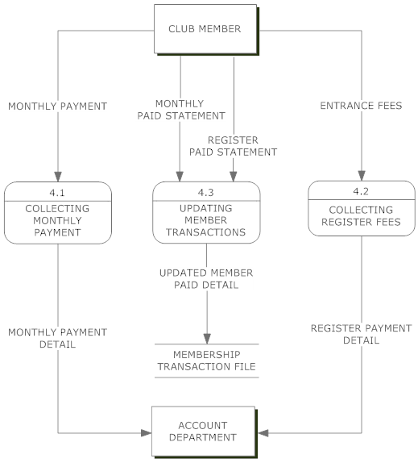

**PROCESS IN LEVEL 1 PROCESS 4 DIAGRAM**

|  |  |  |
| --- | --- | --- |
| Name | : | **4.1 COLLECTING MONTHLY PAYMENT** |
| Description | : | Receive the monthly payment from the club member and send the detail to account department |
| Input data flows | : | MONTHLY PAYMENT |
| Output data flows | : | MONTHLY PAYMENT DETAIL |
| Process description | : | Collect monthly payment from the club member and send the payment detail to the account department |
|  |  |  |
| Name | : | **4.2 COLLECTING REGISTER FEES** |
| Description | : | Receive the register fee payment from the new club member and send the detail to account department |
| Input data flows | : | ENTRANCE FEES |
| Output data flows | : | REGISTER PAYMENT DETAIL |
| Process description | : | Collect register fee payment from the new club member and send the payment detail to the account department |
|  |  |  |
| Name | : | **4.3 UPDATING MEMBER TRANSACTIONS** |
| Description | : | Collect the month and register paid statement and sort it for update to membership transaction file |
| Input data flows | : | MONTHLY PAID STATEMENT, REGISTER PAID STATEMENT |
| Output data flows | : | UPDATED MEMBER PAID DETAIL |
| Process description | : | Gathering the month and register paid statement and arrange it for update the following transaction detail |

**DATA FLOWS IN LEVEL 1 PROCESS 4 DIAGRAM**

|  |  |  |
| --- | --- | --- |
| Name | : | **MONTHLY PAID STATEMENT** |
| Description | : | The statement after the club member pay the monthly statement |
| Origin / Source | : | Account department external entity |
| Destination / Sink | : | 4.3 UPDATING MEMBER TRANSACTIONS |
| Data structure | : | Monthly statement id, member id |
|  |  |  |
| Name | : | **REGISTER PAID STATEMENT** |
| Description | : | The statement after the club member pay the register fee |
| Origin / Source | : | Account department external entity |
| Destination / Sink | : | 3 UPDATING MEMBER TRANSACTIONS |
| Data structure | : | Register fee invoice id, member id |

## Level 1Process 5 Diagram

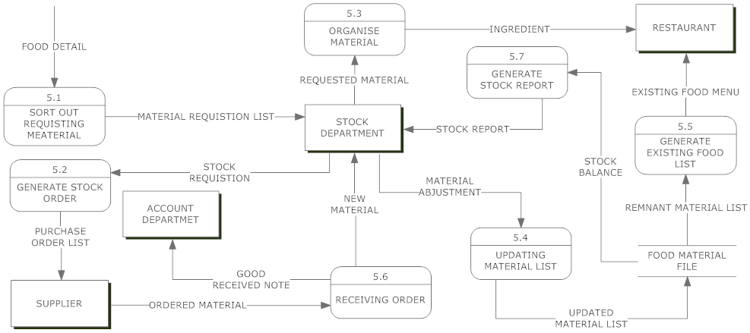

**PROCESS IN LEVEL 1 PROCESS 5 DIAGRAM**

|  |  |  |
| --- | --- | --- |
| Name | : | **5.1 SORT OUT REQUISTING MEATERIAL** |
| Description | : | find out the food material and the quantity requested according the food detail |
| Input data flows | : | FOOD DETAIL |
| Output data flows | : | MATERIAL REQUISTION LIST |
| Process description | : | Receive the ordered food detail then list out all the material requested for prepare the ordered food |
|  |  |  |
| Name | : | **5.2 GENERATE STOCK ORDER** |
| Description | : | Receive the stock requisition and generate the purchase order to supplier |
| Input data flows | : | STOCK REQUISTION |
| Output data flows | : | PURCHASE ORDER LIST |
| Process description | : | Collect the stock requisition from the stock department and create the purchase material list to supplier |
|  |  |  |
| Name | : | **5.3 ORGANISE MATERIAL** |
| Description | : | Rearrange the material according the recipe of the food |
| Input data flows | : | REQUESTED MATERIAL |
| Output data flows | : | INGREDIENT |
| Process description | : | Organize the requested material which received from the stock department follow the recipe of the food |
|  |  |  |
| Name | : | **5.4 UPDATING MATERIAL LIST** |
| Description | : | Update the material when receive or send out the material |
| Input data flows | : | MATERIAL ABJUSTMENT |
| Output data flows | : | UPDATED MATERIAL LIST |
| Process description | : | Reduce the material quantity in the inventory file when send out the material to restaurant and raise up the material quantity in the inventory file when receive the new material or ordered material. |
|  |  |  |
| Name | : | **5.5 GENERATE EXISTING FOOD LIST** |
| Description | : | Receive the current material quantity and generate the food list with the quantity which can be order by the club member |
| Input data flows | : | REMNANT MATERIAL LIST |
| Output data flows | : | EXISTING FOOD MENU |
| Process description | : | Get the remnant material list and create an existing food menu and the quantity can be order by the club member |
|  |  |  |
| Name | : | **5.6 RECEIVING ORDER** |
| Description | : | Receive the ordered material and then send the good received note to account department. |
| Input data flows | : | ORDERED MATERIAL |
| Output data flows | : | GOOD RECEIVED NOTE |
| Process description | : | Collect the material which order by the stock department then generate the material received note to account department when the ordered material quantity is correct |
|  |  |  |
| Name | : | **5.7 GENERATE STOCK REPORT** |
| Description | : | Receive the stock balance and create the stock report for account department |
| Input data flows | : | STOCK BALANCE |
| Output data flows | : | STOCK REPORT |
| Process description | : | Collect the inventory balance detail and generate the stock report for the account department to keep track the requirement stock quantity. |

## C:\Users\alexsoh\Desktop\DFD pic\7.pngLevel 1 Process 7 Diagram

**PROCESS IN LEVEL 1 PROCESS 7 DIAGRAM**

|  |  |  |
| --- | --- | --- |
| Name | : | **7.1 GENERATE OWINING STATEMENT** |
| Description | : | Collect the owed supplier detail and generate the owing statement then store it in the supplier transaction file |
| Input data flows | : | OWED SUPPLIER DETAIL |
| Output data flows | : | OWING STATEMENT DETAIL |
| Process description | : | Gathering the owed supplier detail and create the owing statement detail for make payment to the supplier |
|  |  |  |
| Name | : | **7.2 SORTING SUPPLIER TRANSACTION** |
| Description | : | Receive the all the transaction detail and sort it out for generate the supplier monthly report and the monthly material pay for the supplier |
| Input data flows | : | SUPPLIER TRANSACTION DETAIL |
| Output data flows | : | MONTHLY MATERIAL PAY, SUPPLIER MONTHLY REPORT |
| Process description | : | Collect supplier transaction information and sort it for calculate the total amount to pay the material ordered by the stock department and generate the supplier monthly report for the account department. |

# User Manual

## Login

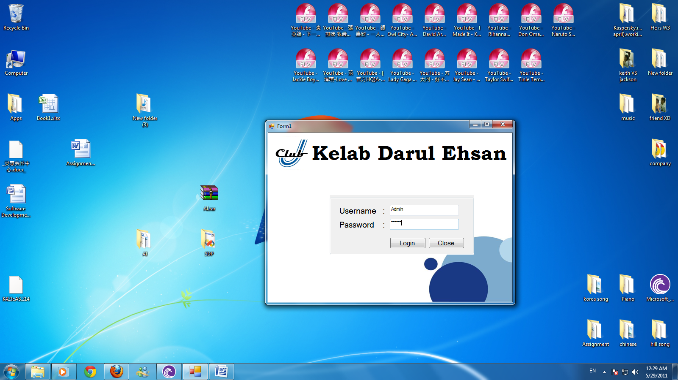

This is the Login page of user; there are few departments with different username and password. Admin can access all the departments.

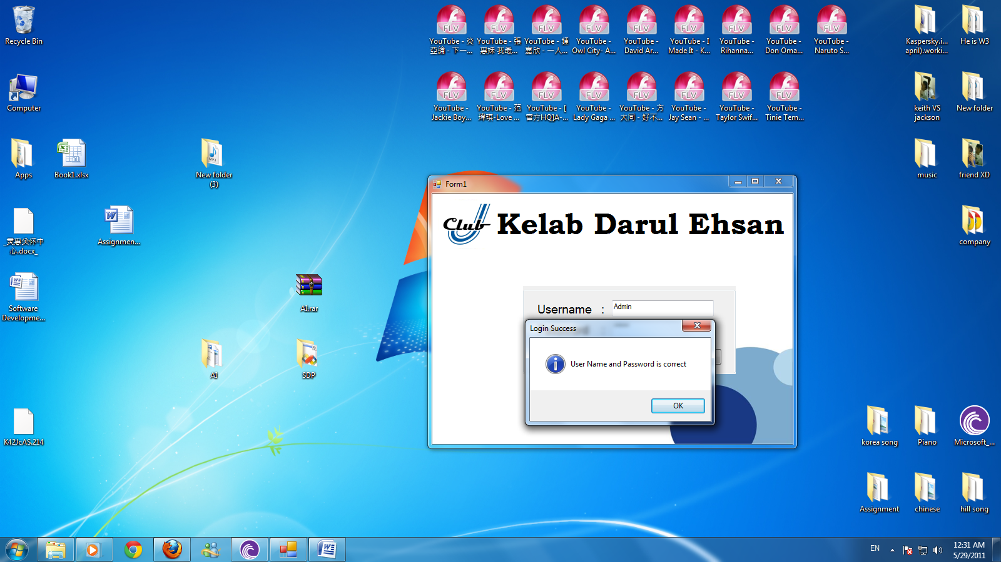

Login success when username and password is correct. The screen will direct go to home panel.

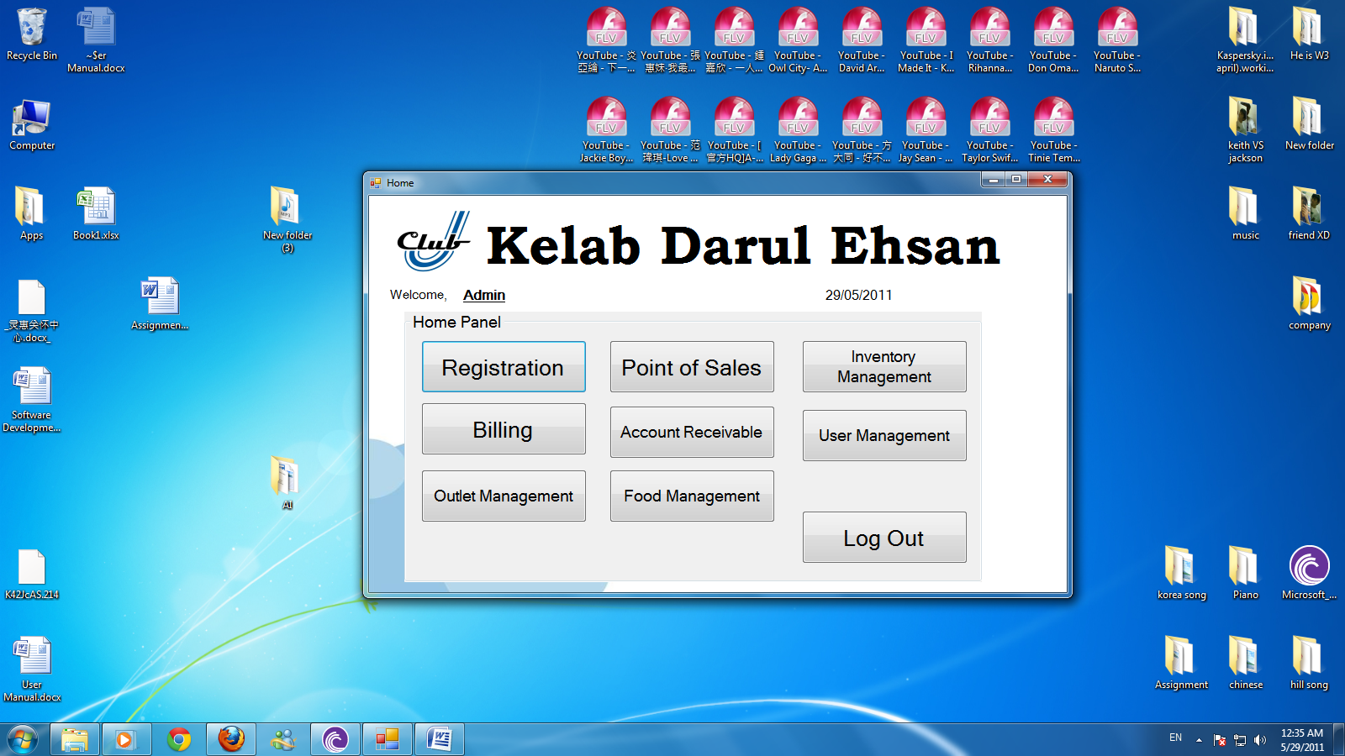

This is the home panel of the system, Admin able to do registration for new member, point of sales, inventory management, billing, account receivable, user management, outlet management and food management.

## Registration

### Register

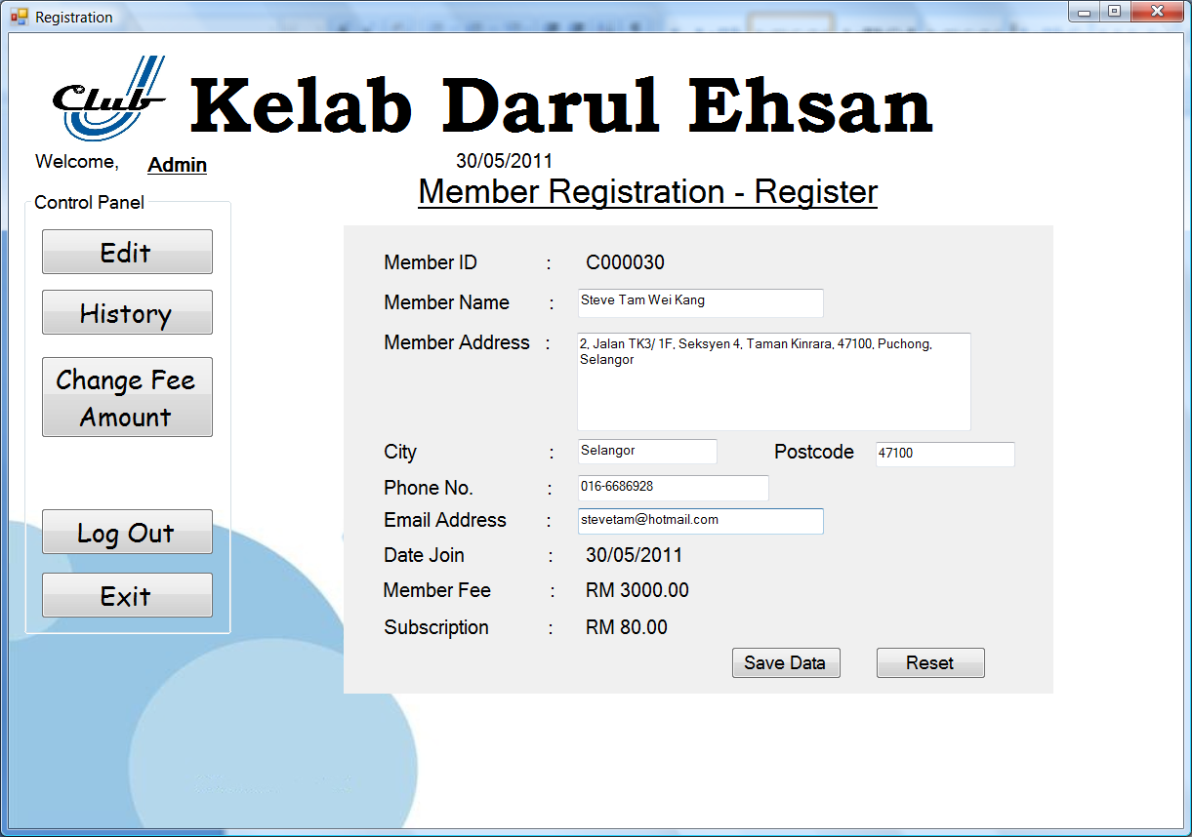

This is registration function, which to do registration to new member. User has to get information from new member. Registration for new member required member name, member address, city, postcode, phone number and email address. System will auto generate Member ID, date join, member fee and subscription.

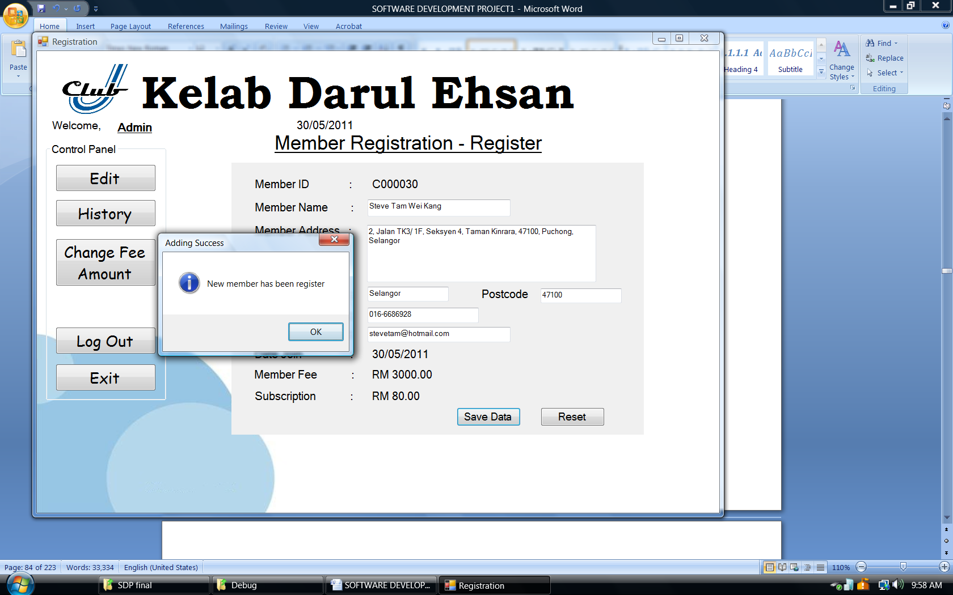

Data save into database once all the field had filled up.

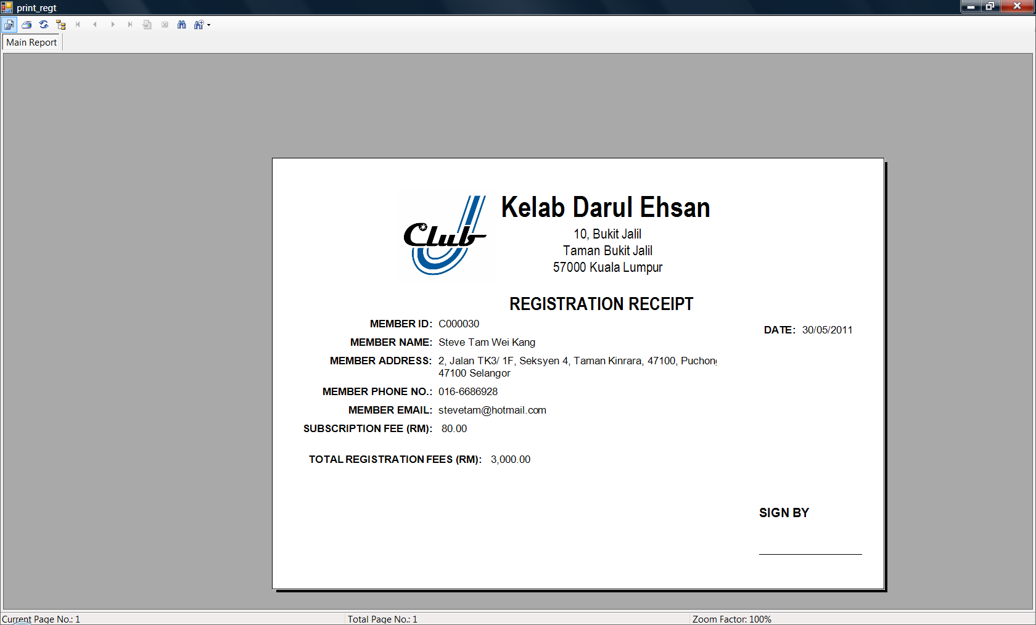

After the member had been registered, the system will auto print out the registration receipt.

### Edit

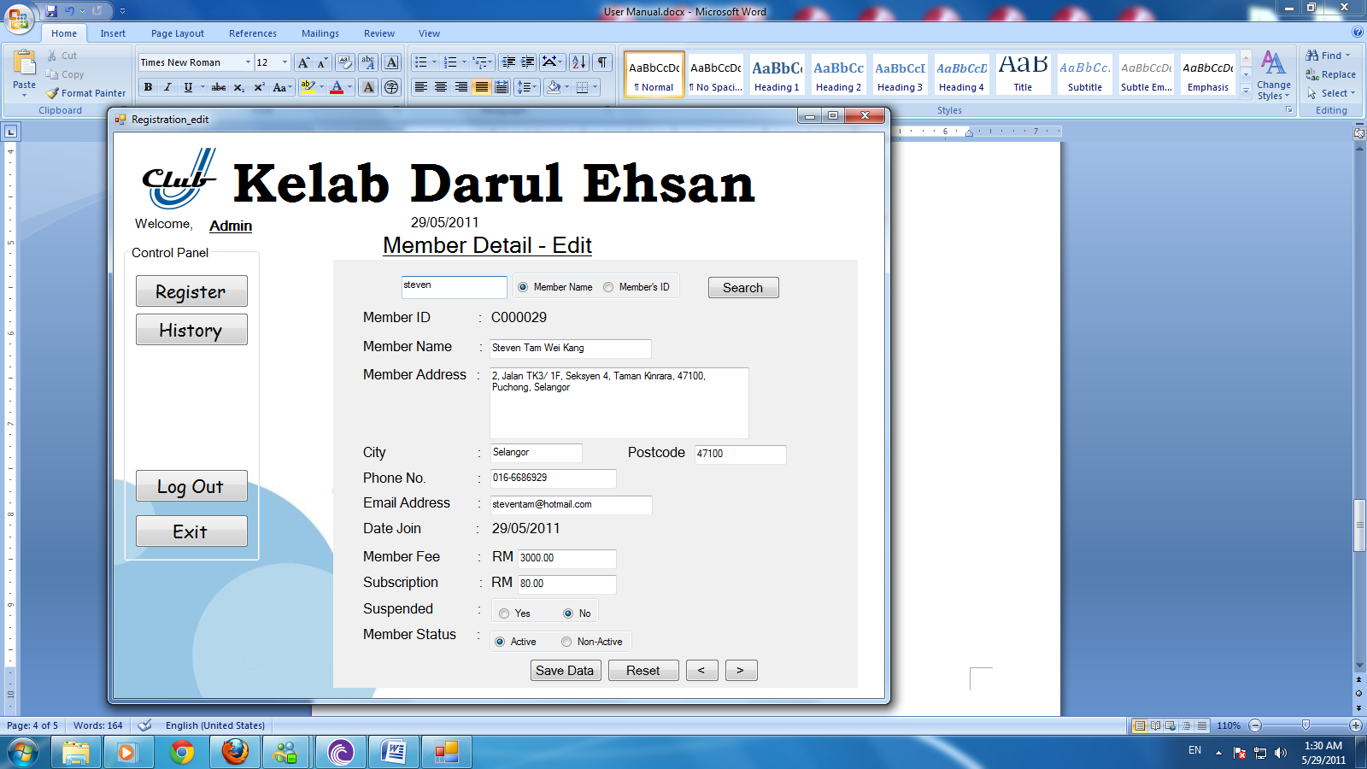

In this page able to do edit of information of member, search member name or member ID to edit.

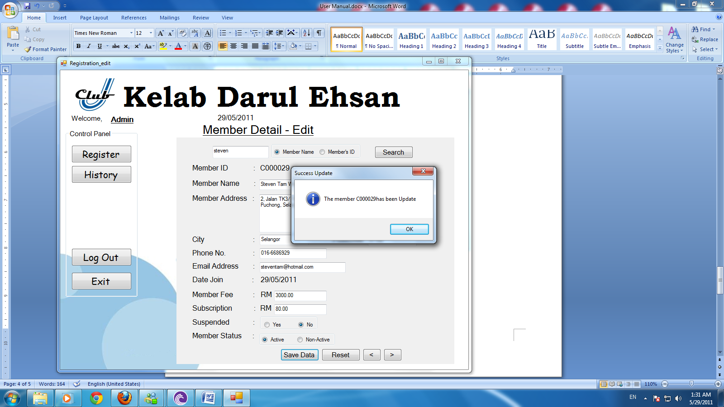

Save data to update the member information.

### History

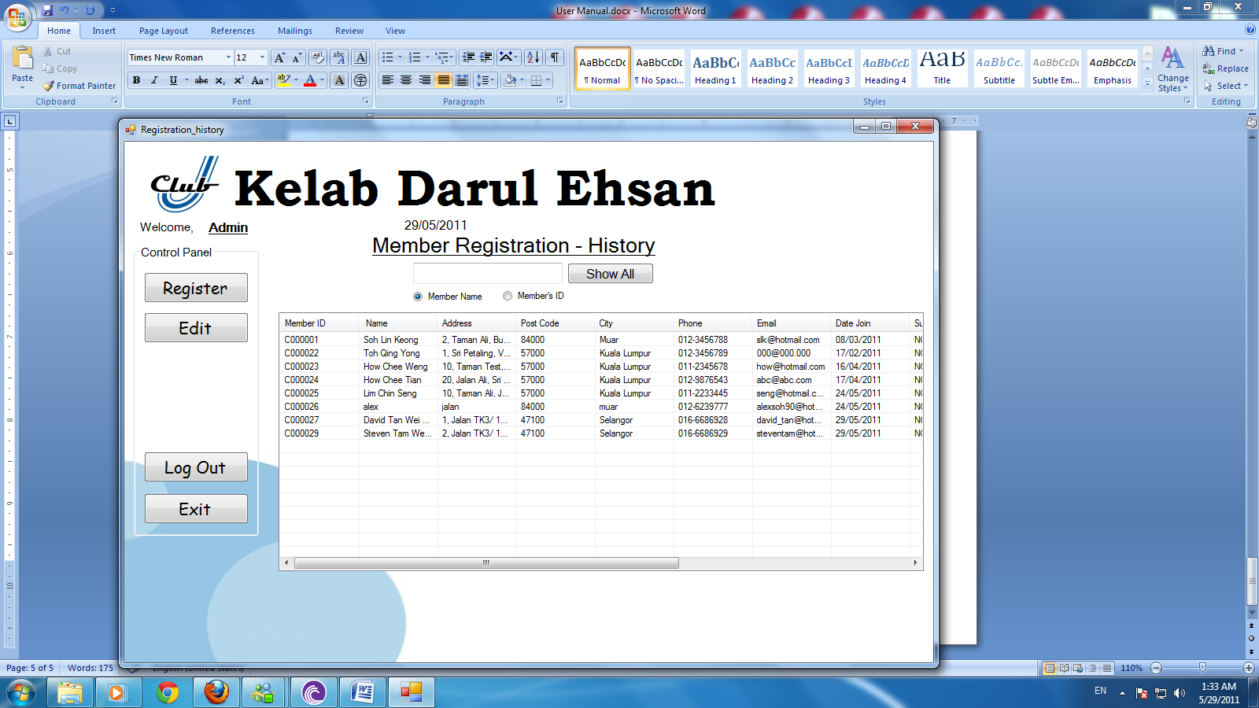

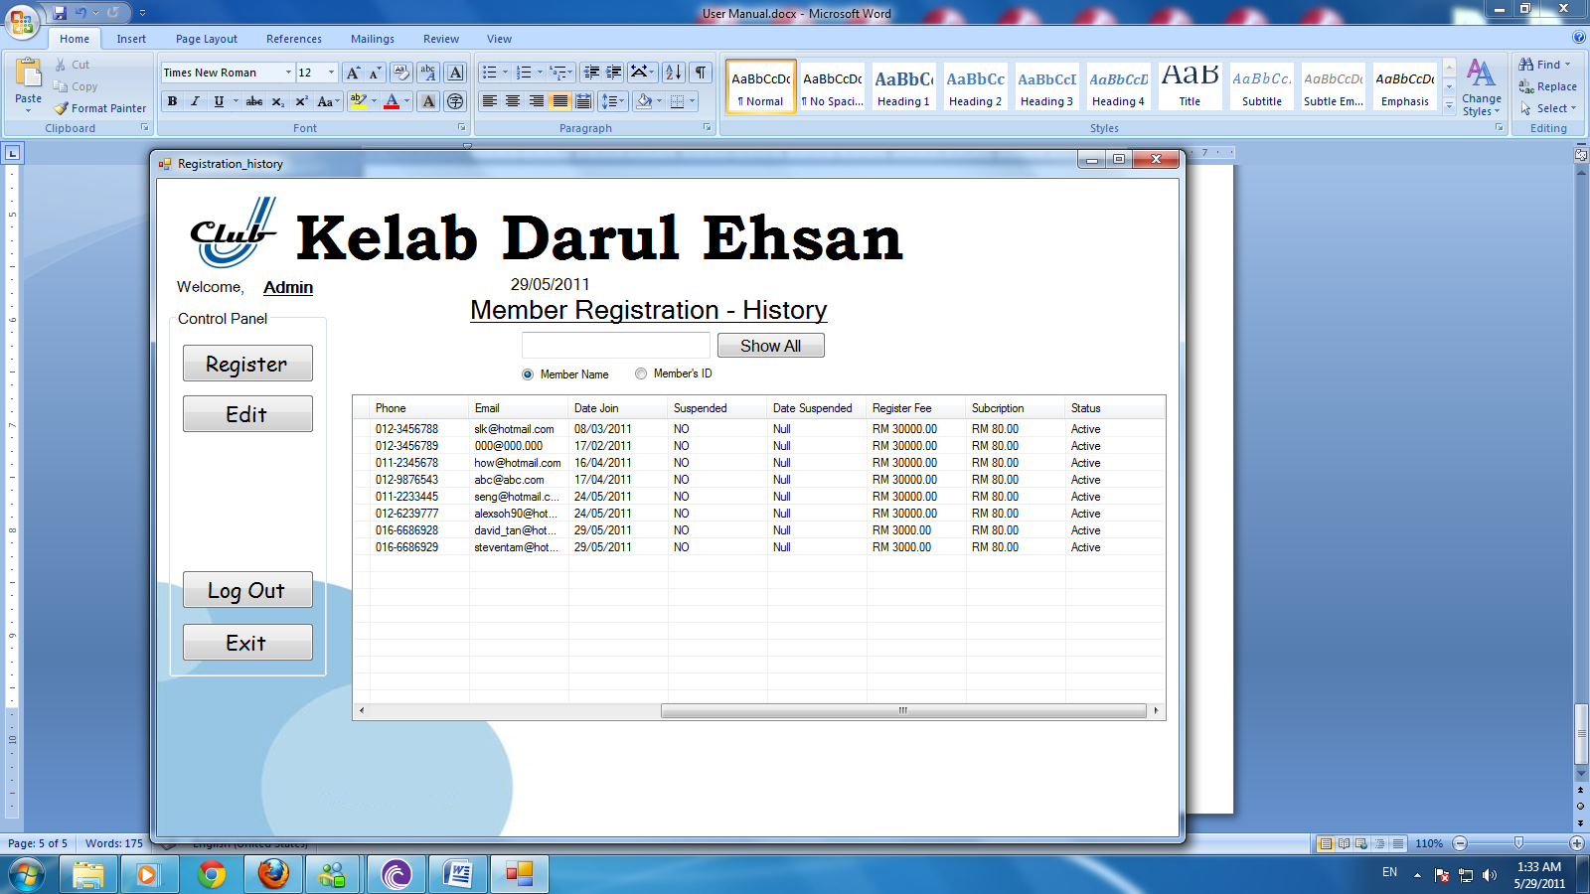

History able to check member information, member date joins, status.

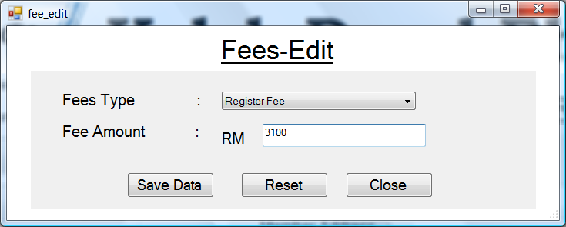

User can change the fee amount from the form. Register fee or subscription fee. Save data to update the form.

## Point Of Sales

### Add Items

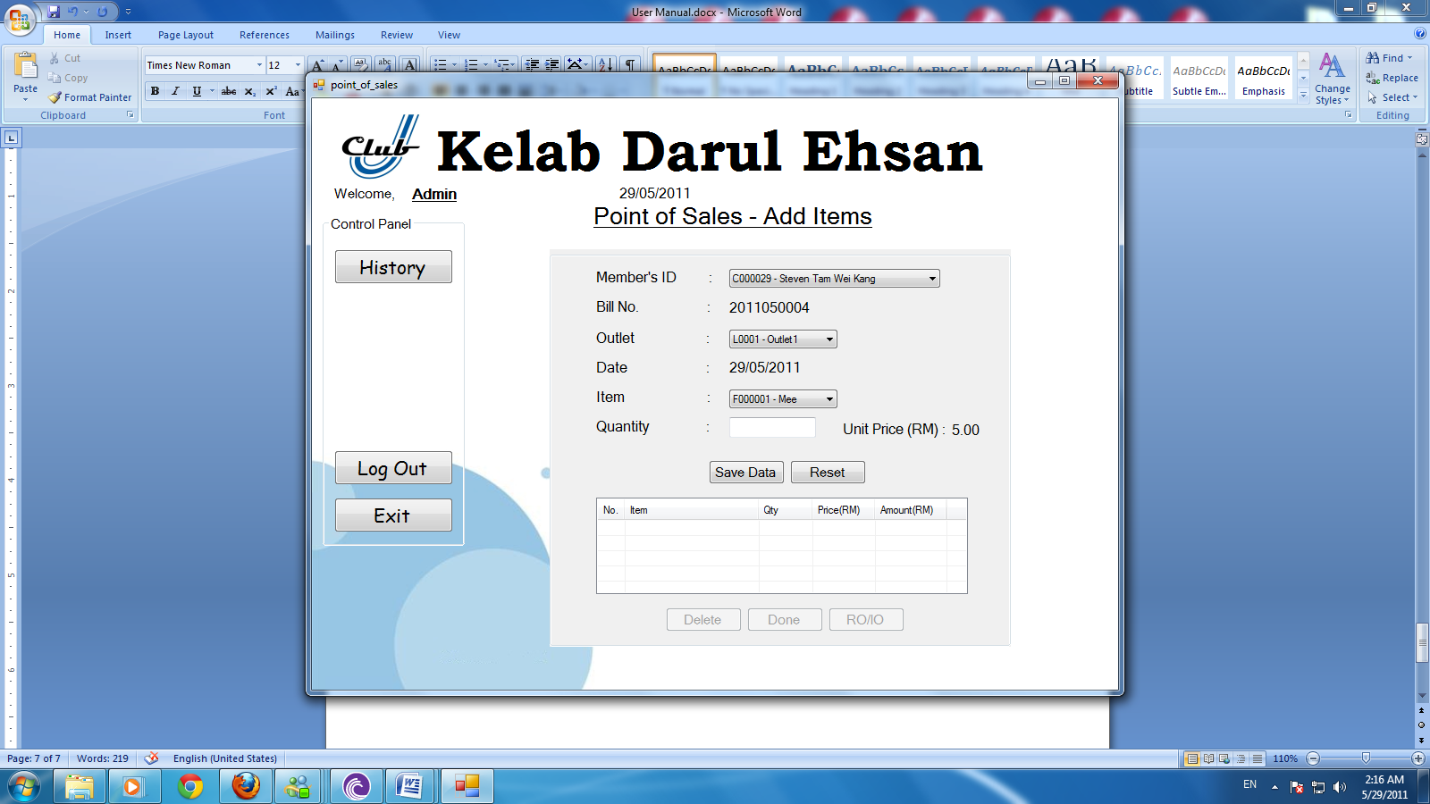

User have to enter the item that member wanted, select member’s ID, outlet and item. Select item with quantity. Bill no and Date auto generate by system.

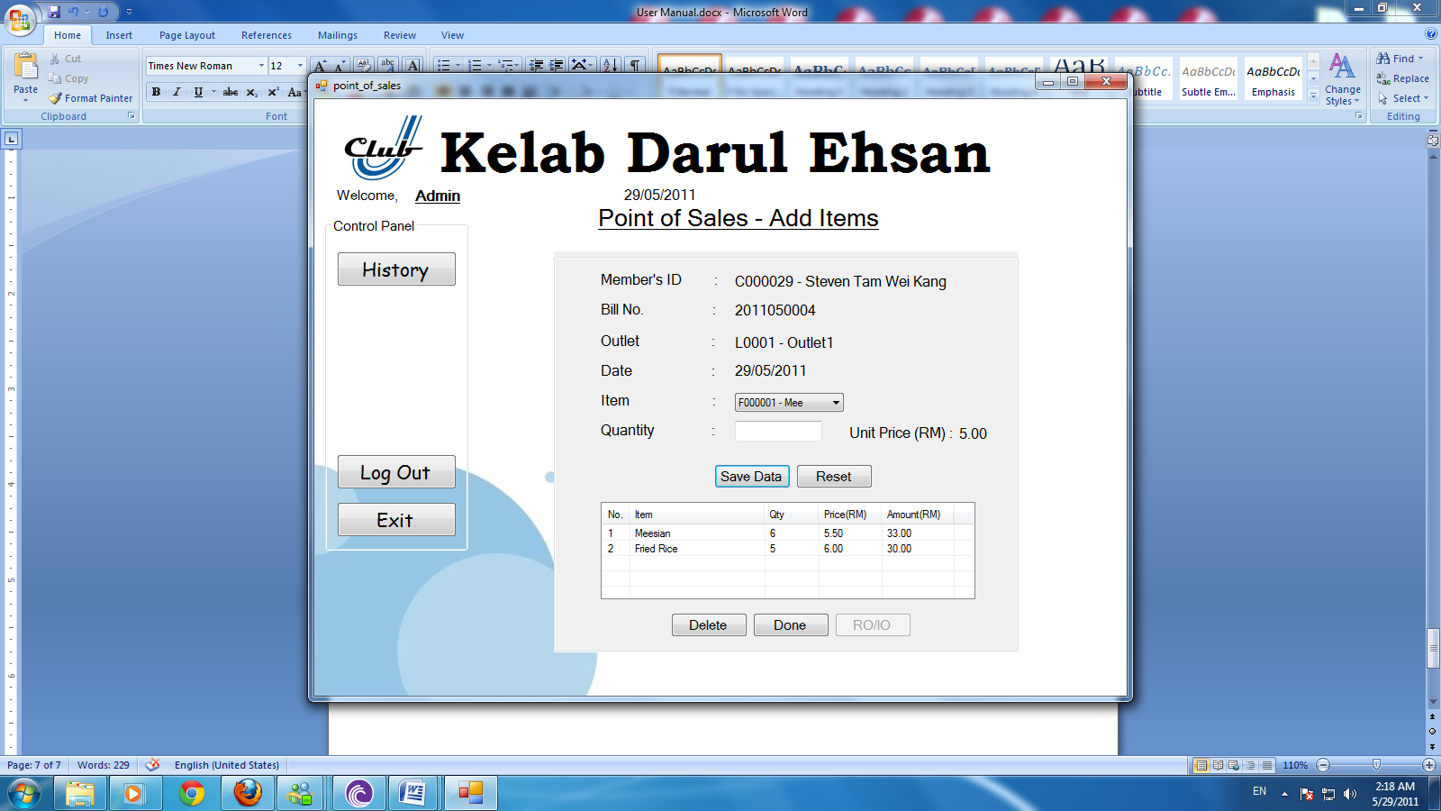

After select the items, enter done to save the data into the system.

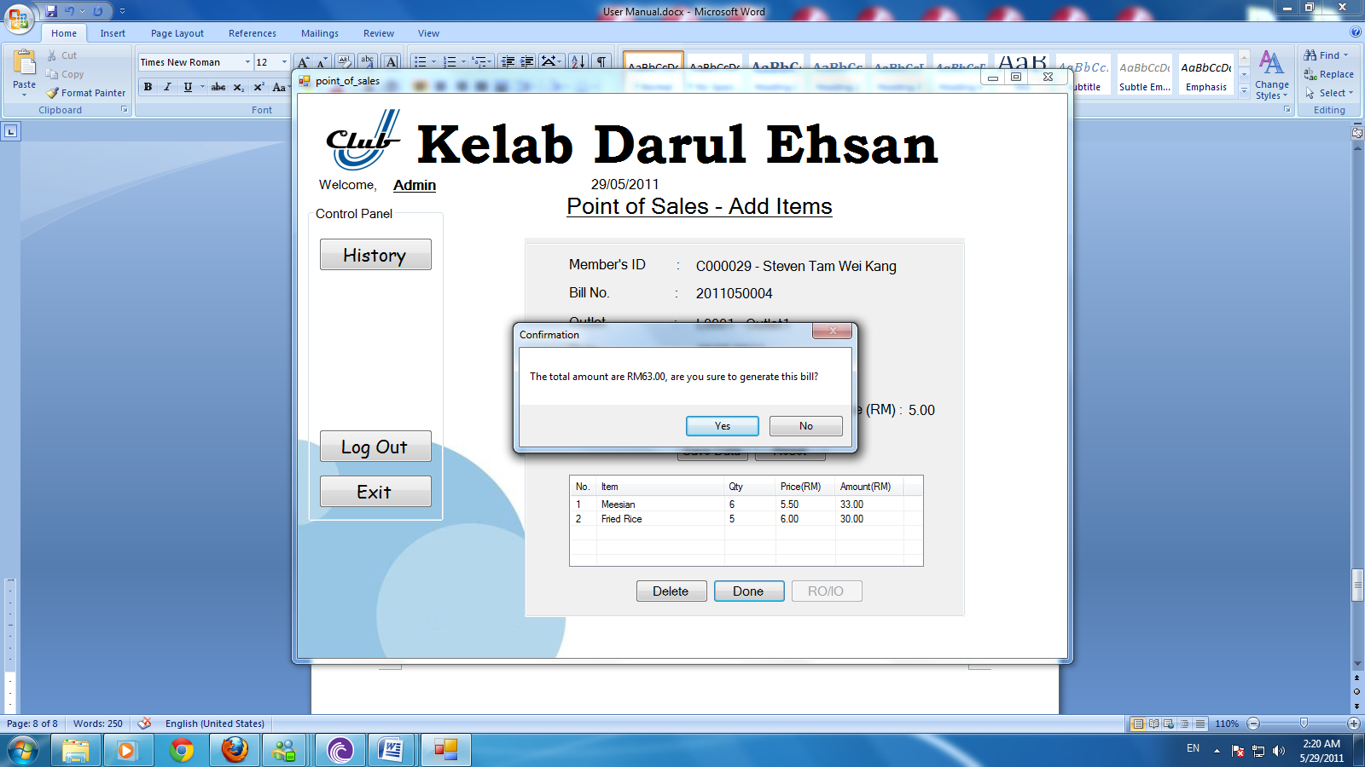

The total amount will show in the box, click yes to generate the bill.

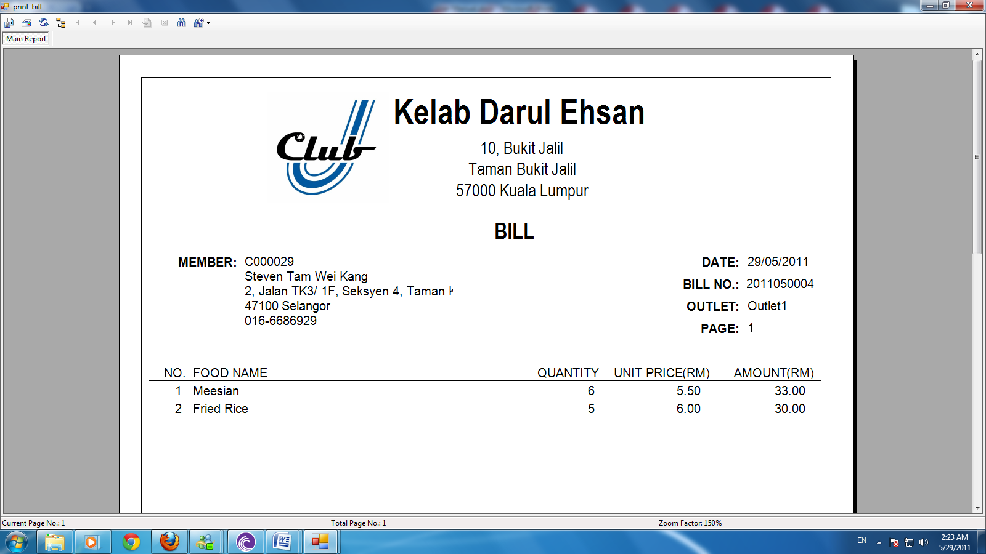

The entire item that orders will list in the bill as receipt.

### History

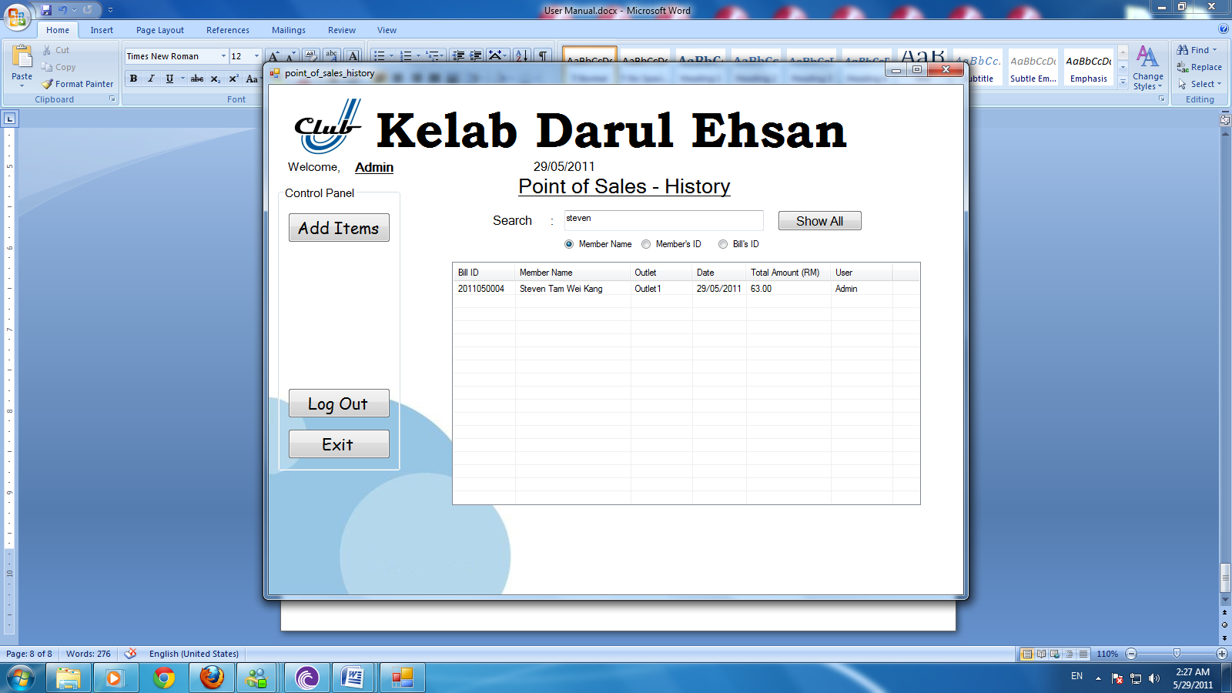

User can track the order from the history, the bill will shown in the table; double click to print the receipt.

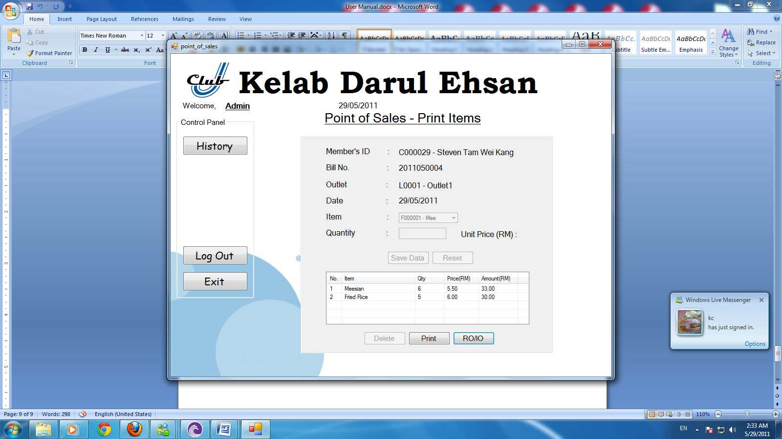

In this page, user able to print the receipt or display requisition order and issues note.

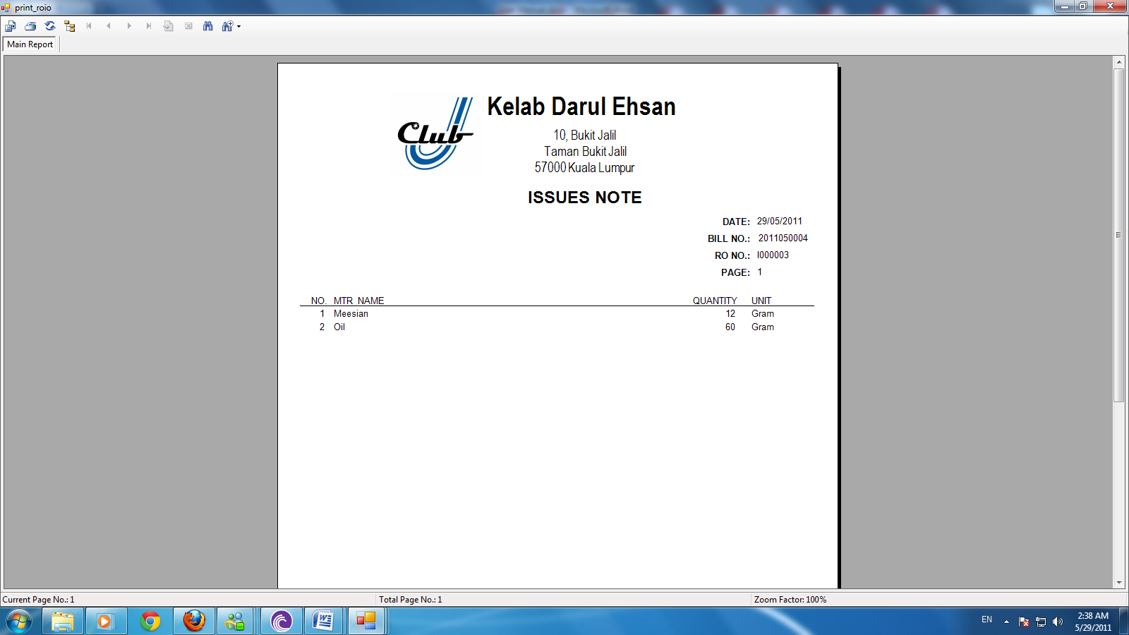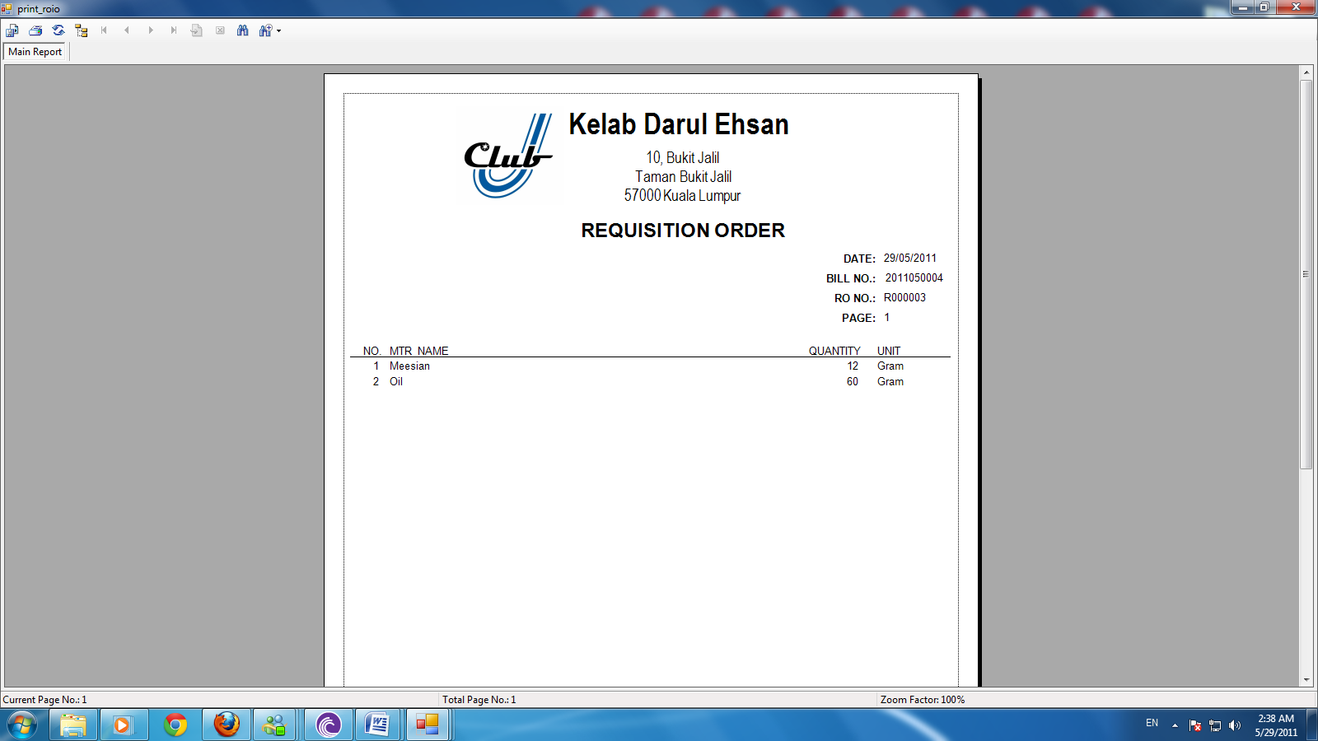

User can print out the requisition order receipt and issues note as reference for member.

## Inventory Management

### Add Inventory

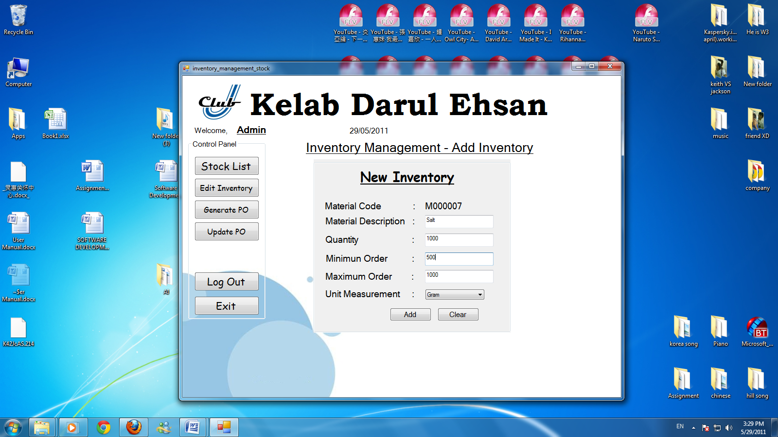

In Inventory Management able to add inventory, edit inventory, check inventory and print receipt. As above, user has to enter material description of the item, quantity, minimum order, maximum order and unit measurement.

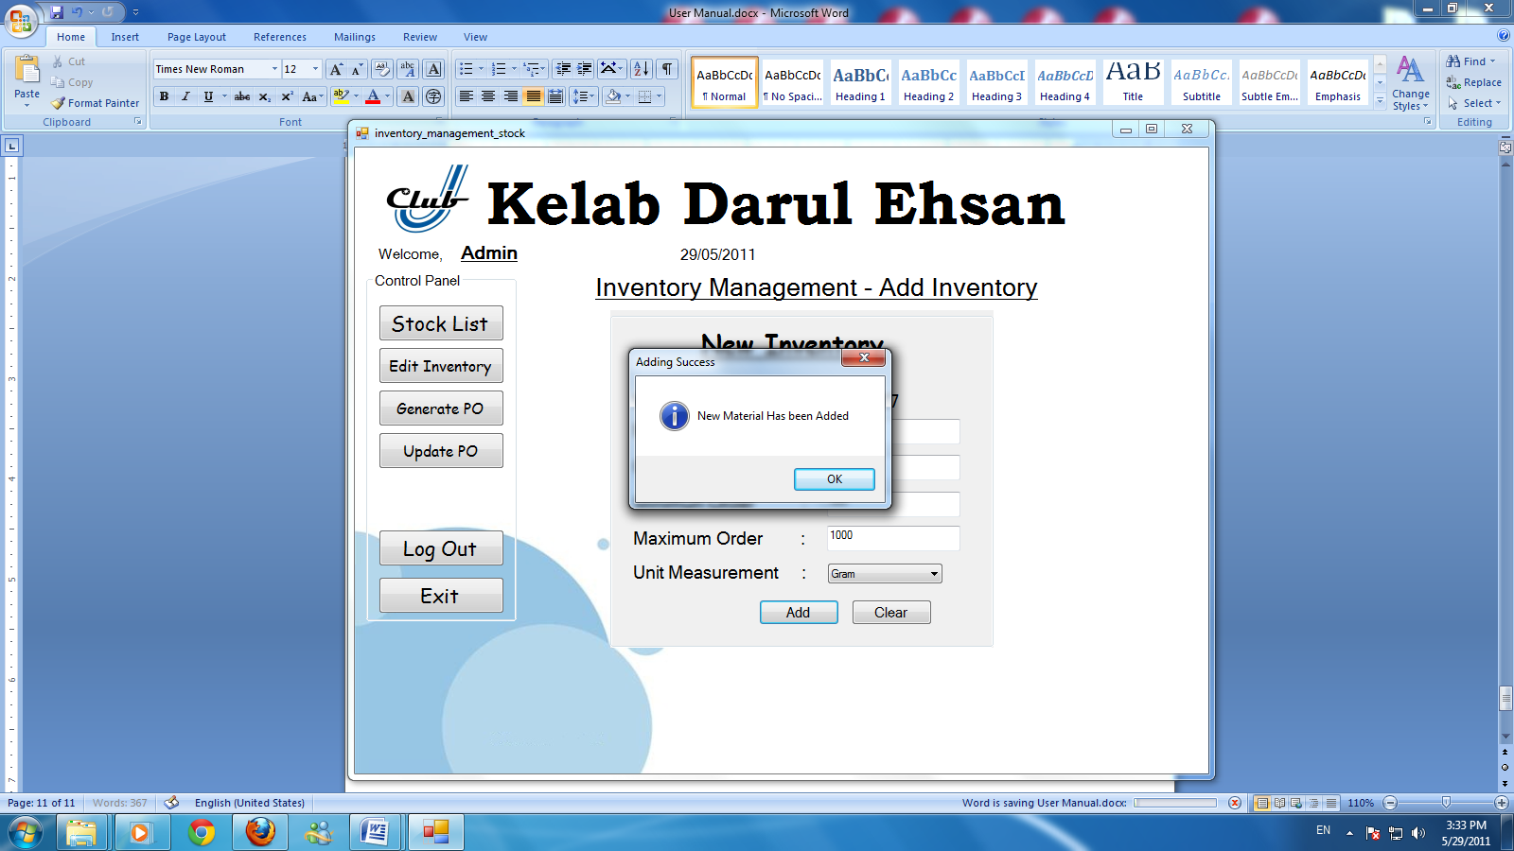

Select add to add new material.

### Stock list

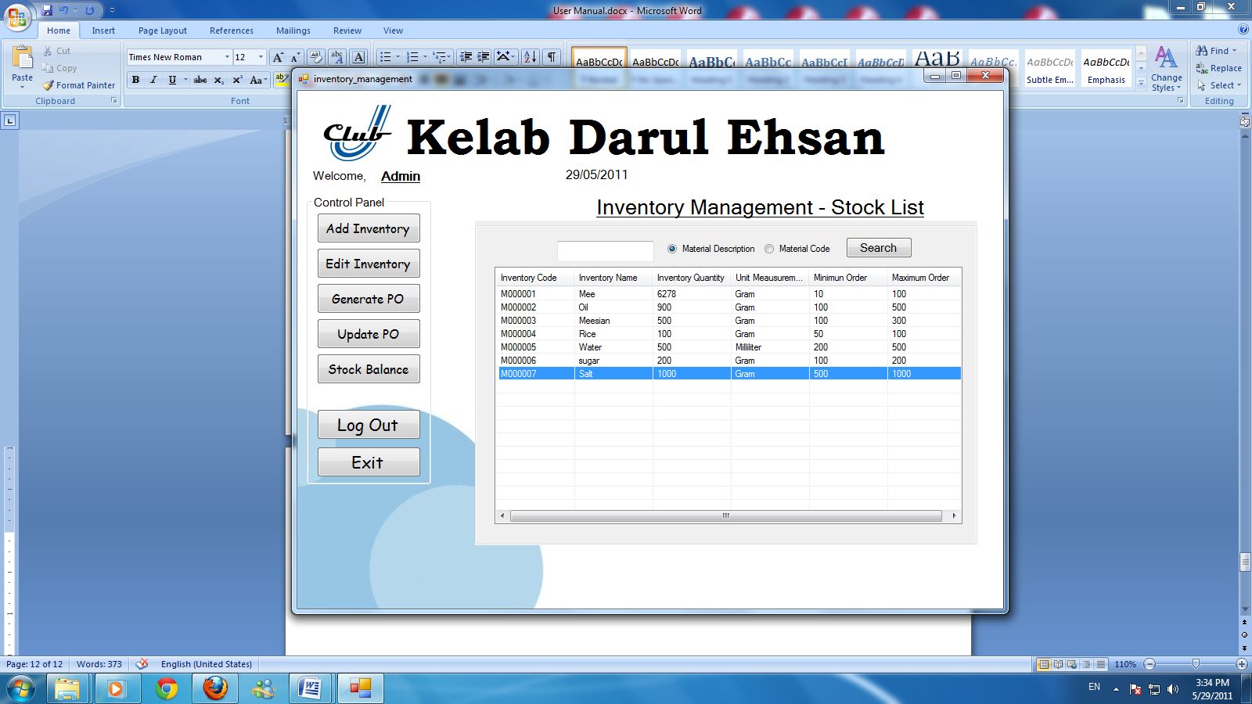

To check the item confirm add into system. Select stock list to search material that the user wanted.

### Edit Inventory

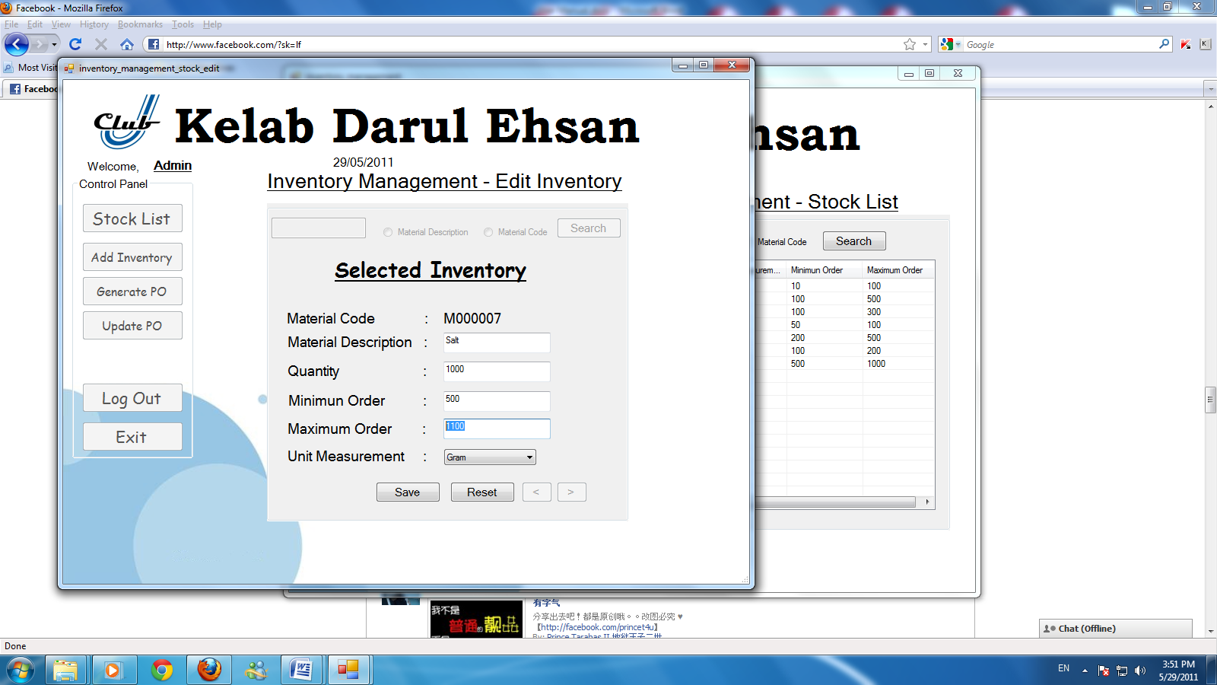

In the stock list, user can edit inventory just double click the material.

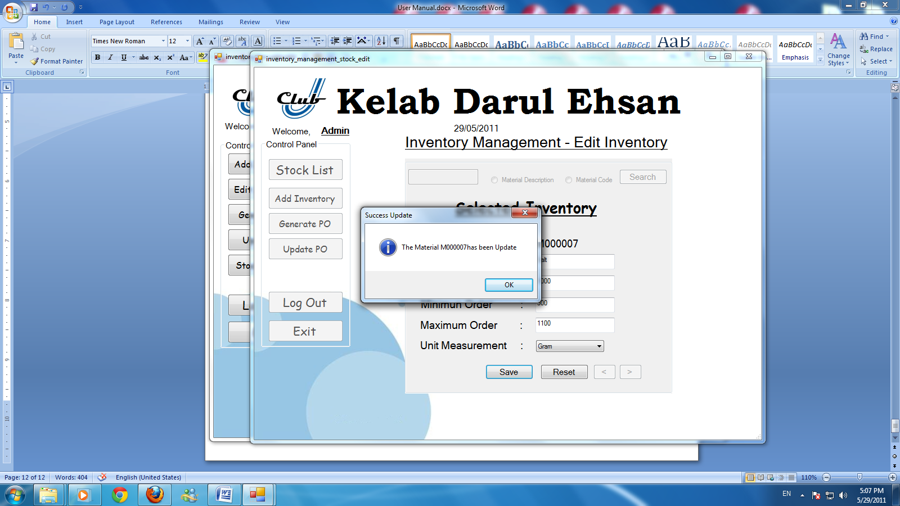

After edit the information of inventory, enter save to update the database.

### Generate PO

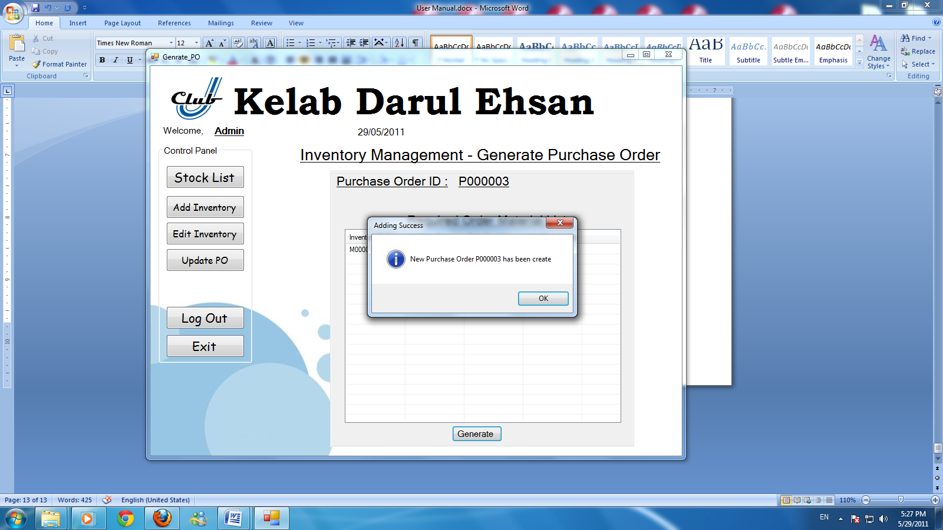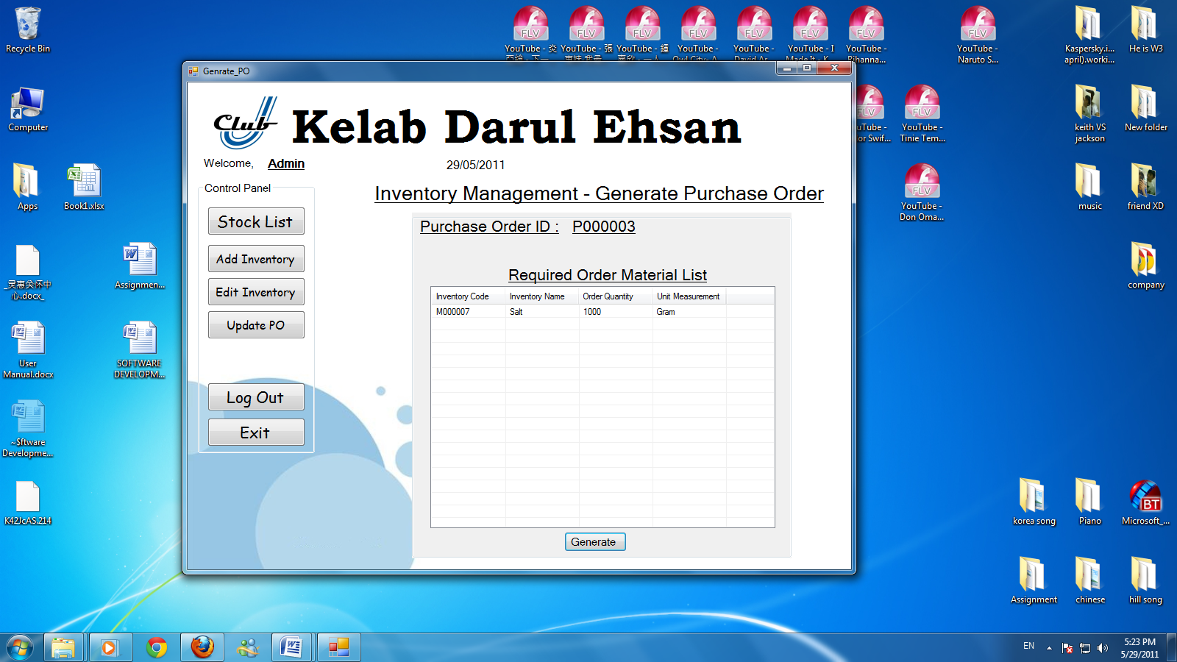

Enter generate PO to create a new purchase order.

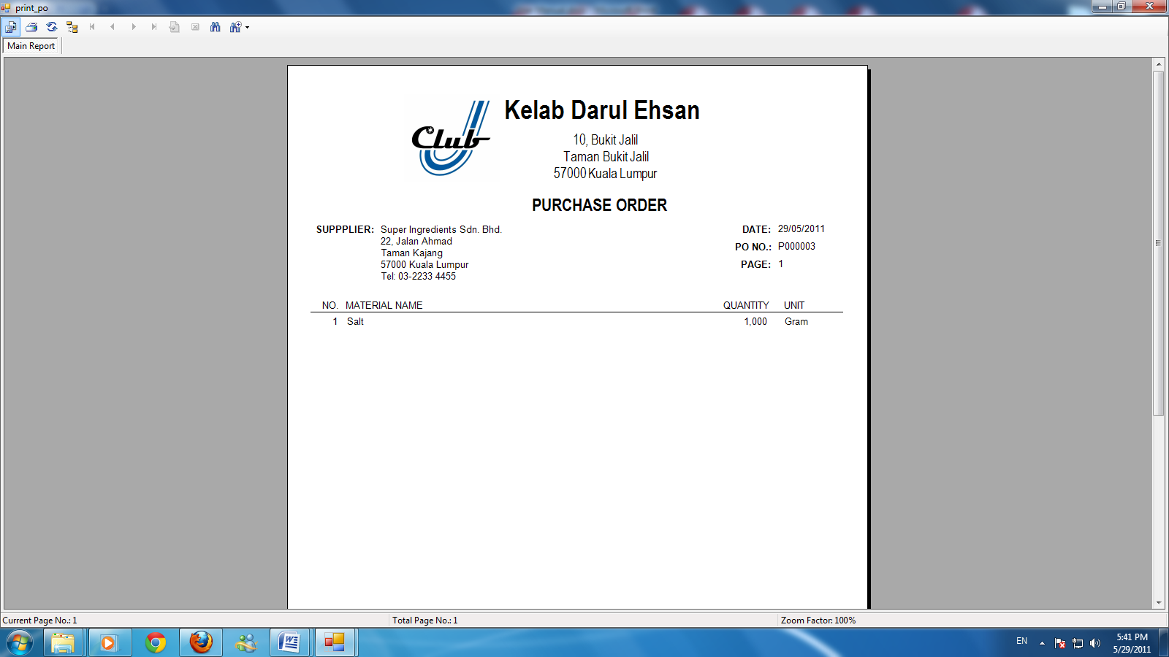

Select OK to go to Purchase Order receipt.

### Update PO

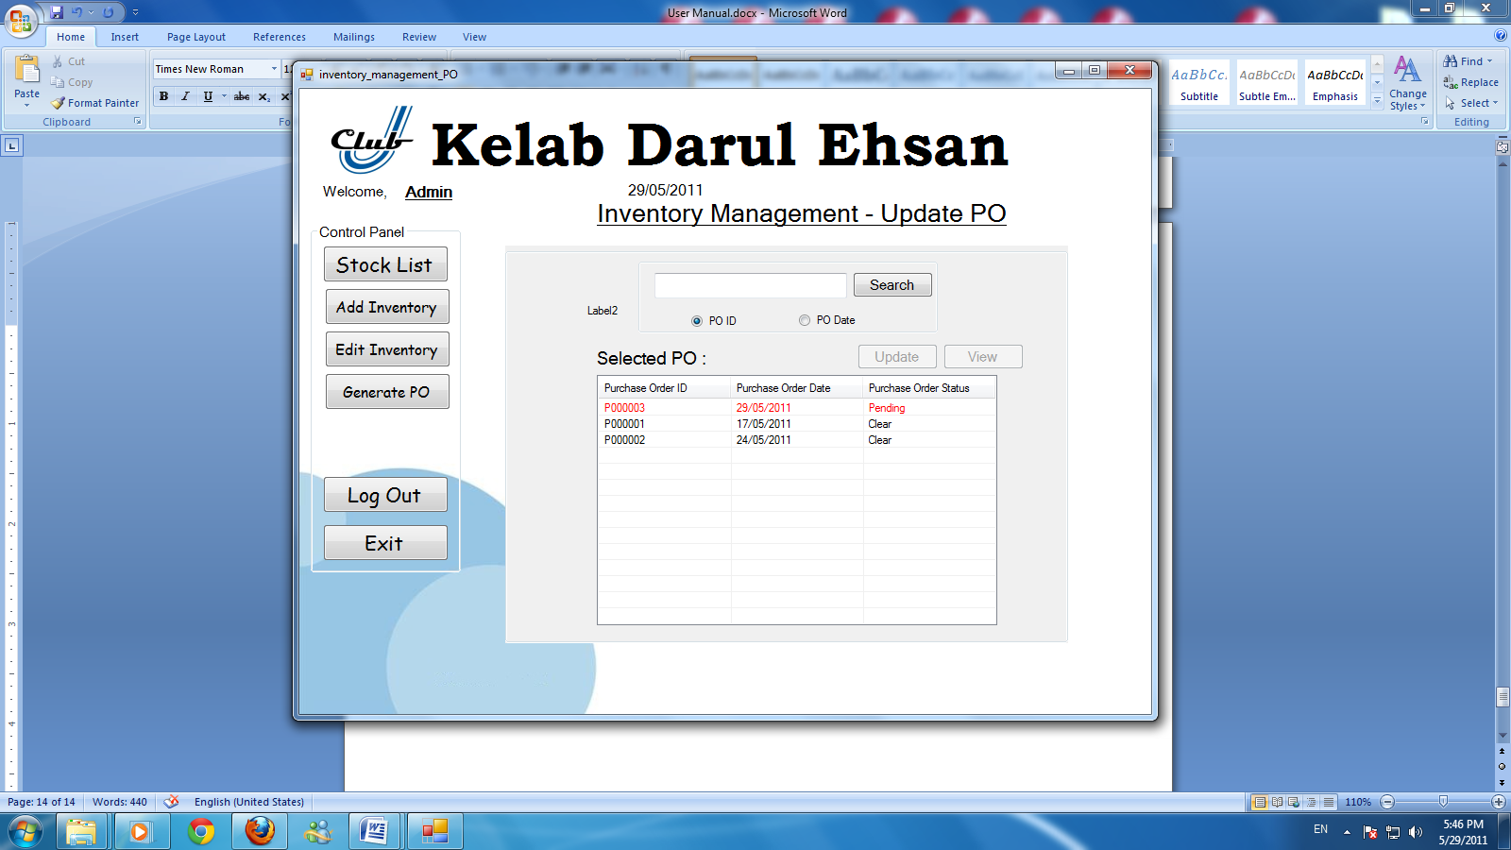

Update purchase order allow user to check purchase order. Purchase order shown red color when the status is in pending.

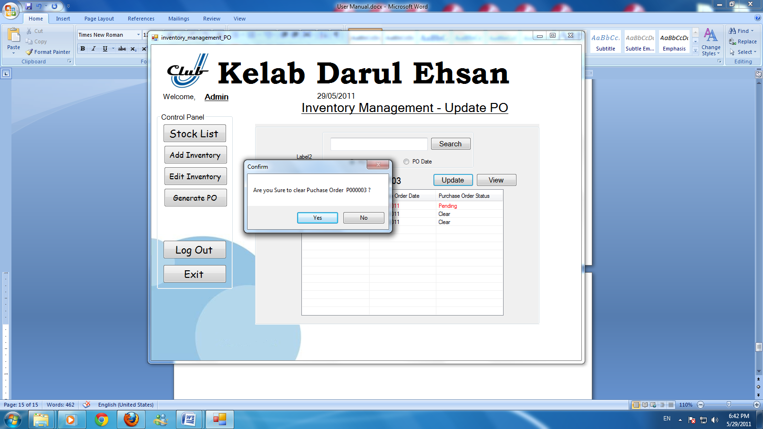

Double click the statement where the status is in pending. Select yes to clear the purchase order.

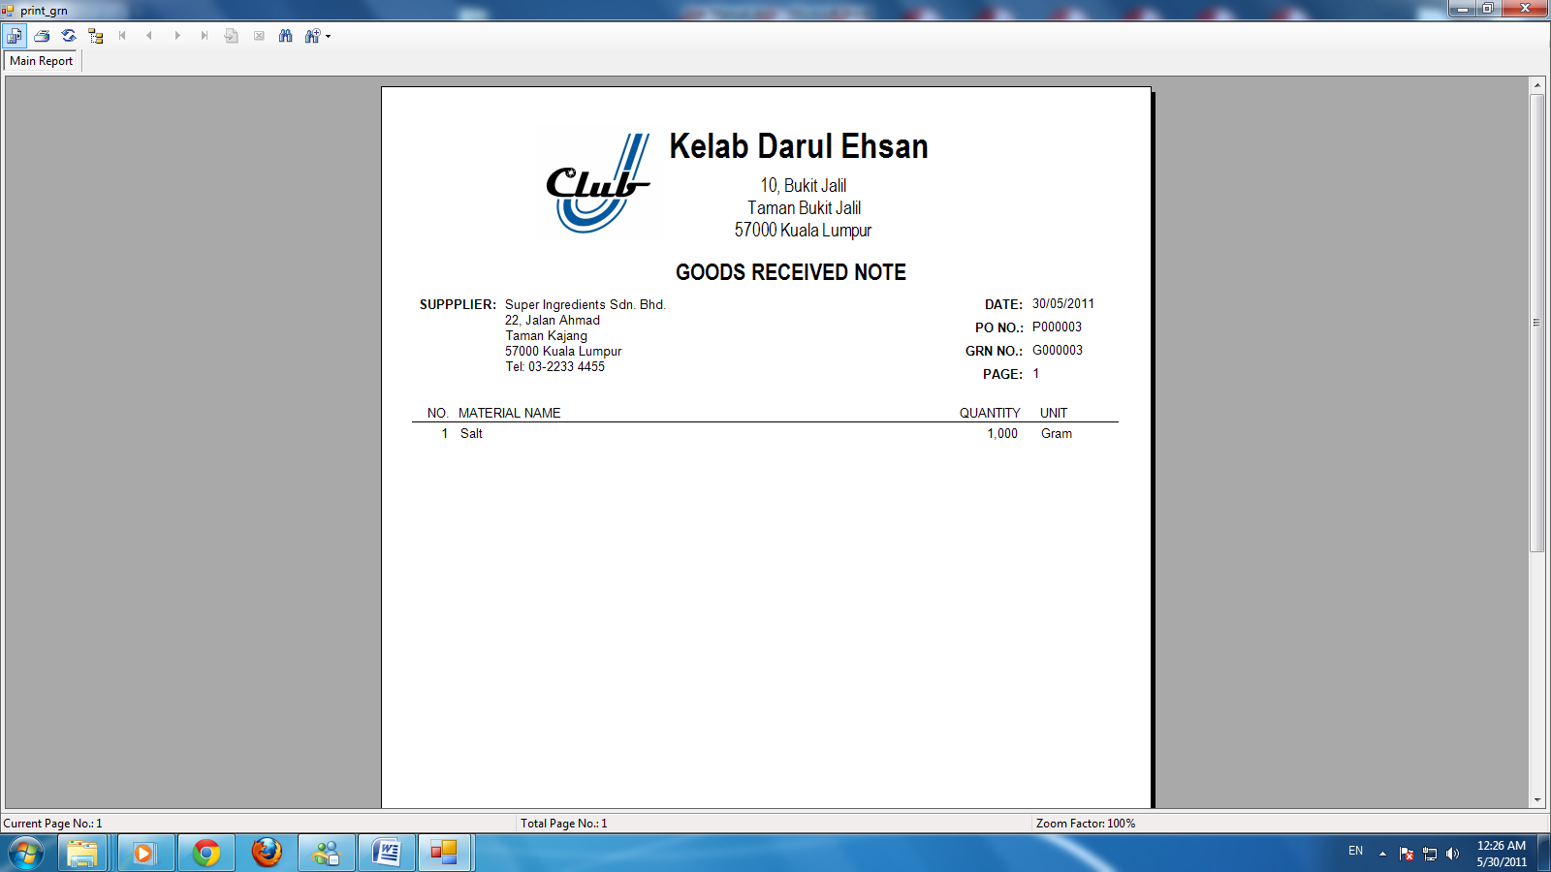

After user select yes, Goods received note will shown in the screen. And it’s printable.

## Billing

### History

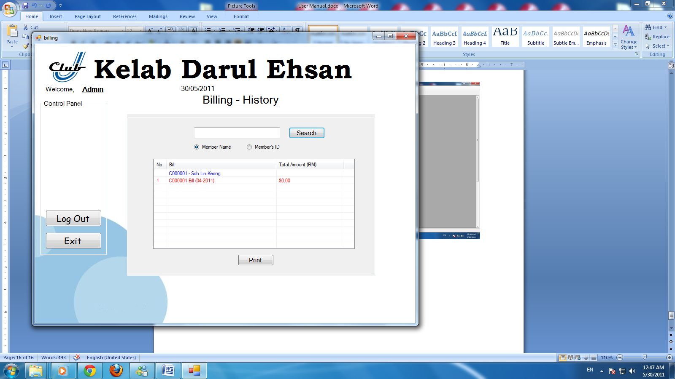

Search member name from the search and display red color word when the bill is overdue.

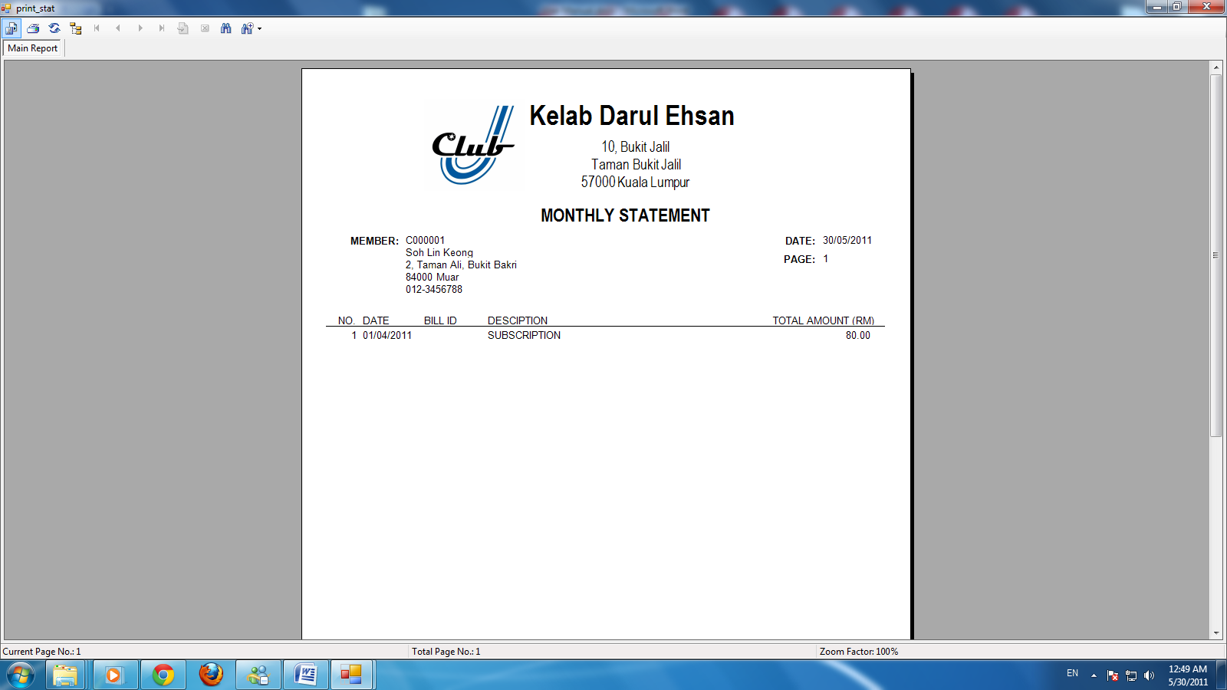

Select print to print the monthly statement.

## Account Receivable

### Statement

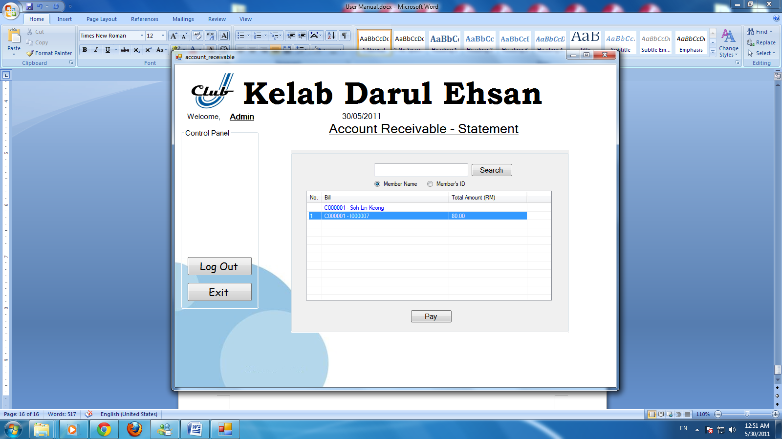

User can pay customer bill from here, select the bill and pay.

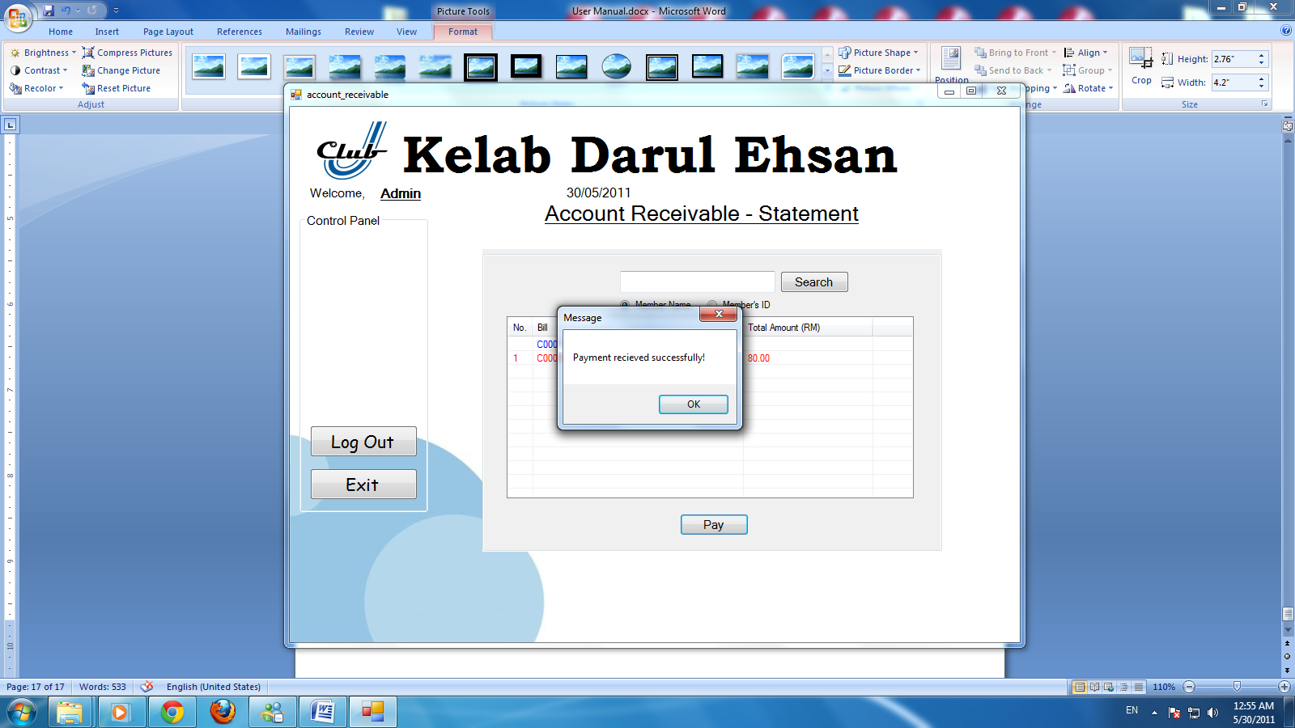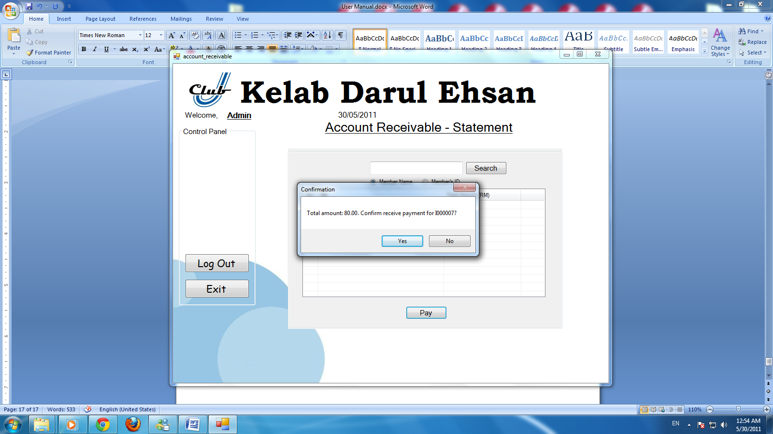

Select the correct bill; select yes to pay the bill. After the user had selected yes, payment received successfully and save into database.

## User Management

### Generate

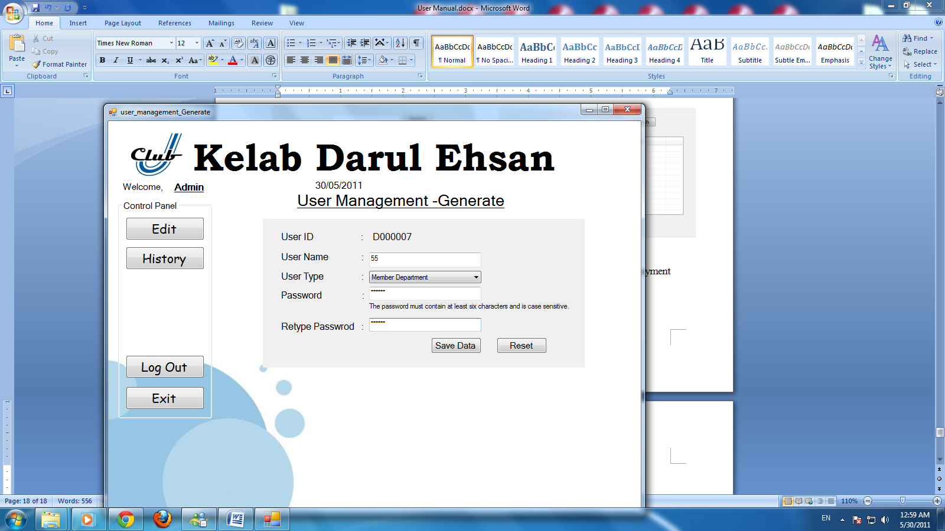

User can generate a new ID for new staff; fill up user name, user type, and password.

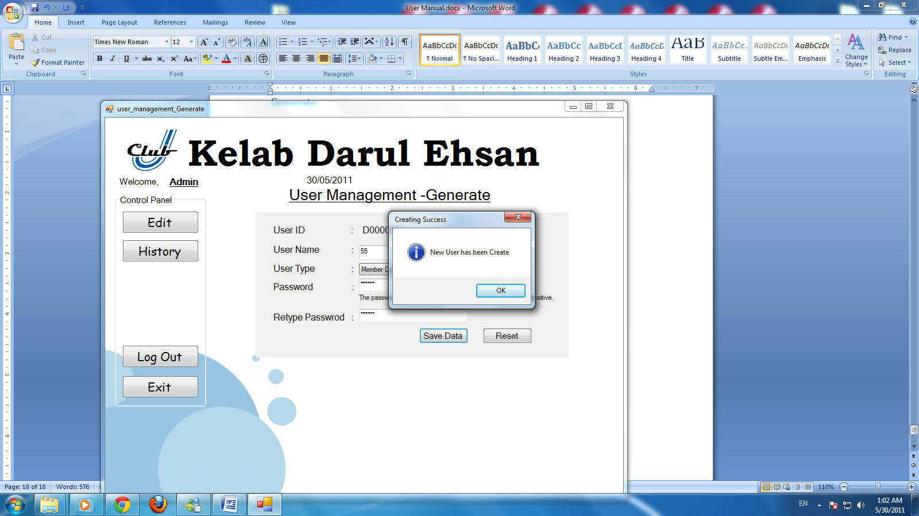

Select save data to create a new user.

### History

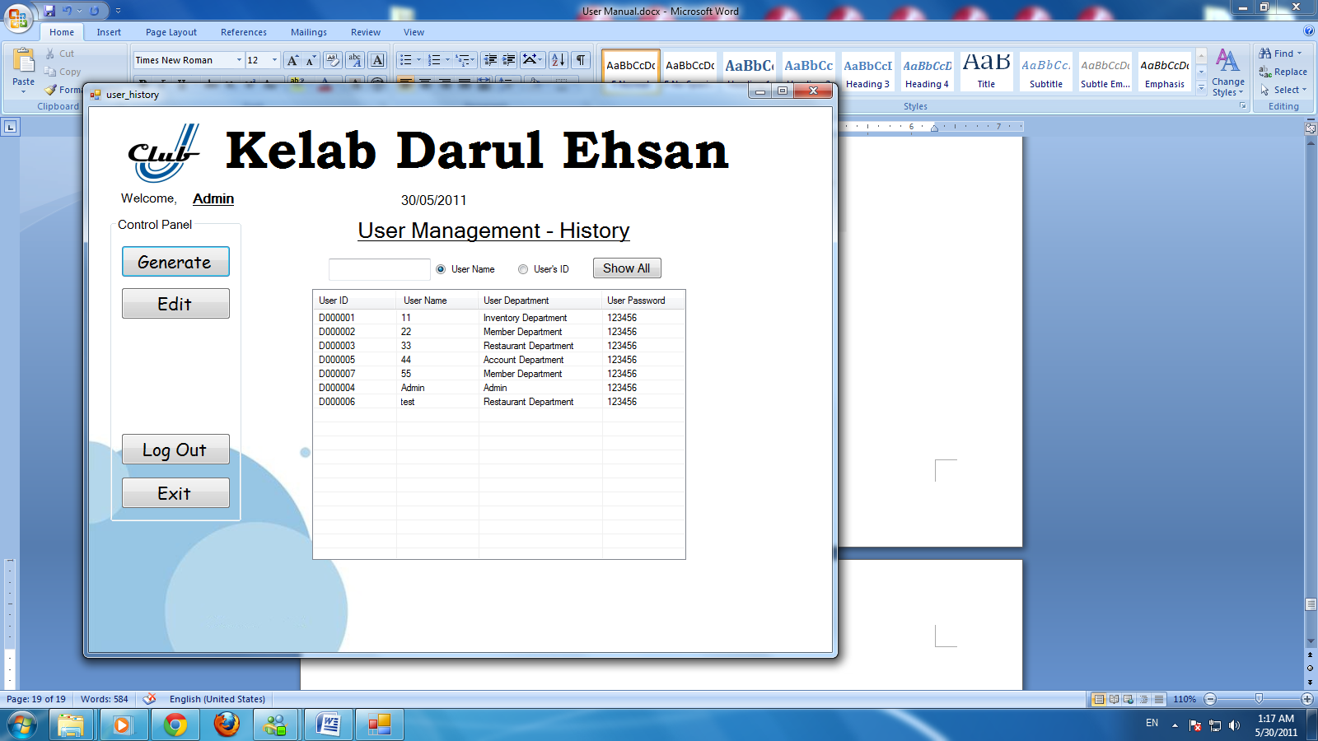

User can check department information, such as User ID, User Name, User Department and User Password.

### Edit

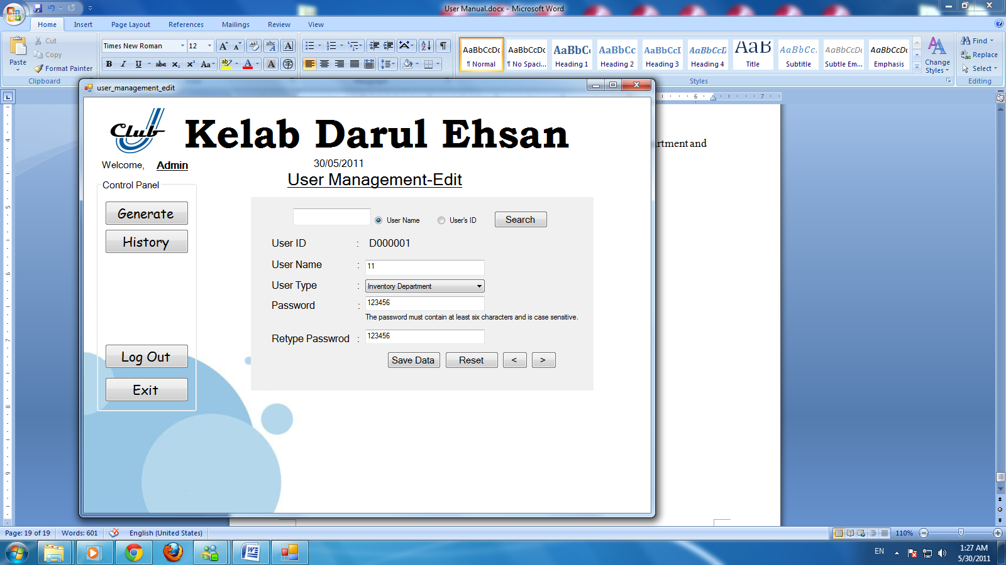

User can edit user name, user type and password.

## Outlet Management

### Create

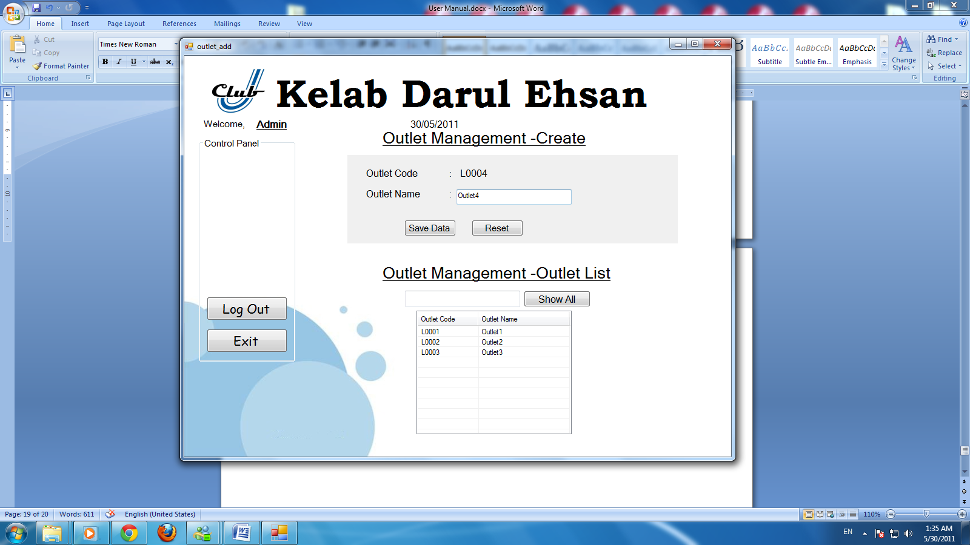

User can create a new outlet in outlet management.

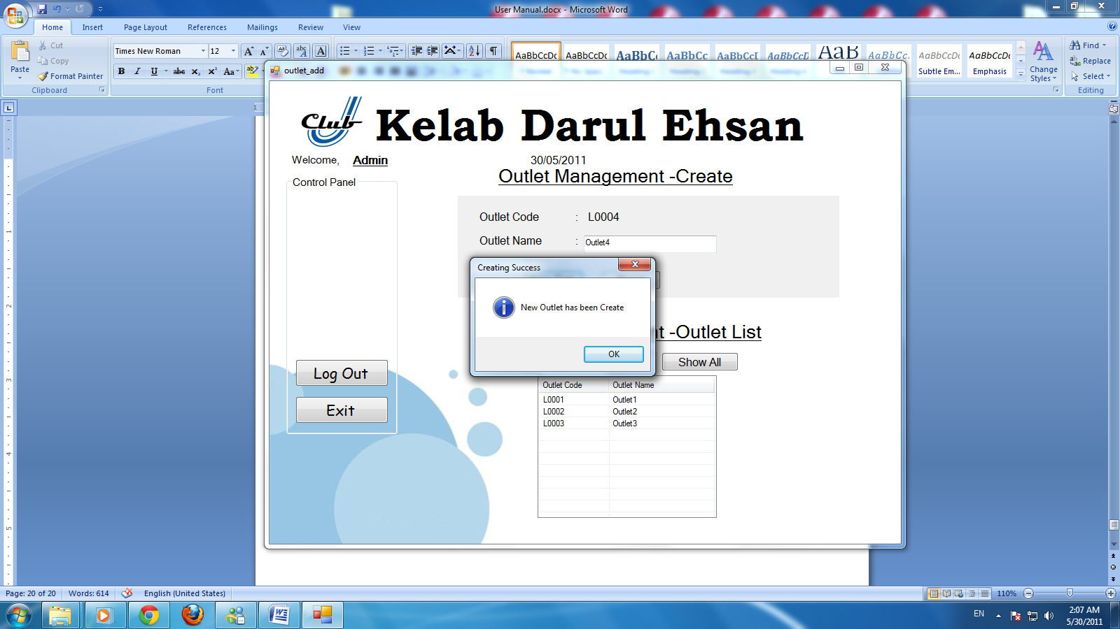

Select save data to create a new outlet. Outlet name will save into database.

## Food Management

### Add Recipe

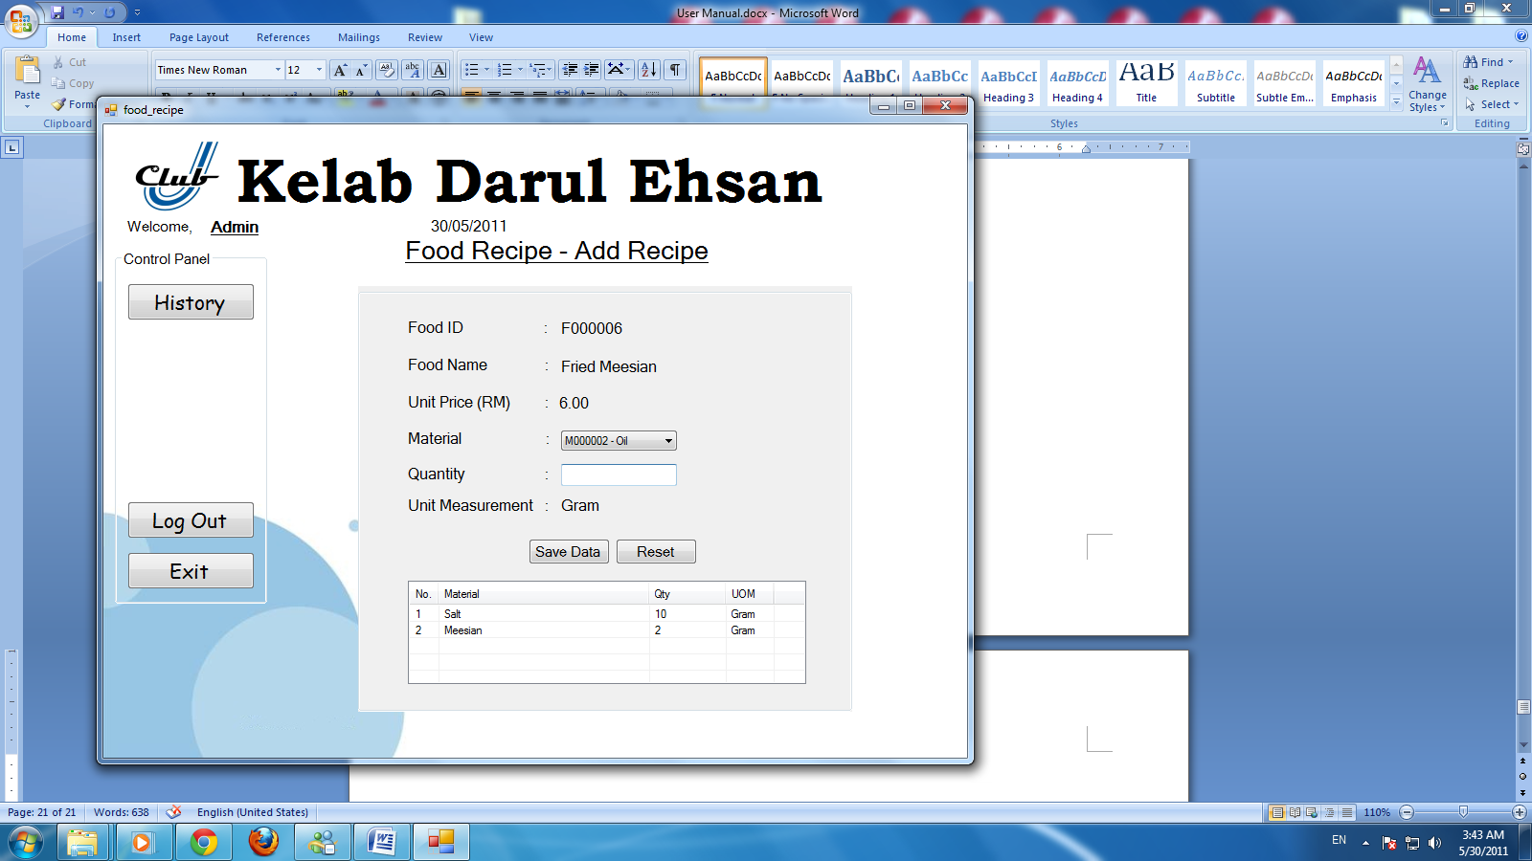

In food management, allow user to add a new recipe, enter food name, unit price, material and quantity.

### History

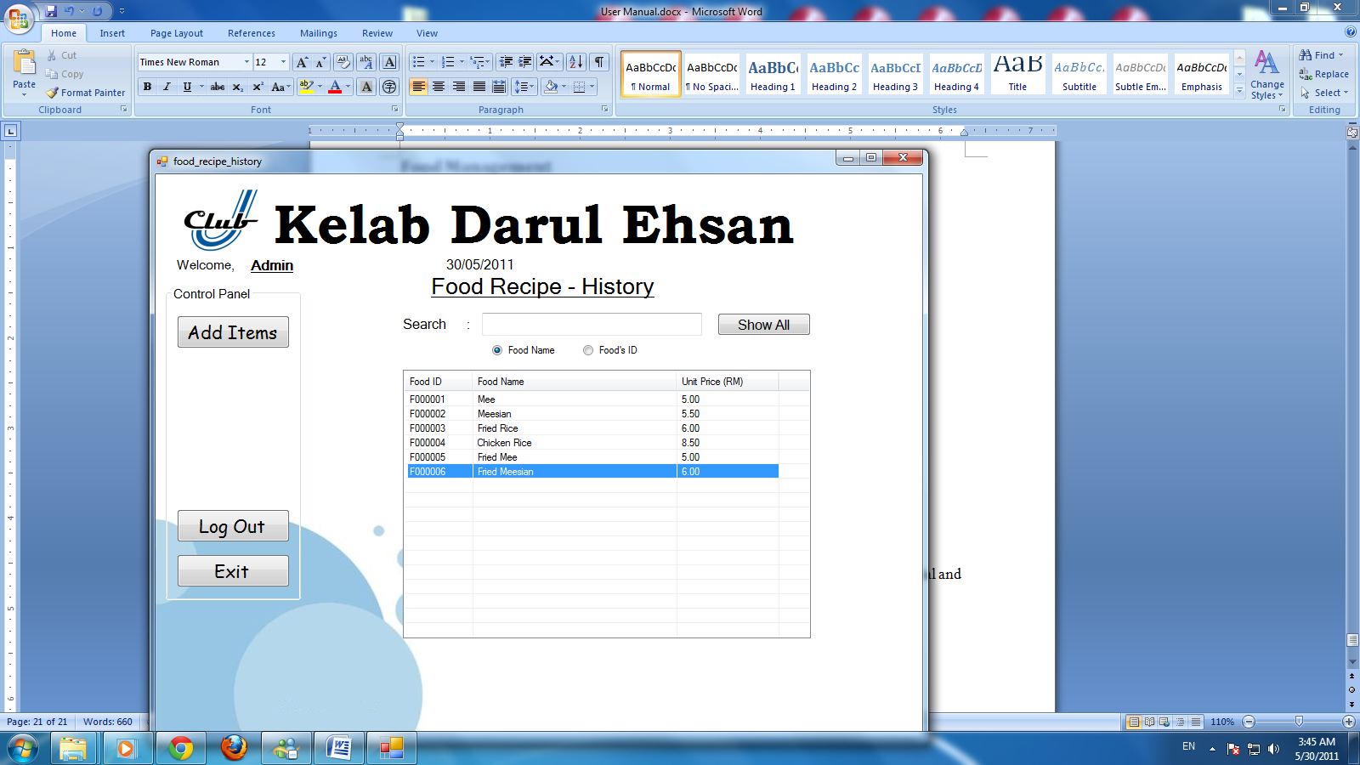

Allow user to view order list.

### Edit Recipe

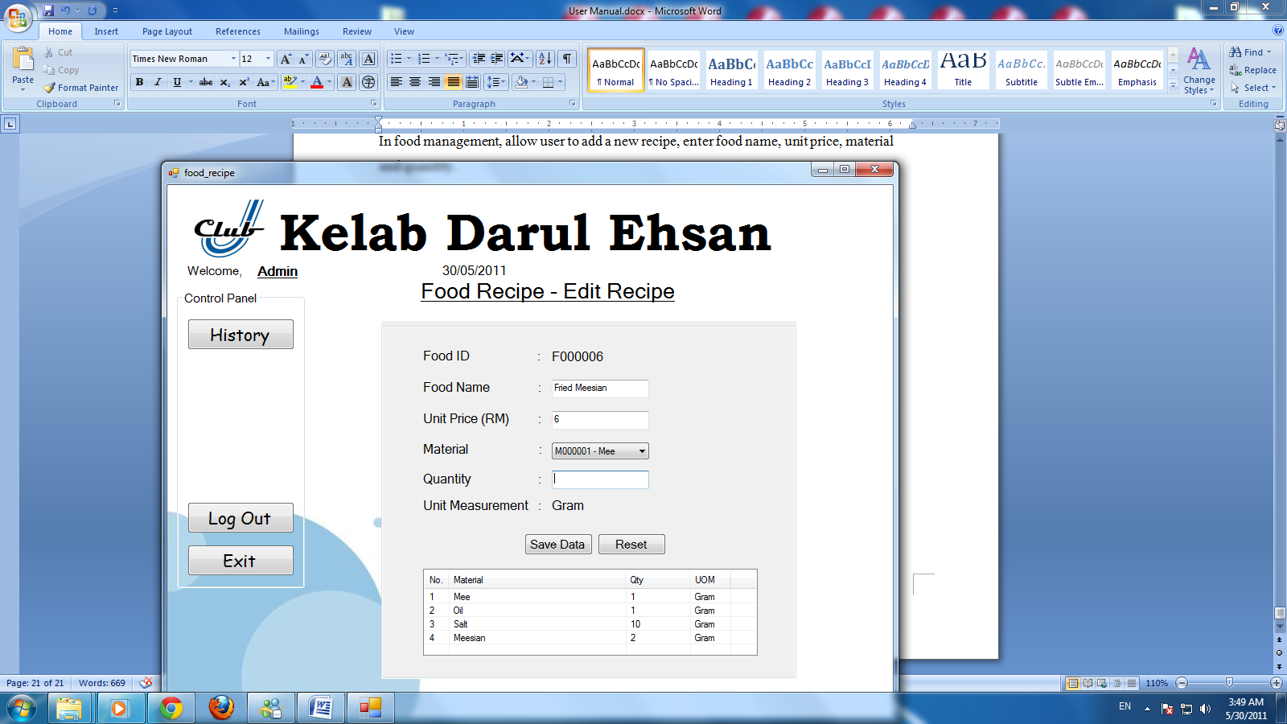

Allow user to edit recipe.

# Minutes of Meeting

## Minutes of Meeting

|  |  |  |  |
| --- | --- | --- | --- |
| **Meeting Name** | SDP Project Group Meeting 1 | **Date** | 03 Mar 2011 |
| **Venue** | APIIT L1-5 | **Time** | 2p.m.-3.15p.m. |

|  |  |  |  |
| --- | --- | --- | --- |
| Members Present | | **Members Absent** | |
|  | LiewChoon Kit |  |  |
|  | Soh Lin Keong |  |  |
|  | Ng Rui Xiang |  |  |
|  |  |  |  |

|  |
| --- |
| **Agenda of the Meeting:** |
| * Analyze the question given. |
| * List down the entire problem. |
| * Separate work task. |

| **No** | **Topic** | **Action Point** | **Responsibility** | **Scheduled Closure Date** |
| --- | --- | --- | --- | --- |
|  | Analyze the question given. | * We analyze the question and discuss it. | Project Team | 03 Mar 2011 |
|  | List down the entire problem. | * We brainstorm the problem and list it down. | Project Team | 03 Mar 2011 |
|  | Separate work task. | * We separate work task and start evaluate the work. | Project Team | 03 Mar 2011 |
|  | Next Meeting | * Next Meeting will be held on | Project Team | 10 Mar 2011 |

**Minutes Prepared By:**LiewChoon Kit

## Minutes of Meeting

|  |  |  |  |
| --- | --- | --- | --- |
| **Meeting Name** | SDP Project Group Meeting 2 | **Date** | 10 Mar 2011 |
| **Venue** | APIIT L1-5 | **Time** | 2p.m.-3p.m. |

|  |  |  |  |
| --- | --- | --- | --- |
| Members Present | | **Members Absent** | |
|  | LiewChoon Kit |  |  |
|  | Soh Lin Keong |  |  |
|  | Ng Rui Xiang |  |  |
|  |  |  |  |

|  |
| --- |
| **Agenda of the Meeting:** |
| * Discuss Data Flow Diagram. |
| * Discuss the interface of Screen Design. |
|  |

| **No** | **Topic** | **Action Point** | **Responsibility** | **Scheduled Closure Date** |
| --- | --- | --- | --- | --- |
|  | Discuss Data Flow Diagram. | * We evaluate Data Flow Diagram of the question and how it goes. | Project Team | 10 Mar 2011 |
|  | Discuss the interface of Screen Design. | * We discuss what element and what function should put inside the Screen Design. | Project Team | 10 Mar 2011 |
|  | Next Meeting | * Next Meeting will be held on | Project Team | 14 Mar 2011 |

**Minutes Prepared By:**LiewChoon Kit

## Minutes of Meeting

|  |  |  |  |
| --- | --- | --- | --- |
| **Meeting Name** | SDP Project Group Meeting 3 | **Date** | 14 Mar 2011 |
| **Venue** | Ent3 1-1 room -3 | **Time** | 1p.m.-1.45p.m. |

|  |  |  |  |
| --- | --- | --- | --- |
| Members Present | | **Members Absent** | |
|  | LiewChoon Kit |  |  |
|  | Soh Lin Keong |  |  |
|  | Ng Rui Xiang |  |  |
|  |  |  |  |

|  |
| --- |
| **Agenda of the Meeting:** |
| * Finalize the project. |
| * Draw Gantt chart. |
|  |

| **No** | **Topic** | **Action Point** | **Responsibility** | **Scheduled Closure Date** |
| --- | --- | --- | --- | --- |
|  | Finalize the project. | * We finalized and check which topic has left out. | Project Team | 14 Mar 2011 |
|  | Draw Gantt chart. | * We Draw Gantt Chart together. | Project Team | 14 Mar 2011 |

**Minutes Prepared By:**LiewChoon Kit

# Reference

codeguru.com, n.d, A Basic VB.NET ADO.NET Tutorial, Available World Wide Web, URL: <http://www.codeguru.com/vb/gen/vb_database/adonet/article.php/c15033>  
(Accessed 2April 2011)

dotnetperls.com, n.d, VB.NET Split String Examples, Available World Wide Web, URL: <http://dotnetperls.com/split-vbnet>  
(Accessed 10April 2011)

Go4Expert, n.d., Calculate Difference Between Two Date in VB.Net, Available World Wide Web: URL: <http://www.go4expert.com/forums/showthread.php?t=3609>

(Accessed 27 April 2011)

net-informations.com, n.d, VB.NET CRYSTAL REPORTS, Available World Wide Web, URL: <http://vb.net-informations.com/crystal-report/vb.net_crystal_reports_tutorials.htm>  
(Accessed 18 April 2011)

Startvbdotnet.com, n.d., System Development Life Cycle, Available World Wide Web, URL: <http://www.startvbdotnet.com/sdlc/sdlc.aspx>  
(Accessed 8 April 2011)

Scott W. Ambler, n.d., Data Flow Diagrams (DFDs), Available World Wide Web, URL:<http://www.agilemodeling.com/artifacts/dataFlowDiagram.htm>  
(Accessed 15 April 2011)

vbdotnetheaven.com, n.d, Pass Data between Forms, Available World Wide Web, URL: <http://www.vbdotnetheaven.com/UploadFile/thiagu304/passdata12262006073406AM/passdata.aspx>  
(Accessed 25April 2011)

# Source Code of the system

Account Receivable – Statement

|  |
| --- |
| Imports System.Data.OleDb  PublicClass account_receivable  Dim cnstr = "Provider=Microsoft.Jet.OLEDB.4.0;Data Source=database.mdb;"  Dim cn As OleDbConnection = New OleDbConnection(cnstr)  Dim cn2 As OleDbConnection = New OleDbConnection(cnstr)  Dim cn3 As OleDbConnection = New OleDbConnection(cnstr)  Dim rdsc AsString = ""  Dim Logon_ID AsInteger  Dim Logon_NAME AsString  Dim Logon_TYPE AsString  PublicSub Rec_Login(ByVal Login_ID AsInteger, ByVal login_Name AsString, ByVal login_type AsString)  Logon_ID = Login_ID  Logon_NAME = login_Name  Logon_TYPE = login_type  lbl_USERNAME.Text = Logon_NAME  lbl_DATE_TODAY.Text = Home.GET_DATE_TODAY()  EndSub  PrivateFunction GetYea(ByVal dat AsString) AsInteger  dtpDate.Value = dat  ReturnCInt(dtpDate.Value.Year)  'Dim dtyr As String() = dat.ToString.Split(New Char() {"/"c})  'Return CInt(dtyr(0))  EndFunction  PrivateFunction GetMon(ByVal dat AsString) AsInteger  dtpDate.Value = dat  ReturnCInt(dtpDate.Value.Month)  'Dim dtmn As String() = dat.ToString.Split(New Char() {"/"c})  'Return CInt(dtmn(1))  EndFunction  PrivateFunction ChgTheID(ByVal ChgID AsString, ByVal ChgType AsChar) AsString  Dim A AsInteger  A = Convert.ToInt32(ChgID)  ChgID = System.Convert.ToString(A)  A = ChgID.Length()  A = 6 - A  For E AsInteger = 1 To A Step 1  ChgID = "0"& ChgID  Next  ChgID = ChgType & ChgID  Return ChgID  EndFunction  PrivateSub searc(ByVal seach AsString)  Dim ttrc AsInteger  Dim ttam AsDecimal  Dim ero AsInteger = 0  lsvShow.Items.Clear()  Dim oblvim As ListViewItem  Try  Dim ds AsNew DataSet()  Dim da AsNew OleDbDataAdapter()  If seach = ""Then  da.SelectCommand = New OleDbCommand("SELECT * FROM MEMBER WHERE MEM_STATUS = '1' ORDER BY MEM_ID ASC")  ElseIf radMemNm.Checked = TrueThen  da.SelectCommand = New OleDbCommand("SELECT * FROM MEMBER WHERE MEM_NAME LIKE '%"& seach &"%' AND MEM_STATUS = '1' ORDER BY MEM_ID ASC")  rdsc = "memne"  ElseIf radMemID.Checked = TrueThen  Dim SearchText AsInteger  If (seach.Substring(0, 1) = "C"Or seach.Substring(0, 1) = "c") And seach.Length() = "7"Then  seach = seach.Remove(0, 1)  SearchText = CInt(seach)  da.SelectCommand = New OleDbCommand("SELECT * FROM MEMBER WHERE MEM_ID LIKE '"& SearchText &"' AND MEM_STATUS = '1' ORDER BY MEM_ID ASC")  ElseIf IsNumeric(seach) Then  SearchText = CInt(seach)  da.SelectCommand = New OleDbCommand("SELECT * FROM MEMBER WHERE MEM_ID LIKE '%"& SearchText &"%' AND MEM_STATUS = '1' ORDER BY MEM_ID ASC")  Else  ero = 1  MessageBox.Show("Please make sure the member ID is numberic or in full ID with letter C"& vbNewLine &"EXP : C000001", "Search Error", MessageBoxButtons.OK, MessageBoxIcon.Information)  EndIf  rdsc = "memid"  EndIf  If ero = 0 Then  da.SelectCommand.Connection = cn  'select command  da.Fill(ds)  If ds.Tables(0).Rows.Count > 0 Then  For rcds AsInteger = 0 To ds.Tables(0).Rows.Count - 1  ttrc = 0  Dim dt1 AsNew DataTable()  Dim dataAdapter1 AsNew OleDb.OleDbDataAdapter("SELECT * FROM INVOICE WHERE MEM_ID = "& ds.Tables(0).Rows(rcds).Item("MEM_ID") &" AND INV_PAID = '0'", cn2)  dataAdapter1.Fill(dt1)  dataAdapter1.Dispose()  IfCInt(dt1.Rows.Count) > 0 Then  oblvim = lsvShow.Items.Add("")  With oblvim  .SubItems.Add(ChgTheID(ds.Tables(0).Rows(rcds).Item("MEM_ID"), "C") &" - "& ds.Tables(0).Rows(rcds).Item("MEM_NAME"))  .SubItems.Add("")  .ForeColor = Color.Blue  EndWith  Dim cmd1 As OleDbCommand  Dim dr1 As OleDbDataReader  cn2.Open()  cmd1 = New OleDbCommand("SELECT DISTINCT INV_NO FROM INVOICE WHERE MEM_ID = "& ds.Tables(0).Rows(rcds).Item("MEM_ID") &" AND INV_PAID = '0' ORDER BY INV_NO ASC", cn2)  dr1 = cmd1.ExecuteReader  While dr1.Read()  ttrc += 1  Dim cmd2 As OleDbCommand  Dim dr2 As OleDbDataReader  cn3.Open()  cmd2 = New OleDbCommand("SELECT SUM(INV_AMT) AS tl_at FROM INVOICE WHERE INV_NO = "&CInt(dr1(0)), cn3)  dr2 = cmd2.ExecuteReader  dr2.Read()  ttam = CDec(dr2(0))  oblvim = lsvShow.Items.Add(ttrc)  With oblvim  .SubItems.Add(ChgTheID(ds.Tables(0).Rows(rcds).Item("MEM_ID"), "C") &" - "& ChgTheID(dr1(0), "I"))  .SubItems.Add(Format(ttam, ".00"))  .ForeColor = Color.Red  EndWith  dr2.Close()  cn3.Close()  EndWhile  dr1.Close()  cn2.Close()  EndIf  Next  EndIf  cn.Close()  EndIf  If lsvShow.Items.Count <= 0 Then  MsgBox("No any record can be found!", , "Message")  EndIf  Catch err As System.Exception  MsgBox("Error!", , "Warning")  EndTry  EndSub  PrivateSub account_receivable_Load(ByVal sender As System.Object, ByVal e As System.EventArgs) HandlesMyBase.Load  If rdsc = ""Then  rdsc = "memne"  ElseIf rdsc <>""Then  searc(txtSearch.Text)  EndIf  If rdsc = ""Or rdsc = "memne"Then  radMemNm.Select()  ElseIf rdsc = "memid"Then  radMemID.Select()  EndIf  With lsvShow  .View = View.Details  .FullRowSelect = True  .GridLines = True  .Columns.Add("No.", 30)  .Columns.Add("Bill", 260)  .Columns.Add("Total Amount (RM)", 160)  EndWith  EndSub  PrivateSub btnSearch_Click(ByVal sender As System.Object, ByVal e As System.EventArgs) Handles btnSearch.Click  If txtSearch.Text.Contains("%") = FalseAnd txtSearch.Text.Contains("'") = FalseThen  searc(txtSearch.Text)  Else  MsgBox("% and ' symbol are not allow to using for searching!", , "Message")  EndIf  EndSub  PrivateSub btnPay_Click(ByVal sender As System.Object, ByVal e As System.EventArgs) Handles btnPay.Click  If lsvShow.Items.Count <= 0 Or lsvShow.SelectedItems.Count <= 0 Then  MsgBox("Please select a bill!", , "Message")  ElseIf lsvShow.Items.Count > 0 And lsvShow.SelectedItems.Count = 1 Then  If lsvShow.SelectedItems(0).Text <>""Then  Dim mbid AsInteger  Dim inid AsInteger  mbid = CInt(lsvShow.SelectedItems(0).SubItems(1).Text.Substring(1, 6))  inid = CInt(lsvShow.SelectedItems(0).SubItems(1).Text.Substring(11, 6))  Dim tlat AsDecimal  Dim prtdate AsDate  Dim tmsp As TimeSpan  Dim cmd4 As OleDbCommand  Dim dr4 As OleDbDataReader  cn2.Open()  cmd4 = New OleDbCommand("SELECT * FROM INVOICE WHERE INV_NO = "& inid, cn2)  dr4 = cmd4.ExecuteReader  dr4.Read()  dtpDate.Value = dr4(4)  prtdate = dtpDate.Value.Date  tmsp = Now.Subtract(prtdate)  dr4.Close()  cn2.Close()  Dim cmd5 As OleDbCommand  Dim dr5 As OleDbDataReader  cn2.Open()  cmd5 = New OleDbCommand("SELECT SUM(INV_AMT) FROM INVOICE WHERE INV_NO = "& inid, cn2)  dr5 = cmd5.ExecuteReader  dr5.Read()  tlat = CDec(dr5(0))  dr5.Close()  cn2.Close()  Dim conf2 As MsgBoxResult  IfCInt(tmsp.Days) > 30 Then  conf2 = MsgBox("Over 30 days, late charges penalty 10%! Total amount: "& Format(CDec(tlat) + (CDec(tlat) * 10 / 100), ".00") &". Confirm receive payment for "& lsvShow.SelectedItems(0).SubItems(1).Text.Substring(10, 7) &"?", MsgBoxStyle.YesNo, "Confirmation")  Else  conf2 = MsgBox("Total amount: "& Format(CDec(tlat), ".00") &". Confirm receive payment for "& lsvShow.SelectedItems(0).SubItems(1).Text.Substring(10, 7) &"?", MsgBoxStyle.YesNo, "Confirmation")  EndIf  If conf2 = MsgBoxResult.Yes Then  IfCInt(tmsp.Days) > 30 Then  Dim cmd6 As OleDbCommand  Dim dr6 As OleDbDataReader  cn2.Open()  cmd6 = New OleDbCommand("SELECT * FROM INVOICE WHERE INV_NO = "& inid &" ORDER BY INV_ID ASC", cn2)  dr6 = cmd6.ExecuteReader  dr6.Read()  Try  Dim DBInsert1 AsNew OleDbCommand()  DBInsert1.CommandText = "Insert Into INVOICE "& _  "(MEM_ID, INV_NO, INV_DATE, PRINT_DATE, PAID_DATE, INV_PAID, FEE_ID, INV_AMT, INV_TYPE) "& _  "Values ("& _  "'"&CInt(dr6(1)) &"', "& _  "'"&CInt(dr6(2)) &"', "& _  "'"& Today &"', "& _  "'"& dr6(4) &"', "& _  "'"& Today &"', "& _  "'1', "& _  "'0', "& _  "'"&CDec(tlat) * 10 / 100 &"', "& _  "'PENALTY')"  DBInsert1.Connection = cn  DBInsert1.Connection.Open()  DBInsert1.ExecuteNonQuery()  cn.Close()  Catch err As System.Exception  MsgBox("Error!", , "Warning")  EndTry  dr6.Close()  cn2.Close()  EndIf  Dim ivno AsInteger  Dim cmd3 As OleDbCommand  Dim dr3 As OleDbDataReader  cn2.Open()  cmd3 = New OleDbCommand("SELECT MIN(INV_NO) FROM INVOICE WHERE MEM_ID = "& mbid &" AND INV_PAID = '0' AND INV_DATE = (SELECT MIN(INV_DATE) FROM INVOICE WHERE MEM_ID = "& mbid &" AND INV_PAID = '0')", cn2)  dr3 = cmd3.ExecuteReader  dr3.Read()  ivno = CInt(dr3(0))  dr3.Close()  cn2.Close()  If ivno = inid Then  Dim dt6 AsNew DataTable()  Dim dataAdapter6 AsNew OleDb.OleDbDataAdapter("SELECT DISTINCT INV_NO FROM INVOICE WHERE MEM_ID = "& mbid &" AND INV_NO <> "& inid &" AND INV_PAID = '0'", cn2)  dataAdapter6.Fill(dt6)  dataAdapter6.Dispose()  IfCInt(dt6.Rows.Count) <= 2 Then  Try  Dim dbCommand2 AsNew OleDbCommand()  dbCommand2.CommandText = "UPDATE MEMBER SET "& _  "MEM_SUSPENDED = '0' "& _  "WHERE MEM_ID = "& mbid  dbCommand2.Connection = cn  dbCommand2.Connection.Open()  dbCommand2.ExecuteNonQuery()  cn.Close()  Catch err As System.Exception  MsgBox("Error!", , "Warning")  EndTry  EndIf  Try  Dim dbCommand3 AsNew OleDbCommand()  dbCommand3.CommandText = "UPDATE INVOICE SET "& _  "PAID_DATE = '"& Today &"', "& _  "INV_PAID = '1' "& _  "WHERE INV_NO = "& inid  dbCommand3.Connection = cn  dbCommand3.Connection.Open()  dbCommand3.ExecuteNonQuery()  cn.Close()  Catch err As System.Exception  MsgBox("Error!", , "Warning")  EndTry  MsgBox("Payment recieved successfully!", , "Message")  searc(txtSearch.Text)  Else  MsgBox("Longest payment must be pay first!", , "Message")  EndIf  EndIf  EndIf  EndIf  EndSub  PrivateSub btnLOGOUT_Click(ByVal sender As System.Object, ByVal e As System.EventArgs) Handles btnLOGOUT.Click  If Logon_TYPE = "Admin"Then  Home.Rec_Login(Logon_ID, Logon_NAME, Logon_TYPE)  Home.Show()  Me.Close()  Else  login_page.Show()  Me.Close()  EndIf  EndSub  PrivateSub btnEXIT_Click(ByVal sender As System.Object, ByVal e As System.EventArgs) Handles btnEXIT.Click  Me.Close()  EndSub  EndClass |

Billing – History

|  |
| --- |
| Imports System.Data.OleDb  PublicClass billing  Dim cnstr = "Provider=Microsoft.Jet.OLEDB.4.0;Data Source=database.mdb;"  Dim cn As OleDbConnection = New OleDbConnection(cnstr)  Dim cn2 As OleDbConnection = New OleDbConnection(cnstr)  Dim rdsc AsString = ""  Dim Logon_ID AsInteger  Dim Logon_NAME AsString  Dim Logon_TYPE AsString  PublicSub Rec_Login(ByVal Login_ID AsInteger, ByVal login_Name AsString, ByVal login_type AsString)  Logon_ID = Login_ID  Logon_NAME = login_Name  Logon_TYPE = login_type  lbl_USERNAME.Text = Logon_NAME  lbl_DATE_TODAY.Text = Home.GET_DATE_TODAY()  EndSub  PrivateFunction GetYea(ByVal dat AsString) AsInteger  dtpDate.Value = dat  ReturnCInt(dtpDate.Value.Year)  'Dim dtyr As String() = dat.ToString.Split(New Char() {"/"c})  'Return CInt(dtyr(0))  EndFunction  PrivateFunction GetMon(ByVal dat AsString) AsInteger  dtpDate.Value = dat  ReturnCInt(dtpDate.Value.Month)  'Dim dtmn As String() = dat.ToString.Split(New Char() {"/"c})  'Return CInt(dtmn(1))  EndFunction  PrivateFunction ChgTheID(ByVal ChgID AsString, ByVal ChgType AsChar) AsString  Dim A AsInteger  A = Convert.ToInt32(ChgID)  ChgID = System.Convert.ToString(A)  A = ChgID.Length()  A = 6 - A  For E AsInteger = 1 To A Step 1  ChgID = "0"& ChgID  Next  ChgID = ChgType & ChgID  Return ChgID  EndFunction  PrivateSub searc(ByVal seach AsString)  Dim ttrc AsInteger = 0  Dim ttmh AsInteger  Dim ttyr AsInteger  Dim ttmh2 AsInteger  Dim ttyr2 AsInteger  Dim ttno AsInteger  Dim ttam AsDecimal  Dim ero AsInteger = 0  lsvShow.Items.Clear()  Dim oblvim As ListViewItem  Try  Dim ds AsNew DataSet()  Dim da AsNew OleDbDataAdapter()  If seach = ""Then  da.SelectCommand = New OleDbCommand("SELECT * FROM MEMBER WHERE MEM_STATUS = '1' ORDER BY MEM_ID ASC")  ElseIf radMemNm.Checked = TrueThen  da.SelectCommand = New OleDbCommand("SELECT * FROM MEMBER WHERE MEM_NAME LIKE '%"& seach &"%' AND MEM_STATUS = '1' ORDER BY MEM_ID ASC")  rdsc = "memne"  ElseIf radMemID.Checked = TrueThen  Dim SearchText AsInteger  If (seach.Substring(0, 1) = "C"Or seach.Substring(0, 1) = "c") And seach.Length() = "7"Then  seach = seach.Remove(0, 1)  SearchText = CInt(seach)  da.SelectCommand = New OleDbCommand("SELECT * FROM MEMBER WHERE MEM_ID LIKE '"& SearchText &"' AND MEM_STATUS = '1' ORDER BY MEM_ID ASC")  ElseIf IsNumeric(seach) Then  SearchText = CInt(seach)  da.SelectCommand = New OleDbCommand("SELECT * FROM MEMBER WHERE MEM_ID LIKE '%"& SearchText &"%' AND MEM_STATUS = '1' ORDER BY MEM_ID ASC")  Else  ero = 1  MessageBox.Show("Please make sure the member ID is numberic or in full ID with letter C"& vbNewLine &"EXP : C000001", "Search Error", MessageBoxButtons.OK, MessageBoxIcon.Information)  EndIf  rdsc = "memid"  EndIf  If ero = 0 Then  da.SelectCommand.Connection = cn  'select command  da.Fill(ds)  If ds.Tables(0).Rows.Count > 0 Then  For rcds AsInteger = 0 To ds.Tables(0).Rows.Count - 1  ttno = 0  ttmh = GetMon(ds.Tables(0).Rows(rcds).Item("MEM_DATE_JOIN"))  ttyr = GetYea(ds.Tables(0).Rows(rcds).Item("MEM_DATE_JOIN"))  ttrc = (CInt(Today.Year) * 12 + CInt(Today.Month)) - (GetYea(ds.Tables(0).Rows(rcds).Item("MEM_DATE_JOIN")) * 12 + GetMon(ds.Tables(0).Rows(rcds).Item("MEM_DATE_JOIN")))  For mth AsInteger = 1 To ttrc  ttmh2 = ttmh + 1  ttyr2 = ttyr  If ttmh2 > 12 Then  ttmh2 = 1  ttyr2 += 1  EndIf  Dim dt7 AsNew DataTable()  Dim dataAdapter7 AsNew OleDb.OleDbDataAdapter("SELECT * FROM INVOICE WHERE MEM_ID = "& ds.Tables(0).Rows(rcds).Item("MEM_ID") &" AND INV_PAID = '1' AND INV_DATE >= #"& ttyr &"/"& ttmh &"/"&"1# AND INV_DATE < #"& ttyr2 &"/"& ttmh2 &"/"&"1#", cn2)  dataAdapter7.Fill(dt7)  dataAdapter7.Dispose()  IfCInt(dt7.Rows.Count) <= 0 Then  ttno += 1  If ttno = 1 Then  oblvim = lsvShow.Items.Add("")  With oblvim  .SubItems.Add(ChgTheID(ds.Tables(0).Rows(rcds).Item("MEM_ID"), "C") &" - "& ds.Tables(0).Rows(rcds).Item("MEM_NAME"))  .SubItems.Add("")  .ForeColor = Color.Blue  EndWith  EndIf  Dim dt1 AsNew DataTable()  Dim dataAdapter1 AsNew OleDb.OleDbDataAdapter("SELECT * FROM BILL WHERE MEM_ID = "& ds.Tables(0).Rows(rcds).Item("MEM_ID") &" AND TOTAL_AMT <> -1 AND POS_DATE >= #"& ttyr &"/"& ttmh &"/"&"1# AND POS_DATE < #"& ttyr2 &"/"& ttmh2 &"/"&"1#", cn2)  dataAdapter1.Fill(dt1)  dataAdapter1.Dispose()  'Dim dt2 As New DataTable()  'Dim dataAdapter2 As New OleDb.OleDbDataAdapter("SELECT * FROM INVOICE WHERE MEM_ID = " & ds.Tables(0).Rows(rcds).Item("MEM_ID") & " AND INV_DATE >= #" & ttyr & "/" & ttmh & "/" & "1# AND INV_DATE < #" & ttyr2 & "/" & ttmh2 & "/" & "1#", cn2)  'dataAdapter2.Fill(dt2)  'dataAdapter2.Dispose()  Dim dt3 AsNew DataTable()  Dim dataAdapter3 AsNew OleDb.OleDbDataAdapter("SELECT * FROM INVOICE WHERE MEM_ID = "& ds.Tables(0).Rows(rcds).Item("MEM_ID") &" AND INV_PAID = '0' AND INV_DATE >= #"& ttyr &"/"& ttmh &"/"&"1# AND INV_DATE < #"& ttyr2 &"/"& ttmh2 &"/"&"1#", cn2)  dataAdapter3.Fill(dt3)  dataAdapter3.Dispose()  Dim cmd1 As OleDbCommand  Dim dr1 As OleDbDataReader  cn2.Open()  cmd1 = New OleDbCommand("SELECT SUM(TOTAL_AMT) AS tl_am FROM BILL WHERE MEM_ID = "& ds.Tables(0).Rows(rcds).Item("MEM_ID") &" AND TOTAL_AMT <> -1 AND POS_DATE >= #"& ttyr &"/"& ttmh &"/"&"1# AND POS_DATE < #"& ttyr2 &"/"& ttmh2 &"/"&"1#", cn2)  dr1 = cmd1.ExecuteReader  dr1.Read()  IfCInt(dt1.Rows.Count) > 0 Then  ttam = CDec(dr1(0))  Else  ttam = 0  EndIf  dr1.Close()  cn2.Close()  Dim cmd2 As OleDbCommand  Dim dr2 As OleDbDataReader  cn2.Open()  cmd2 = New OleDbCommand("SELECT * FROM FEE WHERE FEE_ID = 2", cn2)  dr2 = cmd2.ExecuteReader  dr2.Read()  ttam += CDec(dr2(2))  oblvim = lsvShow.Items.Add(ttno)  With oblvim  .SubItems.Add(ChgTheID(ds.Tables(0).Rows(rcds).Item("MEM_ID"), "C") &" Bill ("& Format(ttmh, "00") &"-"& ttyr &")")  .SubItems.Add(Format(ttam, ".00"))  'If CInt(dt2.Rows.Count) <= 0 Then  ' .ForeColor = Color.Brown  'Else  IfCInt(dt3.Rows.Count) > 0 Then  .ForeColor = Color.Red  EndIf  EndWith  dr2.Close()  cn2.Close()  EndIf  ttmh += 1  If ttmh > 12 Then  ttmh = 1  ttyr += 1  EndIf  Next  Next  EndIf  cn.Close()  EndIf  If lsvShow.Items.Count <= 0 Then  MsgBox("No any record can be found!", , "Message")  EndIf  Catch err As System.Exception  MsgBox("Error!", , "Warning")  EndTry  EndSub  PrivateSub billing_Load(ByVal sender As System.Object, ByVal e As System.EventArgs) HandlesMyBase.Load  If rdsc = ""Then  rdsc = "memne"  ElseIf rdsc <>""Then  searc(txtSearch.Text)  EndIf  If rdsc = ""Or rdsc = "memne"Then  radMemNm.Select()  ElseIf rdsc = "memid"Then  radMemID.Select()  EndIf  With lsvShow  .View = View.Details  .FullRowSelect = True  .GridLines = True  .Columns.Add("No.", 30)  .Columns.Add("Bill", 260)  .Columns.Add("Total Amount (RM)", 160)  EndWith  EndSub  PrivateSub btnSearch_Click(ByVal sender As System.Object, ByVal e As System.EventArgs) Handles btnSearch.Click  If txtSearch.Text.Contains("%") = FalseAnd txtSearch.Text.Contains("'") = FalseThen  searc(txtSearch.Text)  Else  MsgBox("% and ' symbol are not allow to using for searching!", , "Message")  EndIf  EndSub  PrivateSub btnPrint_Click(ByVal sender As System.Object, ByVal e As System.EventArgs) Handles btnPrint.Click  If lsvShow.Items.Count <= 0 Or lsvShow.SelectedItems.Count <= 0 Then  MsgBox("Please select a bill!", , "Message")  ElseIf lsvShow.Items.Count > 0 And lsvShow.SelectedItems.Count = 1 Then  If lsvShow.SelectedItems(0).Text <>""Then  Dim ivid AsInteger = 0  Dim mbid AsInteger  Dim moth AsInteger  Dim yers AsInteger  Dim moth2 AsInteger  Dim yers2 AsInteger  mbid = CInt(lsvShow.SelectedItems(0).SubItems(1).Text.Substring(1, 6))  moth = CInt(lsvShow.SelectedItems(0).SubItems(1).Text.Substring(14, 2))  yers = CInt(lsvShow.SelectedItems(0).SubItems(1).Text.Substring(17, 4))  moth2 = moth + 1  yers2 = yers  If moth2 > 12 Then  moth2 = 1  yers2 += 1  EndIf  Dim dt6 AsNew DataTable()  Dim dataAdapter6 AsNew OleDb.OleDbDataAdapter("SELECT DISTINCT INV_NO FROM INVOICE WHERE MEM_ID = "& mbid &" AND INV_PAID = '0'", cn2)  dataAdapter6.Fill(dt6)  dataAdapter6.Dispose()  IfCInt(dt6.Rows.Count) >= 2 Then  Try  Dim dbCommand2 AsNew OleDbCommand()  dbCommand2.CommandText = "UPDATE MEMBER SET "& _  "MEM_SUSPENDED = '1' "& _  "WHERE MEM_ID = "& mbid  dbCommand2.Connection = cn  dbCommand2.Connection.Open()  dbCommand2.ExecuteNonQuery()  cn.Close()  Catch err As System.Exception  MsgBox("Error!", , "Warning")  EndTry  EndIf  Dim dt4 AsNew DataTable()  Dim dataAdapter4 AsNew OleDb.OleDbDataAdapter("SELECT * FROM INVOICE WHERE MEM_ID = "& mbid &" AND INV_DATE >= #"& yers &"/"& moth &"/"&"1# AND INV_DATE < #"& yers2 &"/"& moth2 &"/"&"1#", cn)  dataAdapter4.Fill(dt4)  dataAdapter4.Dispose()  IfCInt(dt4.Rows.Count) <= 0 Then  Dim dt5 AsNew DataTable()  Dim dataAdapter5 AsNew OleDb.OleDbDataAdapter("SELECT * FROM INVOICE", cn2)  dataAdapter5.Fill(dt5)  dataAdapter5.Dispose()  IfCInt(dt5.Rows.Count) > 0 Then  Dim cmd4 As OleDbCommand  Dim dr4 As OleDbDataReader  'select maximum bill id from invoice table  cn2.Open()  cmd4 = New OleDbCommand("SELECT MAX(INV_NO) FROM INVOICE", cn2)  dr4 = cmd4.ExecuteReader  'read field  dr4.Read()  ivid = CInt(dr4(0)) + 1  'field one  dr4.Close()  cn2.Close()  Else  ivid = 1  EndIf  Dim cmd3 As OleDbCommand  Dim dr3 As OleDbDataReader  cn.Open()  cmd3 = New OleDbCommand("SELECT * FROM FEE WHERE FEE_ID = 2", cn)  dr3 = cmd3.ExecuteReader  dr3.Read()  Try  Dim DBInsert1 AsNew OleDbCommand()  DBInsert1.CommandText = "Insert Into INVOICE "& _  "(MEM_ID, INV_NO, INV_DATE, PRINT_DATE, INV_PAID, FEE_ID, INV_AMT, INV_TYPE) "& _  "Values ("& _  "'"& mbid &"', "& _  "'"& ivid &"', "& _  "'"& yers &"/"& moth &"/1', "& _  "'"& Today &"', "& _  "'0', "& _  "'2', "& _  "'"&CDec(dr3(2)) &"', "& _  "'SUBSCRIPTION')"  DBInsert1.Connection = cn2  DBInsert1.Connection.Open()  DBInsert1.ExecuteNonQuery()  cn2.Close()  Catch err As System.Exception  MsgBox("Error!", , "Warning")  EndTry  dr3.Close()  cn.Close()  Dim cmd5 As OleDbCommand  Dim dr5 As OleDbDataReader  cn.Open()  cmd5 = New OleDbCommand("SELECT * FROM BILL WHERE MEM_ID = "& mbid &" AND TOTAL_AMT <> -1 AND POS_DATE >= #"& yers &"/"& moth &"/"&"1# AND POS_DATE < #"& yers2 &"/"& moth2 &"/"&"1#", cn)  dr5 = cmd5.ExecuteReader  While dr5.Read()  Try  Dim DBInsert2 AsNew OleDbCommand()  DBInsert2.CommandText = "Insert Into INVOICE "& _  "(MEM_ID, INV_NO, INV_DATE, PRINT_DATE, INV_PAID, BILL_ID, INV_AMT, INV_TYPE) "& _  "Values ("& _  "'"& mbid &"', "& _  "'"& ivid &"', "& _  "'"& dr5(2) &"', "& _  "'"& Today &"', "& _  "'0', "& _  "'"&CInt(dr5(0)) &"', "& _  "'"&CDec(dr5(5)) &"', "& _  "'POS')"  DBInsert2.Connection = cn2  DBInsert2.Connection.Open()  DBInsert2.ExecuteNonQuery()  cn2.Close()  Catch err As System.Exception  MsgBox("Error!", , "Warning")  EndTry  EndWhile  dr5.Close()  cn.Close()  Else  Dim cmd6 As OleDbCommand  Dim dr6 As OleDbDataReader  cn.Open()  cmd6 = New OleDbCommand("SELECT DISTINCT INV_NO FROM INVOICE WHERE MEM_ID = "& mbid &" AND INV_DATE >= #"& yers &"/"& moth &"/"&"1# AND INV_DATE < #"& yers2 &"/"& moth2 &"/"&"1#", cn)  dr6 = cmd6.ExecuteReader  dr6.Read()  ivid = dr6(0)  dr6.Close()  cn.Close()  EndIf  Dim frm6 AsNew print_stat  frm6.Recee6(ivid, lsvShow.SelectedItems(0).SubItems(1).Text.Substring(0, 7))  frm6.Show()  searc(txtSearch.Text)  EndIf  EndIf  EndSub  PrivateSub btnLOGOUT_Click(ByVal sender As System.Object, ByVal e As System.EventArgs) Handles btnLOGOUT.Click  If Logon_TYPE = "Admin"Then  Home.Rec_Login(Logon_ID, Logon_NAME, Logon_TYPE)  Home.Show()  Me.Close()  Else  login_page.Show()  Me.Close()  EndIf  EndSub  PrivateSub btnEXIT_Click(ByVal sender As System.Object, ByVal e As System.EventArgs) Handles btnEXIT.Click  Me.Close()  EndSub  EndClass |

Fees-Edit

|  |
| --- |
| Imports System.Data.OleDb  PublicClass fee_edit  Dim con As OleDbConnection = New OleDbConnection("Provider=Microsoft.Jet.OLEDB.4.0;Data Source=Database.mdb;")  Dim Sql AsString  Dim ds AsNew DataSet  Dim da AsNew OleDb.OleDbDataAdapter  PrivateSub GET_Type()  With cbo_TYPE  .Items.Add("")  .Items.Add("Register Fee")  .Items.Add("Subcription Fee")  EndWith  EndSub  PrivateSub fee_edit_Load(ByVal sender As System.Object, ByVal e As System.EventArgs) HandlesMyBase.Load  GET_Type()  EndSub  PrivateSub check()  Dim val_type AsInteger  Dim val_amount AsInteger  If cbo_TYPE.Text = ""Then  ErrorProvider1.SetError(cbo_TYPE, "Please select the Fees Type")  val_type = -1  Else  ErrorProvider1.SetError(cbo_TYPE, "")  EndIf  If txtAmount.Text = ""Then  ErrorProvider2.SetError(txtAmount, "Cannot leave Fees Amount in blank")  val_amount = -1  Else  If IsNumeric(txtAmount.Text) Then  val_amount = 0  ErrorProvider2.SetError(txtAmount, "")  Else  ErrorProvider2.SetError(txtAmount, "Please make sure the Fees amount is Numeric")  val_amount = -1  EndIf  EndIf  If val_amount = 0 And val_type = 0 Then  updating()  EndIf  EndSub  PrivateSub updating()  Dim Types AsInteger  Types = cbo_TYPE.SelectedIndex - 1  da = New OleDb.OleDbDataAdapter(" SELECT *FROM FEE ", con)  da.Fill(ds, "Database")  con.Close()  Dim cb AsNew OleDb.OleDbCommandBuilder(da)  ds.Tables("database").Rows(Types).Item("FEE_AMOUNT") = txtAmount.Text  da.Update(ds, "database")  MessageBox.Show("The Amount of "& cbo_TYPE.Text &"has been Update", "Success Update", MessageBoxButtons.OK, MessageBoxIcon.Information)  ds.Clear()  Me.Close()  EndSub  PrivateSub btnSAVE_Click(ByVal sender As System.Object, ByVal e As System.EventArgs) Handles btnSAVE.Click  check()  EndSub  PrivateSub btn_RESET_Click(ByVal sender As System.Object, ByVal e As System.EventArgs) Handles btn_RESET.Click  cbo_TYPE.SelectedIndex = 0  txtAmount.Text = ""  EndSub  PrivateSub btn_CLOSE_Click(ByVal sender As System.Object, ByVal e As System.EventArgs) Handles btn_CLOSE.Click  Me.Close()  EndSub  EndClass |

Food Recipe - Add Recipe

|  |
| --- |
| Imports System.Data.OleDb  PublicClass food_recipe  Dim cnstr = "Provider=Microsoft.Jet.OLEDB.4.0;Data Source=database.mdb;"  Dim cn As OleDbConnection = New OleDbConnection(cnstr)  Dim cn2 As OleDbConnection = New OleDbConnection(cnstr)  Dim cn3 As OleDbConnection = New OleDbConnection(cnstr)  Dim usid AsInteger = 1  Dim tot_mtrs AsInteger = 0  Dim fnct AsString = ""  Dim edid AsInteger = 0  Dim lssl AsInteger = -1  Dim fodid AsInteger = 0  Dim rdsl AsString = ""  Dim sctx AsString = ""  Dim etfs AsInteger = 0  Dim Logon_ID AsInteger  Dim Logon_NAME AsString  Dim Logon_TYPE AsString  PublicSub Rec_Login(ByVal Login_ID AsInteger, ByVal login_Name AsString, ByVal login_type AsString)  Logon_ID = Login_ID  Logon_NAME = login_Name  Logon_TYPE = login_type  lbl_USERNAME.Text = Logon_NAME  lbl_DATE_TODAY.Text = Home.GET_DATE_TODAY()  EndSub  PublicSub Recee3(ByVal vrb6 AsInteger, ByVal vrb7 AsString, ByVal vrb8 AsString)  fodid = vrb6  rdsl = vrb7  sctx = vrb8  EndSub  PrivateSub FillSw()  Dim cntr AsInteger = 0  lsvMatrs.Items.Clear()  Dim cmd11 As OleDbCommand  Dim dr11 As OleDbDataReader  'select all record from recipe table  cn.Open()  cmd11 = New OleDbCommand("SELECT * FROM RECIPE WHERE FOOD_CODE = "& GetTheID(lblFdID.Text) &" ORDER BY RECIPE_CODE ASC", cn)  dr11 = cmd11.ExecuteReader  'read field  While dr11.Read()  cntr = cntr + 1  Dim cmd12 As OleDbCommand  Dim dr12 As OleDbDataReader  'select all record from material table  cn2.Open()  cmd12 = New OleDbCommand("SELECT * FROM MATERIA WHERE MTR_CODE = "&CInt(dr11(2)), cn2)  dr12 = cmd12.ExecuteReader  'read field  While dr12.Read()  Dim oblvit As ListViewItem  oblvit = lsvMatrs.Items.Add(cntr)  With oblvit  .SubItems.Add(dr12(1))  .SubItems.Add(CInt(dr11(3)))  .SubItems.Add(dr12(3))  EndWith  EndWhile  dr12.Close()  cn2.Close()  EndWhile  dr11.Close()  cn.Close()  EndSub  PrivateSub MtrUOM()  Dim mtrid AsString() = cboMatr.SelectedItem.ToString.Split(NewChar() {"-"c})  Dim cmd6 As OleDbCommand  Dim dr6 As OleDbDataReader  'select all record from material table  cn.Open()  cmd6 = New OleDbCommand("SELECT * FROM MATERIA WHERE MTR_CODE = "& GetTheID(mtrid(0)), cn)  dr6 = cmd6.ExecuteReader  'read field  While dr6.Read()  lblUOM.Text = dr6(3)  'field four  EndWhile  dr6.Close()  cn.Close()  EndSub  PrivateSub GetFoodID()  lblFdName.Text = ""  lblFdPrc.Text = ""  cboMatr.SelectedIndex = 0  txtFdName.Clear()  txtFdPrc.Clear()  txtFdQty.Clear()  tot_mtrs = 0  fnct = ""  edid = 0  lssl = -1  txtFdName.Visible = True  txtFdPrc.Visible = True  lblFdName.Visible = False  lblFdPrc.Visible = False  btnDelete.Visible = False  btnReset.Visible = True  lsvMatrs.Items.Clear()  If cboMatr.Items.Count > 0 Then  cboMatr.SelectedIndex = 0  EndIf  Dim dt2 AsNew DataTable()  Dim dataAdapter2 AsNew OleDb.OleDbDataAdapter("SELECT * FROM FOOD", cn)  dataAdapter2.Fill(dt2)  dataAdapter2.Dispose()  IfCInt(dt2.Rows.Count) > 0 Then  Dim cmd4 As OleDbCommand  Dim dr4 As OleDbDataReader  'select maximum bill id from bill table  cn.Open()  cmd4 = New OleDbCommand("SELECT MAX(FOOD_ID) FROM FOOD", cn)  dr4 = cmd4.ExecuteReader  'read field  dr4.Read()  lblFdID.Text = CInt(dr4(0)) + 1  lblFdID.Text = ChgTheID(lblFdID.Text, "F")  'field one  dr4.Close()  cn.Close()  Else  lblFdID.Text = ChgTheID("1", "F")  EndIf  EndSub  PrivateFunction ChgTheID(ByVal ChgID AsString, ByVal ChgType AsChar) AsString  Dim A AsInteger  A = Convert.ToInt32(ChgID)  ChgID = System.Convert.ToString(A)  A = ChgID.Length()  A = 6 - A  For E AsInteger = 1 To A Step 1  ChgID = "0"& ChgID  Next  ChgID = ChgType & ChgID  Return ChgID  EndFunction  PrivateFunction GetTheID(ByVal GetID AsString) AsInteger  Dim B AsInteger  GetID = GetID.Substring(1)  B = CInt(GetID)  Return B  EndFunction  PrivateFunction ChkExtMatr(ByVal fooid AsInteger, ByVal iteid1 AsInteger) AsInteger  Dim sqlsr1 AsString = ""  If fnct = "edit"Then  sqlsr1 = "SELECT * FROM RECIPE WHERE FOOD_CODE = "& fooid &" AND MTR_CODE = "& iteid1 &" AND RECIPE_CODE <> "& edid  Else  sqlsr1 = "SELECT * FROM RECIPE WHERE FOOD_CODE = "& fooid &" AND MTR_CODE = "& iteid1  EndIf  Dim dt4 AsNew DataTable()  Dim dataAdapter4 AsNew OleDb.OleDbDataAdapter(sqlsr1, cn)  dataAdapter4.Fill(dt4)  dataAdapter4.Dispose()  IfCInt(dt4.Rows.Count) > 0 Then  Return 1  Else  Return 2  EndIf  EndFunction  PrivateFunction ChkExtFood(ByVal foonm AsString) AsInteger  Dim sqlsr2 AsString = ""  If etfs > 0 Then  sqlsr2 = "SELECT * FROM FOOD WHERE FOOD_NAME LIKE '"& foonm &"' AND FOOD_ID <> "& fodid  Else  sqlsr2 = "SELECT * FROM FOOD WHERE FOOD_NAME LIKE '"& foonm &"'"  EndIf  Dim dt3 AsNew DataTable()  Dim dataAdapter3 AsNew OleDb.OleDbDataAdapter(sqlsr2, cn)  dataAdapter3.Fill(dt3)  dataAdapter3.Dispose()  IfCInt(dt3.Rows.Count) > 0 Then  Return 1  Else  Return 2  EndIf  EndFunction  PrivateSub food_recipe_Load(ByVal sender As System.Object, ByVal e As System.EventArgs) HandlesMyBase.Load  Dim dt1 AsNew DataTable()  Dim dataAdapter1 AsNew OleDb.OleDbDataAdapter("SELECT * FROM MATERIA", cn)  dataAdapter1.Fill(dt1)  dataAdapter1.Dispose()  IfCInt(dt1.Rows.Count) > 0 Then  Dim cmd1 As OleDbCommand  Dim dr1 As OleDbDataReader  'select all record from member table  cn.Open()  cmd1 = New OleDbCommand("SELECT * FROM MATERIA ORDER BY MTR_CODE ASC", cn)  dr1 = cmd1.ExecuteReader  'read field  While dr1.Read()  cboMatr.Items.Add(ChgTheID(dr1(0), "M") &" - "& dr1(1))  'field one, field two  EndWhile  dr1.Close()  cn.Close()  EndIf  With lsvMatrs  .View = View.Details  .FullRowSelect = True  .GridLines = True  .Columns.Add("No.", 30)  .Columns.Add("Material", 220)  .Columns.Add("Qty", 80)  .Columns.Add("UOM", 50)  EndWith  If fodid = 0 Then  GetFoodID()  Else  lblTitle.Text = "Food Recipe - Edit Recipe"  lblFdID.Text = ChgTheID(fodid, "F")  Dim dt5 AsNew DataTable()  Dim dataAdapter5 AsNew OleDb.OleDbDataAdapter("SELECT * FROM RECIPE WHERE FOOD_CODE = "& GetTheID(lblFdID.Text), cn)  dataAdapter5.Fill(dt5)  dataAdapter5.Dispose()  tot_mtrs = CInt(dt5.Rows.Count)  Dim cmd17 As OleDbCommand  Dim dr17 As OleDbDataReader  'select all record from bill table  cn.Open()  cmd17 = New OleDbCommand("SELECT * FROM FOOD WHERE FOOD_ID = "& GetTheID(lblFdID.Text), cn)  dr17 = cmd17.ExecuteReader  'read field  dr17.Read()  txtFdName.Text = dr17(1)  txtFdPrc.Text = dr17(2)  dr17.Close()  cn.Close()  FillSw()  cboMatr.SelectedIndex = 0  txtFdQty.Clear()  fnct = ""  edid = 0  lssl = -1  etfs = 1  EndIf  EndSub  PrivateSub btnSave_Click(ByVal sender As System.Object, ByVal e As System.EventArgs) Handles btnSave.Click  Dim eor AsInteger = 0  erpFdName.SetError(txtFdName, "")  erpFdPrc.SetError(txtFdPrc, "")  erpMatr.SetError(cboMatr, "")  erpFdQty.SetError(txtFdQty, "")  If txtFdName.Text = ""Then  erpFdName.SetError(txtFdName, "Cannot leave Food Name in blank")  eor = 1  EndIf  If txtFdPrc.Text = ""Then  erpFdPrc.SetError(txtFdPrc, "Cannot leave Unit Price (RM) in blank")  eor = 1  ElseIf IsNumeric(txtFdPrc.Text) = FalseThen  erpFdPrc.SetError(txtFdPrc, "Incorrect number format of Price")  eor = 1  ElseIfCDec(txtFdPrc.Text) <= 0 Then  erpFdPrc.SetError(txtFdPrc, "Incorrect number of Price")  eor = 1  EndIf  If cboMatr.Text = ""Then  erpMatr.SetError(cboMatr, "Cannot leave Material in blank")  eor = 1  EndIf  If txtFdQty.Text = ""Then  erpFdQty.SetError(txtFdQty, "Cannot leave Quantity in blank")  eor = 1  ElseIf txtFdQty.Text.Contains(".") = TrueOr IsNumeric(txtFdQty.Text) = FalseThen  erpFdQty.SetError(txtFdQty, "Incorrect number format of Quantity")  eor = 1  ElseIfCInt(txtFdQty.Text) <= 0 Then  erpFdQty.SetError(txtFdQty, "Incorrect number of Quantity")  eor = 1  EndIf  If eor = 0 Then  Dim maeid AsString() = cboMatr.SelectedItem.ToString.Split(NewChar() {"-"c})  Dim extmtr AsInteger = ChkExtMatr(GetTheID(lblFdID.Text), GetTheID(maeid(0)))  Dim extfod AsInteger = ChkExtFood(txtFdName.Text)  If tot_mtrs > 0 And lblFdName.Text <>""Then  extfod = 2  EndIf  Dim mtl_nm AsString  Dim cmd5 As OleDbCommand  Dim dr5 As OleDbDataReader  'select all record from food table  cn.Open()  cmd5 = New OleDbCommand("SELECT * FROM MATERIA WHERE MTR_CODE = "& GetTheID(maeid(0)), cn)  dr5 = cmd5.ExecuteReader  'read field  dr5.Read()  mtl_nm = dr5(1)  'field three  dr5.Close()  cn.Close()  If extfod = 1 Then  MsgBox("This food name has been entered already, please insert another food name!", , "Message")  ElseIf extmtr = 1 Then  MsgBox("This material has been entered already, please select another material!", , "Message")  Else  txtFdPrc.Text = Format(CDec(txtFdPrc.Text), ".00")  If etfs = 1 Then  Try  Dim dbCommand5 AsNew OleDbCommand()  dbCommand5.CommandText = "UPDATE FOOD SET "& _  "FOOD_NAME = '"& txtFdName.Text &"', "& _  "UNIT_PRICE = '"&CDec(txtFdPrc.Text) &"' "& _  "WHERE FOOD_ID = "& fodid  dbCommand5.Connection = cn  dbCommand5.Connection.Open()  dbCommand5.ExecuteNonQuery()  cn.Close()  Catch err As System.Exception  MsgBox("Error!", , "Warning")  EndTry  etfs = 2  txtFdName.Visible = False  txtFdPrc.Visible = False  lblFdName.Text = txtFdName.Text  lblFdPrc.Text = txtFdPrc.Text  lblFdName.Visible = True  lblFdPrc.Visible = True  EndIf  If fnct = "edit"Then  Try  Dim dbCommand2 AsNew OleDbCommand()  dbCommand2.CommandText = "UPDATE RECIPE SET "& _  "MTR_CODE = '"& GetTheID(maeid(0)) &"', "& _  "RECIPE_QUA = '"&CInt(txtFdQty.Text) &"' "& _  "WHERE RECIPE_CODE = "& edid  dbCommand2.Connection = cn  dbCommand2.Connection.Open()  dbCommand2.ExecuteNonQuery()  cn.Close()  btnDelete.Visible = False  btnReset.Visible = True  lsvMatrs.Items.RemoveAt(lssl)  Dim oblvit As ListViewItem  oblvit = lsvMatrs.Items.Insert(lssl, lssl + 1)  With oblvit  .SubItems.Add(mtl_nm)  .SubItems.Add(txtFdQty.Text)  .SubItems.Add(lblUOM.Text)  EndWith  Catch err As System.Exception  MsgBox("Error!", , "Warning")  EndTry  Else  tot_mtrs = tot_mtrs + 1  Dim oblvit As ListViewItem  oblvit = lsvMatrs.Items.Add(tot_mtrs)  With oblvit  .SubItems.Add(mtl_nm)  .SubItems.Add(txtFdQty.Text)  .SubItems.Add(lblUOM.Text)  EndWith  If tot_mtrs = 1 Then  Try  Dim DBInsert AsNew OleDbCommand()  DBInsert.CommandText = "Insert Into FOOD "& _  "(FOOD_NAME, UNIT_PRICE) "& _  "Values ("& _  "'"& txtFdName.Text &"', "& _  "'"&CDec(txtFdPrc.Text) &"')"  DBInsert.Connection = cn  DBInsert.Connection.Open()  DBInsert.ExecuteNonQuery()  cn.Close()  Catch err As System.Exception  MsgBox("Error!", , "Warning")  EndTry  txtFdName.Visible = False  txtFdPrc.Visible = False  lblFdName.Text = txtFdName.Text  lblFdPrc.Text = txtFdPrc.Text  lblFdName.Visible = True  lblFdPrc.Visible = True  EndIf  Try  Dim DBInsert2 AsNew OleDbCommand()  DBInsert2.CommandText = "Insert Into RECIPE "& _  "(FOOD_CODE, MTR_CODE, RECIPE_QUA) "& _  "Values ("& _  "'"& GetTheID(lblFdID.Text) &"', "& _  "'"& GetTheID(maeid(0)) &"', "& _  "'"&CInt(txtFdQty.Text) &"')"  DBInsert2.Connection = cn  DBInsert2.Connection.Open()  DBInsert2.ExecuteNonQuery()  cn.Close()  Catch err As System.Exception  MsgBox("Error!", , "Warning")  EndTry  EndIf  cboMatr.SelectedIndex = 0  txtFdQty.Clear()  fnct = ""  edid = 0  lssl = -1  EndIf  EndIf  EndSub  PrivateSub btnReset_Click(ByVal sender As System.Object, ByVal e As System.EventArgs) Handles btnReset.Click  If tot_mtrs <= 0 Then  txtFdName.Clear()  txtFdPrc.Clear()  EndIf  cboMatr.SelectedIndex = 0  txtFdQty.Clear()  fnct = ""  edid = 0  lssl = -1  EndSub  PrivateSub lsvMatrs_DoubleClick(ByVal sender AsObject, ByVal e As System.EventArgs) Handles lsvMatrs.DoubleClick  Dim cotr1 AsInteger = 0  Dim cotr2 AsInteger = 0  For i AsInteger = 0 To lsvMatrs.Items.Count - 1  If lsvMatrs.Items(i).Selected = TrueThen  lssl = i  EndIf  Next  If lssl >= 0 Then  fnct = "edit"  Dim cmd9 As OleDbCommand  Dim dr9 As OleDbDataReader  'select all record from recipe table  cn3.Open()  cmd9 = New OleDbCommand("SELECT * FROM RECIPE WHERE FOOD_CODE = "& GetTheID(lblFdID.Text) &" ORDER BY RECIPE_CODE ASC", cn3)  dr9 = cmd9.ExecuteReader  'read field  While dr9.Read()  cotr2 = 0  If lssl = cotr1 Then  Dim cmd10 As OleDbCommand  Dim dr10 As OleDbDataReader  'select all record from materia table  cn2.Open()  cmd10 = New OleDbCommand("SELECT * FROM MATERIA ORDER BY MTR_CODE ASC", cn2)  dr10 = cmd10.ExecuteReader  'read field  While dr10.Read()  IfCInt(dr10(0)) = CInt(dr9(2)) Then  cboMatr.SelectedIndex = cotr2  EndIf  cotr2 = cotr2 + 1  EndWhile  dr10.Close()  cn2.Close()  edid = CInt(dr9(0))  txtFdQty.Text = dr9(3)  'field one, field four  btnDelete.Visible = True  btnReset.Visible = False  EndIf  cotr1 = cotr1 + 1  EndWhile  dr9.Close()  cn3.Close()  EndIf  EndSub  PrivateSub btnDelete_Click(ByVal sender As System.Object, ByVal e As System.EventArgs) Handles btnDelete.Click  If tot_mtrs <= 1 Then  MsgBox("Please at least keep one material, delete cannot be proceed!", , "Message")  Else  Dim conf2 As MsgBoxResult  conf2 = MsgBox("Are you sure to delete this material?", MsgBoxStyle.YesNo, "Confirmation")  If conf2 = MsgBoxResult.Yes Then  Try  Dim dbCommand4 AsNew OleDbCommand()  dbCommand4.CommandText = "DELETE FROM RECIPE WHERE RECIPE_CODE = "& edid  dbCommand4.Connection = cn  dbCommand4.Connection.Open()  dbCommand4.ExecuteNonQuery()  cn.Close()  Catch err As System.Exception  MsgBox("Error!", , "Warning")  EndTry  tot_mtrs = tot_mtrs - 1  FillSw()  btnDelete.Visible = False  btnReset.Visible = True  cboMatr.SelectedIndex = 0  txtFdQty.Clear()  fnct = ""  edid = 0  lssl = -1  EndIf  EndIf  EndSub  PrivateSub btnAddItems_Click(ByVal sender As System.Object, ByVal e As System.EventArgs)  GetFoodID()  EndSub  PrivateSub btnHistory_Click(ByVal sender As System.Object, ByVal e As System.EventArgs) Handles btnHistory.Click  Dim frm3 AsNew food_recipe_history  frm3.Rec_Login(Logon_ID, Logon_NAME, Logon_TYPE)  frm3.Recee4(rdsl, sctx)  frm3.Show()  Me.Close()  EndSub  PrivateSub btnLOGOUT_Click(ByVal sender As System.Object, ByVal e As System.EventArgs) Handles btnLOGOUT.Click  If Logon_TYPE = "Admin"Then  Home.Rec_Login(Logon_ID, Logon_NAME, Logon_TYPE)  Home.Show()  Me.Close()  Else  login_page.Show()  Me.Close()  EndIf  EndSub  PrivateSub btnEXIT_Click(ByVal sender As System.Object, ByVal e As System.EventArgs) Handles btnEXIT.Click  Me.Close()  EndSub  PrivateSub cboMatr_SelectedIndexChanged(ByVal sender As System.Object, ByVal e As System.EventArgs) Handles cboMatr.SelectedIndexChanged  MtrUOM()  EndSub  EndClass |

Food Recipe – History

|  |
| --- |
| Imports System.Data.OleDb  PublicClass food_recipe_history  Dim cnstr = "Provider=Microsoft.Jet.OLEDB.4.0;Data Source=database.mdb;"  Dim cn As OleDbConnection = New OleDbConnection(cnstr)  Dim cn2 As OleDbConnection = New OleDbConnection(cnstr)  Dim rdsc AsString = ""  Dim Logon_ID AsInteger  Dim Logon_NAME AsString  Dim Logon_TYPE AsString  PublicSub Rec_Login(ByVal Login_ID AsInteger, ByVal login_Name AsString, ByVal login_type AsString)  Logon_ID = Login_ID  Logon_NAME = login_Name  Logon_TYPE = login_type  lbl_USERNAME.Text = Logon_NAME  lbl_DATE_TODAY.Text = Home.GET_DATE_TODAY()  EndSub  PublicSub Recee4(ByVal vrb9 AsString, ByVal vrb10 AsString)  rdsc = vrb9  txtSearch.Text = vrb10  EndSub  PrivateFunction ChgTheID(ByVal ChgID AsString, ByVal ChgType AsChar) AsString  Dim A AsInteger  A = Convert.ToInt32(ChgID)  ChgID = System.Convert.ToString(A)  A = ChgID.Length()  A = 6 - A  For E AsInteger = 1 To A Step 1  ChgID = "0"& ChgID  Next  ChgID = ChgType & ChgID  Return ChgID  EndFunction  PrivateFunction GetTheID(ByVal GetID AsString) AsInteger  Dim B AsInteger  GetID = GetID.Substring(1)  B = CInt(GetID)  Return B  EndFunction  PrivateSub searc(ByVal seach AsString)  lsvShow.Items.Clear()  Dim oblvim As ListViewItem  Dim ero AsInteger = 0  Try  Dim ds AsNew DataSet()  Dim da AsNew OleDbDataAdapter()  If seach = ""Then  da.SelectCommand = New OleDbCommand("SELECT * FROM FOOD ORDER BY FOOD_ID ASC")  If radFdNm.Checked = TrueThen  rdsc = "fodne"  ElseIf radFdID.Checked = TrueThen  rdsc = "fodid"  EndIf  ElseIf radFdNm.Checked = TrueThen  da.SelectCommand = New OleDbCommand("SELECT * FROM FOOD WHERE FOOD_NAME LIKE '%"& seach &"%' ORDER BY FOOD_ID ASC")  rdsc = "fodne"  ElseIf radFdID.Checked = TrueThen  Dim SearchText AsInteger  If (seach.Substring(0, 1) = "F"Or seach.Substring(0, 1) = "f") And seach.Length() = "7"Then  seach = seach.Remove(0, 1)  SearchText = CInt(seach)  da.SelectCommand = New OleDbCommand("SELECT * FROM FOOD WHERE FOOD_ID LIKE '"& SearchText &"' ORDER BY FOOD_ID ASC")  ElseIf IsNumeric(seach) Then  SearchText = CInt(seach)  da.SelectCommand = New OleDbCommand("SELECT * FROM FOOD WHERE FOOD_ID LIKE '%"& SearchText &"%' ORDER BY FOOD_ID ASC")  Else  ero = 1  MessageBox.Show("Please make sure the food ID is numberic or in full ID with letter F"& vbNewLine &"EXP : F000001", "Search Error", MessageBoxButtons.OK, MessageBoxIcon.Information)  EndIf  rdsc = "fodid"  EndIf  If ero = 0 Then  da.SelectCommand.Connection = cn  'select command  da.Fill(ds)  If ds.Tables(0).Rows.Count > 0 Then  For rcds AsInteger = 0 To ds.Tables(0).Rows.Count - 1  oblvim = lsvShow.Items.Add(ChgTheID(ds.Tables(0).Rows(rcds).Item("FOOD_ID"), "F"))  With oblvim  .SubItems.Add(ds.Tables(0).Rows(rcds).Item("FOOD_NAME"))  If ds.Tables(0).Rows(rcds).Item("UNIT_PRICE") > 0 Then  .SubItems.Add(Format(CDec(ds.Tables(0).Rows(rcds).Item("UNIT_PRICE")), ".00"))  Else  .SubItems.Add(Format(CDec(ds.Tables(0).Rows(rcds).Item("UNIT_PRICE")), "0.00"))  EndIf  EndWith  Next  Else  MsgBox("No any record can be found!", , "Message")  EndIf  cn.Close()  EndIf  Catch err As System.Exception  MsgBox("Error!", , "Warning")  EndTry  EndSub  PrivateSub food_recipe_history_Load(ByVal sender As System.Object, ByVal e As System.EventArgs) HandlesMyBase.Load  If rdsc = ""Or rdsc = "fodne"Then  rdsc = "fodne"  radFdNm.Select()  ElseIf rdsc = "fodid"Then  radFdID.Select()  EndIf  If rdsc <>""Then  searc(txtSearch.Text)  EndIf  With lsvShow  .View = View.Details  .FullRowSelect = True  .GridLines = True  .Columns.Add("Food ID", 80)  .Columns.Add("Food Name", 240)  .Columns.Add("Unit Price (RM)", 120)  EndWith  EndSub  PrivateSub btnSearch_Click(ByVal sender As System.Object, ByVal e As System.EventArgs) Handles btnSearch.Click  If txtSearch.Text.Contains("%") = FalseAnd txtSearch.Text.Contains("'") = FalseThen  searc(txtSearch.Text)  Else  MsgBox("% and ' symbol are not allow to using for searching!", , "Message")  EndIf  EndSub  PrivateSub btnAddItems_Click(ByVal sender As System.Object, ByVal e As System.EventArgs) Handles btnAddItems.Click  food_recipe.Rec_Login(Logon_ID, Logon_NAME, Logon_TYPE)  food_recipe.Show()  Me.Close()  EndSub  PrivateSub lsvShow_DoubleClick(ByVal sender AsObject, ByVal e As System.EventArgs) Handles lsvShow.DoubleClick  Dim frm4 AsNew food_recipe  frm4.Rec_Login(Logon_ID, Logon_NAME, Logon_TYPE)  frm4.Recee3(GetTheID(lsvShow.SelectedItems(0).Text), rdsc, txtSearch.Text)  frm4.Show()  Me.Close()  EndSub  PrivateSub btnLOGOUT_Click(ByVal sender As System.Object, ByVal e As System.EventArgs) Handles btnLOGOUT.Click  If Logon_TYPE = "Admin"Then  Home.Rec_Login(Logon_ID, Logon_NAME, Logon_TYPE)  Home.Show()  Me.Close()  Else  login_page.Show()  Me.Close()  EndIf  EndSub  PrivateSub btnEXIT_Click(ByVal sender As System.Object, ByVal e As System.EventArgs) Handles btnEXIT.Click  Me.Close()  EndSub  EndClass |

Inventory Management - Generate Purchase Order

|  |
| --- |
| Imports System.Data.OleDb  PublicClass Genrate_PO  Dim con As OleDbConnection = New OleDbConnection("Provider=Microsoft.Jet.OLEDB.4.0;Data Source=Database.mdb;")  Dim PO_ID AsString  ''Dim User As String = "AAA"  Dim Logon_ID AsInteger  Dim Logon_NAME AsString  Dim Logon_TYPE AsString  PublicSub Rec_Login(ByVal Login_ID AsInteger, ByVal login_Name AsString, ByVal login_type AsString)  Logon_ID = Login_ID  Logon_NAME = login_Name  Logon_TYPE = login_type  lbl_USERNAME.Text = Logon_NAME  lbl_DATE_TODAY.Text = Home.GET_DATE_TODAY()  EndSub  PrivateSub Read_POID()  Dim ds_ID AsNew DataSet  Dim da_ID AsNew OleDb.OleDbDataAdapter  Dim MaxRows_ID AsInteger  Dim A AsInteger  da_ID = New OleDb.OleDbDataAdapter("SELECT *FROM PURCHASE_ORDER ORDER BY PO_ID DESC", con)  da_ID.Fill(ds_ID, "Database")  con.Close()  MaxRows_ID = ds_ID.Tables("Database").Rows.Count  If MaxRows_ID <> 0 Then  PO_ID = ds_ID.Tables("Database").Rows(0).Item("PO_ID")  A = Convert.ToInt32(PO_ID)  A += 1  PO_ID = System.Convert.ToString(A)  A = PO_ID.Length()  A = 6 - A  Else  PO_ID = "1"  A = 5  EndIf  For i AsInteger = 1 To A Step 1  PO_ID = "0"& PO_ID  Next  lbl_POID.Text = "P"& PO_ID  EndSub  PrivateSub Genrate_PO_Load(ByVal sender As System.Object, ByVal e As System.EventArgs) HandlesMyBase.Load  With lv  .View = View.Details  .FullRowSelect = True  .GridLines = True  .Columns.Add("Inventory Code", 100)  .Columns.Add("Inventory Name", 100)  .Columns.Add("Order Quantity", 100)  .Columns.Add("Unit Measurement", 100)  EndWith  Read()  Read_POID()  EndSub  PrivateSub Read()  Dim ds_MTR AsNew DataSet  Dim da_MTR AsNew OleDb.OleDbDataAdapter  Dim MaxRows_MTR AsInteger  Dim i_MTR AsInteger = 0  Dim order_qty AsInteger = 0  da_MTR = New OleDb.OleDbDataAdapter("SELECT *FROM MATERIA WHERE MTR_QUA <= MIN_ORDER AND MTR_CODE NOT IN (SELECT MTR_CODE FROM PURCHASE_ORDER WHERE PO_DATE = #"&New DateTime(DateTime.Now.Year, DateTime.Now.Month, DateTime.Now.Day) &"#) ORDER BY MTR_CODE ASC", con)  da_MTR.Fill(ds_MTR, "Database")  con.Close()  MaxRows_MTR = ds_MTR.Tables("Database").Rows.Count  If MaxRows_MTR > 0 Then  MaxRows_MTR -= 1  Dim objItem As ListViewItem  For i_MTR = 0 To MaxRows_MTR Step 1  objItem = lv.Items.Add(GET_CODE(ds_MTR.Tables("database").Rows(i_MTR).Item("MTR_CODE")))  With objItem  order_qty = Convert.ToInt32(ds_MTR.Tables("database").Rows(i_MTR).Item("MAX_ORDER")) - Convert.ToInt32(ds_MTR.Tables("database").Rows(i_MTR).Item("MTR_QUA"))  .SubItems.Add(ds_MTR.Tables("database").Rows(i_MTR).Item("MTR_NAME"))  .SubItems.Add(order_qty)  .SubItems.Add(ds_MTR.Tables("database").Rows(i_MTR).Item("UNIT_MEA"))  EndWith  Next  Else  btnCreat.Enabled = False  MessageBox.Show("No Materia is going to Order", " No materia", MessageBoxButtons.OK, MessageBoxIcon.Information)  EndIf  EndSub  PrivateFunction GET_CODE(ByVal MTR_CODE AsString) AsString  Dim A AsInteger  'correct Materia Code  A = Convert.ToInt32(MTR_CODE)  MTR_CODE = System.Convert.ToString(A)  A = MTR_CODE.Length()  A = 6 - A  For E AsInteger = 1 To A Step 1  MTR_CODE = "0"& MTR_CODE  Next  MTR_CODE = "M"& MTR_CODE  Return MTR_CODE  EndFunction  PrivateSub lv_DoubleClick(ByVal sender AsObject, ByVal e As System.EventArgs) Handles lv.DoubleClick  If lv.SelectedItems.Count > 0 AndAlso MessageBox.Show("Do you want to cancel order the Materia "& lv.SelectedItems(0).Text &" ?", "Confirm", MessageBoxButtons.YesNo) = Windows.Forms.DialogResult.Yes Then'make sure there is a selected item to delete  lv.SelectedItems(0).Remove()  EndIf  EndSub  PrivateSub btnCreat_Click(ByVal sender As System.Object, ByVal e As System.EventArgs) Handles btnCreat.Click  If lv.Items.Count > 0 Then  Creat()  MessageBox.Show("New Purchase Order P"& PO_ID &" has been create", " Adding Success", MessageBoxButtons.OK, MessageBoxIcon.Information)  btnCreat.Enabled = False  Dim frm7 AsNew print_po  frm7.Recee7(CInt(PO_ID), "P"& PO_ID)  frm7.Show()  EndIf  EndSub  PrivateSub Creat()  Dim row AsInteger  row = lv.Items.Count - 1  Dim ds AsNew DataSet  Dim da AsNew OleDb.OleDbDataAdapter  da = New OleDb.OleDbDataAdapter("SELECT *FROM PURCHASE_ORDER ORDER BY PO_ID DESC", con)  Dim cb AsNew OleDb.OleDbCommandBuilder(da)  For CNT AsInteger = 0 To row  Dim dsNewRow As DataRow  da.Fill(ds, "Database")  dsNewRow = ds.Tables("Database").NewRow()  dsNewRow.Item("PO_ID") = PO_ID  dsNewRow.Item("MTR_CODE") = lv.Items(CNT).SubItems(0).Text.Remove(0, 1)  dsNewRow.Item("ORDER_QUA") = lv.Items(CNT).SubItems(2).Text  dsNewRow.Item("PO_DATE") = New DateTime(DateTime.Now.Year, DateTime.Now.Month, DateTime.Now.Day)  dsNewRow.Item("PO_STATUS") = "0"  dsNewRow.Item("USER_ID") = Logon_ID  ds.Tables("Database").Rows.Add(dsNewRow)  da.Update(ds, "database")  Next  EndSub  PrivateSub btnSTOCKLIST_Click(ByVal sender As System.Object, ByVal e As System.EventArgs) Handles btnSTOCKLIST.Click  inventory_management.Rec_Login(Logon_ID, Logon_NAME, Logon_TYPE)  inventory_management.Show()  Me.Close()  EndSub  PrivateSub btnEDIT_Click(ByVal sender As System.Object, ByVal e As System.EventArgs) Handles btnEDIT.Click  inventory_management_stock_edit.Rec_Login(Logon_ID, Logon_NAME, Logon_TYPE)  inventory_management_stock_edit.Show()  Me.Close()  EndSub  PrivateSub btnADD_Click(ByVal sender As System.Object, ByVal e As System.EventArgs) Handles btnADD.Click  inventory_management_stock.Rec_Login(Logon_ID, Logon_NAME, Logon_TYPE)  inventory_management_stock.Show()  Me.Close()  EndSub  PrivateSub btnUPDATEPO_Click(ByVal sender As System.Object, ByVal e As System.EventArgs) Handles btnUPDATEPO.Click  inventory_management_PO.Rec_Login(Logon_ID, Logon_NAME, Logon_TYPE)  inventory_management_PO.Show()  Me.Close()  EndSub  PrivateSub btnLOGOUT_Click(ByVal sender As System.Object, ByVal e As System.EventArgs) Handles btnLOGOUT.Click  If Logon_TYPE = "Admin"Then  Home.Rec_Login(Logon_ID, Logon_NAME, Logon_TYPE)  Home.Show()  Me.Close()  Else  login_page.Show()  Me.Close()  EndIf  EndSub  PrivateSub btnEXIT_Click(ByVal sender As System.Object, ByVal e As System.EventArgs) Handles btnEXIT.Click  Me.Close()  EndSub  EndClass |

Home Panel

|  |
| --- |
| Imports System.Data.OleDb  PublicClass Home  Dim Logon_ID AsInteger  Dim Logon_NAME AsString  Dim Logon_TYPE AsString  PublicSub Rec_Login(ByVal Login_ID AsInteger, ByVal login_Name AsString, ByVal login_type AsString)  Logon_ID = Login_ID  Logon_NAME = login_Name  Logon_TYPE = login_type  EndSub  PrivateSub Home_Load(ByVal sender As System.Object, ByVal e As System.EventArgs) HandlesMyBase.Load  lbl_USERNAME.Text = Logon_NAME  lbl_DATE_TODAY.Text = GET_DATE_TODAY()  EndSub  PublicFunction GET_USER(ByVal Login_ID AsInteger) AsString  Dim con As OleDbConnection = New OleDbConnection("Provider=Microsoft.Jet.OLEDB.4.0;Data Source=Database.mdb;")  Dim Sql_User AsString  Dim ds_User AsNew DataSet  Dim da_User AsNew OleDb.OleDbDataAdapter  Dim login_Name AsString  da_User = New OleDb.OleDbDataAdapter("SELECT *FROM USER_DETAIL WHERE USER_ID ="& Logon_ID, con)  da_User.Fill(ds_User, "Database")  con.Close()  login_Name = ds_User.Tables("database").Rows(0).Item("USER_NAME")  Return login_Name  EndFunction  PublicFunction GET_DATE_TODAY() AsString  Dim mon AsString  Dim day AsString  Dim DATE_TODAY AsString  If DateTime.Now.Month < 10 Then  mon = "0"  Else  mon = ""  EndIf  If DateTime.Now.Day < 10 Then  day = "0"  Else  day = ""  EndIf  DATE_TODAY = day & DateTime.Now.Day &"/"& mon & DateTime.Now.Month &"/"& DateTime.Now.Year  Return DATE_TODAY  EndFunction  PrivateSub Button1_Click(ByVal sender As System.Object, ByVal e As System.EventArgs) Handles btn_REGISTRATION.Click  Registration.Rec_Login(Logon_ID, Logon_NAME, Logon_TYPE)  Registration.Show()  Me.Close()  EndSub  PrivateSub btn_INVENTORYMANAGEMENT_Click(ByVal sender As System.Object, ByVal e As System.EventArgs) Handles btn_INVENTORYMANAGEMENT.Click  inventory_management_stock.Rec_Login(Logon_ID, Logon_NAME, Logon_TYPE)  inventory_management_stock.Show()  Me.Close()  EndSub  PrivateSub btn_USERMANAGEMENT_Click(ByVal sender As System.Object, ByVal e As System.EventArgs) Handles btn_USERMANAGEMENT.Click  user_management_register.Rec_Login(Logon_ID, Logon_NAME, Logon_TYPE)  user_management_register.Show()  Me.Close()  EndSub  PrivateSub btn_OUTLET_Click_1(ByVal sender As System.Object, ByVal e As System.EventArgs) Handles btn_OUTLET.Click  outlet_add.Rec_Login(Logon_ID, Logon_NAME, Logon_TYPE)  outlet_add.Show()  Me.Close()  EndSub  PrivateSub btn_POINTOFSALES_Click(ByVal sender As System.Object, ByVal e As System.EventArgs) Handles btn_POINTOFSALES.Click  point_of_sales.Rec_Login(Logon_ID, Logon_NAME, Logon_TYPE)  point_of_sales.Show()  Me.Close()  EndSub  PrivateSub btn_BILLING_Click(ByVal sender As System.Object, ByVal e As System.EventArgs) Handles btn_BILLING.Click  billing.Rec_Login(Logon_ID, Logon_NAME, Logon_TYPE)  billing.Show()  Me.Close()  EndSub  PrivateSub btn_ACCOUNTRECEIVABLE_Click(ByVal sender As System.Object, ByVal e As System.EventArgs) Handles btn_ACCOUNTRECEIVABLE.Click  account_receivable.Rec_Login(Logon_ID, Logon_NAME, Logon_TYPE)  account_receivable.Show()  Me.Close()  EndSub  PrivateSub btn_FOOD_Click(ByVal sender As System.Object, ByVal e As System.EventArgs) Handles btn_FOOD.Click  food_recipe.Rec_Login(Logon_ID, Logon_NAME, Logon_TYPE)  food_recipe.Show()  Me.Close()  EndSub  PrivateSub btn_LOGOUT_Click(ByVal sender As System.Object, ByVal e As System.EventArgs) Handles btn_LOGOUT.Click  login_page.Show()  Me.Close()  EndSub  EndClass |

Inventory Management - Stock List

|  |
| --- |
| Imports System.Data.OleDb  PublicClass inventory_management  Dim con As OleDbConnection = New OleDbConnection("Provider=Microsoft.Jet.OLEDB.4.0;Data Source=Database.mdb;")  Dim Sql AsString  Dim ds AsNew DataSet  Dim da AsNew OleDb.OleDbDataAdapter  Dim MaxRows AsInteger  Dim i AsInteger = 0  Dim Logon_ID AsInteger  Dim Logon_NAME AsString  Dim Logon_TYPE AsString  PublicSub Rec_Login(ByVal Login_ID AsInteger, ByVal login_Name AsString, ByVal login_type AsString)  Logon_ID = Login_ID  Logon_NAME = login_Name  Logon_TYPE = login_type  lbl_USERNAME.Text = Logon_NAME  lbl_DATE_TODAY.Text = Home.GET_DATE_TODAY()  EndSub  PrivateSub inventory_management_Load(ByVal sender As System.Object, ByVal e As System.EventArgs) HandlesMyBase.Load  radName.Checked = True  With lv  .View = View.Details  .FullRowSelect = True  .GridLines = True  .Columns.Add("Inventory Code", 100)  .Columns.Add("Inventory Name", 100)  .Columns.Add("Inventory Quantity", 100)  .Columns.Add("Unit Meausurement", 100)  .Columns.Add("Minimun Order", 100)  .Columns.Add("Maximum Order", 100)  EndWith  READ()  EndSub  PrivateSub READ()  Dim Search_text AsString  Dim search_CODE AsInteger  If radName.Checked = TrueThen  Sql = "SELECT *FROM MATERIA WHERE MTR_NAME LIKE '%"&CStr(txtSearch.Text) &"%' ORDER BY MTR_CODE ASC"  ElseIf radCode.Checked = TrueThen  Search_text = txtSearch.Text  If txtSearch.Text <>""Then  If (Search_text.Substring(0, 1) = "M"Or Search_text.Substring(0, 1) = "M") And Search_text.Length() = "7"Then  Search_text = Search_text.Remove(0, 1)  search_CODE = Convert.ToInt32(Search_text)  Search_text = System.Convert.ToString(search_CODE)  Sql = "SELECT *FROM MATERIA WHERE MTR_CODE LIKE '"& Search_text &"' ORDER BY MTR_CODE ASC"  ElseIf IsNumeric(Search_text) Then  search_CODE = Convert.ToInt32(Search_text)  Search_text = System.Convert.ToString(search_CODE)  Sql = "SELECT *FROM MATERIA WHERE MTR_CODE LIKE '%"& Search_text &"%' ORDER BY MTR_CODE ASC"  Else  Sql = ""  MessageBox.Show("Please make sure the Material Code is numberic or in full Code with letter M"& vbNewLine &"EXP : M000001", "Search ERROR", MessageBoxButtons.OK, MessageBoxIcon.Information)  EndIf  Else  Sql = "SELECT *FROM MATERIA WHERE MTR_CODE LIKE '%"& Search_text &"%' ORDER BY MTR_CODE ASC"  EndIf  EndIf  If Sql <>""Then  da = New OleDb.OleDbDataAdapter(Sql, con)  da.Fill(ds, "Database")  con.Close()  MaxRows = ds.Tables("Database").Rows.Count  If MaxRows > 0 Then  Fill_list()  Else  MessageBox.Show("No Material record is finded", "NO Record", MessageBoxButtons.OK, MessageBoxIcon.Information)  EndIf  EndIf  EndSub  PrivateFunction GET_CODE(ByVal MTR_CODE AsString) AsString  Dim A AsInteger  'correct Materia Code  A = Convert.ToInt32(MTR_CODE)  MTR_CODE = System.Convert.ToString(A)  A = MTR_CODE.Length()  A = 6 - A  For E AsInteger = 1 To A Step 1  MTR_CODE = "0"& MTR_CODE  Next  MTR_CODE = "M"& MTR_CODE  Return MTR_CODE  EndFunction  PrivateSub Fill_list()  lv.Items.Clear()  MaxRows -= 1  Dim objItem As ListViewItem  For i = 0 To MaxRows Step 1  objItem = lv.Items.Add(GET_CODE(ds.Tables("database").Rows(i).Item("MTR_CODE")))  With objItem  .SubItems.Add(ds.Tables("database").Rows(i).Item("MTR_NAME"))  .SubItems.Add(ds.Tables("database").Rows(i).Item("MTR_QUA"))  .SubItems.Add(ds.Tables("database").Rows(i).Item("UNIT_MEA"))  .SubItems.Add(ds.Tables("database").Rows(i).Item("MIN_ORDER"))  .SubItems.Add(ds.Tables("database").Rows(i).Item("MAX_ORDER"))  EndWith  Next  ds.Clear()  EndSub  PrivateSub btnSearch_Click(ByVal sender As System.Object, ByVal e As System.EventArgs) Handles btnSearch.Click  ds.Clear()  READ()  EndSub  PrivateSub lv_DoubleClick(ByVal sender AsObject, ByVal e As System.EventArgs) Handles lv.DoubleClick  Dim Send_CODE AsString  If lv.SelectedItems.Count > 0 Then  Send_CODE = lv.SelectedItems(0).Text  Send_CODE = Send_CODE.Remove(0, 1)  Dim frm AsNew inventory_management_stock_edit  frm.CALL_CODE(Send_CODE)  frm.Rec_Login(Logon_ID, Logon_NAME, Logon_TYPE)  frm.ShowDialog()  Call READ()  EndIf  EndSub  PrivateSub btnADD_Click(ByVal sender As System.Object, ByVal e As System.EventArgs) Handles btnADD.Click  inventory_management_stock.Rec_Login(Logon_ID, Logon_NAME, Logon_TYPE)  inventory_management_stock.Show()  Me.Close()  EndSub  PrivateSub btnEDIT_Click(ByVal sender As System.Object, ByVal e As System.EventArgs) Handles btnEDIT.Click  inventory_management_stock_edit.Rec_Login(Logon_ID, Logon_NAME, Logon_TYPE)  inventory_management_stock_edit.Show()  Me.Close()  EndSub  PrivateSub btnGENERATEPO_Click(ByVal sender As System.Object, ByVal e As System.EventArgs) Handles btnGENERATEPO.Click  Genrate_PO.Rec_Login(Logon_ID, Logon_NAME, Logon_TYPE)  Genrate_PO.Show()  Me.Close()  EndSub  PrivateSub btnUPDATEPO_Click(ByVal sender As System.Object, ByVal e As System.EventArgs) Handles btnUPDATEPO.Click  inventory_management_PO.Rec_Login(Logon_ID, Logon_NAME, Logon_TYPE)  inventory_management_PO.Show()  Me.Close()  EndSub  PrivateSub btnPrint_Click(ByVal sender As System.Object, ByVal e As System.EventArgs) Handles btnPrint.Click  Dim frm9 AsNew print_stbl  frm9.Show()  EndSub  PrivateSub btnLOGOUT_Click(ByVal sender As System.Object, ByVal e As System.EventArgs) Handles btnLOGOUT.Click  If Logon_TYPE = "Admin"Then  Home.Rec_Login(Logon_ID, Logon_NAME, Logon_TYPE)  Home.Show()  Me.Close()  Else  login_page.Show()  Me.Close()  EndIf  EndSub  PrivateSub btnEXIT_Click(ByVal sender As System.Object, ByVal e As System.EventArgs) Handles btnEXIT.Click  Me.Close()  EndSub  EndClass |

Inventory Management - Update PO

|  |
| --- |
| Imports System.Data.OleDb  PublicClass inventory_management_PO  Dim con As OleDbConnection = New OleDbConnection("Provider=Microsoft.Jet.OLEDB.4.0;Data Source=Database.mdb;")  Dim Sql AsString  Dim ds AsNew DataSet  Dim da AsNew OleDb.OleDbDataAdapter  Dim MaxRows AsInteger  Dim PO_UID AsString  Dim Logon_ID AsInteger  Dim Logon_NAME AsString  Dim Logon_TYPE AsString  PublicSub Rec_Login(ByVal Login_ID AsInteger, ByVal login_Name AsString, ByVal login_type AsString)  Logon_ID = Login_ID  Logon_NAME = login_Name  Logon_TYPE = login_type  lbl_USERNAME.Text = Logon_NAME  lbl_DATE_TODAY.Text = Home.GET_DATE_TODAY()  EndSub  PrivateSub radPOID_CheckedChanged(ByVal sender As System.Object, ByVal e As System.EventArgs) Handles radPOID.CheckedChanged  dtpDate.Visible = False  txtSearch.Visible = True  EndSub  PrivateSub radPODATE_CheckedChanged(ByVal sender As System.Object, ByVal e As System.EventArgs) Handles radPODATE.CheckedChanged  dtpDate.Visible = True  txtSearch.Visible = False  EndSub  PrivateSub inventory_management_PO_Load(ByVal sender As System.Object, ByVal e As System.EventArgs) HandlesMyBase.Load  radPOID.Checked = True  btn_UPDATE.Enabled = False  btn_VIEW.Enabled = False  With lv  .View = View.Details  .FullRowSelect = True  .GridLines = True  .Columns.Add("Purchase Order ID", 140)  .Columns.Add("Purchase Order Date", 140)  .Columns.Add("Purchase Order Status", 140)  EndWith  READ()  EndSub  PrivateSub READ()  Dim Search_text AsString  Dim search_ID AsInteger  If radPODATE.Checked = TrueThen  Sql = "SELECT *FROM PURCHASE_ORDER WHERE PO_DATE = #"& dtpDate.Value &"# ORDER BY PO_STATUS ,PO_ID ASC"  ElseIf radPOID.Checked = TrueThen  Search_text = txtSearch.Text  If txtSearch.Text <>""Then  If (Search_text.Substring(0, 1) = "P"Or Search_text.Substring(0, 1) = "p") And Search_text.Length() = "7"Then  Search_text = Search_text.Remove(0, 1)  search_ID = Convert.ToInt32(Search_text)  Search_text = System.Convert.ToString(search_ID)  Sql = "SELECT *FROM PURCHASE_ORDER WHERE PO_ID LIKE '"& Search_text &"' ORDER BY PO_STATUS ,PO_ID ASC"  ElseIf IsNumeric(Search_text) Then  search_ID = Convert.ToInt32(Search_text)  Search_text = System.Convert.ToString(search_ID)  Sql = "SELECT *FROM PURCHASE_ORDER WHERE PO_ID LIKE '%"& Search_text &"%' ORDER BY PO_STATUS ,PO_ID ASC"  Else  Sql = ""  MessageBox.Show("Please make sure the PO ID is numberic or in full ID with letter P"& vbNewLine &"EXP : M000001", "Search Error", MessageBoxButtons.OK, MessageBoxIcon.Information)  EndIf  Else  Sql = "SELECT *FROM PURCHASE_ORDER WHERE PO_ID LIKE '%"& Search_text &"%' ORDER BY PO_STATUS ,PO_ID ASC"  EndIf  EndIf  If Sql <>""Then  da = New OleDb.OleDbDataAdapter(Sql, con)  da.Fill(ds, "Database")  con.Close()  MaxRows = ds.Tables("Database").Rows.Count  If MaxRows > 0 Then  Fill_list()  Else  MessageBox.Show("No Purchase Order record is finded", "No record", MessageBoxButtons.OK, MessageBoxIcon.Information)  EndIf  EndIf  EndSub  PrivateSub btnSearch_Click(ByVal sender As System.Object, ByVal e As System.EventArgs) Handles btnSearch.Click  ds.Clear()  READ()  lbl_POID.Text = ""  EndSub  PrivateSub Fill_list()  lv.Items.Clear()  MaxRows -= 1  Dim i AsInteger = 0  Dim REPT AsString  Dim objItem As ListViewItem  For i = 0 To MaxRows Step 1  If i = 0 Then  objItem = lv.Items.Add(GET_ID(ds.Tables("database").Rows(i).Item("PO_ID")))  With objItem  .SubItems.Add(GET_DATE(ds.Tables("database").Rows(i).Item("PO_DATE")))  .ImageIndex = 0  If ds.Tables("database").Rows(i).Item("PO_STATUS") = 0 Then  .SubItems.Add("Pending")  .ForeColor = Color.Red  Else  .SubItems.Add("Clear")  EndIf  EndWith  REPT = ds.Tables("database").Rows(i).Item("PO_ID")  Else  If REPT <> ds.Tables("database").Rows(i).Item("PO_ID") Then  objItem = lv.Items.Add(GET_ID(ds.Tables("database").Rows(i).Item("PO_ID")))  With objItem  .SubItems.Add(GET_DATE(ds.Tables("database").Rows(i).Item("PO_DATE")))  .ImageIndex = 0  If ds.Tables("database").Rows(i).Item("PO_STATUS") = 0 Then  .SubItems.Add("Pending")  .ForeColor = Color.Red  Else  .SubItems.Add("Clear")  EndIf  EndWith  REPT = ds.Tables("database").Rows(i).Item("PO_ID")  EndIf  EndIf  Next  ds.Clear()  EndSub  PrivateFunction GET_DATE(ByVal dpt AsString) AsString  Dim mon AsString  Dim day AsString  dtpDate.Value = dpt  If dtpDate.Value.Month < 10 Then  mon = "0"  Else  mon = ""  EndIf  If dtpDate.Value.Day < 10 Then  day = "0"  Else  day = ""  EndIf  dpt = day & dtpDate.Value.Day &"/"& mon & dtpDate.Value.Month &"/"& dtpDate.Value.Year  Return dpt  EndFunction  PrivateFunction GET_ID(ByVal PO_ID AsString) AsString  Dim A AsInteger  'correct PO ID  A = Convert.ToInt32(PO_ID)  PO_ID = System.Convert.ToString(A)  A = PO_ID.Length()  A = 6 - A  For E AsInteger = 1 To A Step 1  PO_ID = "0"& PO_ID  Next  PO_ID = "P"& PO_ID  Return PO_ID  EndFunction  PrivateFunction ChgTheID(ByVal ChgID AsString, ByVal ChgType AsChar) AsString  Dim A AsInteger  A = Convert.ToInt32(ChgID)  ChgID = System.Convert.ToString(A)  A = ChgID.Length()  A = 6 - A  For E AsInteger = 1 To A Step 1  ChgID = "0"& ChgID  Next  ChgID = ChgType & ChgID  Return ChgID  EndFunction  PrivateSub lv_DoubleClick(ByVal sender AsObject, ByVal e As System.EventArgs) Handles lv.DoubleClick  Dim Send_POID AsString  Dim status AsString  If lv.SelectedItems.Count > 0 Then  Send_POID = lv.SelectedItems(0).Text  status = lv.SelectedItems(0).SubItems(2).Text  lbl_POID.Text = Send_POID  PO_UID = Send_POID.Remove(0, 1)  If status = "Clear"Then  btn_UPDATE.Enabled = False  Else  btn_UPDATE.Enabled = True  EndIf  btn_VIEW.Enabled = True  EndIf  EndSub  PrivateSub Updating()  If MessageBox.Show("Are you Sure to clear Puchase Order P"& PO_UID &" ?", "Confirm", MessageBoxButtons.YesNo) = Windows.Forms.DialogResult.Yes Then  Dim dbCommand3 AsNew OleDbCommand()  dbCommand3.CommandText = "UPDATE PURCHASE_ORDER SET PO_STATUS = '1' WHERE PO_ID = "& PO_UID  dbCommand3.Connection = con  dbCommand3.Connection.Open()  dbCommand3.ExecuteNonQuery()  con.Close()  Dim frm8 AsNew print_grn  frm8.Recee8(PO_UID, ChgTheID(PO_UID, "P"), ChgTheID(PO_UID, "G"))  frm8.Show()  EndIf  EndSub  PrivateSub ADD_MTR()  'search MTR_ID from PO  Dim ds_PO AsNew DataSet  Dim da_PO AsNew OleDb.OleDbDataAdapter  Dim MaxRows_PO AsInteger  da_PO = New OleDb.OleDbDataAdapter("SELECT *FROM PURCHASE_ORDER WHERE PO_ID ="& PO_UID &" ORDER BY PO_STATUS ,PO_ID ASC", con)  da_PO.Fill(ds_PO, "Database")  con.Close()  MaxRows_PO = ds_PO.Tables("Database").Rows.Count  MaxRows_PO -= 1  Dim ds_MTR AsNew DataSet  Dim da_MTR AsNew OleDb.OleDbDataAdapter  Dim MTR_ID AsString  Dim MTR_QUA AsInteger  For U AsInteger = 0 To MaxRows_PO  da_MTR = New OleDb.OleDbDataAdapter("SELECT *FROM MATERIA WHERE MTR_CODE ="& ds_PO.Tables("database").Rows(U).Item("MTR_CODE"), con)  da_MTR.Fill(ds_MTR, "Database")  MTR_QUA = Convert.ToInt32(ds_MTR.Tables("database").Rows(0).Item("MTR_QUA")) + Convert.ToInt32(ds_PO.Tables("database").Rows(U).Item("ORDER_QUA"))  lblTest.Text = MTR_QUA  Dim cbM AsNew OleDb.OleDbCommandBuilder(da_MTR)  ds_MTR.Tables("database").Rows(0).Item("MTR_QUA") = MTR_QUA  da_MTR.Update(ds_MTR, "database")  ds_MTR.Clear()  Next  ds_PO.Clear()  EndSub  PrivateSub btn_UPDATE_Click(ByVal sender As System.Object, ByVal e As System.EventArgs) Handles btn_UPDATE.Click  Updating()  ADD_MTR()  READ()  EndSub  PrivateSub btnADD_Click(ByVal sender As System.Object, ByVal e As System.EventArgs) Handles btnADD.Click  inventory_management_stock.Rec_Login(Logon_ID, Logon_NAME, Logon_TYPE)  inventory_management_stock.Show()  Me.Close()  EndSub  PrivateSub btnUPDATEPO_Click(ByVal sender As System.Object, ByVal e As System.EventArgs)  EndSub  PrivateSub btnSTOCKLIST_Click(ByVal sender As System.Object, ByVal e As System.EventArgs) Handles btnSTOCKLIST.Click  inventory_management.Rec_Login(Logon_ID, Logon_NAME, Logon_TYPE)  inventory_management.Show()  Me.Close()  EndSub  PrivateSub btnEDIT_Click(ByVal sender As System.Object, ByVal e As System.EventArgs) Handles btnEDIT.Click  inventory_management_stock_edit.Rec_Login(Logon_ID, Logon_NAME, Logon_TYPE)  inventory_management_stock_edit.Show()  Me.Close()  EndSub  PrivateSub btnGENERATEPO_Click(ByVal sender As System.Object, ByVal e As System.EventArgs) Handles btnGENERATEPO.Click  Genrate_PO.Rec_Login(Logon_ID, Logon_NAME, Logon_TYPE)  Genrate_PO.Show()  Me.Close()  EndSub  PrivateSub btn_VIEW_Click(ByVal sender As System.Object, ByVal e As System.EventArgs) Handles btn_VIEW.Click  Dim frm7 AsNew print_po  frm7.Recee7(PO_UID, ChgTheID(PO_UID, "P"))  frm7.Show()  EndSub  PrivateSub btnLOGOUT_Click(ByVal sender As System.Object, ByVal e As System.EventArgs) Handles btnLOGOUT.Click  If Logon_TYPE = "Admin"Then  Home.Rec_Login(Logon_ID, Logon_NAME, Logon_TYPE)  Home.Show()  Me.Close()  Else  login_page.Show()  Me.Close()  EndIf  EndSub  PrivateSub btnEXIT_Click(ByVal sender As System.Object, ByVal e As System.EventArgs) Handles btnEXIT.Click  Me.Close()  EndSub  EndClass |

Inventory Management - Add Inventory

|  |
| --- |
| Imports System.Data.OleDb  PublicClass inventory_management_stock  Dim con As OleDbConnection = New OleDbConnection("Provider=Microsoft.Jet.OLEDB.4.0;Data Source=Database.mdb;")  Dim Logon_ID AsInteger  Dim Logon_NAME AsString  Dim Logon_TYPE AsString  PublicSub Rec_Login(ByVal Login_ID AsInteger, ByVal login_Name AsString, ByVal login_type AsString)  Logon_ID = Login_ID  Logon_NAME = login_Name  Logon_TYPE = login_type  lbl_USERNAME.Text = Logon_NAME  lbl_DATE_TODAY.Text = Home.GET_DATE_TODAY()  EndSub  PrivateSub Read_ITEMCODE()  Dim ds_CODE AsNew DataSet  Dim da_CODE AsNew OleDb.OleDbDataAdapter  Dim MaxRows_CODE AsInteger  Dim MTR_CODE AsString  Dim A AsInteger  da_CODE = New OleDb.OleDbDataAdapter("SELECT *FROM MATERIA ORDER BY MTR_CODE DESC", con)  da_CODE.Fill(ds_CODE, "Database")  con.Close()  MaxRows_CODE = ds_CODE.Tables("Database").Rows.Count  'lbl_ITEMCODE.Text = MaxRows_CODE  If MaxRows_CODE <> 0 Then  MTR_CODE = ds_CODE.Tables("Database").Rows(0).Item("MTR_CODE")  A = Convert.ToInt32(MTR_CODE)  A += 1  MTR_CODE = System.Convert.ToString(A)  A = MTR_CODE.Length()  A = 6 - A  Else  MTR_CODE = "1"  A = 5  EndIf  For i AsInteger = 1 To A Step 1  MTR_CODE = "0"& MTR_CODE  Next  lbl_MTRCODE.Text = "M"& MTR_CODE  EndSub  PrivateSub Read_UNITMEASUREMENT()  With cbo_UM  .Items.Add("")  .Items.Add("Milliliter")  .Items.Add("Gram")  .Items.Add("Unit")  EndWith  EndSub  PrivateSub inventory_management_stock_Load(ByVal sender As System.Object, ByVal e As System.EventArgs) HandlesMyBase.Load  Reset()  EndSub  PrivateSub Check()  Dim val_DESCRIPTION AsInteger = 0  Dim val_QUA AsInteger = 0  Dim val_MIN AsInteger = 0  Dim val_MAX AsInteger = 0  Dim val_UM AsInteger = 0  Dim MAX AsInteger  Dim MIN AsInteger  If txt_DESC.Text = ""Then  ErrorProvider1.SetError(txt_DESC, "Cannot leave Material Description in blank")  val_DESCRIPTION = -1  Else  val_DESCRIPTION = Check_Description()  EndIf  If txt_QUA.Text = ""Then  ErrorProvider2.SetError(txt_QUA, "Cannot leave Quantity in blank")  val_QUA = -1  Else  val_QUA = Check_Integer(txt_QUA.Text)  If val_QUA = -2 Then  ErrorProvider2.SetError(txt_QUA, "The quantity is no valid and it must be an integer")  Else  ErrorProvider2.SetError(txt_QUA, "")  EndIf  EndIf  If txt_MIN.Text = ""Then  ErrorProvider3.SetError(txt_MIN, "Cannot leave Minimum Order in blank")  val_MIN = -1  Else  val_MIN = Check_Integer(txt_MIN.Text)  If val_MIN = -2 Then  ErrorProvider3.SetError(txt_MIN, "The Minimum Order is no valid and it must be an integer")  Else  ErrorProvider3.SetError(txt_MIN, "")  EndIf  EndIf  If txt_MAX.Text = ""Then  ErrorProvider4.SetError(txt_MAX, "Cannot leave Maximum Order in blank")  val_MAX = -1  Else  val_MAX = Check_Integer(txt_MAX.Text)  If val_MAX = -2 Then  ErrorProvider4.SetError(txt_MAX, "The Maximum Order is no valid and it must be an integer")  Else  ErrorProvider4.SetError(txt_MAX, "")  EndIf  EndIf  If cbo_UM.Text = ""Then  ErrorProvider5.SetError(cbo_UM, "Cannot leave Unit Measurement in blank")  val_UM = -1  Else  ErrorProvider5.SetError(cbo_UM, "")  val_UM = 0  EndIf  If val_MAX = 0 And val_MIN = 0 Then  MAX = Convert.ToInt32(txt_MAX.Text)  MIN = Convert.ToInt32(txt_MIN.Text)  If MAX <= MIN Then  ErrorProvider3.SetError(txt_MIN, "The Maximum Order Must Bigger Than The Minimum Order")  ErrorProvider4.SetError(txt_MAX, "The Maximum Order Must Bigger Than The Minimum Order")  val_MAX = -1  val_MIN = -1  Else  ErrorProvider3.SetError(txt_MIN, "")  ErrorProvider4.SetError(txt_MAX, "")  val_MAX = 0  val_MIN = 0  EndIf  EndIf  If val_DESCRIPTION = 0 And val_MAX = 0 And val_MIN = 0 And val_QUA = 0 And val_UM = 0 Then  ADD()  MessageBox.Show("New Material Has been Added", "Adding Success", MessageBoxButtons.OK, MessageBoxIcon.Information)  Reset()  EndIf  EndSub  PrivateSub btn_ADD_Click(ByVal sender As System.Object, ByVal e As System.EventArgs) Handles btn_ADD.Click  Check()  EndSub  PrivateFunction Check_Description() AsInteger  Dim ds_check AsNew DataSet  Dim da_check As OleDb.OleDbDataAdapter  Dim Same_Description AsInteger  con.Open()  da_check = New OleDb.OleDbDataAdapter(" SELECT *FROM MATERIA WHERE MTR_NAME ='"& txt_DESC.Text &"'", con)  da_check.Fill(ds_check, "Database")  con.Close()  Same_Description = ds_check.Tables("database").Rows.Count  If Same_Description <> 0 Then  ErrorProvider1.SetError(txt_DESC, "The Material Name has been used")  Else  ErrorProvider1.SetError(txt_DESC, "")  EndIf  Return Same_Description  EndFunction  PrivateFunction Check_Integer(ByVal num AsString) AsInteger  Dim valid AsInteger  If IsNumeric(num) And System.Math.Abs(Val(num) Mod 1) = 0 Then  valid = 0  Else  valid = -2  EndIf  Return valid  EndFunction  PrivateSub ADD()  Dim da AsNew OleDb.OleDbDataAdapter  Dim ds AsNew DataSet  da = New OleDb.OleDbDataAdapter("SELECT *FROM MATERIA ORDER BY MTR_NAME DESC", con)  Dim cb AsNew OleDb.OleDbCommandBuilder(da)  Dim dsNewRow As DataRow  da.Fill(ds, "Database")  dsNewRow = ds.Tables("Database").NewRow()  dsNewRow.Item("MTR_NAME") = txt_DESC.Text  dsNewRow.Item("MTR_QUA") = Convert.ToInt32(txt_QUA.Text)  dsNewRow.Item("UNIT_MEA") = cbo_UM.Text  dsNewRow.Item("MAX_ORDER") = Convert.ToInt32(txt_MAX.Text)  dsNewRow.Item("MIN_ORDER") = Convert.ToInt32(txt_MIN.Text)  ds.Tables("Database").Rows.Add(dsNewRow)  da.Update(ds, "database")  EndSub  PrivateSub Reset()  txt_DESC.Text = ""  txt_MAX.Text = ""  txt_MIN.Text = ""  txt_QUA.Text = ""  cbo_UM.Text = ""  Read_ITEMCODE()  Read_UNITMEASUREMENT()  EndSub  PrivateSub btn_CLEAR_Click(ByVal sender As System.Object, ByVal e As System.EventArgs) Handles btn_CLEAR.Click  Reset()  EndSub  PrivateSub btnSTOCKLIST_Click(ByVal sender As System.Object, ByVal e As System.EventArgs) Handles btnSTOCKLIST.Click  inventory_management.Rec_Login(Logon_ID, Logon_NAME, Logon_TYPE)  inventory_management.Show()  Me.Close()  EndSub  PrivateSub btnEDIT_Click(ByVal sender As System.Object, ByVal e As System.EventArgs) Handles btnEDIT.Click  inventory_management_stock_edit.Rec_Login(Logon_ID, Logon_NAME, Logon_TYPE)  inventory_management_stock_edit.Show()  Me.Close()  EndSub  PrivateSub btnGENERATEPO_Click(ByVal sender As System.Object, ByVal e As System.EventArgs) Handles btnGENERATEPO.Click  Genrate_PO.Rec_Login(Logon_ID, Logon_NAME, Logon_TYPE)  Genrate_PO.Show()  Me.Close()  EndSub  PrivateSub btnUPDATEPO_Click(ByVal sender As System.Object, ByVal e As System.EventArgs) Handles btnUPDATEPO.Click  inventory_management_PO.Rec_Login(Logon_ID, Logon_NAME, Logon_TYPE)  inventory_management_PO.Show()  Me.Close()  EndSub  PrivateSub btnLOGOUT_Click(ByVal sender As System.Object, ByVal e As System.EventArgs) Handles btnLOGOUT.Click  If Logon_TYPE = "Admin"Then  Home.Rec_Login(Logon_ID, Logon_NAME, Logon_TYPE)  Home.Show()  Me.Close()  Else  login_page.Show()  Me.Close()  EndIf  EndSub  PrivateSub btnEXIT_Click(ByVal sender As System.Object, ByVal e As System.EventArgs) Handles btnEXIT.Click  Me.Close()  EndSub  EndClass |

Inventory Management - Edit Inventory

|  |
| --- |
| Imports System.Data.OleDb  PublicClass inventory_management_stock_edit  Dim PASTE AsString  Dim REC_Code AsString  Dim con As OleDbConnection = New OleDbConnection("Provider=Microsoft.Jet.OLEDB.4.0;Data Source=Database.mdb;")  Dim Sql AsString  Dim ds AsNew DataSet  Dim da AsNew OleDb.OleDbDataAdapter  Dim MaxRows AsInteger  Dim inc AsInteger = 0  Dim Logon_ID AsInteger  Dim Logon_NAME AsString  Dim Logon_TYPE AsString  PublicSub Rec_Login(ByVal Login_ID AsInteger, ByVal login_Name AsString, ByVal login_type AsString)  Logon_ID = Login_ID  Logon_NAME = login_Name  Logon_TYPE = login_type  lbl_USERNAME.Text = Logon_NAME  lbl_DATE_TODAY.Text = Home.GET_DATE_TODAY()  EndSub  PublicSub CALL_CODE(ByVal SEND_CODE AsInteger)  REC_Code = SEND_CODE  PASTE = SEND_CODE  EndSub  PrivateSub READ()  Dim Search_text AsString  Dim search_CODE AsInteger  If radName.Checked = TrueThen  Sql = "SELECT *FROM MATERIA WHERE MTR_NAME LIKE '%"&CStr(txtSearch.Text) &"%' ORDER BY MTR_CODE ASC"  ElseIf radCode.Checked = TrueThen  Search_text = txtSearch.Text  If txtSearch.Text <>""Then  If (Search_text.Substring(0, 1) = "M"Or Search_text.Substring(0, 1) = "M") And Search_text.Length() = "7"Then  Search_text = Search_text.Remove(0, 1)  search_CODE = Convert.ToInt32(Search_text)  Search_text = System.Convert.ToString(search_CODE)  Sql = "SELECT *FROM MATERIA WHERE MTR_CODE LIKE '"& Search_text &"' ORDER BY MTR_CODE ASC"  ElseIf IsNumeric(Search_text) Then  search_CODE = Convert.ToInt32(Search_text)  Search_text = System.Convert.ToString(search_CODE)  Sql = "SELECT *FROM MATERIA WHERE MTR_CODE LIKE '%"& Search_text &"%' ORDER BY MTR_CODE ASC"  Else  Sql = ""  MessageBox.Show("Please make sure the Material Code is numberic or in full Code with letter M"& vbNewLine &"EXP : M000001", "Search ERROR", MessageBoxButtons.OK, MessageBoxIcon.Information)  EndIf  Else  Sql = "SELECT *FROM MATERIA WHERE MTR_CODE LIKE '%"& Search_text &"%' ORDER BY MTR_CODE ASC"  EndIf  ElseIf REC_Code <>""Then  Sql = "SELECT *FROM MATERIA WHERE MTR_CODE LIKE '"& REC_Code &"' ORDER BY MTR_CODE ASC"  EndIf  If Sql <>""Then  da = New OleDb.OleDbDataAdapter(Sql, con)  da.Fill(ds, "Database")  con.Close()  MaxRows = ds.Tables("Database").Rows.Count  If MaxRows > 0 Then  NavigateRecords()  Else  MessageBox.Show("No Material record is finded", "NO Record", MessageBoxButtons.OK, MessageBoxIcon.Information)  EndIf  EndIf  EndSub  PrivateSub NavigateRecords()  lbl_MTRCODE.Text = GET_CODE(ds.Tables("database").Rows(inc).Item("MTR_CODE"))  REC_Code = ds.Tables("database").Rows(inc).Item("MTR_CODE")  txt_DESC.Text = ds.Tables("database").Rows(inc).Item("MTR_NAME")  txt_MAX.Text = ds.Tables("database").Rows(inc).Item("MAX_ORDER")  txt_MIN.Text = ds.Tables("database").Rows(inc).Item("MIN_ORDER")  txt_QUA.Text = ds.Tables("database").Rows(inc).Item("MTR_QUA")  If ds.Tables("database").Rows(inc).Item("UNIT_MEA") = "Milliliter"Then  cbo_UM.SelectedIndex = 1  ElseIf ds.Tables("database").Rows(inc).Item("UNIT_MEA") = "Gram"Then  cbo_UM.SelectedIndex = 2  ElseIf ds.Tables("database").Rows(inc).Item("UNIT_MEA") = "Unit"Then  cbo_UM.SelectedIndex = 3  EndIf  EndSub  PrivateFunction GET_CODE(ByVal MTR_CODE AsString) AsString  Dim A AsInteger  'correct Materia Code  A = Convert.ToInt32(MTR_CODE)  MTR_CODE = System.Convert.ToString(A)  A = MTR_CODE.Length()  A = 6 - A  For E AsInteger = 1 To A Step 1  MTR_CODE = "0"& MTR_CODE  Next  MTR_CODE = "M"& MTR_CODE  Return MTR_CODE  EndFunction  PrivateSub inventory_management_stock_edit_Load(ByVal sender As System.Object, ByVal e As System.EventArgs) HandlesMyBase.Load  If PASTE <>""Then  btnSearch.Enabled = False  radName.Enabled = False  radCode.Enabled = False  btnNEXT.Enabled = False  btnPREVIOUR.Enabled = False  txtSearch.Enabled = False  Else  radName.Select()  EndIf  Read_UNITMEASUREMENT()  READ()  EndSub  PrivateSub btn_Reset_Click(ByVal sender As System.Object, ByVal e As System.EventArgs) Handles btn_Reset.Click  ds.Clear()  READ()  EndSub  PrivateSub btnSearch_Click(ByVal sender As System.Object, ByVal e As System.EventArgs) Handles btnSearch.Click  ds.Clear()  READ()  EndSub  PrivateSub btnNEXT_Click(ByVal sender As System.Object, ByVal e As System.EventArgs) Handles btnNEXT.Click  If inc <> MaxRows - 1 Then  inc = inc + 1  NavigateRecords()  Else  MessageBox.Show("This is the last record which you search", "NO Record", MessageBoxButtons.OK, MessageBoxIcon.Information)  EndIf  EndSub  PrivateSub btnPREVIOUR_Click(ByVal sender As System.Object, ByVal e As System.EventArgs) Handles btnPREVIOUR.Click  If inc > 0 Then  inc = inc - 1  NavigateRecords()  Else  MessageBox.Show("This is the first record which you search", "NO Record", MessageBoxButtons.OK, MessageBoxIcon.Information)  EndIf  EndSub  PrivateSub Check()  Dim val_DESCRIPTION AsInteger = 0  Dim val_QUA AsInteger = 0  Dim val_MIN AsInteger = 0  Dim val_MAX AsInteger = 0  Dim val_UM AsInteger = 0  Dim MAX AsInteger  Dim MIN AsInteger  If txt_DESC.Text = ""Then  ErrorProvider1.SetError(txt_DESC, "Cannot leave Material Description in blank")  val_DESCRIPTION = -1  Else  val_DESCRIPTION = Check_Description()  EndIf  If txt_QUA.Text = ""Then  ErrorProvider2.SetError(txt_QUA, "Cannot leave Quantity in blank")  val_QUA = -1  Else  val_QUA = Check_Integer(txt_QUA.Text)  If val_QUA = -2 Then  ErrorProvider2.SetError(txt_QUA, "The quantity is no valid and it must be an integer")  Else  ErrorProvider2.SetError(txt_QUA, "")  EndIf  EndIf  If txt_MIN.Text = ""Then  ErrorProvider3.SetError(txt_MIN, "Cannot leave Minimum Order in blank")  val_MIN = -1  Else  val_MIN = Check_Integer(txt_MIN.Text)  If val_MIN = -2 Then  ErrorProvider3.SetError(txt_MIN, "The Minimum Order is no valid and it must be an integer")  Else  ErrorProvider3.SetError(txt_MIN, "")  EndIf  EndIf  If txt_MAX.Text = ""Then  ErrorProvider4.SetError(txt_MAX, "Cannot leave Maximum Order in blank")  val_MAX = -1  Else  val_MAX = Check_Integer(txt_MAX.Text)  If val_MAX = -2 Then  ErrorProvider4.SetError(txt_MAX, "The Maximum Order is no valid and it must be an integer")  Else  ErrorProvider4.SetError(txt_MAX, "")  EndIf  EndIf  If cbo_UM.Text = ""Then  ErrorProvider5.SetError(cbo_UM, "Cannot leave Unit Measurement in blank")  val_UM = -1  Else  ErrorProvider5.SetError(cbo_UM, "")  val_UM = 0  EndIf  If val_MAX = 0 And val_MIN = 0 Then  MAX = Convert.ToInt32(txt_MAX.Text)  MIN = Convert.ToInt32(txt_MIN.Text)  If MAX <= MIN Then  ErrorProvider3.SetError(txt_MIN, "The Maximum Order Must Bigger Than The Minimum Order")  ErrorProvider4.SetError(txt_MAX, "The Maximum Order Must Bigger Than The Minimum Order")  val_MAX = -1  val_MIN = -1  Else  ErrorProvider3.SetError(txt_MIN, "")  ErrorProvider4.SetError(txt_MAX, "")  val_MAX = 0  val_MIN = 0  EndIf  EndIf  If val_DESCRIPTION = 0 And val_MAX = 0 And val_MIN = 0 And val_QUA = 0 And val_UM = 0 Then  Updating()  Reset()  EndIf  EndSub  PrivateFunction Check_Integer(ByVal num AsString) AsInteger  Dim valid AsInteger  If IsNumeric(num) And System.Math.Abs(Val(num) Mod 1) = 0 Then  valid = 0  Else  valid = -2  EndIf  Return valid  EndFunction  PrivateSub Updating()  Dim cb AsNew OleDb.OleDbCommandBuilder(da)  ds.Tables("database").Rows(inc).Item("MTR_NAME") = txt_DESC.Text  ds.Tables("database").Rows(inc).Item("MAX_ORDER") = txt_MAX.Text  ds.Tables("database").Rows(inc).Item("MIN_ORDER") = txt_MIN.Text  ds.Tables("database").Rows(inc).Item("MTR_QUA") = txt_QUA.Text  ds.Tables("database").Rows(inc).Item("UNIT_MEA") = cbo_UM.Text  da.Update(ds, "database")  MessageBox.Show("The Material "& lbl_MTRCODE.Text &"has been Update", "Success Update", MessageBoxButtons.OK, MessageBoxIcon.Information)  ds.Clear()  READ()  If PASTE <>""Then  Me.Close()  EndIf  EndSub  PrivateFunction Check_Description() AsInteger  Dim ds_check AsNew DataSet  Dim da_check As OleDb.OleDbDataAdapter  Dim Same_Description AsInteger  con.Open()  da_check = New OleDb.OleDbDataAdapter(" SELECT *FROM MATERIA WHERE MTR_NAME ='"& txt_DESC.Text &"'", con)  da_check.Fill(ds_check, "Database")  con.Close()  Same_Description = ds_check.Tables("database").Rows.Count  If Same_Description <> 0 Then  If ds_check.Tables("database").Rows(0).Item("MTR_CODE") <> REC_Code Then  ErrorProvider1.SetError(txt_DESC, "The Material Name has been used")  Else  Same_Description = 0  ErrorProvider1.SetError(txt_DESC, "")  EndIf  Else  ErrorProvider1.SetError(txt_DESC, "")  EndIf  Return Same_Description  EndFunction  PrivateSub Read_UNITMEASUREMENT()  With cbo_UM  .Items.Add("")  .Items.Add("Milliliter")  .Items.Add("Gram")  .Items.Add("Unit")  EndWith  EndSub  PrivateSub btn_Save_Click(ByVal sender As System.Object, ByVal e As System.EventArgs) Handles btn_Save.Click  Check()  EndSub  PrivateSub btnSTOCKLIST_Click(ByVal sender As System.Object, ByVal e As System.EventArgs) Handles btnSTOCKLIST.Click  inventory_management.Rec_Login(Logon_ID, Logon_NAME, Logon_TYPE)  inventory_management.Show()  Me.Close()  EndSub  PrivateSub btnADD_Click(ByVal sender As System.Object, ByVal e As System.EventArgs) Handles btnADD.Click  inventory_management_stock.Rec_Login(Logon_ID, Logon_NAME, Logon_TYPE)  inventory_management_stock.Show()  Me.Close()  EndSub  PrivateSub btnGENERATEPO_Click(ByVal sender As System.Object, ByVal e As System.EventArgs) Handles btnGENERATEPO.Click  Genrate_PO.Rec_Login(Logon_ID, Logon_NAME, Logon_TYPE)  Genrate_PO.Show()  Me.Close()  EndSub  PrivateSub btnUPDATEPO_Click(ByVal sender As System.Object, ByVal e As System.EventArgs) Handles btnUPDATEPO.Click  inventory_management_PO.Rec_Login(Logon_ID, Logon_NAME, Logon_TYPE)  inventory_management_PO.Show()  Me.Close()  EndSub  PrivateSub btnLOGOUT_Click(ByVal sender As System.Object, ByVal e As System.EventArgs) Handles btnLOGOUT.Click  If Logon_TYPE = "Admin"Then  Home.Rec_Login(Logon_ID, Logon_NAME, Logon_TYPE)  Home.Show()  Me.Close()  Else  login_page.Show()  Me.Close()  EndIf  EndSub  PrivateSub btnEXIT_Click(ByVal sender As System.Object, ByVal e As System.EventArgs) Handles btnEXIT.Click  Me.Close()  EndSub  EndClass |

Login

|  |
| --- |
| Imports System.Data.OleDb  PublicClass login_page  Dim con As OleDbConnection = New OleDbConnection("Provider=Microsoft.Jet.OLEDB.4.0;Data Source=Database.mdb;")  Dim Sql AsString  Dim ds AsNew DataSet  Dim da AsNew OleDb.OleDbDataAdapter  Dim MaxRows AsInteger  Dim login_Type AsString  Dim login_ID AsString  Dim login_Name AsString  PrivateSub Login()  ds.Clear()  Sql = "SELECT *FROM USER_DETAIL WHERE USER_NAME = '"& txtNAME.Text &"' And USER_PASS = '"& txtPASS.Text &"'"  da = New OleDb.OleDbDataAdapter(Sql, con)  da.Fill(ds, "Database")  con.Close()  MaxRows = ds.Tables("Database").Rows.Count  If MaxRows > 0 Then  MessageBox.Show("User Name and Password is correct", "Login Success", MessageBoxButtons.OK, MessageBoxIcon.Information)  login_ID = ds.Tables("database").Rows(0).Item("USER_ID")  login_Name = ds.Tables("database").Rows(0).Item("USER_NAME")  login_Type = ds.Tables("database").Rows(0).Item("USER_TYPE")  If login_Type = "Inventory Department"Then  inventory_management_stock.Rec_Login(login_ID, login_Name, login_Type)  inventory_management_stock.Show()  Me.Close()  ElseIf login_Type = "Member Department"Then  Registration.Rec_Login(login_ID, login_Name, login_Type)  Registration.Show()  Me.Close()  ElseIf login_Type = "Restaurant Department"Then  ElseIf login_Type = "Account Department"Then  ElseIf login_Type = "Admin"Then  Home.Rec_Login(login_ID, login_Name, login_Type)  Home.Show()  Me.Close()  EndIf  Else  MessageBox.Show("User Name or Password is not correct", "Login Fail", MessageBoxButtons.OK, MessageBoxIcon.Information)  EndIf  EndSub  PrivateSub btn_UPDATE_Click(ByVal sender As System.Object, ByVal e As System.EventArgs) Handles btn_UPDATE.Click  Login()  EndSub  PrivateSub btn_CLOSE_Click(ByVal sender As System.Object, ByVal e As System.EventArgs) Handles btn_CLOSE.Click  Me.Close()  EndSub  PrivateSub login_page_Load(ByVal sender As System.Object, ByVal e As System.EventArgs) HandlesMyBase.Load  EndSub  EndClass |

Outlet Management –Create

|  |
| --- |
| Imports System.Data.OleDb  PublicClass outlet_add  Dim con As OleDbConnection = New OleDbConnection("Provider=Microsoft.Jet.OLEDB.4.0;Data Source=Database.mdb;")  Dim Sql AsString  Dim ds AsNew DataSet  Dim da AsNew OleDb.OleDbDataAdapter  Dim MaxRows AsInteger  Dim i AsInteger = 0  Dim Logon_ID AsInteger  Dim Logon_NAME AsString  Dim Logon_TYPE AsString  PublicSub Rec_Login(ByVal Login_ID AsInteger, ByVal login_Name AsString, ByVal login_type AsString)  Logon_ID = Login_ID  Logon_NAME = login_Name  Logon_TYPE = login_type  lbl_USERNAME.Text = Logon_NAME  lbl_DATE_TODAY.Text = Home.GET_DATE_TODAY()  EndSub  PrivateSub outlet_add_Load(ByVal sender As System.Object, ByVal e As System.EventArgs) HandlesMyBase.Load  Read_OutletCODE()  READ()  With lv  .View = View.Details  .FullRowSelect = True  .GridLines = True  .Columns.Add("Outlet Code", 100)  .Columns.Add("Outlet Name", 150)  EndWith  EndSub  PrivateSub Read_OutletCODE()  Dim ds_CODE AsNew DataSet  Dim da_CODE AsNew OleDb.OleDbDataAdapter  Dim MaxRows_CODE AsInteger  Dim Outlet_CODE AsString  Dim A AsInteger  da_CODE = New OleDb.OleDbDataAdapter("SELECT *FROM OUTLET ORDER BY OUTLET_CODE DESC", con)  da_CODE.Fill(ds_CODE, "Database")  con.Close()  MaxRows_CODE = ds_CODE.Tables("Database").Rows.Count  If MaxRows_CODE <> 0 Then  Outlet_CODE = ds_CODE.Tables("Database").Rows(0).Item("OUTLET_CODE")  A = Convert.ToInt32(Outlet_CODE)  A += 1  Outlet_CODE = System.Convert.ToString(A)  A = Outlet_CODE.Length()  A = 4 - A  Else  Outlet_CODE = "0"  A = 4  EndIf  For i AsInteger = 1 To A Step 1  Outlet_CODE = "0"& Outlet_CODE  Next  lbl_OUTLETCODE.Text = "L"& Outlet_CODE  EndSub  PrivateSub check()  Dim val_NAME AsInteger = 0  If txtNAME.Text = ""Then  ErrorProvider1.SetError(txtNAME, "Cannot leave Outlet Name in blank")  val_NAME = -1  Else  val_NAME = Check_Name()  EndIf  If val_NAME = 0 Then  ADD()  MessageBox.Show("New Outlet has been Create", " Creating Success", MessageBoxButtons.OK, MessageBoxIcon.Information)  'clear()  EndIf  EndSub  PrivateFunction Check_Name() AsInteger  Dim ds_check AsNew DataSet  Dim da_check As OleDb.OleDbDataAdapter  Dim Same_Name AsInteger  con.Open()  da_check = New OleDb.OleDbDataAdapter(" SELECT *FROM OUTLET WHERE OUTLET_NAME ='"& txtNAME.Text &"'", con)  da_check.Fill(ds_check, "Database")  con.Close()  Same_Name = ds_check.Tables("database").Rows.Count  If Same_Name <> 0 Then  ErrorProvider1.SetError(txtNAME, "The Outlet Name has been used")  Else  ErrorProvider1.SetError(txtNAME, "")  EndIf  Return Same_Name  EndFunction  PrivateSub ADD()  Dim da_ADD AsNew OleDb.OleDbDataAdapter  Dim ds_ADD AsNew DataSet  da_ADD = New OleDb.OleDbDataAdapter("SELECT *FROM OUTLET ORDER BY OUTLET_NAME DESC", con)  Dim cb AsNew OleDb.OleDbCommandBuilder(da_ADD)  Dim dsNewRow As DataRow  da_ADD.Fill(ds_ADD, "Database")  dsNewRow = ds_ADD.Tables("Database").NewRow()  dsNewRow.Item("OUTLET_NAME") = txtNAME.Text  ds_ADD.Tables("Database").Rows.Add(dsNewRow)  da_ADD.Update(ds_ADD, "database")  EndSub  PrivateSub btnSAVE_Click(ByVal sender As System.Object, ByVal e As System.EventArgs) Handles btnSAVE.Click  check()  txtNAME.Text = ""  Read_OutletCODE()  READ()  EndSub  PrivateSub btn_RESET_Click(ByVal sender As System.Object, ByVal e As System.EventArgs) Handles btn_RESET.Click  txtNAME.Text = ""  EndSub  PrivateSub READ()  Sql = "SELECT *FROM OUTLET WHERE OUTLET_NAME LIKE '%"& txtSearch.Text &"%' ORDER BY OUTLET_NAME ASC"  da = New OleDb.OleDbDataAdapter(Sql, con)  da.Fill(ds, "Database")  con.Close()  MaxRows = ds.Tables("Database").Rows.Count  If MaxRows > 0 Then  Fill_list()  Else  MessageBox.Show("No Outlet record is finded", "No record", MessageBoxButtons.OK, MessageBoxIcon.Information)  EndIf  EndSub  PrivateSub Fill_list()  lv.Items.Clear()  MaxRows -= 1  Dim objItem As ListViewItem  For i = 0 To MaxRows Step 1  objItem = lv.Items.Add(GET_CODE(ds.Tables("database").Rows(i).Item("OUTLET_CODE")))  With objItem  .SubItems.Add(ds.Tables("database").Rows(i).Item("OUTLET_NAME"))  .ImageIndex = 0  EndWith  Next  ds.Clear()  EndSub  PrivateFunction GET_CODE(ByVal OUTLET_CODE AsString) AsString  Dim A AsInteger  'correct OUTLET CODE  A = Convert.ToInt32(OUTLET_CODE)  OUTLET_CODE = System.Convert.ToString(A)  A = OUTLET_CODE.Length()  A = 4 - A  For E AsInteger = 1 To A Step 1  OUTLET_CODE = "0"& OUTLET_CODE  Next  OUTLET_CODE = "L"& OUTLET_CODE  Return OUTLET_CODE  EndFunction  PrivateSub btnSearch_Click(ByVal sender As System.Object, ByVal e As System.EventArgs) Handles btnSearch.Click  READ()  EndSub  PrivateSub lv_DoubleClick(ByVal sender AsObject, ByVal e As System.EventArgs) Handles lv.DoubleClick  Dim Send_OUTLET AsString  If lv.SelectedItems.Count > 0 Then  Send_OUTLET = lv.SelectedItems(0).Text  Send_OUTLET = Send_OUTLET.Remove(0, 1)  Dim frm AsNew outlet_edit  frm.CALL_OUTLET(Send_OUTLET)  frm.ShowDialog()  Call READ()  EndIf  EndSub  PrivateSub Button4_Click(ByVal sender As System.Object, ByVal e As System.EventArgs) Handles Button4.Click  If Logon_TYPE = "Admin"Then  Home.Rec_Login(Logon_ID, Logon_NAME, Logon_TYPE)  Home.Show()  Me.Close()  Else  login_page.Show()  Me.Close()  EndIf  EndSub  PrivateSub Button3_Click(ByVal sender As System.Object, ByVal e As System.EventArgs) Handles Button3.Click  Me.Close()  EndSub  EndClass |

Outlet Management – Edit

|  |
| --- |
| Imports System.Data.OleDb  PublicClass outlet_edit  Dim Oultet_code AsString  Dim con As OleDbConnection = New OleDbConnection("Provider=Microsoft.Jet.OLEDB.4.0;Data Source=Database.mdb;")  Dim Sql AsString  Dim ds AsNew DataSet  Dim da AsNew OleDb.OleDbDataAdapter  PublicSub CALL_OUTLET(ByVal SEND_Outlet AsInteger)  Oultet_code = SEND_Outlet  EndSub  PrivateSub outlet_edit_Load(ByVal sender As System.Object, ByVal e As System.EventArgs) HandlesMyBase.Load  read()  EndSub  PrivateSub check()  Dim val_NAME AsInteger = 0  If txtNAME.Text = ""Then  ErrorProvider1.SetError(txtNAME, "Cannot leave Outlet Name in blank")  val_NAME = -1  Else  val_NAME = Check_Name()  EndIf  If val_NAME = 0 Then  Updating()  EndIf  EndSub  PrivateFunction Check_Name() AsInteger  Dim ds_check AsNew DataSet  Dim da_check As OleDb.OleDbDataAdapter  Dim Same_Name AsInteger  con.Open()  da_check = New OleDb.OleDbDataAdapter(" SELECT *FROM OUTLET WHERE OUTLET_NAME ='"& txtNAME.Text &"'", con)  da_check.Fill(ds_check, "Database")  con.Close()  Same_Name = ds_check.Tables("database").Rows.Count  If Same_Name <> 0 Then  If ds_check.Tables("database").Rows(0).Item("OUTLET_CODE") <> Oultet_code Then  ErrorProvider1.SetError(txtNAME, "The Outlet Name has been used")  Else  Same_Name = 0  ErrorProvider1.SetError(txtNAME, "")  EndIf  Else  ErrorProvider1.SetError(txtNAME, "")  EndIf  Return Same_Name  EndFunction  PrivateFunction GET_CODE(ByVal OUTLET_CODE AsString) AsString  Dim A AsInteger  'correct OUTLET CODE  A = Convert.ToInt32(OUTLET_CODE)  OUTLET_CODE = System.Convert.ToString(A)  A = OUTLET_CODE.Length()  A = 4 - A  For E AsInteger = 1 To A Step 1  OUTLET_CODE = "0"& OUTLET_CODE  Next  OUTLET_CODE = "L"& OUTLET_CODE  Return OUTLET_CODE  EndFunction  PrivateSub Updating()  Dim cb AsNew OleDb.OleDbCommandBuilder(da)  ds.Tables("database").Rows(0).Item("OUTLET_NAME") = txtNAME.Text  da.Update(ds, "database")  MessageBox.Show("The Outlet "& lbl_OUTLETCODE.Text &"has been Update", "Success Update", MessageBoxButtons.OK, MessageBoxIcon.Information)  ds.Clear()  Me.Close()  EndSub  PrivateSub read()  da = New OleDb.OleDbDataAdapter(" SELECT *FROM OUTLET WHERE OUTLET_CODE ="& Oultet_code, con)  da.Fill(ds, "Database")  con.Close()  txtNAME.Text = ds.Tables("database").Rows(0).Item("OUTLET_NAME")  lbl_OUTLETCODE.Text = GET_CODE(ds.Tables("database").Rows(0).Item("OUTLET_CODE"))  EndSub  PrivateSub btnSAVE_Click(ByVal sender As System.Object, ByVal e As System.EventArgs) Handles btnSAVE.Click  check()  EndSub  PrivateSub btn_CLOSE_Click(ByVal sender As System.Object, ByVal e As System.EventArgs) Handles btn_CLOSE.Click  Me.Close()  EndSub  PrivateSub btn_RESET_Click(ByVal sender As System.Object, ByVal e As System.EventArgs) Handles btn_RESET.Click  read()  EndSub  EndClass |

Point of Sales - Add Items

|  |
| --- |
| Imports System.Data.OleDb  PublicClass point_of_sales  Dim cnstr = "Provider=Microsoft.Jet.OLEDB.4.0;Data Source=database.mdb;"  Dim cn As OleDbConnection = New OleDbConnection(cnstr)  Dim cn2 As OleDbConnection = New OleDbConnection(cnstr)  Dim cn3 As OleDbConnection = New OleDbConnection(cnstr)  Dim cn4 As OleDbConnection = New OleDbConnection(cnstr)  Dim cn5 As OleDbConnection = New OleDbConnection(cnstr)  Dim tot_items AsInteger = 0  Dim tot_amt AsDecimal  Dim mn_amt AsDecimal  Dim itm_nm AsString  Dim fnct AsString = ""  Dim edid AsInteger = 0  Dim lssl AsInteger = -1  Dim bilid AsInteger = 0  Dim rdsl AsString = ""  Dim sctx AsString = ""  Dim doha AsInteger = 0  Dim Logon_ID AsInteger  Dim Logon_NAME AsString  Dim Logon_TYPE AsString  PublicSub Rec_Login(ByVal Login_ID AsInteger, ByVal login_Name AsString, ByVal login_type AsString)  Logon_ID = Login_ID  Logon_NAME = login_Name  Logon_TYPE = login_type  lbl_USERNAME.Text = Logon_NAME  lbl_DATE_TODAY.Text = Home.GET_DATE_TODAY()  EndSub  PublicSub Recee1(ByVal vrb1 AsInteger, ByVal vrb2 AsString, ByVal vrb3 AsString)  bilid = vrb1  rdsl = vrb2  sctx = vrb3  EndSub  PrivateSub FillSv()  Dim cntr AsInteger = 0  lsvItems.Items.Clear()  Dim cmd11 As OleDbCommand  Dim dr11 As OleDbDataReader  'select all record from pos table  cn.Open()  cmd11 = New OleDbCommand("SELECT * FROM POS WHERE BILL_ID = "&CInt(lblBill.Text) &" ORDER BY POS_ID ASC", cn)  dr11 = cmd11.ExecuteReader  'read field  While dr11.Read()  cntr = cntr + 1  Dim cmd12 As OleDbCommand  Dim dr12 As OleDbDataReader  'select all record from food table  cn2.Open()  cmd12 = New OleDbCommand("SELECT * FROM FOOD WHERE FOOD_ID = "&CInt(dr11(2)), cn2)  dr12 = cmd12.ExecuteReader  'read field  While dr12.Read()  Dim oblvit As ListViewItem  oblvit = lsvItems.Items.Add(cntr)  With oblvit  .SubItems.Add(dr12(1))  .SubItems.Add(CInt(dr11(3)))  .SubItems.Add(Format(CDec(dr11(4)), ".00"))  .SubItems.Add(Format(CDec(dr11(3)) * CDec(dr11(4)), ".00"))  EndWith  'lstItems.Items.Add(cntr & vbTab & dr12(1) & vbTab & vbTab & vbTab & CInt(dr11(3)) & vbTab & Format(CDec(dr11(4)), ".00") & vbTab & vbTab & Format(CDec(dr11(3)) * CDec(dr11(4)), ".00"))  EndWhile  dr12.Close()  cn2.Close()  EndWhile  dr11.Close()  cn.Close()  EndSub  PrivateSub ItmPrc()  Dim itmid AsString() = cboItem.SelectedItem.ToString.Split(NewChar() {"-"c})  Dim cmd5 As OleDbCommand  Dim dr5 As OleDbDataReader  'select all record from food table  cn.Open()  cmd5 = New OleDbCommand("SELECT * FROM FOOD WHERE FOOD_ID = "& GetTheID(itmid(0)), cn)  dr5 = cmd5.ExecuteReader  'read field  While dr5.Read()  lblPrice.Text = Format(CDec(dr5(2)), ".00")  itm_nm = dr5(1)  'field three  EndWhile  dr5.Close()  cn.Close()  EndSub  PrivateSub GetBillID()  lblDat.Text = FormaDate(Today.Date)  lblMember.Text = ""  lblOutlet.Text = ""  cboMember.SelectedIndex = 0  cboOutlet.SelectedIndex = 0  cboItem.SelectedIndex = 0  lblPrice.Text = ""  txtQty.Clear()  tot_items = 0  tot_amt = 0  mn_amt = 0  fnct = ""  edid = 0  lssl = -1  lblMember.Visible = False  lblOutlet.Visible = False  cboMember.Visible = True  cboOutlet.Visible = True  btnDelete.Visible = False  btnReset.Visible = True  btnDelPos.Enabled = False  btnSave.Enabled = True  btnReset.Enabled = True  btnPrint.Enabled = False  btnDone.Enabled = False  btnROIO.Enabled = False  cboItem.Enabled = True  txtQty.Enabled = True  lsvItems.Items.Clear()  If cboMember.Items.Count > 0 Then  cboMember.SelectedIndex = 0  EndIf  If cboOutlet.Items.Count > 0 Then  cboOutlet.SelectedIndex = 0  EndIf  If cboItem.Items.Count Then  cboItem.SelectedIndex = 0  ItmPrc()  EndIf  Dim dt2 AsNew DataTable()  Dim dataAdapter2 AsNew OleDb.OleDbDataAdapter("SELECT * FROM BILL WHERE BILL_ID LIKE '"& Today.Year & Format(Today.Month, "00") &"%'", cn)  dataAdapter2.Fill(dt2)  dataAdapter2.Dispose()  IfCInt(dt2.Rows.Count) > 0 Then  Dim cmd4 As OleDbCommand  Dim dr4 As OleDbDataReader  'select maximum bill id from bill table  cn.Open()  cmd4 = New OleDbCommand("SELECT MAX(BILL_ID) FROM BILL WHERE BILL_ID LIKE '"& Today.Year & Format(Today.Month, "00") &"%'", cn)  dr4 = cmd4.ExecuteReader  'read field  dr4.Read()  lblBill.Text = CInt(dr4(0)) + 1  'field one  dr4.Close()  cn.Close()  Else  lblBill.Text = Today.Year & Format(Today.Month, "00") &"0001"  EndIf  EndSub  PrivateFunction FormaDate(ByVal dte AsString) AsString  dtpDate.Value = dte  Dim dat AsString = Format(CInt(dtpDate.Value.Day), "00") &"/"& Format(CInt(dtpDate.Value.Month), "00") &"/"& dtpDate.Value.Year  Return dat  'Dim dae As String() = dte.Split(New Char() {"/"c})  'Dim dat As String = Format(CInt(dae(2)), "00") & "/" & Format(CInt(dae(1)), "00") & "/" & dae(0)  'Return dat  EndFunction  PrivateFunction ChgTheID(ByVal ChgID AsString, ByVal ChgType AsChar) AsString  Dim A AsInteger  A = Convert.ToInt32(ChgID)  ChgID = System.Convert.ToString(A)  A = ChgID.Length()  If ChgType = "L"Then  A = 4 - A  Else  A = 6 - A  EndIf  For E AsInteger = 1 To A Step 1  ChgID = "0"& ChgID  Next  ChgID = ChgType & ChgID  Return ChgID  EndFunction  PrivateFunction GetTheID(ByVal GetID AsString) AsInteger  Dim B AsInteger  GetID = GetID.Substring(1)  B = CInt(GetID)  Return B  EndFunction  PrivateFunction GetOrderID() AsInteger  Dim C AsInteger  Dim dt7 AsNew DataTable()  Dim dataAdapter7 AsNew OleDb.OleDbDataAdapter("SELECT * FROM REQUEST_MAT", cn3)  dataAdapter7.Fill(dt7)  dataAdapter7.Dispose()  IfCInt(dt7.Rows.Count) > 0 Then  Dim dt8 AsNew DataTable()  Dim dataAdapter8 AsNew OleDb.OleDbDataAdapter("SELECT * FROM REQUEST_MAT WHERE BILL_ID = "&CInt(lblBill.Text), cn4)  dataAdapter8.Fill(dt8)  dataAdapter8.Dispose()  IfCInt(dt8.Rows.Count) > 0 Then  Dim cmd19 As OleDbCommand  Dim dr19 As OleDbDataReader  'select all record from request_mat table  cn5.Open()  cmd19 = New OleDbCommand("SELECT * FROM REQUEST_MAT WHERE BILL_ID = "&CInt(lblBill.Text), cn5)  dr19 = cmd19.ExecuteReader  'read field  dr19.Read()  C = CInt(dr19(0))  dr19.Close()  cn5.Close()  Else  Dim cmd22 As OleDbCommand  Dim dr22 As OleDbDataReader  'select maximum order id from request_mat table  cn5.Open()  cmd22 = New OleDbCommand("SELECT MAX(ORDER_ID) FROM REQUEST_MAT", cn5)  dr22 = cmd22.ExecuteReader  'read field  dr22.Read()  C = CInt(dr22(0)) + 1  dr22.Close()  cn5.Close()  EndIf  Else  C = CInt(1)  EndIf  Return C  EndFunction  PrivateFunction ChkExtItem(ByVal bllid AsInteger, ByVal iteid1 AsInteger) AsInteger  Dim sqlsr1 AsString = ""  If fnct = "edit"Then  sqlsr1 = "SELECT * FROM POS WHERE BILL_ID = "& bllid &" AND FOOD_CODE = "& iteid1 &" AND POS_ID <> "& edid  Else  sqlsr1 = "SELECT * FROM POS WHERE BILL_ID = "& bllid &" AND FOOD_CODE = "& iteid1  EndIf  Dim dt4 AsNew DataTable()  Dim dataAdapter4 AsNew OleDb.OleDbDataAdapter(sqlsr1, cn)  dataAdapter4.Fill(dt4)  dataAdapter4.Dispose()  IfCInt(dt4.Rows.Count) > 0 Then  Return 1  Else  Return 2  EndIf  EndFunction  PrivateFunction ChkItmMtr(ByVal iteid2 AsInteger) AsInteger  Dim sqlsr2 AsString = ""  Dim sqlsr3 AsString = ""  If fnct = "edit"Then  sqlsr2 = "SELECT * FROM POS, BILL WHERE `POS`.`BILL_ID` = `BILL`.`BILL_ID` AND TOTAL_AMT = -1 AND FOOD_CODE = "& iteid2 &" AND POS_ID <> "& edid  sqlsr3 = "SELECT SUM(ORDER_QUA) AS sm_mt FROM POS, BILL WHERE `POS`.`BILL_ID` = `BILL`.`BILL_ID` AND TOTAL_AMT = -1 AND FOOD_CODE = "& iteid2 &" AND POS_ID <> "& edid  Else  sqlsr2 = "SELECT * FROM POS, BILL WHERE `POS`.`BILL_ID` = `BILL`.`BILL_ID` AND TOTAL_AMT = -1 AND FOOD_CODE = "& iteid2  sqlsr3 = "SELECT SUM(ORDER_QUA) AS sm_mt FROM POS, BILL WHERE `POS`.`BILL_ID` = `BILL`.`BILL_ID` AND TOTAL_AMT = -1 AND FOOD_CODE = "& iteid2  EndIf  Dim les AsInteger = 0  Dim sum_mat AsInteger  Dim cmd6 As OleDbCommand  Dim dr6 As OleDbDataReader  'select all record from recipe table  cn.Open()  cmd6 = New OleDbCommand("SELECT * FROM RECIPE WHERE FOOD_CODE = "& iteid2, cn)  dr6 = cmd6.ExecuteReader  'read field  While dr6.Read()  If les < 1 Then  sum_mat = 0  Dim dt5 AsNew DataTable()  Dim dataAdapter5 AsNew OleDb.OleDbDataAdapter(sqlsr2, cn2)  dataAdapter5.Fill(dt5)  dataAdapter5.Dispose()  IfCInt(dt5.Rows.Count) > 0 Then  Dim cmd8 As OleDbCommand  Dim dr8 As OleDbDataReader  'select all record from pos table  cn2.Open()  cmd8 = New OleDbCommand(sqlsr3, cn2)  dr8 = cmd8.ExecuteReader  'read field  While dr8.Read()  sum_mat = CInt(dr8(0))  EndWhile  dr8.Close()  cn2.Close()  EndIf  Dim cmd7 As OleDbCommand  Dim dr7 As OleDbDataReader  'select all record from materia table  cn2.Open()  cmd7 = New OleDbCommand("SELECT * FROM MATERIA WHERE MTR_CODE = "&CInt(dr6(2)), cn2)  dr7 = cmd7.ExecuteReader  'read field  While dr7.Read()  If (CInt(dr6(3)) * (CInt(txtQty.Text) + sum_mat)) >CInt(dr7(2)) Then  les = 1  EndIf  EndWhile  dr7.Close()  cn2.Close()  EndIf  EndWhile  dr6.Close()  cn.Close()  If les = 1 Then  Return 1  Else  Return 2  EndIf  EndFunction  PrivateSub point_of_sales_Load(ByVal sender As System.Object, ByVal e As System.EventArgs) HandlesMyBase.Load  Dim dt1 AsNew DataTable()  Dim dataAdapter1 AsNew OleDb.OleDbDataAdapter("SELECT * FROM MEMBER", cn)  dataAdapter1.Fill(dt1)  dataAdapter1.Dispose()  IfCInt(dt1.Rows.Count) > 0 Then  Dim cmd1 As OleDbCommand  Dim dr1 As OleDbDataReader  'select all record from member table  cn.Open()  cmd1 = New OleDbCommand("SELECT * FROM MEMBER WHERE MEM_STATUS = '1' ORDER BY MEM_ID ASC", cn)  dr1 = cmd1.ExecuteReader  'read field  While dr1.Read()  cboMember.Items.Add(ChgTheID(dr1(0), "C") &" - "& dr1(1))  'field one, field two  EndWhile  dr1.Close()  cn.Close()  EndIf  Dim cmd2 As OleDbCommand  Dim dr2 As OleDbDataReader  'select all record from outlet table  cn.Open()  cmd2 = New OleDbCommand("SELECT * FROM OUTLET ORDER BY OUTLET_CODE ASC", cn)  dr2 = cmd2.ExecuteReader  'read field  While dr2.Read()  cboOutlet.Items.Add(ChgTheID(dr2(0), "L") &" - "& dr2(1))  'field one, field two  EndWhile  dr2.Close()  cn.Close()  Dim cmd3 As OleDbCommand  Dim dr3 As OleDbDataReader  'select all record from food table  cn.Open()  cmd3 = New OleDbCommand("SELECT * FROM FOOD ORDER BY FOOD_ID ASC", cn)  dr3 = cmd3.ExecuteReader  'read field  While dr3.Read()  cboItem.Items.Add(ChgTheID(dr3(0), "F") &" - "& dr3(1))  'field one, field two  EndWhile  dr3.Close()  cn.Close()  With lsvItems  .View = View.Details  .FullRowSelect = True  .GridLines = True  .Columns.Add("No.", 30)  .Columns.Add("Item", 150)  .Columns.Add("Qty", 60)  .Columns.Add("Price(RM)", 70)  .Columns.Add("Amount(RM)", 80)  EndWith  If bilid = 0 Then  GetBillID()  Else  lblBill.Text = bilid  Dim cmd16 As OleDbCommand  Dim dr16 As OleDbDataReader  'select all record from pos table  cn.Open()  cmd16 = New OleDbCommand("SELECT * FROM POS WHERE BILL_ID = "&CInt(lblBill.Text) &" ORDER BY POS_ID ASC", cn)  dr16 = cmd16.ExecuteReader  'read field  While dr16.Read()  tot_items = tot_items + 1  tot_amt = tot_amt + (CDec(dr16(3)) * CDec(dr16(4)))  EndWhile  dr16.Close()  cn.Close()  Dim cmd17 As OleDbCommand  Dim dr17 As OleDbDataReader  'select all record from bill table  cn.Open()  cmd17 = New OleDbCommand("SELECT * FROM BILL WHERE BILL_ID = "&CInt(lblBill.Text), cn)  dr17 = cmd17.ExecuteReader  'read field  dr17.Read()  If dr17(5) <> -1 Then  doha = 1  EndIf  If doha = 1 Then  lblDat.Text = FormaDate(dr17(2))  Else  lblDat.Text = FormaDate(Today.Date)  EndIf  For j AsInteger = 0 To cboMember.Items.Count - 1  Dim mebid AsString() = cboMember.Items(j).ToString.Split(NewChar() {"-"c})  IfCInt(dr17(1)) = GetTheID(mebid(0)) Then  cboMember.SelectedIndex = j  EndIf  Next  For k AsInteger = 0 To cboOutlet.Items.Count - 1  Dim ottid AsString() = cboOutlet.Items(k).ToString.Split(NewChar() {"-"c})  IfCInt(dr17(3)) = GetTheID(ottid(0)) Then  cboOutlet.SelectedIndex = k  EndIf  Next  dr17.Close()  cn.Close()  FillSv()  lblMember.Text = cboMember.Text  lblOutlet.Text = cboOutlet.Text  cboMember.Visible = False  cboOutlet.Visible = False  lblMember.Visible = True  lblOutlet.Visible = True  btnDelPos.Enabled = True  cboItem.SelectedIndex = 0  lblPrice.Text = ""  txtQty.Clear()  fnct = ""  edid = 0  lssl = -1  ItmPrc()  If doha > 0 Then  btnSave.Enabled = False  btnReset.Enabled = False  btnDelete.Enabled = False  btnDelPos.Enabled = False  btnDone.Enabled = False  btnDone.Visible = False  cboItem.Enabled = False  txtQty.Enabled = False  lblPrice.Text = ""  lblTitle.Text = "Point of Sales - Print Items"  Else  btnPrint.Enabled = False  btnPrint.Visible = False  btnROIO.Enabled = False  EndIf  EndIf  EndSub  PrivateSub cboItem_SelectedIndexChanged(ByVal sender As System.Object, ByVal e As System.EventArgs) Handles cboItem.SelectedIndexChanged  ItmPrc()  EndSub  PrivateSub btnSave_Click(ByVal sender As System.Object, ByVal e As System.EventArgs) Handles btnSave.Click  Dim eor AsInteger = 0  erpMember.SetError(cboMember, "")  erpOutlet.SetError(cboOutlet, "")  erpItem.SetError(cboItem, "")  erpQty.SetError(txtQty, "")  If cboMember.Text = ""Then  erpMember.SetError(cboMember, "Cannot leave Member's ID in blank")  eor = 1  EndIf  If cboOutlet.Text = ""Then  erpOutlet.SetError(cboOutlet, "Cannot leave Outlet in blank")  eor = 1  EndIf  If cboItem.Text = ""Then  erpItem.SetError(cboItem, "Cannot leave Item in blank")  eor = 1  EndIf  If txtQty.Text = ""Then  erpQty.SetError(txtQty, "Cannot leave Quantity in blank")  eor = 1  ElseIf txtQty.Text.Contains(".") = TrueOr IsNumeric(txtQty.Text) = FalseThen  erpQty.SetError(txtQty, "Incorrect number format of Quantity")  eor = 1  ElseIfCInt(txtQty.Text) <= 0 Then  erpQty.SetError(txtQty, "Incorrect number of Quantity")  eor = 1  EndIf  If eor = 0 Then  Dim memid AsString() = cboMember.SelectedItem.ToString.Split(NewChar() {"-"c})  Dim oltid AsString() = cboOutlet.SelectedItem.ToString.Split(NewChar() {"-"c})  Dim iemid AsString() = cboItem.SelectedItem.ToString.Split(NewChar() {"-"c})  Dim extitm AsInteger = ChkExtItem(CInt(lblBill.Text), GetTheID(iemid(0)))  Dim matitm AsInteger = ChkItmMtr(GetTheID(iemid(0)))  Dim dt3 AsNew DataTable()  Dim dataAdapter3 AsNew OleDb.OleDbDataAdapter("SELECT * FROM MEMBER WHERE MEM_ID = "& GetTheID(memid(0)) &" AND MEM_SUSPENDED = '1'", cn)  dataAdapter3.Fill(dt3)  dataAdapter3.Dispose()  IfCInt(dt3.Rows.Count) > 0 Then  MsgBox("This member account is under suspended, order cannot be proceed!", , "Message")  ElseIf extitm = 1 Then  MsgBox("This item has been entered already, please select another item!", , "Message")  ElseIf matitm = 1 Then  MsgBox("The stock balance are not enough to proceed this item, please select another item!", , "Message")  Else  If fnct = "edit"Then  tot_amt = tot_amt - mn_amt  Try  Dim dbCommand2 AsNew OleDbCommand()  dbCommand2.CommandText = "UPDATE POS SET "& _  "FOOD_CODE = '"& GetTheID(iemid(0)) &"', "& _  "ORDER_QUA = '"&CInt(txtQty.Text) &"', "& _  "UNIT_PRICE = '"&CDec(lblPrice.Text) &"' "& _  "WHERE POS_ID = "& edid  dbCommand2.Connection = cn  dbCommand2.Connection.Open()  dbCommand2.ExecuteNonQuery()  cn.Close()  btnDelete.Visible = False  btnReset.Visible = True  lsvItems.Items.RemoveAt(lssl)  Dim oblvit As ListViewItem  oblvit = lsvItems.Items.Insert(lssl, lssl + 1)  With oblvit  .SubItems.Add(itm_nm)  .SubItems.Add(txtQty.Text)  .SubItems.Add(lblPrice.Text)  .SubItems.Add(Format(CDec(txtQty.Text) * CDec(lblPrice.Text), ".00"))  EndWith  'lstItems.Items.Insert(lssl, lssl & vbTab & itm_nm & vbTab & vbTab & vbTab & txtQty.Text & vbTab & lblPrice.Text & vbTab & vbTab & Format(CDec(txtQty.Text) * CDec(lblPrice.Text), ".00"))  Catch err As System.Exception  MsgBox("Error!", , "Warning")  EndTry  Else  tot_items = tot_items + 1  Dim oblvit As ListViewItem  oblvit = lsvItems.Items.Add(tot_items)  With oblvit  .SubItems.Add(itm_nm)  .SubItems.Add(txtQty.Text)  .SubItems.Add(lblPrice.Text)  .SubItems.Add(Format(CDec(txtQty.Text) * CDec(lblPrice.Text), ".00"))  EndWith  'lstItems.Items.Add(tot_items & vbTab & itm_nm & vbTab & vbTab & vbTab & txtQty.Text & vbTab & lblPrice.Text & vbTab & vbTab & Format(CDec(txtQty.Text) * CDec(lblPrice.Text), ".00"))  If tot_items = 1 Then  btnDone.Enabled = True  Try  Dim DBInsert AsNew OleDbCommand()  DBInsert.CommandText = "Insert Into BILL "& _  "(BILL_ID, MEM_ID, POS_DATE, OUTLET_CODE, USER_ID, TOTAL_AMT) "& _  "Values ("& _  "'"&CInt(lblBill.Text) &"', "& _  "'"& GetTheID(memid(0)) &"', "& _  "'"& FormaDate(Today.Date) &"', "& _  "'"& GetTheID(oltid(0)) &"', "& _  "'"& Logon_ID &"', "& _  "'-1')"  DBInsert.Connection = cn  DBInsert.Connection.Open()  DBInsert.ExecuteNonQuery()  cn.Close()  Catch err As System.Exception  MsgBox("Error!", , "Warning")  EndTry  cboMember.Visible = False  cboOutlet.Visible = False  lblMember.Text = cboMember.Text  lblOutlet.Text = cboOutlet.Text  lblMember.Visible = True  lblOutlet.Visible = True  btnDelPos.Enabled = True  EndIf  Try  Dim DBInsert2 AsNew OleDbCommand()  DBInsert2.CommandText = "Insert Into POS "& _  "(BILL_ID, FOOD_CODE, ORDER_QUA, UNIT_PRICE) "& _  "Values ("& _  "'"&CInt(lblBill.Text) &"', "& _  "'"& GetTheID(iemid(0)) &"', "& _  "'"&CInt(txtQty.Text) &"', "& _  "'"&CDec(lblPrice.Text) &"')"  DBInsert2.Connection = cn  DBInsert2.Connection.Open()  DBInsert2.ExecuteNonQuery()  cn.Close()  Catch err As System.Exception  MsgBox("Error!", , "Warning")  EndTry  EndIf  tot_amt = tot_amt + (CDec(txtQty.Text) * CDec(lblPrice.Text))  cboItem.SelectedIndex = 0  lblPrice.Text = ""  txtQty.Clear()  fnct = ""  edid = 0  lssl = -1  ItmPrc()  EndIf  EndIf  EndSub  PrivateSub btnReset_Click(ByVal sender As System.Object, ByVal e As System.EventArgs) Handles btnReset.Click  If tot_items <= 0 Then  cboMember.SelectedIndex = 0  cboOutlet.SelectedIndex = 0  EndIf  cboItem.SelectedIndex = 0  lblPrice.Text = ""  txtQty.Clear()  fnct = ""  edid = 0  lssl = -1  ItmPrc()  EndSub  PrivateSub btnDone_Click(ByVal sender As System.Object, ByVal e As System.EventArgs) Handles btnDone.Click  If tot_items > 0 Then  Dim conf1 As MsgBoxResult  conf1 = MsgBox("The total amount are RM"& Format(tot_amt, ".00") &", are you sure to generate this bill?", MsgBoxStyle.YesNo, "Confirmation")  If conf1 = MsgBoxResult.Yes Then  Try  Dim dbCommand1 AsNew OleDbCommand()  dbCommand1.CommandText = "UPDATE BILL SET "& _  "TOTAL_AMT = '"& tot_amt &"' "& _  "WHERE BILL_ID = "&CInt(lblBill.Text)  dbCommand1.Connection = cn  dbCommand1.Connection.Open()  dbCommand1.ExecuteNonQuery()  cn.Close()  Dim cmd13 As OleDbCommand  Dim dr13 As OleDbDataReader  'select all record from pos table  cn.Open()  cmd13 = New OleDbCommand("SELECT * FROM POS WHERE BILL_ID = "&CInt(lblBill.Text) &" ORDER BY POS_ID ASC", cn)  dr13 = cmd13.ExecuteReader  'read field  While dr13.Read()  Dim cmd14 As OleDbCommand  Dim dr14 As OleDbDataReader  'select all record from recipe table  cn2.Open()  cmd14 = New OleDbCommand("SELECT * FROM RECIPE WHERE FOOD_CODE = "&CInt(dr13(2)), cn2)  dr14 = cmd14.ExecuteReader  'read field  While dr14.Read()  Dim dt6 AsNew DataTable()  Dim dataAdapter6 AsNew OleDb.OleDbDataAdapter("SELECT * FROM REQUEST_MAT WHERE BILL_ID = "&CInt(lblBill.Text) &" AND MTR_CODE = "&CInt(dr14(2)), cn3)  dataAdapter6.Fill(dt6)  dataAdapter6.Dispose()  IfCInt(dt6.Rows.Count) > 0 Then  Dim cmd20 As OleDbCommand  Dim dr20 As OleDbDataReader  'select all record from request_mat table  cn4.Open()  cmd20 = New OleDbCommand("SELECT * FROM REQUEST_MAT WHERE BILL_ID = "&CInt(lblBill.Text) &" AND MTR_CODE = "&CInt(dr14(2)), cn4)  dr20 = cmd20.ExecuteReader  'read field  dr20.Read()  Dim dbCommand7 AsNew OleDbCommand()  dbCommand7.CommandText = "UPDATE REQUEST_MAT SET "& _  "QUANTITY = '"& dr20(3) + (CInt(dr14(3)) * CInt(dr13(3))) &"' "& _  "WHERE BILL_ID = "&CInt(lblBill.Text) &" AND MTR_CODE = "&CInt(dr14(2))  dbCommand7.Connection = cn5  dbCommand7.Connection.Open()  dbCommand7.ExecuteNonQuery()  cn5.Close()  dr20.Close()  cn4.Close()  Else  Dim roio AsInteger = GetOrderID()  Try  Dim DBInsert3 AsNew OleDbCommand()  DBInsert3.CommandText = "Insert Into REQUEST_MAT "& _  "(ORDER_ID, BILL_ID, MTR_CODE, QUANTITY) "& _  "Values ("& _  "'"& roio &"', "& _  "'"&CInt(lblBill.Text) &"', "& _  "'"&CInt(dr14(2)) &"', "& _  "'"&CInt(dr14(3)) * CInt(dr13(3)) &"')"  DBInsert3.Connection = cn4  DBInsert3.Connection.Open()  DBInsert3.ExecuteNonQuery()  cn4.Close()  Catch err As System.Exception  MsgBox("Error!", , "Warning")  EndTry  EndIf  EndWhile  dr14.Close()  cn2.Close()  EndWhile  dr13.Close()  cn.Close()  Catch err As System.Exception  MsgBox("Error!", , "Warning")  EndTry  MsgBox("Bill generated successfully!", , "Message")  Dim frm5 AsNew print_bill  frm5.Recee5(CInt(lblBill.Text), lblMember.Text.Substring(0, 7))  frm5.Show()  GetBillID()  EndIf  Else  MsgBox("Please insert at least one item!", , "Message")  EndIf  EndSub  PrivateSub lsvItems_DoubleClick(ByVal sender AsObject, ByVal e As System.EventArgs) Handles lsvItems.DoubleClick  If doha = 0 Then  Dim cotr1 AsInteger = 0  Dim cotr2 AsInteger = 0  For i AsInteger = 0 To lsvItems.Items.Count - 1  If lsvItems.Items(i).Selected = TrueThen  lssl = i  EndIf  Next  If lssl >= 0 Then  fnct = "edit"  Dim cmd9 As OleDbCommand  Dim dr9 As OleDbDataReader  'select all record from pos table  cn3.Open()  cmd9 = New OleDbCommand("SELECT * FROM POS WHERE BILL_ID = "&CInt(lblBill.Text) &" ORDER BY POS_ID ASC", cn3)  dr9 = cmd9.ExecuteReader  'read field  While dr9.Read()  cotr2 = 0  If lssl = cotr1 Then  Dim cmd10 As OleDbCommand  Dim dr10 As OleDbDataReader  'select all record from food table  cn2.Open()  cmd10 = New OleDbCommand("SELECT * FROM FOOD ORDER BY FOOD_ID ASC", cn2)  dr10 = cmd10.ExecuteReader  'read field  While dr10.Read()  IfCInt(dr10(0)) = CInt(dr9(2)) Then  cboItem.SelectedIndex = cotr2  EndIf  cotr2 = cotr2 + 1  EndWhile  dr10.Close()  cn2.Close()  edid = CInt(dr9(0))  txtQty.Text = dr9(3)  lblPrice.Text = Format(CDec(dr9(4)), ".00")  mn_amt = CDec(dr9(3)) * CDec(dr9(4))  'field one, three, field four, field five  btnDelete.Visible = True  btnReset.Visible = False  EndIf  cotr1 = cotr1 + 1  EndWhile  dr9.Close()  cn3.Close()  EndIf  EndIf  EndSub  PrivateSub btnDelete_Click(ByVal sender As System.Object, ByVal e As System.EventArgs) Handles btnDelete.Click  If tot_items <= 1 Then  MsgBox("Please at least keep one item, delete cannot be proceed!", , "Message")  Else  Dim conf2 As MsgBoxResult  conf2 = MsgBox("Are you sure to delete this item?", MsgBoxStyle.YesNo, "Confirmation")  If conf2 = MsgBoxResult.Yes Then  Try  Dim dbCommand4 AsNew OleDbCommand()  dbCommand4.CommandText = "DELETE FROM POS WHERE POS_ID = "& edid  dbCommand4.Connection = cn  dbCommand4.Connection.Open()  dbCommand4.ExecuteNonQuery()  cn.Close()  Catch err As System.Exception  MsgBox("Error!", , "Warning")  EndTry  tot_amt = tot_amt - mn_amt  tot_items = tot_items - 1  FillSv()  btnDelete.Visible = False  btnReset.Visible = True  cboItem.SelectedIndex = 0  lblPrice.Text = ""  txtQty.Clear()  fnct = ""  edid = 0  lssl = -1  ItmPrc()  EndIf  EndIf  EndSub  PrivateSub btnDelPos_Click(ByVal sender As System.Object, ByVal e As System.EventArgs) Handles btnDelPos.Click  Dim conf3 As MsgBoxResult  conf3 = MsgBox("Are you sure to delete this bill?", MsgBoxStyle.YesNo, "Confirmation")  If conf3 = MsgBoxResult.Yes Then  Try  Dim dbCommand5 AsNew OleDbCommand()  dbCommand5.CommandText = "DELETE FROM POS WHERE BILL_ID = "&CInt(lblBill.Text)  dbCommand5.Connection = cn  dbCommand5.Connection.Open()  dbCommand5.ExecuteNonQuery()  cn.Close()  Dim dbCommand6 AsNew OleDbCommand()  dbCommand6.CommandText = "DELETE FROM BILL WHERE BILL_ID = "&CInt(lblBill.Text)  dbCommand6.Connection = cn  dbCommand6.Connection.Open()  dbCommand6.ExecuteNonQuery()  cn.Close()  Catch err As System.Exception  MsgBox("Error!", , "Warning")  EndTry  GetBillID()  EndIf  EndSub  PrivateSub btnPrint_Click(ByVal sender As System.Object, ByVal e As System.EventArgs) Handles btnPrint.Click  Dim frm5 AsNew print_bill  frm5.Recee5(CInt(lblBill.Text), lblMember.Text.Substring(0, 7))  frm5.Show()  EndSub  PrivateSub btnAddItems_Click(ByVal sender As System.Object, ByVal e As System.EventArgs)  GetBillID()  EndSub  PrivateSub btnHistory_Click(ByVal sender As System.Object, ByVal e As System.EventArgs) Handles btnHistory.Click  Dim frm2 AsNew point_of_sales_history  frm2.Rec_Login(Logon_ID, Logon_NAME, Logon_TYPE)  frm2.Recee2(rdsl, sctx)  frm2.Show()  Me.Close()  EndSub  PrivateSub btnROIO_Click(ByVal sender As System.Object, ByVal e As System.EventArgs) Handles btnROIO.Click  Dim riid AsInteger = GetOrderID()  Dim frm10 AsNew print_roio  frm10.Recee10(riid, "REQUISITION ORDER", ChgTheID(riid, "R"))  frm10.Show()  Dim frm11 AsNew print_roio  frm11.Recee10(riid, "ISSUES NOTE", ChgTheID(riid, "I"))  frm11.Show()  EndSub  PrivateSub btnLOGOUT_Click(ByVal sender As System.Object, ByVal e As System.EventArgs) Handles btnLOGOUT.Click  If Logon_TYPE = "Admin"Then  Home.Rec_Login(Logon_ID, Logon_NAME, Logon_TYPE)  Home.Show()  Me.Close()  Else  login_page.Show()  Me.Close()  EndIf  EndSub  PrivateSub btnEXIT_Click(ByVal sender As System.Object, ByVal e As System.EventArgs) Handles btnEXIT.Click  Me.Close()  EndSub  EndClass |

Point of Sales – History

|  |
| --- |
| Imports System.Data.OleDb  PublicClass point_of_sales_history  Dim cnstr = "Provider=Microsoft.Jet.OLEDB.4.0;Data Source=database.mdb;"  Dim cn As OleDbConnection = New OleDbConnection(cnstr)  Dim cn2 As OleDbConnection = New OleDbConnection(cnstr)  Dim rdsc AsString = ""  Dim Logon_ID AsInteger  Dim Logon_NAME AsString  Dim Logon_TYPE AsString  PublicSub Rec_Login(ByVal Login_ID AsInteger, ByVal login_Name AsString, ByVal login_type AsString)  Logon_ID = Login_ID  Logon_NAME = login_Name  Logon_TYPE = login_type  lbl_USERNAME.Text = Logon_NAME  lbl_DATE_TODAY.Text = Home.GET_DATE_TODAY()  EndSub  PublicSub Recee2(ByVal vrb4 AsString, ByVal vrb5 AsString)  rdsc = vrb4  txtSearch.Text = vrb5  EndSub  PrivateFunction FormaDate(ByVal dte AsString) AsString  dtpDate.Value = dte  Dim dat AsString = Format(CInt(dtpDate.Value.Day), "00") &"/"& Format(CInt(dtpDate.Value.Month), "00") &"/"& dtpDate.Value.Year  Return dat  'Dim dae As String() = dte.Split(New Char() {"/"c})  'Dim dat As String = Format(CInt(dae(2)), "00") & "/" & Format(CInt(dae(1)), "00") & "/" & dae(0)  'Return dat  EndFunction  PrivateSub searc(ByVal seach AsString)  Dim mena AsString  Dim otlt AsString  Dim usrd AsString  Dim ero AsInteger = 0  lsvShow.Items.Clear()  Dim oblvim As ListViewItem  Try  Dim ds AsNew DataSet()  Dim da AsNew OleDbDataAdapter()  If seach = ""Then  da.SelectCommand = New OleDbCommand("SELECT * FROM BILL ORDER BY BILL_ID ASC")  If radMemNm.Checked = TrueThen  rdsc = "memne"  ElseIf radMemID.Checked = TrueThen  rdsc = "memid"  ElseIf radBillID.Checked = TrueThen  rdsc = "bllid"  EndIf  ElseIf radMemNm.Checked = TrueThen  da.SelectCommand = New OleDbCommand("SELECT * FROM BILL WHERE MEM_ID IN (SELECT DISTINCT MEM_ID FROM MEMBER WHERE MEM_NAME LIKE '%"& seach &"%' AND MEM_STATUS = '1') ORDER BY BILL_ID ASC")  rdsc = "memne"  ElseIf radMemID.Checked = TrueThen  Dim SearchText AsInteger  If (seach.Substring(0, 1) = "C"Or seach.Substring(0, 1) = "c") And seach.Length() = "7"Then  seach = seach.Remove(0, 1)  SearchText = CInt(seach)  da.SelectCommand = New OleDbCommand("SELECT * FROM BILL WHERE MEM_ID IN (SELECT DISTINCT MEM_ID FROM MEMBER WHERE MEM_ID LIKE '"& SearchText &"' AND MEM_STATUS = '1') ORDER BY BILL_ID ASC")  ElseIf IsNumeric(seach) Then  SearchText = CInt(seach)  da.SelectCommand = New OleDbCommand("SELECT * FROM BILL WHERE MEM_ID IN (SELECT DISTINCT MEM_ID FROM MEMBER WHERE MEM_ID LIKE '%"& SearchText &"%' AND MEM_STATUS = '1') ORDER BY BILL_ID ASC")  Else  ero = 1  MessageBox.Show("Please make sure the member ID is numberic or in full ID with letter C"& vbNewLine &"EXP : C000001", "Search Error", MessageBoxButtons.OK, MessageBoxIcon.Information)  EndIf  rdsc = "memid"  ElseIf radBillID.Checked = TrueThen  da.SelectCommand = New OleDbCommand("SELECT * FROM BILL WHERE BILL_ID LIKE '%"& seach &"%' ORDER BY BILL_ID ASC")  rdsc = "bllid"  EndIf  If ero = 0 Then  da.SelectCommand.Connection = cn  'select command  da.Fill(ds)  If ds.Tables(0).Rows.Count > 0 Then  For rcds AsInteger = 0 To ds.Tables(0).Rows.Count - 1  Dim cmd1 As OleDbCommand  Dim dr1 As OleDbDataReader  cn2.Open()  cmd1 = New OleDbCommand("SELECT * FROM MEMBER WHERE MEM_ID = "& ds.Tables(0).Rows(rcds).Item("MEM_ID"), cn2)  dr1 = cmd1.ExecuteReader  dr1.Read()  mena = dr1(1)  dr1.Close()  cn2.Close()  Dim cmd2 As OleDbCommand  Dim dr2 As OleDbDataReader  cn2.Open()  cmd2 = New OleDbCommand("SELECT * FROM OUTLET WHERE OUTLET_CODE = "& ds.Tables(0).Rows(rcds).Item("OUTLET_CODE"), cn2)  dr2 = cmd2.ExecuteReader  dr2.Read()  otlt = dr2(1)  dr2.Close()  cn2.Close()  Dim cmd3 As OleDbCommand  Dim dr3 As OleDbDataReader  cn2.Open()  cmd3 = New OleDbCommand("SELECT * FROM USER_DETAIL WHERE USER_ID = "& ds.Tables(0).Rows(rcds).Item("USER_ID"), cn2)  dr3 = cmd3.ExecuteReader  dr3.Read()  usrd = dr3(1)  dr3.Close()  cn2.Close()  oblvim = lsvShow.Items.Add(ds.Tables(0).Rows(rcds).Item("BILL_ID"))  With oblvim  .SubItems.Add(mena)  .SubItems.Add(otlt)  .SubItems.Add(FormaDate(ds.Tables(0).Rows(rcds).Item("POS_DATE")))  IfCInt(ds.Tables(0).Rows(rcds).Item("TOTAL_AMT")) = -1 Then  .SubItems.Add("0.00")  Else  .SubItems.Add(Format(ds.Tables(0).Rows(rcds).Item("TOTAL_AMT"), ".00"))  EndIf  .SubItems.Add(usrd)  IfCInt(ds.Tables(0).Rows(rcds).Item("TOTAL_AMT")) = -1 Then  .ForeColor = Color.Red  EndIf  EndWith  Next  Else  MsgBox("No any record can be found!", , "Message")  EndIf  cn.Close()  EndIf  Catch err As System.Exception  MsgBox("Error!", , "Warning")  EndTry  EndSub  PrivateSub point_of_sales_history_Load(ByVal sender As System.Object, ByVal e As System.EventArgs) HandlesMyBase.Load  Dim dnha AsInteger = 0  If rdsc = ""Or rdsc = "memne"Then  If rdsc = ""Then  dnha = 1  rdsc = "memne"  EndIf  radMemNm.Select()  ElseIf rdsc = "memid"Then  radMemID.Select()  ElseIf rdsc = "bllid"Then  radBillID.Select()  EndIf  If dnha < 1 Then  searc(txtSearch.Text)  EndIf  With lsvShow  .View = View.Details  .FullRowSelect = True  .GridLines = True  .Columns.Add("Bill ID", 80)  .Columns.Add("Member Name", 150)  .Columns.Add("Outlet", 80)  .Columns.Add("Date", 70)  .Columns.Add("Total Amount (RM)", 110)  .Columns.Add("User", 80)  EndWith  EndSub  PrivateSub btnSearch_Click(ByVal sender As System.Object, ByVal e As System.EventArgs) Handles btnSearch.Click  If txtSearch.Text.Contains("%") = FalseAnd txtSearch.Text.Contains("'") = FalseThen  searc(txtSearch.Text)  Else  MsgBox("% and ' symbol are not allow to using for searching!", , "Message")  EndIf  EndSub  PrivateSub btnAddItems_Click(ByVal sender As System.Object, ByVal e As System.EventArgs) Handles btnAddItems.Click  point_of_sales.Rec_Login(Logon_ID, Logon_NAME, Logon_TYPE)  point_of_sales.Show()  Me.Close()  EndSub  PrivateSub lsvShow_DoubleClick(ByVal sender AsObject, ByVal e As System.EventArgs) Handles lsvShow.DoubleClick  Dim frm1 AsNew point_of_sales  frm1.Rec_Login(Logon_ID, Logon_NAME, Logon_TYPE)  frm1.Recee1(CInt(lsvShow.SelectedItems(0).Text), rdsc, txtSearch.Text)  frm1.Show()  Me.Close()  EndSub  PrivateSub btnLOGOUT_Click(ByVal sender As System.Object, ByVal e As System.EventArgs) Handles btnLOGOUT.Click  If Logon_TYPE = "Admin"Then  Home.Rec_Login(Logon_ID, Logon_NAME, Logon_TYPE)  Home.Show()  Me.Close()  Else  login_page.Show()  Me.Close()  EndIf  EndSub  PrivateSub btnEXIT_Click(ByVal sender As System.Object, ByVal e As System.EventArgs) Handles btnEXIT.Click  Me.Close()  EndSub  EndClass |

print_bill

|  |
| --- |
| Imports CrystalDecisions.CrystalReports.Engine  Imports CrystalDecisions.Shared  PublicClass print_bill  Dim numb1 AsInteger  Dim strg1 AsString  PublicSub Recee5(ByVal vrl1 AsInteger, ByVal vre1 AsString)  numb1 = vrl1  strg1 = vre1  EndSub  PrivateSub print_bill_Load(ByVal sender As System.Object, ByVal e As System.EventArgs) HandlesMyBase.Load  Dim cryRpt AsNew ReportDocument  cryRpt.Load("..\..\CrystalReport2.rpt")  Dim crParameterFieldDefinitions As ParameterFieldDefinitions  Dim crParameterFieldDefinition As ParameterFieldDefinition  Dim crParameterValues AsNew ParameterValues  Dim crParameterDiscreteValue AsNew ParameterDiscreteValue  crParameterDiscreteValue.Value = numb1  crParameterFieldDefinitions = cryRpt.DataDefinition.ParameterFields  crParameterFieldDefinition = crParameterFieldDefinitions.Item("num")  crParameterValues = crParameterFieldDefinition.CurrentValues  crParameterValues.Clear()  crParameterValues.Add(crParameterDiscreteValue)  crParameterFieldDefinition.ApplyCurrentValues(crParameterValues)  crParameterDiscreteValue.Value = strg1  crParameterFieldDefinitions = cryRpt.DataDefinition.ParameterFields  crParameterFieldDefinition = crParameterFieldDefinitions.Item("stg")  crParameterValues = crParameterFieldDefinition.CurrentValues  crParameterValues.Clear()  crParameterValues.Add(crParameterDiscreteValue)  crParameterFieldDefinition.ApplyCurrentValues(crParameterValues)  cyrPrintBill.ReportSource = cryRpt  cyrPrintBill.Refresh()  EndSub  PrivateSub cyrPrintBill_Load(ByVal sender As System.Object, ByVal e As System.EventArgs) Handles cyrPrintBill.Load  EndSub  EndClass |

print_grn

|  |
| --- |
| Imports CrystalDecisions.CrystalReports.Engine  Imports CrystalDecisions.Shared  PublicClass print_grn  Dim numb5 AsInteger  Dim strg51 AsString  Dim strg52 AsString  PublicSub Recee8(ByVal vrl5 AsInteger, ByVal vre51 AsString, ByVal vre52 AsString)  numb5 = vrl5  strg51 = vre51  strg52 = vre52  EndSub  PrivateSub print_grn_Load(ByVal sender As System.Object, ByVal e As System.EventArgs) HandlesMyBase.Load  Dim cryRpt AsNew ReportDocument  cryRpt.Load("..\..\CrystalReport5.rpt")  Dim crParameterFieldDefinitions As ParameterFieldDefinitions  Dim crParameterFieldDefinition As ParameterFieldDefinition  Dim crParameterValues AsNew ParameterValues  Dim crParameterDiscreteValue AsNew ParameterDiscreteValue  crParameterDiscreteValue.Value = numb5  crParameterFieldDefinitions = cryRpt.DataDefinition.ParameterFields  crParameterFieldDefinition = crParameterFieldDefinitions.Item("num")  crParameterValues = crParameterFieldDefinition.CurrentValues  crParameterValues.Clear()  crParameterValues.Add(crParameterDiscreteValue)  crParameterFieldDefinition.ApplyCurrentValues(crParameterValues)  crParameterDiscreteValue.Value = strg51  crParameterFieldDefinitions = cryRpt.DataDefinition.ParameterFields  crParameterFieldDefinition = crParameterFieldDefinitions.Item("stg1")  crParameterValues = crParameterFieldDefinition.CurrentValues  crParameterValues.Clear()  crParameterValues.Add(crParameterDiscreteValue)  crParameterFieldDefinition.ApplyCurrentValues(crParameterValues)  crParameterDiscreteValue.Value = strg52  crParameterFieldDefinitions = cryRpt.DataDefinition.ParameterFields  crParameterFieldDefinition = crParameterFieldDefinitions.Item("stg2")  crParameterValues = crParameterFieldDefinition.CurrentValues  crParameterValues.Clear()  crParameterValues.Add(crParameterDiscreteValue)  crParameterFieldDefinition.ApplyCurrentValues(crParameterValues)  cyrPrintGRN.ReportSource = cryRpt  cyrPrintGRN.Refresh()  EndSub  PrivateSub cyrPrintGRN_Load(ByVal sender As System.Object, ByVal e As System.EventArgs) Handles cyrPrintGRN.Load  EndSub  EndClass |

print_po_Load

|  |
| --- |
| Imports CrystalDecisions.CrystalReports.Engine  Imports CrystalDecisions.Shared  PublicClass print_po  Dim numb3 AsInteger  Dim strg3 AsString  PublicSub Recee7(ByVal vrl3 AsInteger, ByVal vre3 AsString)  numb3 = vrl3  strg3 = vre3  EndSub  PrivateSub print_po_Load(ByVal sender As System.Object, ByVal e As System.EventArgs) HandlesMyBase.Load  Dim cryRpt AsNew ReportDocument  cryRpt.Load("..\..\CrystalReport1.rpt")  Dim crParameterFieldDefinitions As ParameterFieldDefinitions  Dim crParameterFieldDefinition As ParameterFieldDefinition  Dim crParameterValues AsNew ParameterValues  Dim crParameterDiscreteValue AsNew ParameterDiscreteValue  crParameterDiscreteValue.Value = numb3  crParameterFieldDefinitions = cryRpt.DataDefinition.ParameterFields  crParameterFieldDefinition = crParameterFieldDefinitions.Item("num")  crParameterValues = crParameterFieldDefinition.CurrentValues  crParameterValues.Clear()  crParameterValues.Add(crParameterDiscreteValue)  crParameterFieldDefinition.ApplyCurrentValues(crParameterValues)  crParameterDiscreteValue.Value = strg3  crParameterFieldDefinitions = cryRpt.DataDefinition.ParameterFields  crParameterFieldDefinition = crParameterFieldDefinitions.Item("stg")  crParameterValues = crParameterFieldDefinition.CurrentValues  crParameterValues.Clear()  crParameterValues.Add(crParameterDiscreteValue)  crParameterFieldDefinition.ApplyCurrentValues(crParameterValues)  cyrPrintPO.ReportSource = cryRpt  cyrPrintPO.Refresh()  EndSub  PrivateSub cyrPrintPO_Load(ByVal sender As System.Object, ByVal e As System.EventArgs) Handles cyrPrintPO.Load  EndSub  EndClass |

print_regt

|  |
| --- |
| Imports CrystalDecisions.CrystalReports.Engine  Imports CrystalDecisions.Shared  PublicClass print_regt  Dim numb4 AsInteger  Dim strg4 AsString  PublicSub Recee7(ByVal vrl4 AsInteger, ByVal vre4 AsString)  numb4 = vrl4  strg4 = vre4  EndSub  PrivateSub print_regt_Load(ByVal sender As System.Object, ByVal e As System.EventArgs) HandlesMyBase.Load  Dim cryRpt AsNew ReportDocument  cryRpt.Load("..\..\CrystalReport3.rpt")  Dim crParameterFieldDefinitions As ParameterFieldDefinitions  Dim crParameterFieldDefinition As ParameterFieldDefinition  Dim crParameterValues AsNew ParameterValues  Dim crParameterDiscreteValue AsNew ParameterDiscreteValue  crParameterDiscreteValue.Value = numb4  crParameterFieldDefinitions = cryRpt.DataDefinition.ParameterFields  crParameterFieldDefinition = crParameterFieldDefinitions.Item("num")  crParameterValues = crParameterFieldDefinition.CurrentValues  crParameterValues.Clear()  crParameterValues.Add(crParameterDiscreteValue)  crParameterFieldDefinition.ApplyCurrentValues(crParameterValues)  crParameterDiscreteValue.Value = strg4  crParameterFieldDefinitions = cryRpt.DataDefinition.ParameterFields  crParameterFieldDefinition = crParameterFieldDefinitions.Item("stg")  crParameterValues = crParameterFieldDefinition.CurrentValues  crParameterValues.Clear()  crParameterValues.Add(crParameterDiscreteValue)  crParameterFieldDefinition.ApplyCurrentValues(crParameterValues)  cyrPrintReg.ReportSource = cryRpt  cyrPrintReg.Refresh()  EndSub  PrivateSub cyrPrintReg_Load(ByVal sender As System.Object, ByVal e As System.EventArgs) Handles cyrPrintReg.Load  EndSub  EndClass |

print_roio

|  |
| --- |
| Imports CrystalDecisions.CrystalReports.Engine  Imports CrystalDecisions.Shared  PublicClass print_roio  Dim numb7 AsInteger  Dim strg71 AsString  Dim strg72 AsString  PublicSub Recee10(ByVal vrl7 AsInteger, ByVal vre71 AsString, ByVal vre72 AsString)  numb7 = vrl7  strg71 = vre71  strg72 = vre72  EndSub  PrivateSub print_roio_Load(ByVal sender As System.Object, ByVal e As System.EventArgs) HandlesMyBase.Load  Dim cryRpt AsNew ReportDocument  cryRpt.Load("..\..\CrystalReport7.rpt")  Dim crParameterFieldDefinitions As ParameterFieldDefinitions  Dim crParameterFieldDefinition As ParameterFieldDefinition  Dim crParameterValues AsNew ParameterValues  Dim crParameterDiscreteValue AsNew ParameterDiscreteValue  crParameterDiscreteValue.Value = numb7  crParameterFieldDefinitions = cryRpt.DataDefinition.ParameterFields  crParameterFieldDefinition = crParameterFieldDefinitions.Item("num")  crParameterValues = crParameterFieldDefinition.CurrentValues  crParameterValues.Clear()  crParameterValues.Add(crParameterDiscreteValue)  crParameterFieldDefinition.ApplyCurrentValues(crParameterValues)  crParameterDiscreteValue.Value = strg71  crParameterFieldDefinitions = cryRpt.DataDefinition.ParameterFields  crParameterFieldDefinition = crParameterFieldDefinitions.Item("stg1")  crParameterValues = crParameterFieldDefinition.CurrentValues  crParameterValues.Clear()  crParameterValues.Add(crParameterDiscreteValue)  crParameterFieldDefinition.ApplyCurrentValues(crParameterValues)  crParameterDiscreteValue.Value = strg72  crParameterFieldDefinitions = cryRpt.DataDefinition.ParameterFields  crParameterFieldDefinition = crParameterFieldDefinitions.Item("stg2")  crParameterValues = crParameterFieldDefinition.CurrentValues  crParameterValues.Clear()  crParameterValues.Add(crParameterDiscreteValue)  crParameterFieldDefinition.ApplyCurrentValues(crParameterValues)  cyrPrintROIO.ReportSource = cryRpt  cyrPrintROIO.Refresh()  EndSub  PrivateSub cyrPrintROIO_Load(ByVal sender As System.Object, ByVal e As System.EventArgs) Handles cyrPrintROIO.Load  EndSub  EndClass |

print_stat

|  |
| --- |
| Imports CrystalDecisions.CrystalReports.Engine  Imports CrystalDecisions.Shared  PublicClass print_stat  Dim numb2 AsInteger  Dim strg2 AsString  PublicSub Recee6(ByVal vrl2 AsInteger, ByVal vre2 AsString)  numb2 = vrl2  strg2 = vre2  EndSub  PrivateSub print_stat_Load(ByVal sender As System.Object, ByVal e As System.EventArgs) HandlesMyBase.Load  Dim cryRpt AsNew ReportDocument  cryRpt.Load("..\..\CrystalReport4.rpt")  Dim crParameterFieldDefinitions As ParameterFieldDefinitions  Dim crParameterFieldDefinition As ParameterFieldDefinition  Dim crParameterValues AsNew ParameterValues  Dim crParameterDiscreteValue AsNew ParameterDiscreteValue  crParameterDiscreteValue.Value = numb2  crParameterFieldDefinitions = cryRpt.DataDefinition.ParameterFields  crParameterFieldDefinition = crParameterFieldDefinitions.Item("num")  crParameterValues = crParameterFieldDefinition.CurrentValues  crParameterValues.Clear()  crParameterValues.Add(crParameterDiscreteValue)  crParameterFieldDefinition.ApplyCurrentValues(crParameterValues)  crParameterDiscreteValue.Value = strg2  crParameterFieldDefinitions = cryRpt.DataDefinition.ParameterFields  crParameterFieldDefinition = crParameterFieldDefinitions.Item("stg")  crParameterValues = crParameterFieldDefinition.CurrentValues  crParameterValues.Clear()  crParameterValues.Add(crParameterDiscreteValue)  crParameterFieldDefinition.ApplyCurrentValues(crParameterValues)  cyrPrintStat.ReportSource = cryRpt  cyrPrintStat.Refresh()  EndSub  PrivateSub cyrPrintStat_Load(ByVal sender As System.Object, ByVal e As System.EventArgs) Handles cyrPrintStat.Load  EndSub  EndClass |

print_stbl

|  |
| --- |
| Imports CrystalDecisions.CrystalReports.Engine  Imports CrystalDecisions.Shared  PublicClass print_stbl  'Dim numb6 As String  'Public Sub Recee9(ByVal vrl6 As String)  ' numb6 = vrl6  'End Sub  PrivateSub print_stbl_Load(ByVal sender As System.Object, ByVal e As System.EventArgs) HandlesMyBase.Load  Dim cryRpt AsNew ReportDocument  cryRpt.Load("..\..\CrystalReport6.rpt")  'Dim crParameterFieldDefinitions As ParameterFieldDefinitions  'Dim crParameterFieldDefinition As ParameterFieldDefinition  'Dim crParameterValues As New ParameterValues  'Dim crParameterDiscreteValue As New ParameterDiscreteValue  'crParameterDiscreteValue.Value = numb6  'crParameterFieldDefinitions = cryRpt.DataDefinition.ParameterFields  'crParameterFieldDefinition = crParameterFieldDefinitions.Item("num")  'crParameterValues = crParameterFieldDefinition.CurrentValues  'crParameterValues.Clear()  'crParameterValues.Add(crParameterDiscreteValue)  'crParameterFieldDefinition.ApplyCurrentValues(crParameterValues)  cyrPrintStbl.ReportSource = cryRpt  cyrPrintStbl.Refresh()  EndSub  PrivateSub cyrPrintStbl_Load(ByVal sender As System.Object, ByVal e As System.EventArgs) Handles cyrPrintStbl.Load  EndSub  EndClass |

Member Registration – Register

|  |
| --- |
| Imports System.Data.OleDb  PublicClass Registration  Dim con As OleDbConnection = New OleDbConnection("Provider=Microsoft.Jet.OLEDB.4.0;Data Source=Database.mdb;")  Dim Register_fee AsDouble  Dim Subscription_fee AsDouble  Dim Logon_ID AsInteger  Dim Logon_NAME AsString  Dim Logon_TYPE AsString  PublicSub Rec_Login(ByVal Login_ID AsInteger, ByVal login_Name AsString, ByVal login_type AsString)  Logon_ID = Login_ID  Logon_NAME = login_Name  Logon_TYPE = login_type  lbl_USERNAME.Text = Logon_NAME  lbl_DATE_TODAY.Text = Home.GET_DATE_TODAY()  EndSub  PrivateFunction GetTheID(ByVal GetID AsString) AsInteger  Dim B AsInteger  GetID = GetID.Substring(1)  B = CInt(GetID)  Return B  EndFunction  PrivateSub Read_MemID()  Dim ds_ID AsNew DataSet  Dim da_ID AsNew OleDb.OleDbDataAdapter  Dim MaxRows_ID AsInteger  Dim MEM_ID AsString  Dim A AsInteger  da_ID = New OleDb.OleDbDataAdapter("SELECT *FROM MEMBER ORDER BY MEM_ID DESC", con)  da_ID.Fill(ds_ID, "Database")  con.Close()  MaxRows_ID = ds_ID.Tables("Database").Rows.Count  If MaxRows_ID <> 0 Then  MEM_ID = ds_ID.Tables("Database").Rows(0).Item("MEM_ID")  A = Convert.ToInt32(MEM_ID)  A += 1  MEM_ID = System.Convert.ToString(A)  A = MEM_ID.Length()  A = 6 - A  Else  MEM_ID = "1"  A = 5  EndIf  For i AsInteger = 1 To A Step 1  MEM_ID = "0"& MEM_ID  Next  lbl_MEMID.Text = "C"& MEM_ID  EndSub  PrivateSub Read_Fee()  Dim ds_FEE AsNew DataSet  Dim da_FEE AsNew OleDb.OleDbDataAdapter  da_FEE = New OleDb.OleDbDataAdapter("SELECT *FROM FEE ORDER BY FEE_ID ASC", con)  da_FEE.Fill(ds_FEE, "Database")  con.Close()  Register_fee = Convert.ToDouble(ds_FEE.Tables("Database").Rows(0).Item("FEE_AMOUNT"))  Subscription_fee = Convert.ToDouble(ds_FEE.Tables("Database").Rows(1).Item("FEE_AMOUNT"))  lblregister.Text = "RM "& Format(Register_fee, "0.00")  lblsub.Text = "RM "& Format(Subscription_fee, "0.00")  EndSub  PrivateSub Registration_Load(ByVal sender As System.Object, ByVal e As System.EventArgs) HandlesMyBase.Load  GET_DATE()  Read_MemID()  Read_Fee()  EndSub  PrivateSub Button1_Click(ByVal sender As System.Object, ByVal e As System.EventArgs) Handles btnSAVE.Click  GET_DATE()  check()  EndSub  PrivateSub check()  Dim val_NAME AsInteger = 0  Dim val_ADDRESS AsInteger = 0  Dim val_CITY AsInteger = 0  Dim val_POSTCODE AsInteger = 0  Dim val_PHONE AsInteger = 0  Dim val_EMAIL AsInteger = 0  If txtNAME.Text = ""Then  ErrorProvider1.SetError(txtNAME, "Cannot leave Member Name in blank")  val_NAME = -1  Else  val_NAME = Check_Name()  EndIf  If txtADDRESS.Text = ""Then  ErrorProvider2.SetError(txtADDRESS, "Cannot leave Address in blank")  val_ADDRESS = -1  Else  val_ADDRESS = 0  ErrorProvider2.SetError(txtADDRESS, "")  EndIf  If txtCITY.Text = ""Then  ErrorProvider3.SetError(txtCITY, "Cannot leave City in blank")  val_CITY = -1  Else  val_CITY = 0  ErrorProvider3.SetError(txtCITY, "")  EndIf  If txtPOSTCODE.Text = ""Then  ErrorProvider4.SetError(txtPOSTCODE, "Cannot leave Postcode in blank")  val_POSTCODE = -1  Else  val_POSTCODE = Check_Postcode()  EndIf  If txtPHONE.Text = ""Then  ErrorProvider5.SetError(txtPHONE, "Cannot leave Phone number in blank")  val_PHONE = -1  Else  val_PHONE = Check_Phone_Format()  EndIf  If txtEMAIL.Text = ""Then  ErrorProvider6.SetError(txtEMAIL, "Cannot leave Email-Address in blank")  val_EMAIL = -1  Else  val_EMAIL = Check_Email_Format()  EndIf  If val_ADDRESS = 0 And val_CITY = 0 And val_EMAIL = 0 And val_NAME = 0 And val_PHONE = 0 And val_POSTCODE = 0 Then  ADD()  MessageBox.Show("New member has been register", " Adding Success", MessageBoxButtons.OK, MessageBoxIcon.Information)  Dim frm7 AsNew print_regt  frm7.Recee7(GetTheID(lbl_MEMID.Text), lbl_MEMID.Text)  frm7.Show()  Reset()  EndIf  EndSub  PrivateFunction Check_Name() AsInteger  Dim ds_check AsNew DataSet  Dim da_check As OleDb.OleDbDataAdapter  Dim Same_Name AsInteger  con.Open()  da_check = New OleDb.OleDbDataAdapter(" SELECT *FROM MEMBER WHERE MEM_NAME ='"& txtNAME.Text &"'", con)  da_check.Fill(ds_check, "Database")  con.Close()  Same_Name = ds_check.Tables("database").Rows.Count  If Same_Name <> 0 Then  ErrorProvider1.SetError(txtNAME, "The Member Name has been used")  Else  ErrorProvider1.SetError(txtNAME, "")  EndIf  Return Same_Name  EndFunction  PrivateFunction Check_Email() AsInteger  Dim ds_check AsNew DataSet  Dim da_check As OleDb.OleDbDataAdapter  Dim Same_Email AsInteger  con.Open()  da_check = New OleDb.OleDbDataAdapter("SELECT * FROM MEMBER WHERE MEM_EMAIL='"& txtEMAIL.Text &"'", con)  da_check.Fill(ds_check, "Database")  con.Close()  Same_Email = ds_check.Tables("Database").Rows.Count  If Same_Email <> 0 Then  ErrorProvider6.SetError(txtEMAIL, "The Email-Address has been used")  Else  ErrorProvider6.SetError(txtEMAIL, "")  EndIf  Return Same_Email  EndFunction  PrivateFunction Check_Email_Format() AsInteger  Dim Same_Email AsInteger = -1  Dim Expression AsNew System.Text.RegularExpressions.Regex("\S+@\S+\.\S+")  If Expression.IsMatch(txtEMAIL.Text) Then  Same_Email = Check_Email()  Return Same_Email  Else  ErrorProvider6.SetError(txtEMAIL, "The Email-Address is no valid")  Return Same_Email  ExitFunction  EndIf  EndFunction  PrivateFunction Check_Phone() AsInteger  Dim ds_check AsNew DataSet  Dim da_check As OleDb.OleDbDataAdapter  Dim Same_Phone AsInteger  con.Open()  da_check = New OleDb.OleDbDataAdapter("SELECT * FROM MEMBER WHERE MEM_PHONE='"& txtPHONE.Text &"'", con)  da_check.Fill(ds_check, "Database")  con.Close()  Same_Phone = ds_check.Tables("Database").Rows.Count  If Same_Phone <> 0 Then  ErrorProvider5.SetError(txtPHONE, "The Phone number has been used")  Else  ErrorProvider5.SetError(txtPHONE, "")  EndIf  Return Same_Phone  EndFunction  PrivateFunction Check_Phone_Format() AsInteger  Dim Same_Phone AsInteger = -1  Dim Expression AsNew System.Text.RegularExpressions.Regex("\d{3}-\d{7}$")  If Expression.IsMatch(txtPHONE.Text) Then  Same_Phone = Check_Phone()  Return Same_Phone  Else  ErrorProvider5.SetError(txtPHONE, "The Phone number is no valid")  Return Same_Phone  ExitFunction  EndIf  EndFunction  PrivateFunction Check_Postcode() AsInteger  Dim Same_Postcode AsInteger = -1  If IsNumeric(txtPOSTCODE.Text) Then  Same_Postcode = 0  ErrorProvider4.SetError(txtPOSTCODE, "")  Return Same_Postcode  Else  ErrorProvider4.SetError(txtPOSTCODE, "The Postcode is no Valid")  Return Same_Postcode  EndIf  EndFunction  PrivateSub ADD()  Dim da AsNew OleDb.OleDbDataAdapter  Dim ds AsNew DataSet  da = New OleDb.OleDbDataAdapter("SELECT *FROM MEMBER ORDER BY MEM_ID DESC", con)  Dim cb AsNew OleDb.OleDbCommandBuilder(da)  Dim dsNewRow As DataRow  da.Fill(ds, "Database")  dsNewRow = ds.Tables("Database").NewRow()  dsNewRow.Item("MEM_NAME") = txtNAME.Text  dsNewRow.Item("MEM_ADDRESS") = txtADDRESS.Text  dsNewRow.Item("MEM_POST_CODE") = txtPOSTCODE.Text  dsNewRow.Item("MEM_CITY") = txtCITY.Text  dsNewRow.Item("MEM_PHONE") = txtPHONE.Text  dsNewRow.Item("MEM_EMAIL") = txtEMAIL.Text  dsNewRow.Item("MEM_DATE_JOIN") = New DateTime(DateTime.Now.Year, DateTime.Now.Month, DateTime.Now.Day)  dsNewRow.Item("MEM_DATE_SUSPENDED") = New DateTime(DateTime.Now.Year, DateTime.Now.Month, DateTime.Now.Day)  dsNewRow.Item("MEM_FEES") = Register_fee  dsNewRow.Item("MEM_SUBCRIPTION") = Subscription_fee  dsNewRow.Item("MEM_SUSPENDED") = "0"  dsNewRow.Item("MEM_STATUS") = "1"  ds.Tables("Database").Rows.Add(dsNewRow)  da.Update(ds, "database")  EndSub  PrivateSub GET_DATE()  Dim mon AsString  Dim day AsString  If DateTime.Now.Month < 10 Then  mon = "0"  Else  mon = ""  EndIf  If DateTime.Now.Day < 10 Then  day = "0"  Else  day = ""  EndIf  lblDATE.Text = day & DateTime.Now.Day &"/"& mon & DateTime.Now.Month &"/"& DateTime.Now.Year  EndSub  PrivateSub Reset()  txtADDRESS.Text = ""  txtCITY.Text = ""  txtEMAIL.Text = ""  txtNAME.Text = ""  txtPHONE.Text = ""  txtPOSTCODE.Text = ""  Read_MemID()  Read_Fee()  GET_DATE()  EndSub  PrivateSub Button2_Click(ByVal sender As System.Object, ByVal e As System.EventArgs) Handles Button2.Click  Reset()  EndSub  PrivateSub Button6_Click(ByVal sender As System.Object, ByVal e As System.EventArgs) Handles btnEDIT.Click  Registration_edit.Rec_Login(Logon_ID, Logon_NAME, Logon_TYPE)  Registration_edit.Show()  Me.Close()  EndSub  PrivateSub btn_FEE_Click(ByVal sender As System.Object, ByVal e As System.EventArgs) Handles btn_FEE.Click  Dim frm AsNew fee_edit  frm.ShowDialog()  Call Read_Fee()  EndSub  PrivateSub btnHISTORY_Click(ByVal sender As System.Object, ByVal e As System.EventArgs) Handles btnHISTORY.Click  Registration_history.Rec_Login(Logon_ID, Logon_NAME, Logon_TYPE)  Registration_history.Show()  Me.Close()  EndSub  PrivateSub btnLOGOUT_Click(ByVal sender As System.Object, ByVal e As System.EventArgs) Handles btnLOGOUT.Click  If Logon_TYPE = "Admin"Then  Home.Rec_Login(Logon_ID, Logon_NAME, Logon_TYPE)  Home.Show()  Me.Close()  Else  login_page.Show()  Me.Close()  EndIf  EndSub  PrivateSub btnEXIT_Click(ByVal sender As System.Object, ByVal e As System.EventArgs) Handles btnEXIT.Click  Me.Close()  EndSub  EndClass |

Member Detail – Edit

|  |
| --- |
| Imports System.Data.OleDb  PublicClass Registration_edit  Dim LOCK AsString  Dim REC_ID AsString  Dim con As OleDbConnection = New OleDbConnection("Provider=Microsoft.Jet.OLEDB.4.0;Data Source=Database.mdb;")  Dim Sql AsString  Dim ds AsNew DataSet  Dim da AsNew OleDb.OleDbDataAdapter  Dim MaxRows AsInteger  Dim inc AsInteger = 0  Dim Logon_ID AsInteger  Dim Logon_NAME AsString  Dim Logon_TYPE AsString  PublicSub Rec_Login(ByVal Login_ID AsInteger, ByVal login_Name AsString, ByVal login_type AsString)  Logon_ID = Login_ID  Logon_NAME = login_Name  Logon_TYPE = login_type  lbl_USERNAME.Text = Logon_NAME  lbl_DATE_TODAY.Text = Home.GET_DATE_TODAY()  EndSub  PublicSub CALL_ID(ByVal SEND_ID AsInteger)  REC_ID = SEND_ID  LOCK = SEND_ID  EndSub  PrivateSub Registration_edit_Load(ByVal sender As System.Object, ByVal e As System.EventArgs) HandlesMyBase.Load  If LOCK <>""Then  btnSearch.Enabled = False  radName.Enabled = False  radID.Enabled = False  btnNEXT.Enabled = False  btnPREVIOUR.Enabled = False  txtSearch.Enabled = False  btnHISTORY.Enabled = False  btnREGISTER.Enabled = False  btnEXIT.Enabled = False  btnLOGOUT.Enabled = False  Else  radName.Select()  EndIf  READ()  EndSub  PrivateSub READ()  Dim Search_text AsString  Dim search_ID AsInteger  If radName.Checked = TrueThen  Sql = "SELECT *FROM MEMBER WHERE MEM_NAME LIKE '%"&CStr(txtSearch.Text) &"%' ORDER BY MEM_STATUS ,MEM_ID ASC"  ElseIf radID.Checked = TrueThen  Search_text = txtSearch.Text  If txtSearch.Text <>""Then  If (Search_text.Substring(0, 1) = "C"Or Search_text.Substring(0, 1) = "c") And Search_text.Length() = "7"Then  Search_text = Search_text.Remove(0, 1)  search_ID = Convert.ToInt32(Search_text)  Search_text = System.Convert.ToString(search_ID)  Sql = "SELECT *FROM MEMBER WHERE MEM_ID LIKE '%"& Search_text &"%' ORDER BY MEM_STATUS ,MEM_ID ASC"  ElseIf IsNumeric(Search_text) Then  search_ID = Convert.ToInt32(Search_text)  Search_text = System.Convert.ToString(search_ID)  Sql = "SELECT *FROM MEMBER WHERE MEM_ID LIKE '%"& Search_text &"%' ORDER BY MEM_STATUS ,MEM_ID ASC"  Else  Sql = ""  MessageBox.Show("Please make sure the member ID is numberic or in full ID with letter C"& vbNewLine &"EXP : C000001", "Search ERROR", MessageBoxButtons.OK, MessageBoxIcon.Information)  EndIf  Else  Sql = "SELECT *FROM MEMBER WHERE MEM_ID LIKE '%"& Search_text &"%' ORDER BY MEM_STATUS ,MEM_ID ASC"  EndIf  ElseIf REC_ID <>""Then  Sql = "SELECT *FROM MEMBER WHERE MEM_ID = "& REC_ID &" ORDER BY MEM_STATUS ,MEM_ID ASC"  EndIf  If Sql <>""Then  da = New OleDb.OleDbDataAdapter(Sql, con)  da.Fill(ds, "Database")  con.Close()  MaxRows = ds.Tables("Database").Rows.Count  If MaxRows > 0 Then  NavigateRecords()  Else  MessageBox.Show("No Member record is finded", "NO Record", MessageBoxButtons.OK, MessageBoxIcon.Information)  EndIf  EndIf  EndSub  PrivateSub NavigateRecords()  lblID.Text = GET_ID(ds.Tables("database").Rows(inc).Item("MEM_ID"))  REC_ID = ds.Tables("database").Rows(inc).Item("MEM_ID")  txtNAME.Text = ds.Tables("database").Rows(inc).Item("MEM_NAME")  txtADDRESS.Text = ds.Tables("database").Rows(inc).Item("MEM_ADDRESS")  txtCITY.Text = ds.Tables("database").Rows(inc).Item("MEM_CITY")  txtPOSTCODE.Text = ds.Tables("database").Rows(inc).Item("MEM_POST_CODE")  txtPHONE.Text = ds.Tables("database").Rows(inc).Item("MEM_PHONE")  txtEMAIL.Text = ds.Tables("database").Rows(inc).Item("MEM_EMAIL")  lblDATE.Text = GET_DATE(ds.Tables("database").Rows(inc).Item("MEM_DATE_JOIN"))  txtREGISTER.Text = GET_CURRENCY(ds.Tables("database").Rows(inc).Item("MEM_FEES"))  txtSUB.Text = GET_CURRENCY(ds.Tables("database").Rows(inc).Item("MEM_SUBCRIPTION"))  If ds.Tables("database").Rows(inc).Item("MEM_SUSPENDED") = 0 Then  radSUB_NO.Checked = True  Else  radSUB_YES.Checked = True  EndIf  If ds.Tables("database").Rows(inc).Item("MEM_STATUS") = 0 Then  radSTATUS_NO.Checked = True  Else  radSTATUS_YES.Checked = True  EndIf  EndSub  PrivateFunction GET_ID(ByVal MEM_ID AsString) AsString  Dim A AsInteger  'correct member id  A = Convert.ToInt32(MEM_ID)  MEM_ID = System.Convert.ToString(A)  A = MEM_ID.Length()  A = 6 - A  For E AsInteger = 1 To A Step 1  MEM_ID = "0"& MEM_ID  Next  MEM_ID = "C"& MEM_ID  Return MEM_ID  EndFunction  PrivateFunction GET_DATE(ByVal dpt AsString) AsString  Dim mon AsString  Dim day AsString  dtpDate.Value = dpt  If dtpDate.Value.Month < 10 Then  mon = "0"  Else  mon = ""  EndIf  If dtpDate.Value.Day < 10 Then  day = "0"  Else  day = ""  EndIf  dpt = day & dtpDate.Value.Day &"/"& mon & dtpDate.Value.Month &"/"& dtpDate.Value.Year  Return dpt  EndFunction  PrivateFunction GET_CURRENCY(ByVal CUR AsString) AsString  Dim value AsDouble  value = Convert.ToDouble(CUR)  CUR = Format(value, "0.00")  Return CUR  EndFunction  PrivateSub btnSearch_Click(ByVal sender As System.Object, ByVal e As System.EventArgs) Handles btnSearch.Click  ds.Clear()  READ()  EndSub  PrivateSub btnRESET_Click(ByVal sender As System.Object, ByVal e As System.EventArgs) Handles btnRESET.Click  READ()  EndSub  PrivateSub btnPREVIOUR_Click(ByVal sender As System.Object, ByVal e As System.EventArgs) Handles btnPREVIOUR.Click  If inc > 0 Then  inc = inc - 1  NavigateRecords()  Else  MessageBox.Show("This is the first record which you search", "NO Record", MessageBoxButtons.OK, MessageBoxIcon.Information)  EndIf  EndSub  PrivateSub btnNEXT_Click(ByVal sender As System.Object, ByVal e As System.EventArgs) Handles btnNEXT.Click  If inc <> MaxRows - 1 Then  inc = inc + 1  NavigateRecords()  Else  MessageBox.Show("This is the last record which you search", "NO Record", MessageBoxButtons.OK, MessageBoxIcon.Information)  EndIf  EndSub  PrivateSub check()  Dim val_NAME AsInteger = 0  Dim val_ADDRESS AsInteger = 0  Dim val_CITY AsInteger = 0  Dim val_POSTCODE AsInteger = 0  Dim val_PHONE AsInteger = 0  Dim val_EMAIL AsInteger = 0  Dim val_REGISTER AsInteger = 0  Dim val_SUBSCRIPTION AsInteger = 0  If txtNAME.Text = ""Then  ErrorProvider1.SetError(txtNAME, "Cannot leave Member Name in blank")  val_NAME = -1  Else  val_NAME = Check_Name()  EndIf  If txtADDRESS.Text = ""Then  ErrorProvider2.SetError(txtADDRESS, "Cannot leave Address in blank")  val_ADDRESS = -1  Else  val_ADDRESS = 0  ErrorProvider2.SetError(txtADDRESS, "")  EndIf  If txtCITY.Text = ""Then  ErrorProvider3.SetError(txtCITY, "Cannot leave City in blank")  val_CITY = -1  Else  val_CITY = 0  ErrorProvider3.SetError(txtCITY, "")  EndIf  If txtPOSTCODE.Text = ""Then  ErrorProvider4.SetError(txtPOSTCODE, "Cannot leave Postcode in blank")  val_POSTCODE = -1  Else  val_POSTCODE = Check_Postcode()  EndIf  If txtPHONE.Text = ""Then  ErrorProvider5.SetError(txtPHONE, "Cannot leave Phone number in blank")  val_PHONE = -1  Else  val_PHONE = Check_Phone_Format()  EndIf  If txtEMAIL.Text = ""Then  ErrorProvider6.SetError(txtEMAIL, "Cannot leave Email-Address in blank")  val_EMAIL = -1  Else  val_EMAIL = Check_Email_Format()  EndIf  If txtREGISTER.Text = ""Then  ErrorProvider7.SetError(txtREGISTER, "Cannot leave Member Fee in blank")  Else  val_REGISTER = Check_Register()  EndIf  If txtSUB.Text = ""Then  ErrorProvider8.SetError(txtSUB, "Cannot leave Member Fee in blank")  Else  val_SUBSCRIPTION = Check_Subscription()  EndIf  If val_ADDRESS = 0 And val_CITY = 0 And val_EMAIL = 0 And val_NAME = 0 And val_PHONE = 0 And val_POSTCODE = 0 And val_REGISTER = 0 And val_SUBSCRIPTION = 0 Then  Updating()  EndIf  EndSub  PrivateFunction Check_Name() AsInteger  Dim ds_check AsNew DataSet  Dim da_check As OleDb.OleDbDataAdapter  Dim Same_Name AsInteger  con.Open()  da_check = New OleDb.OleDbDataAdapter(" SELECT *FROM MEMBER WHERE MEM_NAME ='"& txtNAME.Text &"'", con)  da_check.Fill(ds_check, "Database")  con.Close()  Same_Name = ds_check.Tables("Database").Rows.Count  If Same_Name <> 0 Then  If ds_check.Tables("database").Rows(0).Item("MEM_ID") <> REC_ID Then  'lbltest.Text = ds_check.Tables("database").Rows(0).Item("MEM_ID")  ErrorProvider1.SetError(txtNAME, "The Member Name has been used")  Else  Same_Name = 0  ErrorProvider1.SetError(txtNAME, "")  EndIf  Else  ErrorProvider1.SetError(txtNAME, "")  EndIf  Return Same_Name  EndFunction  PrivateFunction Check_Phone() AsInteger  Dim ds_check AsNew DataSet  Dim da_check As OleDb.OleDbDataAdapter  Dim Same_Phone AsInteger  con.Open()  da_check = New OleDb.OleDbDataAdapter("SELECT * FROM MEMBER WHERE MEM_PHONE='"& txtPHONE.Text &"'", con)  da_check.Fill(ds_check, "Database")  con.Close()  Same_Phone = ds_check.Tables("Database").Rows.Count  If Same_Phone <> 0 Then  If ds_check.Tables("database").Rows(0).Item("MEM_ID") <> REC_ID Then  ErrorProvider5.SetError(txtPHONE, "The Phone number has been used")  Else  Same_Phone = 0  ErrorProvider5.SetError(txtPHONE, "")  EndIf  Else  ErrorProvider5.SetError(txtPHONE, "")  EndIf  Return Same_Phone  EndFunction  PrivateFunction Check_Phone_Format() AsInteger  Dim Same_Phone AsInteger = -1  Dim Expression AsNew System.Text.RegularExpressions.Regex("\d{3}-\d{7}$")  If Expression.IsMatch(txtPHONE.Text) Then  Same_Phone = Check_Phone()  Return Same_Phone  Else  ErrorProvider5.SetError(txtPHONE, "The Phone number is no valid")  Return Same_Phone  ExitFunction  EndIf  EndFunction  PrivateFunction Check_Email() AsInteger  Dim ds_check AsNew DataSet  Dim da_check As OleDb.OleDbDataAdapter  Dim Same_Email AsInteger  con.Open()  da_check = New OleDb.OleDbDataAdapter("SELECT * FROM MEMBER WHERE MEM_EMAIL='"& txtEMAIL.Text &"'", con)  da_check.Fill(ds_check, "Database")  con.Close()  Same_Email = ds_check.Tables("Database").Rows.Count  If Same_Email <> 0 Then  If ds_check.Tables("database").Rows(0).Item("MEM_ID") <> REC_ID Then  ErrorProvider6.SetError(txtEMAIL, "The Email-Address has been used")  Else  Same_Email = 0  ErrorProvider6.SetError(txtEMAIL, "")  EndIf  Else  ErrorProvider6.SetError(txtEMAIL, "")  EndIf  Return Same_Email  EndFunction  PrivateFunction Check_Email_Format() AsInteger  Dim Same_Email AsInteger = -1  Dim Expression AsNew System.Text.RegularExpressions.Regex("\S+@\S+\.\S+")  If Expression.IsMatch(txtEMAIL.Text) Then  Same_Email = Check_Email()  Return Same_Email  Else  ErrorProvider6.SetError(txtEMAIL, "The Email-Address is no valid")  Return Same_Email  ExitFunction  EndIf  EndFunction  PrivateFunction Check_Postcode() AsInteger  Dim Same_Postcode AsInteger = -1  If IsNumeric(txtPOSTCODE.Text) Then  Same_Postcode = 0  ErrorProvider4.SetError(txtPOSTCODE, "")  Return Same_Postcode  Else  ErrorProvider4.SetError(txtPOSTCODE, "The Postcode is no Valid")  Return Same_Postcode  EndIf  EndFunction  PrivateFunction Check_Register() AsInteger  Dim Same_Register AsInteger = -1  If IsNumeric(txtREGISTER.Text) Then  Same_Register = 0  ErrorProvider7.SetError(txtREGISTER, "")  Return Same_Register  Else  ErrorProvider7.SetError(txtREGISTER, "The Member Fee is no Valid")  Return Same_Register  EndIf  EndFunction  PrivateFunction Check_Subscription() AsInteger  Dim Same_Subscription AsInteger = -1  If IsNumeric(txtSUB.Text) Then  Same_Subscription = 0  ErrorProvider8.SetError(txtSUB, "")  Return Same_Subscription  Else  ErrorProvider8.SetError(txtSUB, "The Subscription is no Valid")  Return Same_Subscription  EndIf  EndFunction  PrivateSub Updating()  Dim SUBP AsInteger  Dim STATUS AsInteger  If radSUB_NO.Checked = TrueThen  SUBP = 0  ElseIf radSUB_YES.Checked = TrueThen  SUBP = 1  EndIf  If radSTATUS_NO.Checked = TrueThen  STATUS = 0  ElseIf radSTATUS_YES.Checked = TrueThen  STATUS = 1  EndIf  Dim cb AsNew OleDb.OleDbCommandBuilder(da)  ds.Tables("database").Rows(inc).Item("MEM_NAME") = txtNAME.Text  ds.Tables("database").Rows(inc).Item("MEM_ADDRESS") = txtADDRESS.Text  ds.Tables("database").Rows(inc).Item("MEM_CITY") = txtCITY.Text  ds.Tables("database").Rows(inc).Item("MEM_POST_CODE") = txtPOSTCODE.Text  ds.Tables("database").Rows(inc).Item("MEM_PHONE") = txtPHONE.Text  ds.Tables("database").Rows(inc).Item("MEM_EMAIL") = txtEMAIL.Text  ds.Tables("database").Rows(inc).Item("MEM_FEES") = txtREGISTER.Text  ds.Tables("database").Rows(inc).Item("MEM_SUBCRIPTION") = txtSUB.Text  ds.Tables("database").Rows(inc).Item("MEM_SUSPENDED") = SUBP  ds.Tables("database").Rows(inc).Item("MEM_STATUS") = STATUS  da.Update(ds, "database")  MessageBox.Show("The member "& lblID.Text &"has been Update", "Success Update", MessageBoxButtons.OK, MessageBoxIcon.Information)  ds.Clear()  READ()  If LOCK <>""Then  Me.Close()  EndIf  EndSub  PrivateSub BTNSAVE_Click(ByVal sender As System.Object, ByVal e As System.EventArgs) Handles BTNSAVE.Click  check()  EndSub  PrivateSub btnREGISTER_Click(ByVal sender As System.Object, ByVal e As System.EventArgs) Handles btnREGISTER.Click  Registration.Rec_Login(Logon_ID, Logon_NAME, Logon_TYPE)  Registration.Show()  Me.Close()  EndSub  PrivateSub btnHISTORY_Click(ByVal sender As System.Object, ByVal e As System.EventArgs) Handles btnHISTORY.Click  Registration_history.Rec_Login(Logon_ID, Logon_NAME, Logon_TYPE)  Registration_history.Show()  Me.Close()  EndSub  PrivateSub btnLOGOUT_Click(ByVal sender As System.Object, ByVal e As System.EventArgs) Handles btnLOGOUT.Click  If Logon_TYPE = "Admin"Then  Home.Rec_Login(Logon_ID, Logon_NAME, Logon_TYPE)  Home.Show()  Me.Close()  Else  login_page.Show()  Me.Close()  EndIf  EndSub  PrivateSub btnEXIT_Click(ByVal sender As System.Object, ByVal e As System.EventArgs) Handles btnEXIT.Click  Me.Close()  EndSub  EndClass |

Member Registration – History

|  |
| --- |
| Imports System.Data.OleDb  PublicClass Registration_history  Dim con As OleDbConnection = New OleDbConnection("Provider=Microsoft.Jet.OLEDB.4.0;Data Source=Database.mdb;")  Dim Sql AsString  Dim ds AsNew DataSet  Dim da AsNew OleDb.OleDbDataAdapter  Dim MaxRows AsInteger  Dim i AsInteger = 0  Dim Logon_ID AsInteger  Dim Logon_NAME AsString  Dim Logon_TYPE AsString  PublicSub Rec_Login(ByVal Login_ID AsInteger, ByVal login_Name AsString, ByVal login_type AsString)  Logon_ID = Login_ID  Logon_NAME = login_Name  Logon_TYPE = login_type  lbl_USERNAME.Text = Logon_NAME  lbl_DATE_TODAY.Text = Home.GET_DATE_TODAY()  EndSub  PrivateSub Registration_history_Load(ByVal sender As System.Object, ByVal e As System.EventArgs) HandlesMyBase.Load  radName.Checked = True  With lv  .View = View.Details  .FullRowSelect = True  .GridLines = True  .Columns.Add("Member ID", 100)  .Columns.Add(" Name", 100)  .Columns.Add("Address", 100)  .Columns.Add("Post Code", 100)  .Columns.Add("City", 100)  .Columns.Add("Phone", 100)  .Columns.Add("Email", 100)  .Columns.Add("Date Join", 100)  .Columns.Add("Suspended", 100)  .Columns.Add("Date Suspended", 100)  .Columns.Add("Register Fee", 100)  .Columns.Add("Subcription", 100)  .Columns.Add("Status", 100)  EndWith  READ()  EndSub  PrivateSub READ()  Dim Search_text AsString  Dim search_ID AsInteger  If radName.Checked = TrueThen  Sql = "SELECT *FROM MEMBER WHERE MEM_NAME LIKE '%"&CStr(txtSearch.Text) &"%' ORDER BY MEM_STATUS DESC, MEM_ID ASC"  ElseIf radID.Checked = TrueThen  If txtSearch.Text <>""Then  Search_text = txtSearch.Text  If (Search_text.Substring(0, 1) = "C"Or Search_text.Substring(0, 1) = "c") And Search_text.Length() = "7"Then  Search_text = Search_text.Remove(0, 1)  search_ID = Convert.ToInt32(Search_text)  Search_text = System.Convert.ToString(search_ID)  Sql = "SELECT *FROM MEMBER WHERE MEM_ID LIKE '"& Search_text &"' ORDER BY MEM_STATUS DESC ,MEM_ID ASC"  ElseIf IsNumeric(Search_text) Then  search_ID = Convert.ToInt32(Search_text)  Search_text = System.Convert.ToString(search_ID)  Sql = "SELECT *FROM MEMBER WHERE MEM_ID LIKE '%"& Search_text &"%' ORDER BY MEM_STATUS DESC ,MEM_ID ASC"  Else  Sql = ""  MessageBox.Show("Please make sure the member ID is numberic or in full ID with letter C"& vbNewLine &"EXP : C000001", "Search Error", MessageBoxButtons.OK, MessageBoxIcon.Information)  EndIf  Else  Sql = "SELECT *FROM MEMBER WHERE MEM_ID LIKE '%"& Search_text &"%' ORDER BY MEM_STATUS DESC ,MEM_ID ASC"  EndIf  EndIf  If Sql <>""Then  da = New OleDb.OleDbDataAdapter(Sql, con)  da.Fill(ds, "Database")  con.Close()  MaxRows = ds.Tables("Database").Rows.Count  If MaxRows > 0 Then  Fill_list()  Else  MessageBox.Show("No Member record is finded", "No record", MessageBoxButtons.OK, MessageBoxIcon.Information)  EndIf  EndIf  EndSub  PrivateSub Fill_list()  lv.Items.Clear()  MaxRows -= 1  Dim STATUS AsString  Dim objItem As ListViewItem  For i = 0 To MaxRows Step 1  objItem = lv.Items.Add(GET_ID(ds.Tables("database").Rows(i).Item("MEM_ID")))  STATUS = ds.Tables("database").Rows(i).Item("MEM_STATUS")  With objItem  .SubItems.Add(ds.Tables("database").Rows(i).Item("MEM_NAME"))  .SubItems.Add(ds.Tables("database").Rows(i).Item("MEM_ADDRESS"))  .SubItems.Add(ds.Tables("database").Rows(i).Item("MEM_POST_CODE"))  .SubItems.Add(ds.Tables("database").Rows(i).Item("MEM_CITY"))  .SubItems.Add(ds.Tables("database").Rows(i).Item("MEM_PHONE"))  .SubItems.Add(ds.Tables("database").Rows(i).Item("MEM_EMAIL"))  .SubItems.Add(GET_DATE(ds.Tables("database").Rows(i).Item("MEM_DATE_JOIN")))  If ds.Tables("database").Rows(i).Item("MEM_SUSPENDED") = 0 Then  .SubItems.Add("NO")  .SubItems.Add("Null")  Else  .SubItems.Add("YES")  .SubItems.Add(GET_DATE(ds.Tables("database").Rows(i).Item("MEM_DATE_SUSPENDED")))  EndIf  .SubItems.Add(GET_CURRENCY(ds.Tables("database").Rows(i).Item("MEM_FEES")))  .SubItems.Add(GET_CURRENCY(ds.Tables("database").Rows(i).Item("MEM_SUBCRIPTION")))  If ds.Tables("database").Rows(i).Item("MEM_STATUS") = 0 Then  .SubItems.Add("Non-Active")  .ForeColor = Color.Red  Else  .SubItems.Add("Active")  EndIf  .ImageIndex = 0  EndWith  Next  ds.Clear()  EndSub  PrivateSub lv_DoubleClick(ByVal sender AsObject, ByVal e As System.EventArgs) Handles lv.DoubleClick  Dim Send_ID AsString  If lv.SelectedItems.Count > 0 Then  Send_ID = lv.SelectedItems(0).Text  Send_ID = Send_ID.Remove(0, 1)  Dim frm AsNew Registration_edit  frm.Rec_Login(Logon_ID, Logon_NAME, Logon_TYPE)  frm.CALL_ID(Send_ID)  frm.ShowDialog()  Call READ()  EndIf  EndSub  PrivateFunction GET_ID(ByVal MEM_ID AsString) AsString  Dim A AsInteger  'correct member id  A = Convert.ToInt32(MEM_ID)  MEM_ID = System.Convert.ToString(A)  A = MEM_ID.Length()  A = 6 - A  For E AsInteger = 1 To A Step 1  MEM_ID = "0"& MEM_ID  Next  MEM_ID = "C"& MEM_ID  Return MEM_ID  EndFunction  PrivateFunction GET_DATE(ByVal dpt AsString) AsString  Dim mon AsString  Dim day AsString  dtpDate.Value = dpt  If dtpDate.Value.Month < 10 Then  mon = "0"  Else  mon = ""  EndIf  If dtpDate.Value.Day < 10 Then  day = "0"  Else  day = ""  EndIf  dpt = day & dtpDate.Value.Day &"/"& mon & dtpDate.Value.Month &"/"& dtpDate.Value.Year  Return dpt  EndFunction  PrivateFunction GET_CURRENCY(ByVal CUR AsString) AsString  Dim value AsDouble  value = Convert.ToDouble(CUR)  CUR = "RM "& Format(value, "0.00")  Return CUR  EndFunction  PrivateSub btnSearch_Click(ByVal sender As System.Object, ByVal e As System.EventArgs) Handles btnSearch.Click  ds.Clear()  READ()  EndSub  PrivateSub btnREGISTER_Click(ByVal sender As System.Object, ByVal e As System.EventArgs) Handles btnREGISTER.Click  Registration.Rec_Login(Logon_ID, Logon_NAME, Logon_TYPE)  Registration.Show()  Me.Close()  EndSub  PrivateSub btnEDIT_Click(ByVal sender As System.Object, ByVal e As System.EventArgs) Handles btnEDIT.Click  Registration_edit.Rec_Login(Logon_ID, Logon_NAME, Logon_TYPE)  Registration_edit.Show()  Me.Close()  EndSub  PrivateSub btnLOGOUT_Click(ByVal sender As System.Object, ByVal e As System.EventArgs) Handles btnLOGOUT.Click  If Logon_TYPE = "Admin"Then  Home.Rec_Login(Logon_ID, Logon_NAME, Logon_TYPE)  Home.Show()  Me.Close()  Else  login_page.Show()  Me.Close()  EndIf  EndSub  PrivateSub btnEXIT_Click(ByVal sender As System.Object, ByVal e As System.EventArgs) Handles btnEXIT.Click  Me.Close()  EndSub  EndClass |

User Management – History

|  |
| --- |
| Imports System.Data.OleDb  PublicClass user_history  Dim con As OleDbConnection = New OleDbConnection("Provider=Microsoft.Jet.OLEDB.4.0;Data Source=Database.mdb;")  Dim Sql AsString  Dim ds AsNew DataSet  Dim da AsNew OleDb.OleDbDataAdapter  Dim MaxRows AsInteger  Dim i AsInteger = 0  Dim Logon_ID AsInteger  Dim Logon_NAME AsString  Dim Logon_TYPE AsString  PublicSub Rec_Login(ByVal Login_ID AsInteger, ByVal login_Name AsString, ByVal login_type AsString)  Logon_ID = Login_ID  Logon_NAME = login_Name  Logon_TYPE = login_type  lbl_USERNAME.Text = Logon_NAME  lbl_DATE_TODAY.Text = Home.GET_DATE_TODAY()  EndSub  PrivateSub user_history_Load(ByVal sender As System.Object, ByVal e As System.EventArgs) HandlesMyBase.Load  radName.Checked = True  With lv  .View = View.Details  .FullRowSelect = True  .GridLines = True  .Columns.Add("User ID", 100)  .Columns.Add(" User Name", 100)  .Columns.Add("User Department", 150)  .Columns.Add("User Password", 100)  EndWith  READ()  EndSub  PrivateSub READ()  Dim Search_text AsString  Dim search_ID AsInteger  If radName.Checked = TrueThen  Sql = "SELECT *FROM USER_DETAIL WHERE USER_NAME LIKE '%"&CStr(txtSearch.Text) &"%' ORDER BY USER_NAME ,USER_ID ASC"  ElseIf radID.Checked = TrueThen  Search_text = txtSearch.Text  If txtSearch.Text <>""Then  If (Search_text.Substring(0, 1) = "D"Or Search_text.Substring(0, 1) = "D") And Search_text.Length() = "7"Then  Search_text = Search_text.Remove(0, 1)  search_ID = Convert.ToInt32(Search_text)  Search_text = System.Convert.ToString(search_ID)  Sql = "SELECT *FROM USER_DETAIL WHERE USER_ID LIKE '"& Search_text &"' ORDER BY USER_ID ,USER_NAME ASC"  ElseIf IsNumeric(Search_text) Then  search_ID = Convert.ToInt32(Search_text)  Search_text = System.Convert.ToString(search_ID)  Sql = "SELECT *FROM USER_DETAIL WHERE USER_ID LIKE '%"& Search_text &"%' ORDER BY USER_ID ,USER_NAME ASC"  Else  Sql = ""  MessageBox.Show("Please make sure the User ID is numberic or in full ID with letter D"& vbNewLine &"EXP : C000001", "Search ERROR", MessageBoxButtons.OK, MessageBoxIcon.Information)  EndIf  Else  Sql = "SELECT *FROM USER_DETAIL WHERE USER_ID LIKE '%"& Search_text &"%' ORDER BY USER_NAME ,USER_ID ASC"  EndIf  EndIf  If Sql <>""Then  da = New OleDb.OleDbDataAdapter(Sql, con)  da.Fill(ds, "Database")  con.Close()  MaxRows = ds.Tables("Database").Rows.Count  If MaxRows > 0 Then  Fill_list()  Else  MessageBox.Show("No User record is finded", "NO Record", MessageBoxButtons.OK, MessageBoxIcon.Information)  EndIf  EndIf  EndSub  PrivateSub Fill_list()  lv.Items.Clear()  MaxRows -= 1  Dim objItem As ListViewItem  For i = 0 To MaxRows Step 1  objItem = lv.Items.Add(GET_ID(ds.Tables("database").Rows(i).Item("USER_ID")))  With objItem  .SubItems.Add(ds.Tables("database").Rows(i).Item("USER_NAME"))  .SubItems.Add(ds.Tables("database").Rows(i).Item("USER_TYPE"))  .SubItems.Add(ds.Tables("database").Rows(i).Item("USER_PASS"))  .ImageIndex = 0  EndWith  Next  ds.Clear()  EndSub  PrivateFunction GET_ID(ByVal USER_ID AsString) AsString  Dim A AsInteger  'correct User id  A = Convert.ToInt32(USER_ID)  USER_ID = System.Convert.ToString(A)  A = USER_ID.Length()  A = 6 - A  For E AsInteger = 1 To A Step 1  USER_ID = "0"& USER_ID  Next  USER_ID = "D"& USER_ID  Return USER_ID  EndFunction  PrivateSub btnSearch_Click(ByVal sender As System.Object, ByVal e As System.EventArgs) Handles btnSearch.Click  ds.Clear()  READ()  EndSub  PrivateSub lv_DoubleClick(ByVal sender AsObject, ByVal e As System.EventArgs) Handles lv.DoubleClick  Dim User_ID AsString  If lv.SelectedItems.Count > 0 Then  User_ID = lv.SelectedItems(0).Text  User_ID = User_ID.Remove(0, 1)  Dim frm AsNew user_management_edit  frm.CALL_UserID(User_ID)  frm.Rec_Login(Logon_ID, Logon_NAME, Logon_TYPE)  frm.ShowDialog()  Call READ()  EndIf  EndSub  PrivateSub btnREGISTER_Click(ByVal sender As System.Object, ByVal e As System.EventArgs) Handles btnREGISTER.Click  user_management_register.Rec_Login(Logon_ID, Logon_NAME, Logon_TYPE)  user_management_register.Show()  Me.Close()  EndSub  PrivateSub btnEDIT_Click(ByVal sender As System.Object, ByVal e As System.EventArgs) Handles btnEDIT.Click  user_management_edit.Rec_Login(Logon_ID, Logon_NAME, Logon_TYPE)  user_management_edit.Show()  Me.Close()  EndSub  PrivateSub btnLOGOUT_Click(ByVal sender As System.Object, ByVal e As System.EventArgs) Handles btnLOGOUT.Click  If Logon_TYPE = "Admin"Then  Home.Rec_Login(Logon_ID, Logon_NAME, Logon_TYPE)  Home.Show()  Me.Close()  Else  login_page.Show()  Me.Close()  EndIf  EndSub  PrivateSub btnEXIT_Click(ByVal sender As System.Object, ByVal e As System.EventArgs) Handles btnEXIT.Click  Me.Close()  EndSub  EndClass |

User Management-Edit

|  |
| --- |
| Imports System.Data.OleDb  PublicClass user_management_edit  Dim LOCK AsString  Dim REC_UserID AsString  Dim con As OleDbConnection = New OleDbConnection("Provider=Microsoft.Jet.OLEDB.4.0;Data Source=Database.mdb;")  Dim Sql AsString  Dim ds AsNew DataSet  Dim da AsNew OleDb.OleDbDataAdapter  Dim MaxRows AsInteger  Dim inc AsInteger = 0  Dim Logon_ID AsInteger  Dim Logon_NAME AsString  Dim Logon_TYPE AsString  PublicSub Rec_Login(ByVal Login_ID AsInteger, ByVal login_Name AsString, ByVal login_type AsString)  Logon_ID = Login_ID  Logon_NAME = login_Name  Logon_TYPE = login_type  lbl_USERNAME.Text = Logon_NAME  lbl_DATE_TODAY.Text = Home.GET_DATE_TODAY()  EndSub  PublicSub CALL_UserID(ByVal User_ID AsInteger)  REC_UserID = User_ID  LOCK = User_ID  EndSub  PrivateSub READ()  Dim Search_text AsString  Dim search_ID AsInteger  If radName.Checked = TrueThen  Sql = "SELECT *FROM USER_DETAIL WHERE USER_NAME LIKE '%"&CStr(txtSearch.Text) &"%' ORDER BY USER_NAME ,USER_ID ASC"  ElseIf radID.Checked = TrueThen  Search_text = txtSearch.Text  If txtSearch.Text <>""Then  If (Search_text.Substring(0, 1) = "D"Or Search_text.Substring(0, 1) = "D") And Search_text.Length() = "7"Then  Search_text = Search_text.Remove(0, 1)  search_ID = Convert.ToInt32(Search_text)  Search_text = System.Convert.ToString(search_ID)  Sql = "SELECT *FROM USER_DETAIL WHERE USER_ID LIKE '"& Search_text &"' ORDER BY USER_ID ,USER_NAME ASC"  ElseIf IsNumeric(Search_text) Then  search_ID = Convert.ToInt32(Search_text)  Search_text = System.Convert.ToString(search_ID)  Sql = "SELECT *FROM USER_DETAIL WHERE USER_ID LIKE '%"& Search_text &"%' ORDER BY USER_ID ,USER_NAME ASC"  Else  Sql = ""  MessageBox.Show("Please make sure the User ID is numberic or in full ID with letter D"& vbNewLine &"EXP : C000001", "Search ERROR", MessageBoxButtons.OK, MessageBoxIcon.Information)  EndIf  Else  Sql = "SELECT *FROM USER_DETAIL WHERE USER_ID LIKE '%"& Search_text &"%' ORDER BY USER_NAME ,USER_ID ASC"  EndIf  ElseIf REC_UserID <>""Then  Sql = "SELECT *FROM USER_DETAIL WHERE USER_ID = "& REC_UserID &" ORDER BY USER_NAME ,USER_ID ASC"  EndIf  If Sql <>""Then  da = New OleDb.OleDbDataAdapter(Sql, con)  da.Fill(ds, "Database")  con.Close()  MaxRows = ds.Tables("Database").Rows.Count  If MaxRows > 0 Then  NavigateRecords()  Else  MessageBox.Show("No User record is finded", "NO Record", MessageBoxButtons.OK, MessageBoxIcon.Information)  EndIf  EndIf  EndSub  PrivateSub NavigateRecords()  Dim depart AsString  depart = ds.Tables("database").Rows(inc).Item("USER_TYPE")  lbl_USERID.Text = GET_ID(ds.Tables("database").Rows(inc).Item("USER_ID"))  REC_UserID = ds.Tables("database").Rows(inc).Item("USER_ID")  txtNAME.Text = ds.Tables("database").Rows(inc).Item("USER_NAME")  txtPASS1.Text = ds.Tables("database").Rows(inc).Item("USER_PASS")  txtPASS2.Text = ds.Tables("database").Rows(inc).Item("USER_PASS")  If depart = "Inventory Department"Then  cbo_TYPE.SelectedIndex = 1  ElseIf depart = "Member Department"Then  cbo_TYPE.SelectedIndex = 2  ElseIf depart = "Restaurant Department"Then  cbo_TYPE.SelectedIndex = 3  ElseIf depart = "Account Department"Then  cbo_TYPE.SelectedIndex = 4  EndIf  EndSub  PrivateFunction GET_ID(ByVal USER_ID AsString) AsString  Dim A AsInteger  'correct User id  A = Convert.ToInt32(USER_ID)  USER_ID = System.Convert.ToString(A)  A = USER_ID.Length()  A = 6 - A  For E AsInteger = 1 To A Step 1  USER_ID = "0"& USER_ID  Next  USER_ID = "D"& USER_ID  Return USER_ID  EndFunction  PrivateSub GET_DEPAT()  With cbo_TYPE  .Items.Add("")  .Items.Add("Inventory Department")  .Items.Add("Member Department")  .Items.Add("Restaurant Department")  .Items.Add("Account Department")  EndWith  EndSub  PrivateSub user_management_edit_Load(ByVal sender As System.Object, ByVal e As System.EventArgs) HandlesMyBase.Load  If LOCK <>""Then  btnSearch.Enabled = False  radName.Enabled = False  radID.Enabled = False  btnNEXT.Enabled = False  btnPREVIOUR.Enabled = False  txtSearch.Enabled = False  Else  radName.Select()  EndIf  GET_DEPAT()  READ()  EndSub  PrivateSub check()  Dim val_NAME AsInteger = 0  Dim val_Department AsInteger = 0  Dim val_Pass1 AsInteger = 0  Dim val_Pass2 AsInteger = 0  If txtNAME.Text = ""Then  ErrorProvider1.SetError(txtNAME, "Cannot leave User Name in blank")  val_NAME = -1  Else  'val_NAME = Check_Name()  EndIf  If cbo_TYPE.SelectedItem = ""Then  ErrorProvider2.SetError(cbo_TYPE, "Please select the User Department")  val_Department = -1  Else  ErrorProvider2.SetError(cbo_TYPE, "")  val_Department = 0  EndIf  If txtPASS1.Text = ""Then  ErrorProvider3.SetError(txtPASS1, "Cannot leave User Password in blank")  val_Pass1 = -1  Else  If txtPASS1.Text.Length() < 6 Then  ErrorProvider3.SetError(txtPASS1, "The User Password must at least 6 character")  val_Pass1 = -1  Else  ErrorProvider3.SetError(txtPASS1, "")  val_Pass1 = 0  EndIf  EndIf  If txtPASS2.Text = ""Then  ErrorProvider4.SetError(txtPASS2, "Cannot leave Retype Password in blank")  val_Pass2 = -1  Else  If txtPASS2.Text <> txtPASS1.Text Then  ErrorProvider4.SetError(txtPASS2, "The two Password must be same")  val_Pass2 = -1  Else  ErrorProvider4.SetError(txtPASS2, "")  val_Pass2 = 0  EndIf  EndIf  If val_Department = 0 And val_NAME = 0 And val_Pass1 = 0 And val_Pass2 = 0 Then  Updating()  EndIf  EndSub  PrivateFunction Check_Name() AsInteger  Dim ds_check AsNew DataSet  Dim da_check As OleDb.OleDbDataAdapter  Dim Same_Name AsInteger  con.Open()  da_check = New OleDb.OleDbDataAdapter(" SELECT *FROM USER_DETAIL WHERE USER_NAME ='"& txtNAME.Text &"'", con)  da_check.Fill(ds_check, "Database")  con.Close()  Same_Name = ds_check.Tables("database").Rows.Count  If Same_Name <> 0 Then  If ds_check.Tables("database").Rows(0).Item("USER_ID") <> REC_UserID Then  ErrorProvider1.SetError(txtNAME, "The User Name has been used")  Else  Same_Name = 0  ErrorProvider1.SetError(txtNAME, "")  EndIf  Else  ErrorProvider1.SetError(txtNAME, "")  EndIf  Return Same_Name  EndFunction  PrivateSub Updating()  Dim cb AsNew OleDb.OleDbCommandBuilder(da)  ds.Tables("database").Rows(inc).Item("USER_NAME") = txtNAME.Text  ds.Tables("database").Rows(inc).Item("USER_TYPE") = cbo_TYPE.SelectedItem  ds.Tables("database").Rows(inc).Item("USER_PASS") = txtPASS1.Text  da.Update(ds, "database")  MessageBox.Show("The User "& lbl_USERID.Text &"has been Update", "Success Update", MessageBoxButtons.OK, MessageBoxIcon.Information)  ds.Clear()  READ()  If LOCK <>""Then  Me.Close()  EndIf  EndSub  PrivateSub btnSAVE_Click(ByVal sender As System.Object, ByVal e As System.EventArgs) Handles btnSAVE.Click  check()  EndSub  PrivateSub btnPREVIOUR_Click(ByVal sender As System.Object, ByVal e As System.EventArgs) Handles btnPREVIOUR.Click  If inc > 0 Then  inc = inc - 1  NavigateRecords()  Else  MessageBox.Show("This is the first record which you search", "NO Record", MessageBoxButtons.OK, MessageBoxIcon.Information)  EndIf  EndSub  PrivateSub btnNEXT_Click(ByVal sender As System.Object, ByVal e As System.EventArgs) Handles btnNEXT.Click  If inc <> MaxRows - 1 Then  inc = inc + 1  NavigateRecords()  Else  MessageBox.Show("This is the last record which you search", "NO Record", MessageBoxButtons.OK, MessageBoxIcon.Information)  EndIf  EndSub  PrivateSub btnSearch_Click(ByVal sender As System.Object, ByVal e As System.EventArgs) Handles btnSearch.Click  ds.Clear()  READ()  EndSub  PrivateSub btn_RESET_Click(ByVal sender As System.Object, ByVal e As System.EventArgs) Handles btn_RESET.Click  READ()  EndSub  PrivateSub btnREGISTER_Click(ByVal sender As System.Object, ByVal e As System.EventArgs) Handles btnREGISTER.Click  user_management_register.Rec_Login(Logon_ID, Logon_NAME, Logon_TYPE)  user_management_register.Show()  Me.Close()  EndSub  PrivateSub btnHISTORY_Click(ByVal sender As System.Object, ByVal e As System.EventArgs) Handles btnHISTORY.Click  user_history.Rec_Login(Logon_ID, Logon_NAME, Logon_TYPE)  user_history.Show()  Me.Close()  EndSub  PrivateSub btnLOGOUT_Click(ByVal sender As System.Object, ByVal e As System.EventArgs) Handles btnLOGOUT.Click  If Logon_TYPE = "Admin"Then  Home.Rec_Login(Logon_ID, Logon_NAME, Logon_TYPE)  Home.Show()  Me.Close()  Else  login_page.Show()  Me.Close()  EndIf  EndSub  PrivateSub btnEXIT_Click(ByVal sender As System.Object, ByVal e As System.EventArgs) Handles btnEXIT.Click  Me.Close()  EndSub  EndClass |

User Management –Generate

|  |
| --- |
| Imports System.Data.OleDb  PublicClass user_management_register  Dim con As OleDbConnection = New OleDbConnection("Provider=Microsoft.Jet.OLEDB.4.0;Data Source=Database.mdb;")  Dim Logon_ID AsInteger  Dim Logon_NAME AsString  Dim Logon_TYPE AsString  PublicSub Rec_Login(ByVal Login_ID AsInteger, ByVal login_Name AsString, ByVal login_type AsString)  Logon_ID = Login_ID  Logon_NAME = login_Name  Logon_TYPE = login_type  lbl_USERNAME.Text = Logon_NAME  lbl_DATE_TODAY.Text = Home.GET_DATE_TODAY()  EndSub  PrivateSub user_management_register_Load(ByVal sender As System.Object, ByVal e As System.EventArgs) HandlesMyBase.Load  Read_UserID()  GET_DEPAT()  EndSub  PrivateSub Read_UserID()  Dim ds_ID AsNew DataSet  Dim da_ID AsNew OleDb.OleDbDataAdapter  Dim MaxRows_ID AsInteger  Dim User_ID AsString  Dim A AsInteger  da_ID = New OleDb.OleDbDataAdapter("SELECT *FROM USER_DETAIL ORDER BY USER_ID DESC", con)  da_ID.Fill(ds_ID, "Database")  con.Close()  MaxRows_ID = ds_ID.Tables("Database").Rows.Count  lbl_USERID.Text = MaxRows_ID  If MaxRows_ID <> 0 Then  User_ID = ds_ID.Tables("Database").Rows(0).Item("USER_ID")  A = Convert.ToInt32(User_ID)  A += 1  User_ID = System.Convert.ToString(A)  A = User_ID.Length()  A = 6 - A  Else  User_ID = "1"  A = 5  EndIf  For i AsInteger = 1 To A Step 1  User_ID = "0"& User_ID  Next  lbl_USERID.Text = "D"& User_ID  EndSub  PrivateSub check()  Dim val_NAME AsInteger = 0  Dim val_Department AsInteger = 0  Dim val_Pass1 AsInteger = 0  Dim val_Pass2 AsInteger = 0  If txtNAME.Text = ""Then  ErrorProvider1.SetError(txtNAME, "Cannot leave User Name in blank")  val_NAME = -1  Else  val_NAME = Check_Name()  EndIf  If cbo_TYPE.SelectedItem = ""Then  ErrorProvider2.SetError(cbo_TYPE, "Please select the User Department")  val_Department = -1  Else  ErrorProvider2.SetError(cbo_TYPE, "")  val_Department = 0  EndIf  If txtPASS1.Text = ""Then  ErrorProvider3.SetError(txtPASS1, "Cannot leave User Password in blank")  val_Pass1 = -1  Else  If txtPASS1.Text.Length() < 6 Then  ErrorProvider3.SetError(txtPASS1, "The User Password must at least 6 character")  val_Pass1 = -1  Else  ErrorProvider3.SetError(txtPASS1, "")  val_Pass1 = 0  EndIf  EndIf  If txtPASS2.Text = ""Then  ErrorProvider4.SetError(txtPASS2, "Cannot leave Retype Password in blank")  val_Pass2 = -1  Else  If txtPASS2.Text <> txtPASS1.Text Then  ErrorProvider4.SetError(txtPASS2, "The two Password must be same")  val_Pass2 = -1  Else  ErrorProvider4.SetError(txtPASS2, "")  val_Pass2 = 0  EndIf  EndIf  If val_Department = 0 And val_NAME = 0 And val_Pass1 = 0 And val_Pass2 = 0 Then  ADD()  MessageBox.Show("New User has been Create", " Creating Success", MessageBoxButtons.OK, MessageBoxIcon.Information)  clear()  EndIf  EndSub  PrivateSub GET_DEPAT()  With cbo_TYPE  .Items.Add("")  .Items.Add("Inventory Department")  .Items.Add("Member Department")  .Items.Add("Restaurant Department")  .Items.Add("Account Department")  EndWith  EndSub  PrivateSub cbo_TYPE_SelectedIndexChanged(ByVal sender As System.Object, ByVal e As System.EventArgs) Handles cbo_TYPE.SelectedIndexChanged  EndSub  PrivateSub btnSAVE_Click(ByVal sender As System.Object, ByVal e As System.EventArgs) Handles btnSAVE.Click  check()  EndSub  PrivateFunction Check_Name() AsInteger  Dim ds_check AsNew DataSet  Dim da_check As OleDb.OleDbDataAdapter  Dim Same_Name AsInteger  con.Open()  da_check = New OleDb.OleDbDataAdapter(" SELECT *FROM USER_DETAIL WHERE USER_NAME ='"& txtNAME.Text &"'", con)  da_check.Fill(ds_check, "Database")  con.Close()  Same_Name = ds_check.Tables("database").Rows.Count  If Same_Name <> 0 Then  ErrorProvider1.SetError(txtNAME, "The User Name has been used")  Else  ErrorProvider1.SetError(txtNAME, "")  EndIf  Return Same_Name  EndFunction  PrivateSub ADD()  Dim da AsNew OleDb.OleDbDataAdapter  Dim ds AsNew DataSet  da = New OleDb.OleDbDataAdapter("SELECT *FROM USER_DETAIL ORDER BY USER_ID DESC", con)  Dim cb AsNew OleDb.OleDbCommandBuilder(da)  Dim dsNewRow As DataRow  Dim depart AsString  depart = System.Convert.ToString(cbo_TYPE.SelectedItem)  da.Fill(ds, "Database")  dsNewRow = ds.Tables("Database").NewRow()  dsNewRow.Item("USER_NAME") = txtNAME.Text  dsNewRow.Item("USER_TYPE") = cbo_TYPE.SelectedItem  dsNewRow.Item("USER_PASS") = txtPASS1.Text  ds.Tables("Database").Rows.Add(dsNewRow)  da.Update(ds, "database")  EndSub  PrivateSub clear()  txtNAME.Text = ""  txtPASS1.Text = ""  txtPASS2.Text = ""  cbo_TYPE.SelectedIndex = 0  EndSub  PrivateSub Button2_Click(ByVal sender As System.Object, ByVal e As System.EventArgs) Handles btn_RESET.Click  clear()  Read_UserID()  EndSub  PrivateSub btnEDIT_Click(ByVal sender As System.Object, ByVal e As System.EventArgs) Handles btnEDIT.Click  user_management_edit.Rec_Login(Logon_ID, Logon_NAME, Logon_TYPE)  user_management_edit.Show()  Me.Close()  EndSub  PrivateSub btnHISTORY_Click(ByVal sender As System.Object, ByVal e As System.EventArgs) Handles btnHISTORY.Click  user_history.Rec_Login(Logon_ID, Logon_NAME, Logon_TYPE)  user_history.Show()  Me.Close()  EndSub  PrivateSub btnLOGOUT_Click(ByVal sender As System.Object, ByVal e As System.EventArgs) Handles btnLOGOUT.Click  If Logon_TYPE = "Admin"Then  Home.Rec_Login(Logon_ID, Logon_NAME, Logon_TYPE)  Home.Show()  Me.Close()  Else  login_page.Show()  Me.Close()  EndIf  EndSub  PrivateSub btnEXIT_Click(ByVal sender As System.Object, ByVal e As System.EventArgs) Handles btnEXIT.Click  Me.Close()  EndSub  EndClass |